Brian Duenas

CSE 460

Lab 2

20 points Total

1. **Basic Shell Programming**

A)

Q: What difference do you see when executing the script with $ ./ginfo and with $ . ./ginfo ?

A: $ ./ginfo opens the executable. $ . ./ginfo closed my ssh window for some reason. Using $ . ginfo ran the script then closed my ssh window probably because I set up my environment to open executables without the “./” prefix.

B)

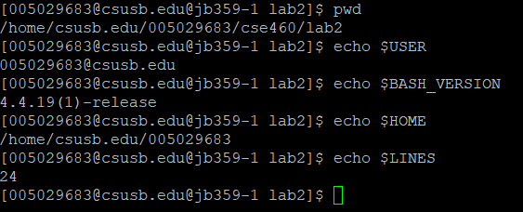

C)

Q: How do you define variable x with value 10 and print it on screen?

A:

***$ x=10  
$ echo $x***

Q: How do you define variable xn with value 'Rani' and print it on screen?

A:

***$ xn=Rani  
$ echo $xn***

Q: How do you print the sum of two numbers, say, 6 and 3?

A:

***$ echo 6 + 3***

Q: How do you define two variables x=20, y=5 and then print the quotient of x and y (i.e. x/y)?

A:

***$x=20  
$ y=5  
$ expr x / y***

Q: Modify the above question to store the result of dividing x by y to a variable called z.

A:

***$ x=20  
$ y=5  
$ z=`expr x / y`  
$ echo $z***

Q: Write a script XYZ=2017. What do you see? Explain the difference you observe in the two cases.

A: I see no differences in my shell. I am using a ssh to the machine. See proof below.

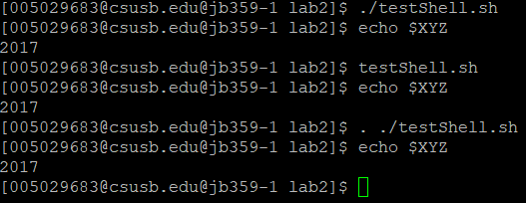

2. **AWK**

Q: Try the command: ***$ ps auxw | awk '{print $1 "\t\t" $2}'*** What do you see? What does the command do?

A: It print the processes running on the machine with the user that’s running/ in control of it.

3. **Viewing Processes**

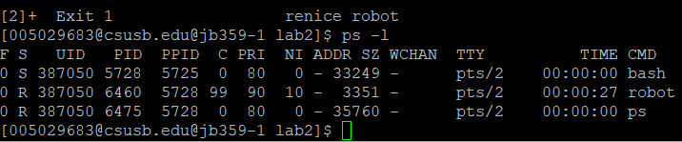

4. **Starting New Processes**

Q: Compile and run the program given. What do you see? A: It shows system processes with variables TTY, STAT, TIME, and COMMANAD.

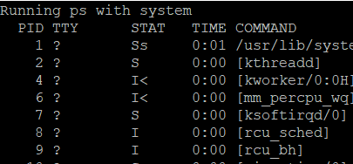

Q: Change the***system*** statement in test_system.cpp to ***system ( "ps -ax &" );****.* Compile and run it again. What happens? What does '&' here do?

A: It printed and process runs in background

5. **Shell Programming Practice**

