Brian Duenas

CSE 460

Lab5 - Study of Interprocess Communication (IPC) and XV6

**Part I - Message Queues**



*msgctl()* performs the control operation specified by cmd on

the System V message queue with identifier msqid.



*msgget()* returns value will be the message queue identifier



*msgrcv()* receive messages from, a System V message queue.



*msgsnd()* sends messages to a System V message queue.

Modified program so that each program can both receive and send messages alternatively:

What I did was combine code from each file and ran a receiver and sender simultaneously using a *fork*.

*highlights = code added*









**Output for *msg1*:**

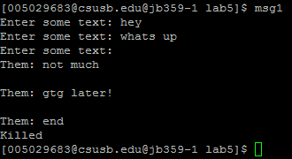

**Output for *msg2*:**

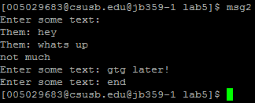

**Part II - IPC Status Commands**

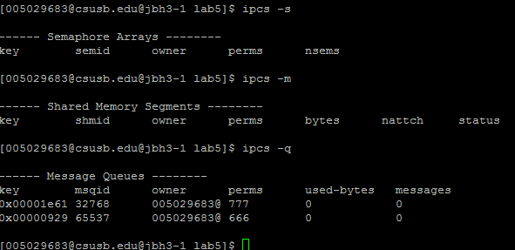

The first two commands *ipcs –s* and *ipcs –m* don’t show outputs. The command *ipcs –q* shows us that there is message queues present.

**Part III - Study of XV6**

**GDB terminal:**

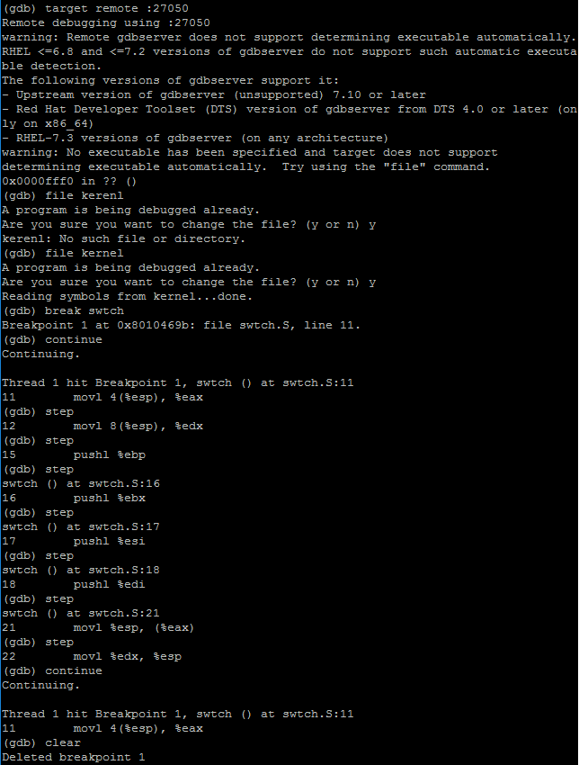

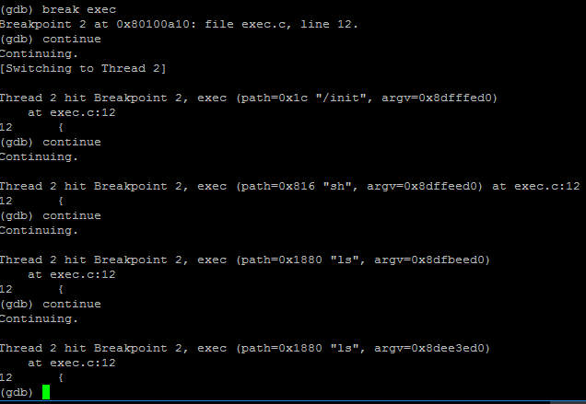

**qemu-nox terminal:**

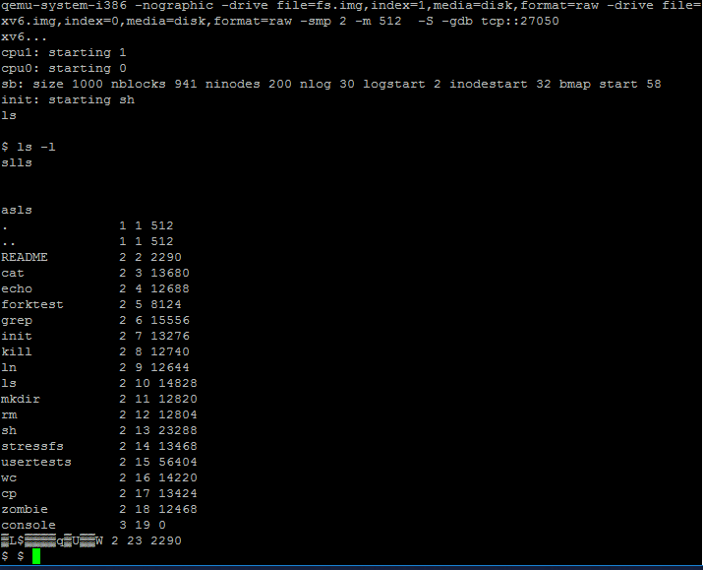

**GDB terminal for scheduler in *proc.c:***

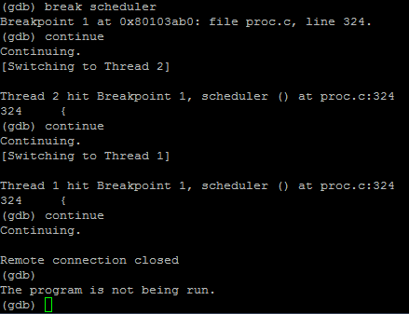

**qemu-nox terminal for scheduler in *proc.c*:**

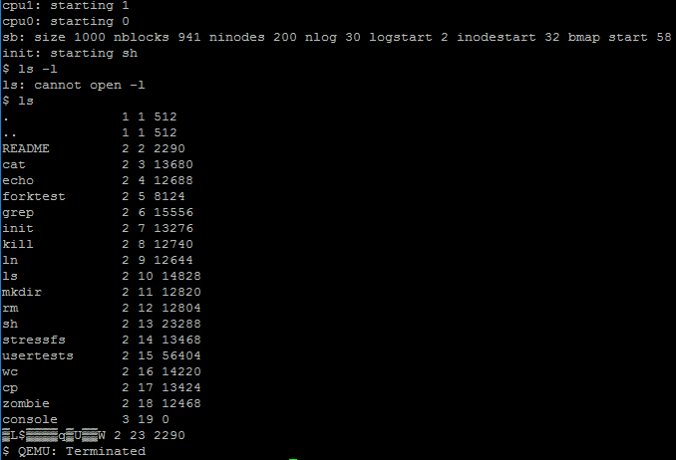

**Fully completed 20/20**