Brian Duenas

CSE 460

Lab 6 – Thread Programming and Semaphore Part I and XV6 Scheduling

**I. Introduction to Thread Programming**

**Q:** Modify the programs so that they run 3 threads and each thread runs a different function, displaying a different message.

**Code for pthread:**



**Output:**

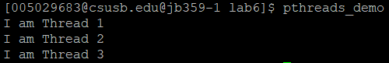

**Code for SDL:**



**Output:**

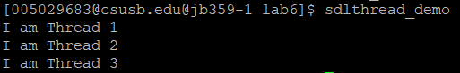

**II. Using Semaphores**

**Q:** Run *./sema1* do you see any printout of letters 'e' and 'l'? Why? Also run *./sema1 a do you see any printout of letters 'E' and 'l'? Why?*

**Outputs:**



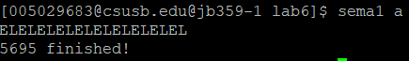

**A:** The program prints an "E" when entering and an "L" when leaving a critical section if the program is invoked with one or more parameters, otherwise it prints an "e" and an "l" respectively.

**III. XV6 Scheduling**

**Q:** Modify the *proc.c* file to print the pid’s of xv6 and add a *foo.c* dummy file.

**Code (partial) for *proc.h*:**



**Code (partial) for *proc.c*:**



**Output from *proc.c*:**

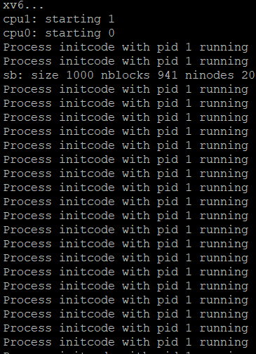

**Output for *foo.c*:**

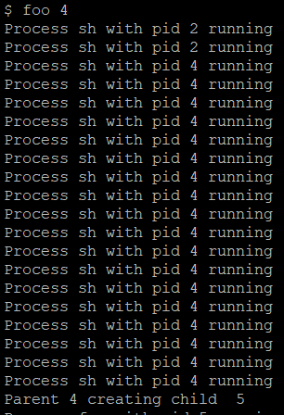

**Q:** Add in the file proc.h the struct proc> the timestamps and the priority

**Output:**

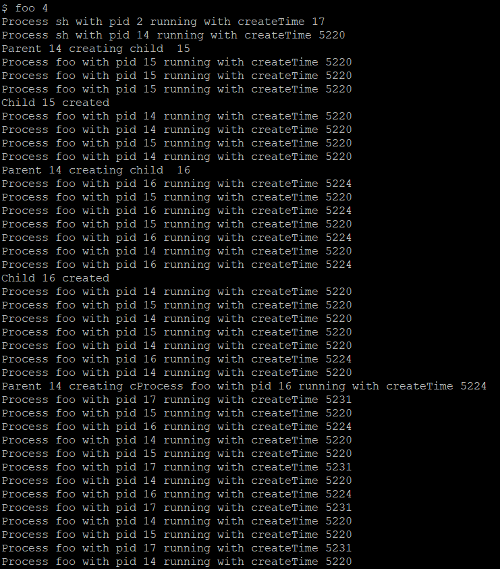

**20/20 Total Points**