CSE516 Winter 2018
Micromouse Simulation Project
Prepared by Brian Duenas

- Introduction

Micromouse maze is a 16 x 16 square-grid maze. Maze has walls along the boundaries of each position and allows a path in between the starting cell and destination. The objective is to simulate the mouse path-finding and reach the destination in the shortest time. Mouse can start at any corner of the maze and have to the find its way to the destination. The destination is the center four grid blocks of the maze which will have one opening into it. Virtual mouse will a maze file transferred to an array to see if a wall is around it in current position and chooses its path accordingly. Simulation is done taking head direction of the mouse and around the mouse inside the maze.

Note: the micromouse can only turn left or right, move back or forward. It cannot make U-turn due to the size constraint.

- Description
Programing language: JAVA is used to program the algorithm. GUI is made using the swings in JAVA.
Input File: Input to the program is taken from the text file. The text file is a 33 x 33 matrix with " | " and "-" symbols with spaces in between them. " | " represent a vertical wall and "-" represent a horizontal wall. This representation is shown in the following screenshot. The path of this text file is given in the program.

Input Text File

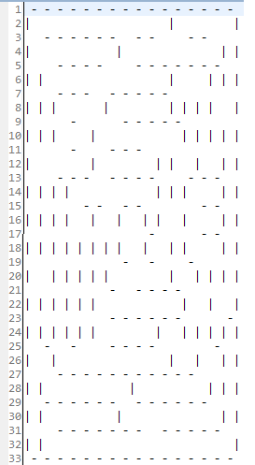
Two arrays Horizontal 17 x 16 and Vertical 16x 17 are used to store the horizontal walls and vertical wall respectively. They are used to tell where there is an open side for a particular individual cell.

- Algorithm

For each and every cell in the maze, follow the following steps:
- Use the built in repeats and position algorithm for moving through the maze. (Provided by professor Haiyan Qiao).
- If you’ve reached a dead end and gone back to a cell where you can take more than two paths (a ‘Node’), build a virtual wall to block where you came from.
- If you repeat onto a ‘Node’ (means you have gone in a loop), build a virtual wall to block where you came from.
- Keep track of the ‘Nodes’ you have been into in an array.
- Do not reverse at any time except when you’ve reached a dead end, and after you get out resume as normal.
- For training: keep track of moves you’ve already taken at a ‘Node’ and if you repeat onto it again try a different move if available.
- On the final run (not test run) don’t use the repeat s to move through the maze only the positions array.

- Procedure

- System should have the Eclipse (IDE) and JDK environment to run the JAVA applications.
- Two JAVA classes MicroMouse.java and Direction.java are provided, one for the direction and another for the actual algorithm. The GUI part is provided in MicroMouse.java, without the algorithm included.
- In the MicroMouse.java file the input text file (the maze) is read. As shown in the screenshot.
- Implement the algorithm in MicroMouse.java
- Save, compile and run the MicroMouse.java file.
- Output: The output path flow is shown in the GUI. Along with GUI a 16 x 16 Matrix which shows number of times each cell visited and the output path is printed.

- Testing & Results
Mazes used:

- Maze1 configuration Output
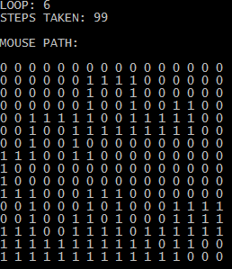
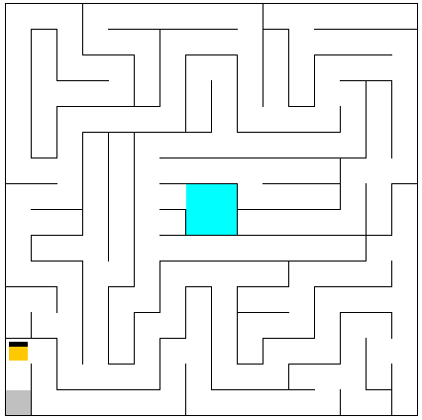

2) Maze2 configuration Output
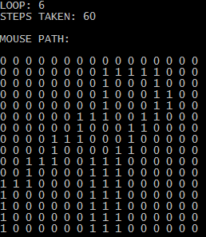
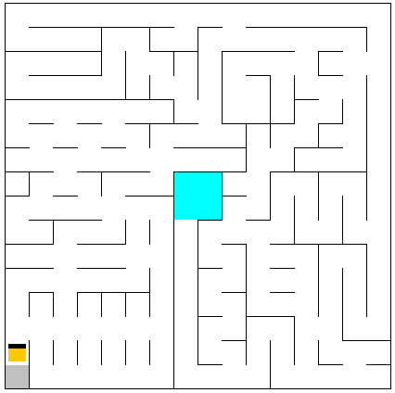

- Maze3 configuration Output
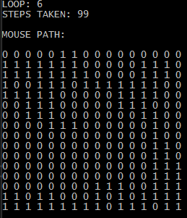
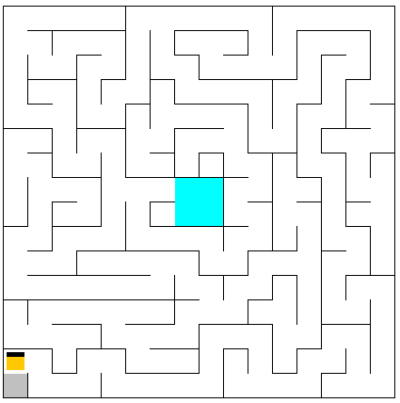

Maze | TEST 1 | TEST 2 | TEST 3 | MEAN | STD DEV.
Maze 1 | 99 | 99 | 99 | 99 | 0
Maze 2 | 60 | 60 | 60 | 60 | 0
Maze 3 | 99 | 99 | 99 | 99 | 0
*Each test had 5 runs for consistency

- Discussions and Conclusion
Our algorithm has achieved the shortest paths by the final run of all three mazes. Between each test the result of steps is the same because the algorithm once reset has a systematic way of moving through the maze, not a random way. This is why each test yields the same results and pattern of direction through the maze. The algorithm tries to transverse the entire maze, so the more repetitions per test the higher the chances are of finding the shortest path. The current repetition amount of 5 was fine for these three mazes used. The algorithm used was to our knowledge unique and not used before. Other algorithms like flood fill are more widely used. This algorithm has a chance at beating out flood fill method in some cases.

Although the algorithm works there are a few complications as is. Firstly, it may not find the shortest path or get stuck if there is no nearby wall and many blank spaces like the one shown below. It has to do with some logic in the algorithm and should be solvable.
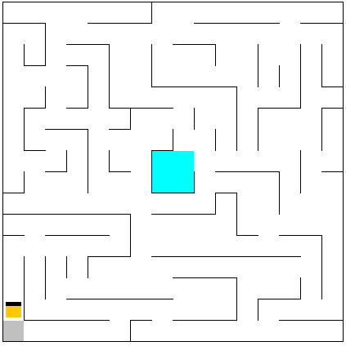
For the future a way to optimize this algorithm may be to cut off the longest path of a loop that leads to the finish. A deterministic approach would need to happen so the micromouse would be able to know one of those ways is the optimal path.
References

[1] MicroMouse URL: http://www.micromouseinfo.com/index.html

