Maximum (Bicycle) Chain Efficiency
Theo Schmidt 21.12.2019

Introduction
There are a great many data available on the efficiency of bicycle chain drives and sometimes the chains themselves, starting over a century ago with Mack 1897 and Carpenter 1898. These and many more references are given in Matthew Kidd’s (2000) doctoral thesis at Heriot Watt University. Kidd appears to be one of very few researchers to have examined also by theory the various sources of friction in the bicycle chain.
The aim of this article is not to present an overview of bicycle chain efficiency (for this see Wilson and Schmidt 2020 and its references), but to examine the theoretical maximum value of chain efficiency. A complete link of a bicycle chain is made up of two half-links. One of the half-links consists of a pair of outer plates fixed together in a friction fit via two pins, the other of a pair of inner plates held together by two bushings, or in modern chains, loose inner plates with integral half-bushings. Each pin and bushing form a miniature journal (plain) bearing. Although not strictly necessary, there is a third loose coaxial element surrounding each bushing: the roller giving the roller chain its name and making up a further journal bearing.

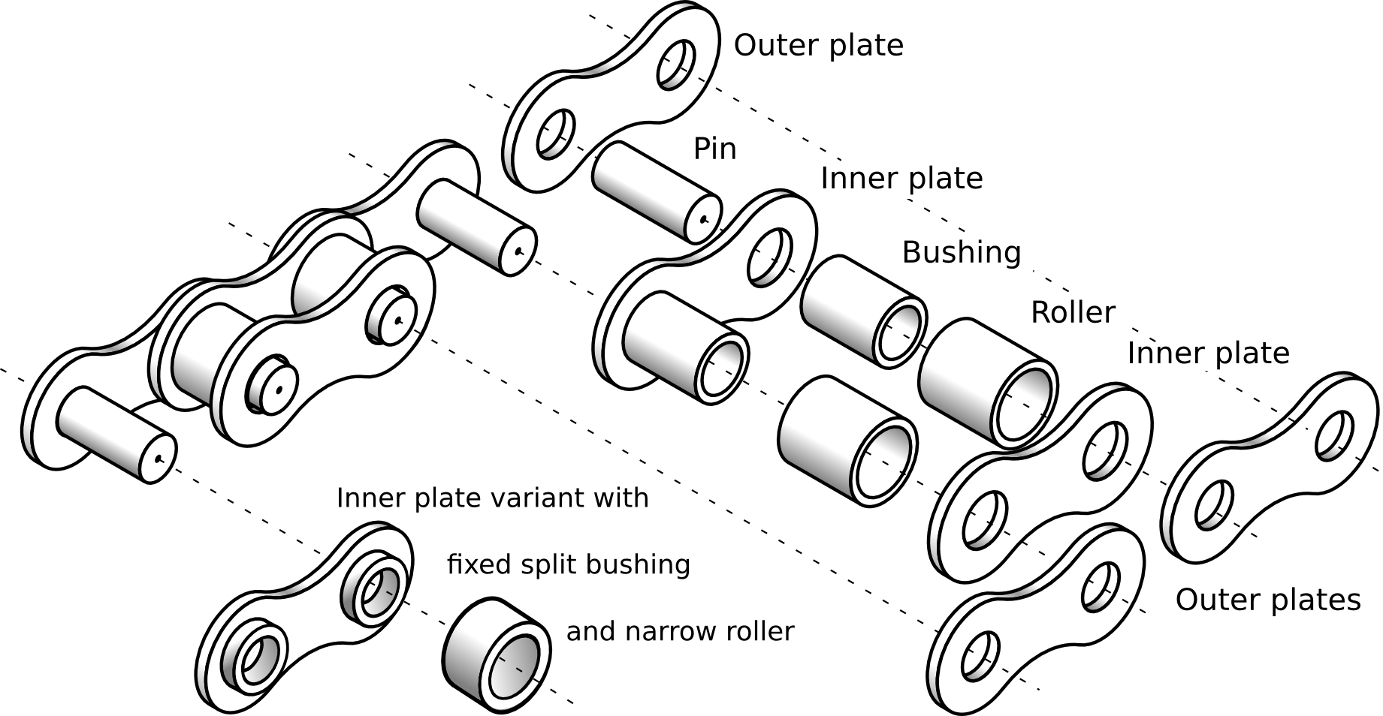
Figure 1: Roller-chain components, including a modern design for thin chains with one-piece inner plates and half-bushings. Adapted from a drawing by Markus Roeder.

Friction and Efficiency
Maximum efficiency involves minimising the power loss due to mechanical friction. This power is proportional to the product of force and rate of movement between the components in contact, and a coefficient of friction μ. In a chain there are two potential internal friction surfaces: between a fixed pin and bushing, or pair of half-bushings, and between a bushing and roller. The pin-bushing friction is intrinsic and unavoidable, as two (half-)links each have to rotate relative to one another each time they articulate onto and off of a sprocket, which they do with an angle equal to 360°/N, in which N is the total number of teeth on the sprocket or chainwheel. The bushing-roller friction is less, as a for a geometrically perfect chain and sprocket, the duration and length of sliding contact between a roller and the flank of a sprocket tooth are infinitesimally small. However, the chain geometry is never perfect: the chain stretches very slightly due to tension and lengthens much more when the components wear with time. In practice, therefore, the roller can transform sliding friction at the tooth's flank into rolling friction and rotational sliding friction between the roller and the bushing, Although this change might appear in geometrical terms, the surface between the roller and the bushing can retain its lubrication better and is subjected to less grit, than the the surface of the tooth's flank. Also there is less wear and it is distributed over a larger surface area.
In addition, for an imperfectly aligned chain, there is some friction between the chain-link plates and the sides of a sprocket-tooth. Kidd (2000) derived equations for all of these frictions and concluded that the friction between pins and bushings is the most important, suggesting 75% of the total. In the following, however, we'll assume 100% , that is ignore all but the intrinsically unavoidable pin-bushing friction.

Connecting Rod Model
Under the above assumption it's possible to consider a chain as a special form of linkage or connecting rod. Imagine a single-bar linkage as the simplest way of connecting two longitudinally spaced wheels, as is done with a connecting or side rod in a steam locomotive, see figure 2. When it is 90° from dead center, such a rod behaves momentarly like a chain with one lengthened (half-)link. Imagine the link moving a short distance. As long as the displacement is less than the pitch of the chain, there is friction only at two pins, one at the driving sprocket and one at the driven one. During this limited time and movement there is in principle no difference between a chain link and the locomotive linkage. There are of course plenty of practical differences. A locomotive siderod works in both tension and compression, a kinematically quite different chain works under tension only, and needs a return path (slack part not shown in fig. 2), where it isn't under much tension but still generates a small amount of friction, that we conveniently ignore for the moment. For a siderod to work smoothly, a second one is needed on the other side of the locomotive, set at angular difference of 90° (the wheels are fixed on a common axle). The locomotive journal bearings are large and fast-moving enough to benefit from dynamic lubrication permitting no metal-to-metal contact, or could use roller bearings. The bicycle-chain pin-bearings are not in this league and we discuss the implications of this and the friction in the slack part later.

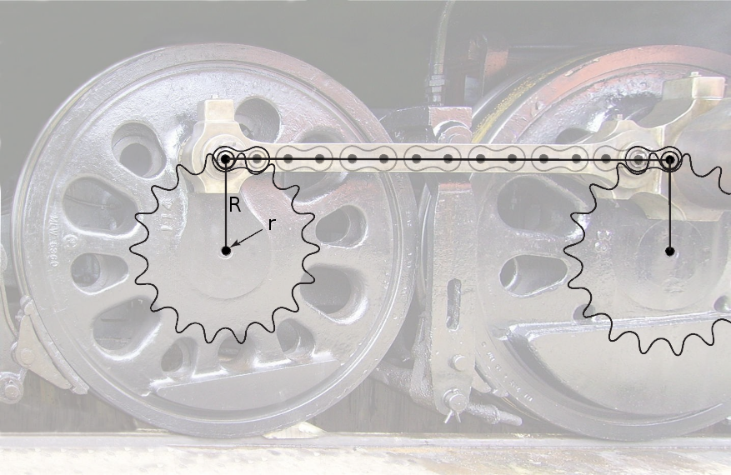Figure 2: At the top two joints left and right, a chain between two sprockets is physically equivalent to the connecting rod of a locomotive at 90° from dead center. Background based on photo by Didier Duforest CC-BY-SA 4.0.(The analogy isn't perfect here, as the side rod appears a half-link short.)
This analogy between one half of a connecting rod and a specific pin of a chain is plausible when considering the period from the moment that the pin's roller arrives (or leaves) its seat between two teeth on the sprocket until the moment that the next one does so. The corresponding length is equal to the chain's pitch and the angle equal to 360° devided by the number of teeth on the sprocket. But what happens afterward? Visualising the movement, it can be seen that, assuming the perfect geometry of an unstretched chain and unworn sprocket, the articulation of the first (half-)link stops at the exact moment that that of the next (half-)link starts, so that, per sprocket, there is always exactly one pin rotating in its bushing at a time. As a first approxiamtion we can thus calculate the friction of rotation as if it belonged to a single joint rotating continuously. However, a continuous movement divided up into a discrete number of single movements implies a lateral deceleration or jerk each time, and there is an additional amount of longitudinal vibration that becomes stronger the smaller the number of teeth on the sprocket. This is known as the polygon-effect, or chordal action, and the actual speed variation in the chain is 1 ‒ 180° divided by the number of sprocket teeth. This exceeds 4% with an eleven-tooth sprocket and rises sharply with fewer teeth. This is the main reason that sprockets of this size or less wear so quickly and result in considerably less efficiency than with more sprocket teeth.
Assuming enough sprocket-teeth to be able to ignore chordal action and using the above connecting rod analogy, if such a rod is connected to a wheel or sprocket at radius R with a pin of radius r, there is, as regards friction, a mechanical advantage of R/r because the relative movement between pin and bushing decreases by this ratio. If r were equal to R (which is sometimes the case for engine crankshafts or eccentric rods), the joint's sliding speed would be the same as linear speed of the chain or connecting rod. Although there appears to be no logical connection between these two speeds, it seems clear that the power transmitted by a rod or chain link is F V, F being the compressive force or tension and V the chain speed or maximum longitudinal rod speed. The power lost is then F V μ, with μ being the joint's coefficient of friction, because F and V in the joint have the same (scalar) quantities. Therefore the efficiency (still assuming R = r) is η = 1 − μ, for example 90% if a value of 0.1 is assumed for μ. However, with the usual mechanical advantage, and for two pins and sprockets (taken here to be the same size), the efficiency is η = 1 − 2 μ r/R.

Estimating the Coefficient of Friction
The pin of a bicycle chain has a diameter of 3.6 mm and the effective diameter of a thirty-six-tooth sprocket is about 72 mm. With μ = 0.1, an efficiency of 99 percent results. This is less than the best efficiency—99.5 percent—that Kidd (2000) measures for well-lubricated bicycle chains, which even includes the friction between bushings, rollers and sprocket teeth, and that in the slack part of the chain. Therefore μ must have been less than 0.1 in these measurements. Indeed Kidd measured pin friction coefficients with pendulum tests (4.5 kg mass ≈ 44 N load) and obtained a very best value of μ ≈ 0.001 L/(π r), L being the effective length of the pendulum. L was not given in the thesis, but a photo sent by Matthew Kidd in 2019 shows it to be about 285 mm, yielding μ = 0.05 or η = 99.5 percent by the simple formula given above, for the 72 mm sprocket. The results for this best case thus seem in agreement, but Kidd also obtained several higher values of μ at half the load, and higher again for misaligned, unlubricated or worn chains, right up to μ = 0.75 (which would still give an efficiency in our example of 92.5%).
The value of μ is seen to be crucial. For dry, unlubricated surfaces, the usual assumption of a constant value independent of speed and pressure (Coulombic friction) is a good one, it then depends on the nature of the two contacting surfaces only. Even the best polished metal surfaces are „hilly“ when viewed microscopically. These „hills“ are called asperities and the two surfaces only touch at a few percent of the actual surface. Therefore the local pressures are very high and sliding movement tears away tiny chunks of material and produces debris, abrasion and wear. In spite of this, μ is lower this way than if the surfaces were perfectly smooth: they would stick together strongly, giving a very high value of μ. The actual coefficient of friction depends not only on the exact geometry of the asperities but the nature of the debris: rounded particles would tend to reduce, angular particles to increase friction. Typical values of μ for the dry, kinetic friction of steel touching steel measure, from various sources, between 0.4 and 0.6. Using 0.5, our example above would exhibit an efficiency of 95%, giving some credibility to claims that even completely unlubricated old chains can perform reasonably well on a bicycle. (New bicycle chains are always prelubricated.)

The Effect of Lubrication
As soon as a lubricant is present, μ can no longer be taken as constant, but varies with pressure, sliding speed and nature of the lubricant, especially viscosity. At very low speeds and low viscosity the asperities touch just as much as if unlubricated, but they are „coated“ with a film of lubricant of one or more molecular layers. This is called boundary lubrication. The bulk properities of the lubricant don't count, but the molecular structure and weight do. According to Hamrock et al. 2004, fatty acids wirh molecular chains of over 14 units (corresponding to a molecular weight over 120) are particularly good boundary lubricants with μ values as low as 0.05. This include myrtistic, palmitic and stearic acids.
As speed increases and/or load decreases and/or viscosity becomes higher, μ decreases, eventually by 2-3 orders of magnitude with minima as low as 0.001. Measurements of μ are often expressed as a function of rotational speed (ω, 1/s) times the lubricant's dynamic viscosity (η, Pa s), divided by a pressure (p, Pa). The combination ω η / p is dimensionless and called the Hersey number H. A plot of μ as a function of H is called a Stribeck curve, named after one of the several researchers who discovered in the decades around 1900 the relationships given above. The most prominent feature of a Stribeck curve is the relatively sharp minimum which indicates complete hydrodynamic lubrication, i.e. the point where the wedge of lubricant has enough pressure to completely separate the sliding surfaces so that their asperities no longer touch at all. This doesn't concern us at all for a bicycle chain's pin/bushing bearing, which rotates rather slowly and also intermittently and is very far from this condition. However, comparing Stribeck curves for various lubricants could give an indication whether a pin/bushing is completely in the region of boundary lubrication or could be „pushed“ into the region of mixed lubrication with sharply declining μ values, by the proper choice of lubricant or changes of chain and sprocket geometry. Stribeck curves for vegetable oils are evaluated here (with a repeat of the above section).
In theory at least, the use of a lubricant with a very high viscosity should do the trick. In practice this extreme solution might not work as we also have the links' side plates: using an extremely viscous liquid would almost glue them together. However there may be an optimal lubricant for each condition and it certainly won't be a low-viscosity light oil which intuition might suggest. This would indicate a case for using grease (η = 2-20 Pa s) rather than oil (typically < 0.1 Pa s). Or other high-η substances such as castor oil, glycerine (η nearly 1 Pa s at room temperature) or paraffin wax, which however is then a solid. The problem is that the high viscosity prevents the substances from getting into the pin/bushing joint except when immersed at high temperatures. This is exactly what many cyclists do when they take their chains off their bikes and boil them in paraffin wax. The advantages (mainly cleanliness and cost) are widely discussed, e.g. see https://forum.slowtwitch.com/forum/Slowtwitch_Forums_C1/Triathlon_Forum_F1/Paraffin_wax_bike_chain_converts_-_drawbacks%3F_P6274625/. Another solution is to use a mixture of paraffin and oil called slack wax. The best commercial chain lubricants use something like this and also often include a suspension of polytetrafluoroethylene (PTFE)-particles. PTFE (e.g. Teflon) is a solid but with a friction coefficient of only 0.04 against steel. The commercial lubricants also add a solvent to make the suspension thin enough to apply and increase the price compared to that of the base substances by several orders of magnitude!

Measurements
I tried to reproduce one of Kidd's tests with a 4.5 kg pendulum, a piece of log, suspended by a short piece of chain. I used both a modern slim (6.6 mm pin length) “bushingless” chain for derailleurs (YBN SH9 S2) and a classical wide one for single sprockets or hub gears. They were both new and I didn't degrease them at first but just added a squirt of a modern wax-PTFE-based lubricant. After determing that the wide chain behaved about like the slim one, I did a few more tests with the wide one, first degreasing with hot detergent water and then ethanol, then trying glycerine and paraffin wax as lubricants. They were applied by completely immersing and moving the chain for 10 minutes and boiling the paraffin wax. For comparison, I replaced the chain with a knife-edge joint, so that the friction of this test should be almost entirely due to air drag.
In a multitude of test I obtained μ-values of 0.35-0.4 for both chains and the lubricants mentioned and also with the wide chain degreased. However, these experiments were conducted in a course manner and it is possible that my degreasing procedure was insufficient to get rid of all the manufacturer's pregreasing, so that I was more or less always measuring this, and also the pendulum's air drag, which hasn't yet been subtracted. I'll try to do this in the near future.

Conclusion
It is seen that there can be great variation in a chain's coefficient of friction, which however only costs a few percentage points in efficiency. My own attempts to reproduce maximum chain efficiencies over 99% failed, even when attempting special lubricants, but still reached 96%. Such variations aren't felt much by ordinary cyclists but can of course win or lose races. Achieving low μ-values in the „mixed lubrication“ region in bicycle chains (theoretically resulting in around 99.9% link-efficiency in the tension part) hasn't yet been achieved or disproved and remains elusive.

References
Carpenter, R. C. (1898). "The Efficiency of Bicycles". Engineering Aug l9th-Aug 26th,1898.
Hamrock, Bernard J; Steven R. Schmid; Bo O. Jacobson (2004). „Fundamentals in Fuid Film Lubrication, Second Edition“. Marcel Dekker Inc., Hoboken.
Kidd, Matthew D. (2000). “Bicycle-Chain Efficiency.” Ph.D. diss., Department of Mechanical Engineering, Heriot-Watt University, Edinburgh, Scotland. https://ethos.bl.uk/OrderDetails.do?uin=uk.bl.ethos.313628
Mack, G. D. (1897). "Tests of the Efficiency of the Bicycle". Transactions of the ASME vol XVIII(May), 1067-1071.
Wilson David Gordon and Theodor Schmidt. (2020). „Bicycling Science, Fourth Edition“. https://mitpress.mit.edu/books/bicycling-science-fourth-edition

