Object-Oriented Programming in Java
MISM/MSIT 95-712-C
Homework 4
Due: Wednesday, October 13, 2004, start of class
There are 3 exercises in this homework. The first exercise is 25 points, the second is 35 points and the third is 40 points.
Follow the commenting and coding convention, and the minimal class description guideline as discussed in the lectures for all the classes you introduce, except for the test driver classes that contain the main function.
Name your files as specified in each of the exercises below. Generate the Java documentation by running the javadoc utility over all the classes and packages. Put all your java files, compiled class files and the documentation files into a zip file named Homework4.zip and submit it via the Drop Box on the blackboard before the beginning of the class on October 13, 2004. Also, print all your .java files with your name and bring them to me at the beginning of the class on October 13, 2004. Don’t print nor bring the documentation files.
- Enhance the ReflectionTest.java in the following way: Copy the code of the ReflectionTest.java to a file named Homework4_1.java. In the printFields() method, while printing the field information, print the value of each field along with its name. To do this, you need create an instance of the class that is passed to this method through the default constructor. Enclose the whole code of this method with a try { … }catch (Exception e) { e.printStackTrace(); }
- Implement the inheritance hierarchy shown Figure 1 as described below:
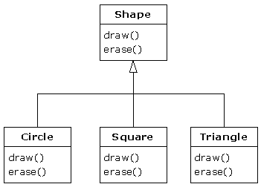
Figure 1 Inheritance Hierarchy for Shape Classes
Create a package called edu.heinz.cmu.oop95712c.Shape and define the Shape, Circle, Square and Triangle classes in that package. Also define a Point class in this package as explained below. All the classes inside this package should be public.
Shape class is an abstract class with abstract draw and erase methods, both public and void. Circle, Square and Triangle classes are all final.
Introduce a Point class that has two integer instance members, x and y. You can use the Point class that you wrote for homework 3, but make x and y private for this exercise. The toString() method of the Point class should return a String of the form “(x,y)” with the actual values of x and y.
The Circle class should have an instance of Point class representing its center and a double member representing its radius. The draw method of the Circle class simply should print out something like “Drawing circle at point (10,20) with radius 5.0”. Its erase() method should print out “Erasing circle at point (10,20) with radius 5.0”.
The Square class should have four instances of Point class. Its draw() method should print out something like “Drawing square at points (x1,y1), (x2,y1), (x1,y2), (x2,y2)” with actual values of x1, y1, x2, y2. Its erase method should simply print out erasing at those points.
The Triangle class should have three instances of Point class. Its draw() and erase() methods should be similar to those of the Square class.
While printing out the messages in draw() and erase() methods, use the toString() method of the Point instances implicitly.
The constructors of Circle, Square and Triangle classes should be overloaded to take either x and y values for points, or, objects of Point class. For example, you should allow creation of Circle objects like:
Circle c = new Circle(10, 20, 5);
and also like:
Point p = new Point(10, 20);
Circle c = new Circle(p, 5);
Don’t worry about verifying the points passed onto the constructors of Square and Triangle; just take them without error checking.
Define your main function in Homework4_2 class using the default package. In your main function, create objects of Circle, Square and Triangle classes, put them in an array of Shape references, invoke draw() on all of them and then invoke erase() on all of them.
- Consider the inheritance hierarchy in Figure 2.

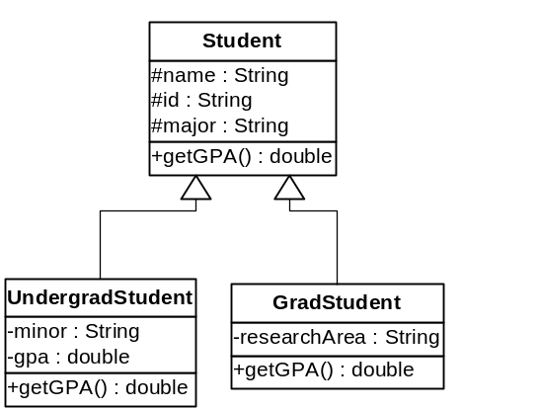
Figure 2 Inheritance Hierarchy for Exercise 3
Introduce Student, UndergradStudent and GradStudent classes in a package called edu.heinz.cmu.oop95712c.Student. Also define a StudentFactory class in this package as explained below.
Student is an abstract class with abstract getGPA() method. UndergradStudent and GradStudent are final classes. Information about students is kept in a data file as in the following format:
G|Adam Smith|123-4567|CISC|Network Management
U|Chris Smith|987-6543|MATH|ENGL|3.98
The fields are separated by the | character. The first field is either a G representing a graduate student or a U representing an undergraduate student. Graduate student entries have name, id, major and research area fields, whereas the undergraduate entries have name, id, major, minor and gpa fields. The getGPA() method for the graduate students should always return 4.0.
Introduce the StudentFactory class with just a static function of the form:
public static ArrayList createStudents(String filename) throws IOException {…}
This function should take the name of the data file and read it line by line until the end of file. For each line read, it should examine the first field, create either a graduate or an undergraduate student object, store the student object reference in an array list. Once, all the entries are read, it should return the array list object.
Define your main function in a class named Homework4_3 in the default package. Your main function should invoke the createStudents() function of the StudentFactory class and get the list of students into a local array list variable. It should then loop over the array list and print out the information about each student on a separate line onto the console.

