Object-Oriented Programming in Java
MISM/MSIT 95-712-C
Homework 5
Due: Wednesday, October 27, 2004, start of class
There is only one exercise in this homework, which is 100 points.
Follow the commenting and coding convention, and the minimal class description guidelines as discussed in the lectures for all the classes you introduce, except for the test driver classes that contain the main function.
Name your files as specified below. Generate the Java documentation by running the javadoc utility over all the classes and packages. Put all your java files, compiled class files and the documentation files into a zip file named Homework5.zip and submit it via the Drop Box on the blackboard before the beginning of the class on October 27, 2004. Also, print all your .java files with your name and bring them to me at the beginning of the class on October 27, 2004. Don’t print nor bring the documentation files.
- Consider the inheritance hierarchy in Figure 1.

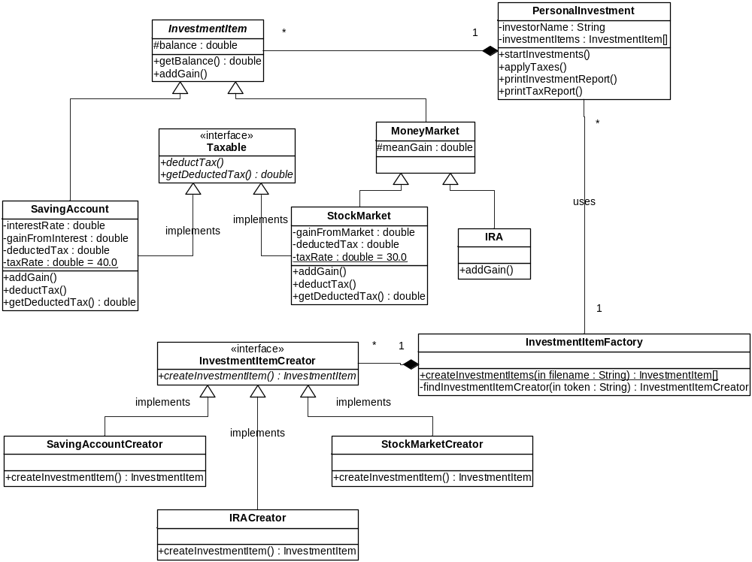
Figure 1 Inheritance Hierarchy for Exercise 3
Create a package named edu.heinz.cmu.oop95712c.Investment and put all the classes shown in Figure 1 into this package as explained below:
- InvestmentItem is an abstract class with an abstract addGain() method. getBalance() is the getter method for protected member balance.
- Taxable is an interface with deductTax() and getDeductedTax() methods.
- SavingAccount is a subclass of InvestmentItem and it implements the Taxable interface. taxRate is static and final whereas all others are instance members. addGain() method calculates the (yearly) interest and adds it into the balance and to the gainFromInterest. deductTax() method calculates the tax based on the gainFromInterest, reduces the balance by the tax, adds the tax to the deductedTax member and sets the gainFromInterest to 0. getDeductedTax() returns the deductedTax member variable.
- MoneyMarket extends InvestmentItem and has an instance variable named meanGain.
- The IRA class is a subclass of MoneyMarket. Its addGain() will generate an exponentially distributed random number with a mean of meanGain and add it to the balance. The method to generate exponentially distributed random number will be provided to you.
- StockMarket is a subclass of InvestmentItem and implements Taxable interface. The taxRate is static and final whereas all others are instance variables. addGain() generates exponentially distributed random number with a mean of meanGain and add it to the balance. It also increments the gainFromMarket by that generated number. deductTax() and getDeductedTax() work similarly to those of the SavingAccount class.
- PersonalInvestment has the investorName and investmentItems, both instance members. The startInvestments() calls the following static function of the InvestmentItemFactory class in a try –catch block
investmentItems =
InvestmentItemFactory.createInvestmentItems(investorName + "_investment.data");
This function reads a file and creates all the InvestmentItem objects into an array, as explained later on. It then creates a local ActionListener object named adder and passes that object to a Timer instance as the ActionListener as follows:
Timer t = new Timer(1000, adder);
t.start();
The actionPerformed() method of the adder object should iterate over all the InvestmentItem objects inside the investmentItems and invoke their addGain() method.
The applyTaxes() method should iterate over all the InvestmentItem objects inside the investmentItems and invoke the deductTax() method only on the investment objects that implement the Taxable interface.
The printInvestmentReport() method should iterate over all the InvestmentItem objects inside the investmentItems, print them out and invoke the getBalance() method in order to add the balance of this item into a running total balance. It should print out the total balance at the end.
The printTaxReport() method should find the total taxes paid by this personal investment account by iterating over all the InvestmentItem objects inside the investmentItems, invoking the getDeductedTax() method only on the investment objects that implement the Taxable interface and adding the return values of getDeductedTax() into a running total tax variable. It should print out the total tax at the end.
- InvestmentItemFactory implements the factory design pattern discussed in the class. The database for investment items are stored in a file named name_investment.data where name is the investorName instance variable of the PersonalInvestment object. The format of the file is shown below:
SA|1000|2.5
IRA|10000|200
SM|5000|100
The first field in each of the lines represents the type of the investment: SA for SavingAccount, IRA for IRA and SM for StockMarket. For SA, the remaining fields are the initial balance and the interest rate; for IRA and SM, the first field is the initial balance and the second is the mean gain.
Define InvestmentItemCreator interface and SavingAccountCreator, IRACreator, StockMarketCreator classes as private inner classes inside the InvestmentItemFactory class.
The createInvestmentItems() static function opens the buffered input stream and read it line by line. For each line read from the input stream, it will get the first token using a StringTokenizer. This token identifies the type of the investment item. This function will pass the identifier token to the private findInvestmentItemCreator() which finds the creator object corresponding to the identifier of the investment item. The createInvestmentItems() will invoke the createInvestmentItem() method of the creator object.
The createInvestmentItem() methods of all the creator classes take a StringTokenizer parameter and uses it to read the values that are necessary to create an investment item object. The createInvestmentItem() method of the SavingAccountCreator class calls the nextToken() on the StringTokenizer parameter to get the values for the initial balance and the interest rate. It uses these two values to create and return a SavingAccount instance. Other creator objects work similarly.
Once the createInvestmentItem() method of the creator object returns an investment item, the createInvestmentItems() will put that object into an array list. Once all the lines are complete reading, createInvestmentItems() will call the toArray() method on that array list and return the array of investment items.
All the creator objects are stored in a static array inside the InvestmentItemFactory class. A skeleton will be provided for you to use these creator objects.
The main function inside the Homework5_1.java file in default package will be provided for you to experiment with your program.

The skeleton code is available in Homework5 directory of http://www.andrew.cmu.edu/user/syucel/Java/homework_solutions/

