Object-Oriented Programming in Java
MISM/MSIT 95-712-C
Homework 7
Due: Wednesday, December 1, 2004, start of class
There is one exercise in this homework and it is 100 points.
Follow the commenting and coding convention, and the minimal class description guidelines as discussed in the lectures for all the classes you introduce, except for the test driver classes that contain the main function.
In this homework, you are free to use packages or not. Generate the Java documentation by running the javadoc utility over all the classes and packages you introduced. Put all your java files, compiled class files and the documentation files into a zip file named Homework7.zip and submit it via the Drop Box on the blackboard by the due time. Also, print all your .java files with your name and bring them to me at the beginning of the class on the due date. Don’t print nor bring the documentation files.

In this homework, you will write a GUI for displaying student information in a university. The information is stored hierarchically in separate files. At the top level, a data file stores the name of the university and the departments within that university.
See the cmu_departments.dat below
Carnegie Mellon University
Heinz
CIS
The first line represents the name of the university. The remaining lines are the departments within that university.
For each department, there are three files: XXX_courses.dat, XXX_students.dat and XXX_studentcourse.dat where XXX is the name of the department.
See below the Heinz data files:
- Heinz_courses.dat: This file has the information about the courses. The fields are course id, course name, credits, course description, and all the sections.
95712|Object Oriented Programming in Java|12|Teaches Object Oriented Programming in Java|A|B|C
95703|Database Management|12|Teaches Database Management|A|B|C|D
- Heinz_students.dat: This file has the information about the students. The common fields are G or U representing either a graduate or an undergraduate student, student name, student id and major. The graduate student records additionally have the research area field whereas the undergraduate student records additionally have the minor and the GPA fields. This is the same file format used in Exercise 3 of Homework 4.
G|Adam Smith|123-4567|Heinz|Risk Management
G|Chris Smith|987-6543|Heinz|Product Marketing
- Heinz_studentcourse.dat: This file contains information about courses taken by students. The fields are the student id, the course id and the section. Each line in this file refers to a student taking a specific course.
123-4567|95712|C
987-6543|95703|A
Similar files exist for the CIS department.
Your program should read the information stored in these files and display them in a GUI in the following way:
- Introduce Java classes representing the model of this program. Some classes you can introduce would be to abstract university information, department information, course information and information abstracting the records for students taking courses . For abstracting the student classes, you can use the package edu.heinz.cmu.oop95712c.Student that was created in Homework 4 (you are free to modify it).
- Create a top level frame with a menu bar. The menu bar should have “File” and “Look and Feel” menus. “File” menu should have “Open” and “Exit” menu items. “Look and Feel” menu should have menu items for changing the look and feel to “Metal”, “Motif” and “Windows”.
- When the user selects the “Open” menu item, a file chooser dialog box should come up listing the files in the current directory. The user may select a file that has the information about university departments (e.g. cmu_departments.dat).
- When the user selects a file, your program should read all the information from the files into your objects.
- After reading the files, your program should set up the GUI as shown in Figure 1, Figure 2 and Figure 3

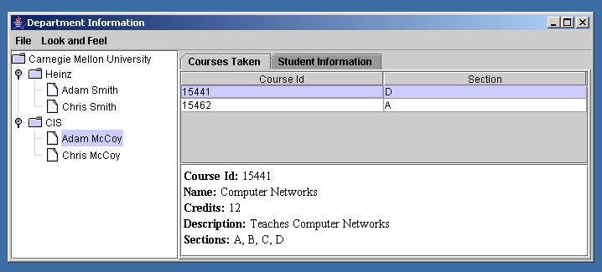
Figure 1 GUI showing the "Courses Taken" tabbed pane
- On the left side is a JTree showing the departments and their students.
- On the right side is a tabbed pane with two panels. The first panel, shown in Figure 1, lists the courses taken by a student. The table shows all the courses taken by the student selected in the JTree structure. Underneath the table is a JEditorPane displaying the course information in HTML format. When a student is selected on the tree, all the courses taken by that student should be listed in the table. When a row is selected in the table, the information about that course should be displayed inside the editor pane.
- The second panel displays the information about the student that is selected on the tree. The first form, which is at the top, is common for all the students. Depending on whether the student is graduate or undergraduate, the second form displays specific information on a card layout panel. For graduate students, as shown in Figure 2, the form has the research area and the GPA fields where the text field for GPA is set to 4.0 and is not editable. For undergraduate student, as shown in Figure 3, the form has the minor and the GPA fields. Save and Help buttons don’t do anything.

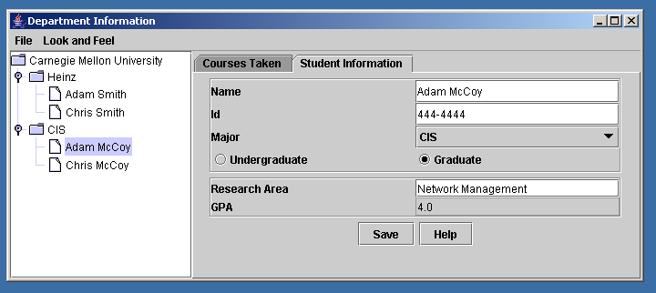
Figure 2 GUI showing the "Student Information" tabbed pane for a graduate student

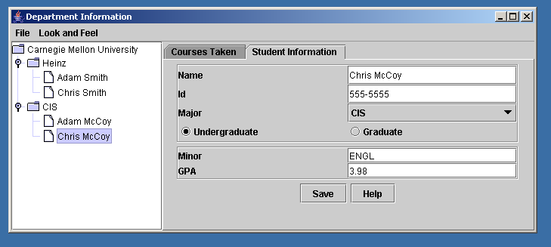
Figure 3 GUI showing the "Student Information" tabbed pane for an undergraduate student
You can assume that the input files are all well-formed and the users choose the correct data files.
As usual, details about how to implement this exercise will be discussed in the class. The executable files and the skeleton code will be available in Homework7 directory of http://www.andrew.cmu.edu/user/syucel/Java/homework_solutions/

