95712C Lecture Notes

Wednesday, September 15, 2004

Objects and Classes
Reference: Chapter 4 of Core Java, Chapters 1 & 2 of Thinking in Java.

Characteristics of OOP
OOP enables you to represent elements of the problem domain in the language, referred to as objects. Characteristic of object oriented programs (see Thinking in Java)
- Everything is an object. You can take any conceptual component in the problem you’re trying to solve (dogs, buildings, services, etc.) and represent it as an object in your program.
- A program is a bunch of objects telling each other what to do by sending messages.
- Each object has its own memory made up of other objects. You create a new kind of object by making a package containing existing objects.
- Every object has a type. Each object is an instance of a class, in which “class” is synonymous with “type.” The most important distinguishing characteristic of a class is “What messages can you send to it?”
- All objects of a particular type can receive the same messages. This is actually a loaded statement because of many interfaces an object may implement.

Revisit the Terminology
- Class
- Object
- Abstraction
- Encapsulation
- Constructor
- Instance member/field
- Method
- Setter/Getter method

Class
Since a class describes a set of objects that have identical characteristics (data elements) and behaviors (functionality), a class is really a data type. You extend the programming language by adding new data types specific to your needs. The programming system welcomes the new classes and gives them all the care and type-checking that it gives to built-in types.

Object
Once a class is established, you can make as many objects of that class as you like, and then manipulate those objects as if they are the elements that exist in the problem you are trying to solve. Indeed, one of the challenges of object-oriented programming is to create a one-to-one mapping between the elements in the problem space and objects in the solution space.
A class definition simply introduces a new type. To be useful, the classes should be instantiated into the actual objects. Hence:
Class | Object
Type | variable
One | Many
Abstract | Real

Three key characteristics of objects:
- Behavior
- State
- Identity

Abstraction
Abstraction is the representation of an element of the problem domain in the programming language. A simple example might be a representation of a light bulb:
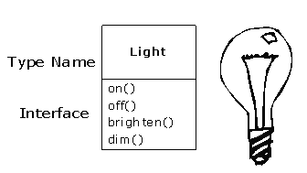
Light lt = new Light();
lt.on();

Encapsulation
Encapsulation is hiding the data, that is the instance variables, from the outside of the class. This can be done by
- Having private members, and
- Providing public methods that access and modify the private members in a controlled way.

Constructors
Constructors are used for providing the initial state of the class object. They can only be used with the new operator.
If no constructor is specified, a default no-argument constructor is called that initializes all instance variables to their default values (0 for number, null for references, false for booleans).
Constructors don't have return types.
Constructors can be overloaded.

Instance Members/Fields
These are non-static variables. There are duplicated for each object. Therefore, each object has its own instance variables.

Methods
These are the non-static methods that are to be invoked with an object. Implicitly, the object that invokes the method is passed as a parameter to the method. Indeed, it is the first parameter in the run-time system and can be accessed with the this keyword.
Remember that a static method cannot refer to instance variables of its class and cannot have this reference. The static variables and the static methods are independent of any object of a class. However, an instance method can refer to the class variables.
Methods can be overloaded to have different type and number of arguments. They cannot be overloaded just based on the return type.

Setter and getter methods
To be able to keep a valid object state, the instance members of objects should be hidden from outside world. The programmers should use methods to access these fields. Methods that modify the fields are called setter methods. Similarly, methods that reads the fields are called getter methods.
This has considerable benefits
- Internal implementation may be modified easily.
- Setter methods may implement error-checking.
- Getter methods may implement access control.
- Setter and getter methods may be synchronized to be executed safely in separate threads.

The toString Method
If a class defines a public toString method that takes no parameters and returns a String object, that method is invoked an object of that type occurs in a statement where a String is expected. This way, the objects can be printed easily.

Minimal Class Description
For any class you define in this course, make sure you have at least:
- Overloaded constructors (with default constructor if applicable)
- Private instance members
- Public setter/getter methods for private members
- Public toString method
See EmployeeTest.java.
See StaticTest.java

Relationships Between Classes
Common relationships between two classes are:
- Composition/Aggregation: has-a relation
- Dependence: uses-a relation
- Inheritance: is-a relation
See Figure 1 as an example.

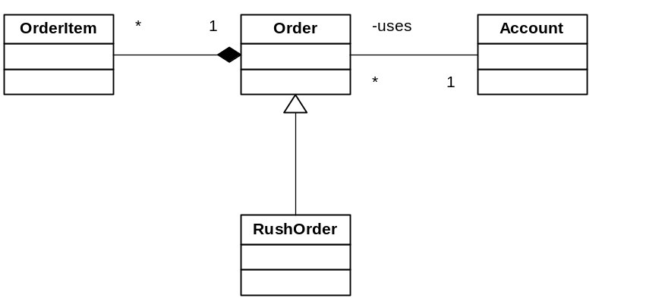
Figure 1 UML Conceptual Diagram showing relations among concepts

We will study the has-a and the uses-a relation today. In the has-a relation, objects of class A contains objects of class B. In many situations, objects of class B come into existence with the creation of objects of A and they disappear when objects of class A disappear. Sometimes, objects of class A manages the lifetime of objects of class B, that is, objects of class A creates objects of class B, use them and dispose them. Note that, however, in Java, object disposal is not an explicit operation.
In the uses-a relation, an object of class A has a reference to an object of class B. Object of class A doesn’t create object of class B. Rather, object of class B may exist without an object of class A. Most of the time, when an object of class A is being constructed, the reference to object of class B is passed to the constructor of object A. Also, it is common that a reference to object B is attached to the object A via a setter method.
Your new class can be made up of any number and type of other objects, in any combination that you need to achieve the functionality desired in your new class. Because you are composing a new class from existing classes, this concept is called composition (if the composition happens dynamically, it’s usually called aggregation). Composition is often referred to as a “has-a” relationship, as in “a car has an engine.”
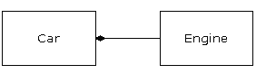
Composition comes with a great deal of flexibility. The member objects of your new class are typically private, making them inaccessible to the client programmers who are using the class. This allows you to change those members without disturbing existing client code. You can also change the member objects at run time, to dynamically change the behavior of your program. Inheritance does not have this flexibility since the compiler must place compile-time restrictions on classes created with inheritance, as we shall see next week.

Use of the Clone Method
When returning an object reference via its getter method, consider using the clone() method. If you want to prevent the client from modifying the object, you should use clone(). If the client is permitted to modify the object, return the object reference.
If the object that you are returning is an immutable object, don’t worry about returning a reference for it. Immutable objects are those who don’t change after being constructed basically because all of their instance variables are final. String objects are such objects. So, feel free to pass around the references to Strings. [StringBuffer class allows dynamic strings].

Parameter Passing
In Java, the convention of parameter passing is always call-by-value. This is true for primitive types as well as for object references. However, note that, when an object reference is passed to a method as a parameter, the object pointed to by the reference may be modified, although the reference itself cannot be modified.
See the ParamTest.java.

Object Initialization
Reference: Chapter 4 of Core Java, Chapters 1 & 2 of Thinking in Java.
See the Lecture Slides.
See ConstructorTest.java

Object Destruction
Java doesn’t allow you to explicitly delete an object. This limits the programmers who want to automate resource acquisition and release through the object constructors and destructors.
The garbage collector, from time to time, deletes the no longer referenced objects. You can add a finalize method into your class. It will be invoked before the garbage collector deletes the object.

Date and Calendar
Date class represents the number of milliseconds since Jan 1, 1970. Calendar classes represent points in time. The GregorianCalendar class represents dates in the format familiar to most people.
See http://java.sun.com/j2se/1.4.2/docs/api/index.html for Date and GregorianCalendar classes.
See the CalendarTest.java.

StringBuffer Class
When a String object is created, its content remains the same. The StringBuffer class can create dynamic strings i.e. modifiable, extendable in runtime. In other words, String objects are constant strings and StringBuffer objects are dynamic strings.
buf = new StringBuffer() creates an empty StringBuffer
buf = new StringBuffer(10) creates a StringBuffer of size 10 with no characters in it
buf = new StringBuffer("Hello") creates a StringBuffer containing the string Hello.
toString() method will convert StringBuffer objects into String objects so that they can be printed with PrintStream methods.
length() returns the number of characters of the StringBuffer.
setLength() increases or decreases the length of the StringBuffer.
The StringBuffer has a number of overloaded append methods to allow primitive data types and the Strings to append to the end of StringBuffer. The append method will return the StringBuffer objects
buf.append("hello");
buf.append(` `);
buf.append(true);
buf.append(10).append(2.5); // chaining.
The insert(index, m) methods allow to insert primitive data types and strings at any position of StringBuffer. The index should be >= 0 and <= length of String buffer, or otherwise a StringIndexOutOfBoundsException is generated. Like append, insert returns the StringBuffer object.
See http://java.sun.com/j2se/1.4.2/docs/api/index.html for StringBuffer class.

Comments
Reference: Chapter 4 of textbook
There are documentation comments and implementation comments in Java. You can generate HTML documentation out of your documentation comments in your source files using the javadoc utility. Comments enclosed with /** …. */ are documentation comments and are parsed by the javadoc utility in order to form the HTML documentation. Such comments may contain free form text and some tags. A tag starts with an @, such as @author or @param. The first sentence of the free form text should be the summary statement. Here are some conventions:
- For each class:
  - describe the abstraction it represents
  - have the @author tag
- For each public method and select private methods:
  - Describe what it does in the first sentence
  - Have @param tag for each of its parameters, if any
  - Have @return tag for its return value, if any
  - Additionally you may include the following depending on the method [this is a subset of operation contracts in UML documents]:
    - Describe the pre-conditions: Describe what has to be done before invoking this method. You may also list the assumptions made by this method.
    - Describe the post-conditions – Describe what has happened when this method finishes execution.
    - Mention the exceptions this method may throw via @throws tag
    - Implementation Notes – Describe any implementation detail necessary for someone to understand the code of this method with respect to the algorithm followed, error handling, multithreading synchronization, locking issues, security issues, performance issues, etc. One downside with this kind of comments is to keep them up to date as the code evolves.
- For select private instance variables:
  - Describe what it represents. Don’t use a tag.
Implementation Comments: These are enclosed by /* .. */ or preceded by //. Occasionally, provide implementation comments around your code; thinking of the persons who will be reading your code and of yourself who will be reading your own code sometime later. But, avoid excessive commenting. The best comment is the readability of your code.

Coding Convention
Reference: http://java.sun.com/docs/codeconv/
Coding convention is usually personal and to some extent company thing. Read the Sun Systems Java coding convention. Follow it except for the class organization. Follow Core Java’s convention for class organization in the following order: Constructors, methods, fields.

Eclipse features
- Javadoc comments
- Export to zip files

