12/7/2012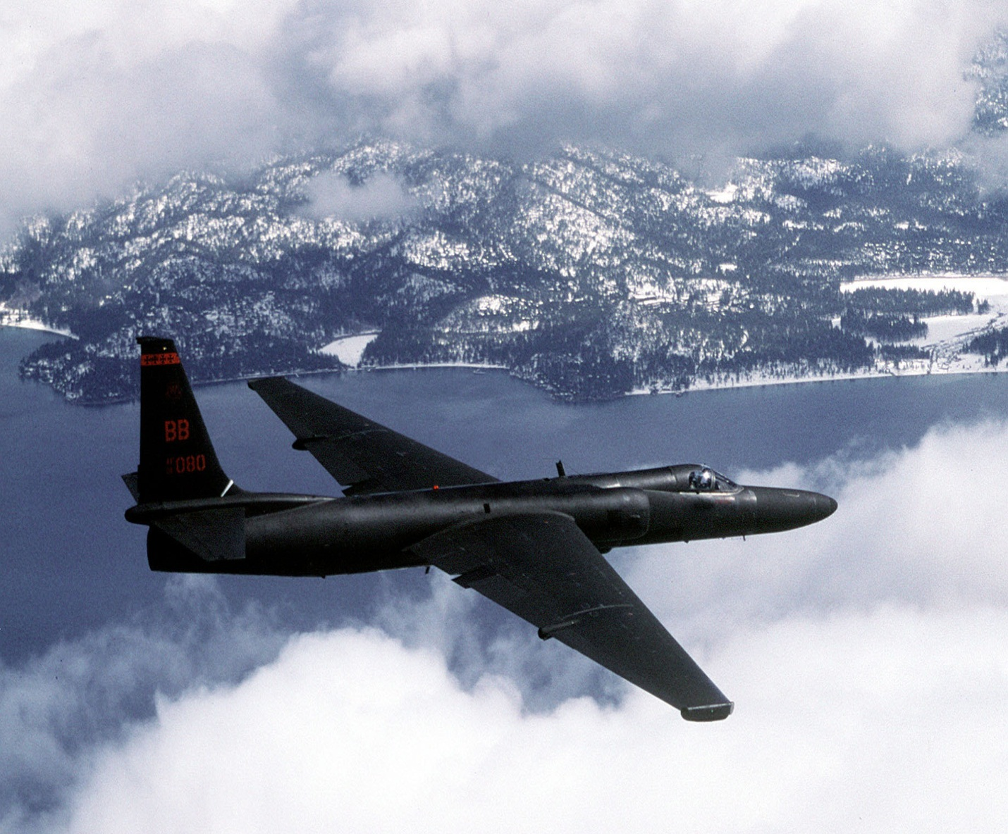

|  |  |
| --- | --- |
| WESTERN MICHIGAN UNIVERSITY | U2-R AIRCRAFT RENAISSANCE PERFORMANCE ANALYSIS |

|  |
| --- |
| PROF. TIANSHU LIU  AAE 4500 VEHICLE PERFORMANCE BRIAN OMONDI |

#### U-2R AIRCRAFT [http://www.airforce-technology.com/projects/u2/]

TERMS OF REFERENCE

A report submitted in fulfilment of the requirements for Course AAE 4500 Department of Engineering,Western Michigan University

Table of Contents

ABSTRACT 2

BACKGROUND 2

INTRODUCTION 3

U-2 PERFORMANCE ANALYSIS: 4

THRUST REQUIRED AND THRUST AVAILABLE 4

Figure 1: U-2R engine 5

Figure 2: Diagram showing Thrust Required 5

*Figure3: Variation of L/D with velocity for U-2 aircraft* 6

AERODYNAMIC RELATIONS ASSOCIATED WITH MAXIMUM CL/CD0, CL^3/2/CD,CL^1/2/CD. 6

*Figure 4: Variation of CL/CD, CL^3/2/CD,CL^1/2/CD for the U-2R aircraft* 8

THRUST AVAILABLE AND MAXIMUM VELOCITY 8

Figure 5: Thrust available and Thrust Required curve for the U-2R airplane. 9

POWER REQUIRED AND POWER AVAILABLE 9

*Figure 6: Power available and power required curves for the U-2 plane* 11

RATE OF CLIMB 12

Figure 7:Diagram showing climb forces 13

Figure 8: Variation of the Rate of Climb with velocity at different altitudes. 14

Figure 9: Hodograph diagram for climb performance of the U-2R aircraft at different altitudes 15

Maximum Climb Angle 15

Time to Climb 15

Figure 10: Graphical representation of the time to climb to 10000 ft. 16

GLIDING FLIGHT (UNPOWERED) 16

Figure 11: Diagram showing glide forces 17

*Figure 12: Representation of the rate of descent of U-2 aircraft*. 17

RANGE 17

ENDURANCE 18

LEVEL TURN 18

Figure 13: Figure showing turn forces 18

TAKEOFF PERFORMANCE 19

LANDING PERFORMANCE 19

RESULTS 20

CONCLUSION 26

REFERENCES: 27

APPENDICES 28

# ABSTRACT

U-2 is used in high altitude research aircraft used to carry experiments and sensors. They can carry airborne scientific payloads of up to 2,600lbs to investigate such matters as earth resources, celestial phenomena, atmospheric chemistry and dynamics and oceanic processes. The main purpose of this report is to undertake a performance analysis on the U2 airplane using a computer program and compare the results with analytical results. In order to do this matlab codes were used to insert the various formulae needed for this analysis. After that they were run and the results checked for authenticity. Although some of the data were missing since it is a military aircraft, approximations were made where necessary.

# BACKGROUND

Built in complete secrecy by Kelly Johnson and the Lockheed Skunk Works, the original U-2A first flew in August 1955. Early flights over the Soviet Union in the late 1950s provided the president and other U.S. decision makers with key intelligence on Soviet military capability. In October 1962, the U-2 photographed the buildup of Soviet offensive nuclear missiles in Cuba, touching off the Cuban Missile Crisis. In more recent times, the U-2 has provided intelligence during operations in Korea, the Balkans, Afghanistan, and Iraq. When requested, the U-2 also provides peacetime reconnaissance in support of disaster relief from floods, earthquakes, and forest fires as well as search and rescue operations.   
  
The U-2R, first flown in 1967, was 40 percent larger and more capable than the original aircraft. A tactical reconnaissance version, the TR-1A, first flew in August 1981 and was structurally identical to the U-2R. The last U-2 and TR-1 aircraft were delivered in October 1989; in 1992 all TR-1s and U-2s were designated as U-2Rs. Since 1994, $1.7 billion has been invested to modernize the U-2 airframe and sensors. These upgrades also included the transition to the GE F118-101 engine which resulted in the re-designation of all Air Force U-2 aircraft to the U-2S.  
  
U-2s are home based at the 9th Reconnaissance Wing, Beale Air Force Base, California, but are rotated to operational detachments worldwide. U-2 pilots are trained at Beale using five two-seat aircraft designated as TU-2S before deploying for operational missions.

# I**NTRODUCTION**

The U-2S is a single-seat, single-engine, high-altitude/near space reconnaissance and surveillance aircraft providing signals, imagery, and electronic measurements and signature intelligence, or MASINT. Long and narrow wings give the U-2 glider-like characteristics and allow it to quickly lift heavy sensor payloads to unmatched altitudes, keeping them there for extended periods of time. The U-2 is capable of gathering a variety of imagery, including multi-spectral electro-optic, infrared, and synthetic aperture radar products which can be stored or sent to ground exploitation centers. In addition, it also supports high-resolution, broad-area synoptic coverage provided by the optical bar camera producing traditional film products which are developed and analyzed after landing.  
  
The U-2 also carries a signals intelligence payload. All intelligence products except for wet film can be transmitted in near real-time anywhere in the world via air-to-ground or air-to-satellite data links, rapidly providing critical information to combatant commanders. MASINT provides indications of recent activity in areas of interest and reveals efforts to conceal the placement or true nature of man-made objects.  
  
Routinely flown at altitudes over 70,000 feet, the U-2 pilot must wear a full pressure suit similar to those worn by astronauts. The low-altitude handling characteristics of the aircraft and bicycle-type landing gear require precise control inputs during landing; forward visibility is also limited due to the extended aircraft nose and "taildragger" configuration. A second U-2 pilot normally "chases" each landing in a high-performance vehicle, assisting the pilot by providing radio inputs for altitude and runway alignment. These characteristics combine to earn the U-2 a widely accepted title as the most difficult aircraft in the world to fly.   
  
The U-2 is powered by a lightweight , fuel efficient General Electric F118-101 engine, which negates the need for air refueling on long duration missions. The U-2S Block 10 electrical system upgrade replaced legacy wiring with advanced fiber-optic technology and lowered the overall electronic noise signature to provide a quieter platform for the newest generation of sensors.   
  
The aircraft has the following sensor packages: electro-optical infrared camera, optical bar camera, advanced synthetic aperture radar, signals intelligence, and network-centric communication.  
  
A U-2 Reliability and Maintainability Program provided a complete redesign of the cockpit with digital color multifunction displays and up-front avionics controls to replace the 1960s-vintage round dial gauges which were no longer supportable.

In this project, I am going to perform a performance analysis on the U-2 aircraft. In order to be able to do this I am going to study the major performance analysis characteristics of the U-2 plane. A full performance analysis includes study of the plane’s power required and power available, rate of climb, range, stalling speed, landing distance and finally takeoff distance.

# U-2 PERFORMANCE ANALYSIS:

Performance analysis of an aircraft is the analysis of the aircraft in terms of the various parameters such as:

* Power required and power available
* Rate of climb
* Range
* Stalling speed
* Landing distance
* Take off distance

## THRUST REQUIRED AND THRUST AVAILABLE

Thrust available is the thrust provided by the power plant of an airplane. The U-2R uses the P&W J75-P-13B engine as shown in figure 1, which is a turbojet engine capable of providing a thrust of 17000 lb.

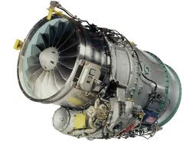

### Figure 1: U-2R engine [http://www.bubbasoft.com/military/U2.htm]

Thrust Required is the amount of thrust needed to maintain the aircraft speed and altitude. This is analogous to the thrust needed to overcome the drag and to maintain a steady speed and altitude.It depends on the velocity, altitude, the aerodynamic shape, size, and weight of the airplane- it is an airframe-associated feature rather than anything having to do with the engines themselves.

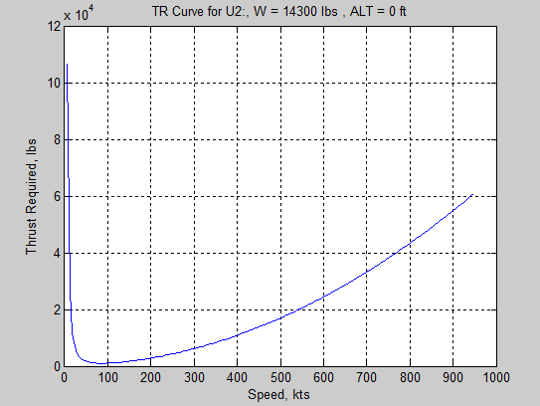

### Figure 2: Diagram showing Thrust Required

From the graph, it is evident that as TR decreases with increasing velocity, reaching a minimum value and then increasing as the velocity further increases. This is because at low velocity, where the CL is high, the total drag is dominated by the drag due to lift. Since the drag due to lift is proportional to CL, as CL decreases due to increase in velocity the drag due to lift rapidly decreases, in spite of the fact that the dynamic pressure is increasing as well. This is also evident from equation (1).

http://people.rit.edu/pnveme/treq_h_form1.gif (1)

From an analytical point of view, the thrust required for steady, level flight is given by:

TR=W/L/D (2)

L/D = CL/ CD (3)

A generic variation of L/D is sketched in figure 2. From a comparison of these two figures, we see that point 2 in both figures correspond to the maximum value of L/D. The flight condition is denoted by V(L/D)max which is the velocity at which TR is minimum.

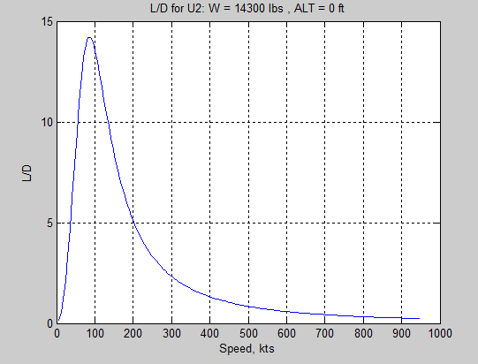

#### Figure3: Variation of L/D with velocity for U-2 aircraft. Altitude=0 ft, W=14700 lbs.

### AERODYNAMIC RELATIONS ASSOCIATED WITH MAXIMUM CL/CD0, CL^3/2/CD,CL^1/2/CD.

Apart from L/D ratio, there are other aerodynamic ratios which play a role in airplane performance. These are the ratios CL^3/2/CD and CL^1/2/CD .In order to compare the three for the U-2R aircraft, let’s consider the plot in figure 3. From the results from the computer program we have the maximum altitude lift to drag ratio as 16.5791. This can be accounted for due to its large wing surface area. As the altitude increases, the lift to drag ratio increases which is as expected from our analytical solutions. This is the case for both CL/CD0, CL^3/2/CD, CL^1/2/CD plots as shown in figure 3. Also the maximum velocity increases as (CL/CD)< (CL^1.5/CD)< (CL^0.5/CD) . Their values are 16.5791<18.563<25.0479 respectively. Their velocities are shown in the tables below.

ALT(ft) Max(CL/CD) V at maxCL/CD(fps)

--------------------------------------------

0 16.5791 100.0

20000 18.7847 200.0

40000 18.6090 300.0

60000 19.0094 400.0

ALT(ft) Max(CL^1.5/CD) V at max (CL^1.5/CD)(fps)

-------------------------------------------------------

0 18.5638 100.0

20000 16.4910 100.0

40000 18.5624 200.0

60000 18.3964 300.0

ALT(ft) Max(CL^0.5/CD) V at max (CL^0.5/CD)(fps)

-------------------------------------------------------

0 25.0479 200.0

20000 24.5045 200.0

40000 25.0967 400.0

60000 25.5912 600.0

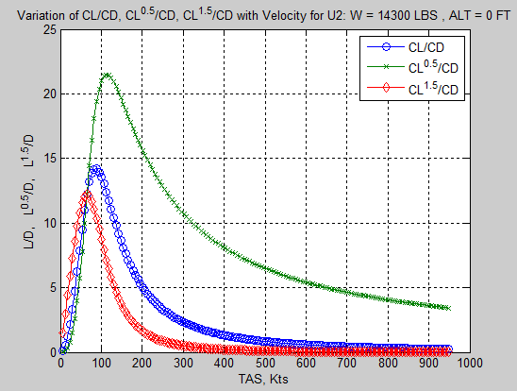

#### Figure 4: Variation of CL/CD, CL^3/2/CD,CL^1/2/CD for the U-2R aircraft. Altitude 0ft, W=14,900 lbs.

From this graph we can see that the V(CL^3/2/CD)max< V(CL/CD)max<V(CL^1/2/CD)max.

### THRUST AVAILABLE AND MAXIMUM VELOCITY

In steady flight, the maximum velocity of the airplane is determined by the high speed intersection of the thrust required and the thrust available curves. This is shown graphically in figure 4. The interaction between the (TA)max curve and the TR curve determines the maximum velocity of the airplane.

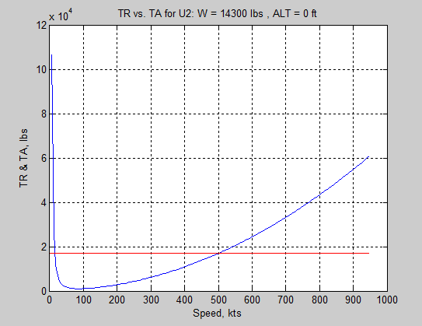

### Figure 5: Thrust available and Thrust Required curve for the U-2R airplane.

From this diagram the thrust available does not change with velocity, it is essentially constant with velocity at subsonic speeds. From my program, the results for power calculations are:

Minimum Velocity using TA & TR Curves = 26.54 FPS

Maximum Velocity using TA & TR Curves = 845.32 FPS

The interaction between the (TA)max curve and the TR curve determines the maximum velocity of the airplane. The maximum velocity of the U-2R airplane from the curves above is given by 845.32 kts. The Thrust available is constant at 17,000 lbs.It is also evident that TR= ( TA)max. Thrust required is given by the drag of the airplane.

## POWER REQUIRED AND POWER AVAILABLE

A graphical approach of PR versus V for an airplane is called power required curve. A simple equation to calculate power required ig given by:

PR=W/CL/CD*V (4)

Where; W-gross weight of the airplane

CL- Coefficient of Lift for the airplane

CD-Coefficient of drag for the airplane

V-Velocity of the airplane

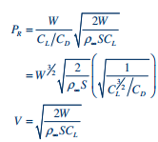

Power available is the power required by the power plant of the airplane.

PA =TAV (5)

Where:

TA –Thrust available

V-Velocity of the airplane.

Figure 6 shows the graphs of power required and power available.

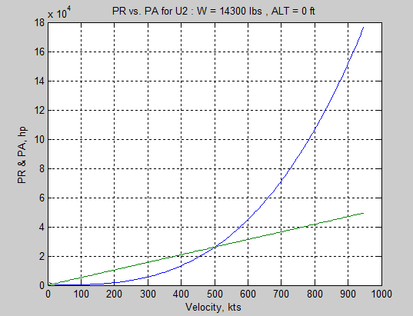

#### Figure 6: Power available and power required curves for the U-2 plane. Altitude = 0ft

From this figure it is evident that:

Minimum Power Required by Graphical Method = 233.85 HP

Minimum Power Required by Analytical Method = 233.84 HP

Velocity at the Minimum Power Required by Graphical Method = 110.00 FPS

Velocity at the Minimum Power Required by Analytical Method = 110.60 FPS

From the comparison we can see that our graphical method was valid since it is almost similar with a very small error to the analytical results.

For the U-2R, since it contains turbojet engine, the power available varies linearly with the velocity as shown in figure 6.The maximum velocity that is attainable is got indicated by the intersection of the curves. Thus, the U-2R maximum velocity is 500 knots. The maximum power required from the diagram is about 2.5 hp.

The region between the maximum thrust power curve and the power required (to maintain level flight) curve indicates the excess power available at various cruise speeds — this excess power is available for various maneuvers if the throttle is fully opened. The simplest use would be a straight unaccelerated climb, in which case the maximum rate of climb would be achieved at the airspeed where the two curves are furthest apart. It can be seen that the best rate of climb speed is around the same airspeed as the minimum drag airspeed shown in the earlier powered required diagram. At higher altitudes, the less dense air causes the Power Required curve to rise and rotate to the right, as shown below in figure 2. This occurs because

1. Induced drag increases at every airspeed because the less dense air requires a greater angle of attack to ensure that lift = weight;
2. Parasite drag decreases at every airspeed because less dense air provides a smaller frictional force at every airspeed.

Since induced drag predominates at low airspeeds, total drag within this speed range increases. At faster airspeeds, where parasite drag predominates, the total drag is reduced

## RATE OF CLIMB

The rate of climb of an airplane is given by the formula:

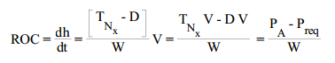 (6)

Where:

PA-PR-the excess power available which can be calculated from the power required and power available curves

W-Gross weight of the aircraft.

It is important to notice that for steady climbing, part of the weight of the airplane is supported by the thrust, and hence less lift is needed than for level flight.

When cruising, the difference between the current power requirement and power available — the excess power — can be used to accelerate the aircraft or climb, to accelerate and climb, or perform any manoeuver that requires additional power. For instance if the aircraft has potential power available and the pilot opens the throttle, the thrust will exceed drag and the pilot can utilize that extra thrust to accelerate to a higher speed while maintaining level flight. Alternatively the pilot can opt to maintain the existing speed but use the extra thrust to climb to a higher altitude. The rate of climb (altitude gained per minute) depends on the amount of available power utilized for climbing, which depends in part on the airspeed chosen for the climb. There are other choices than the best rate of climb speed available for the climb — for example, the best angle of climb speed (which is around the same as the speed for minimum power) or a combination enroute cruise/climb speed. The climb speed chosen depends on terrain, weather, cloud cover and other operating variables.

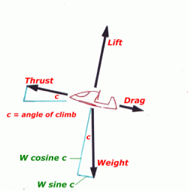

Figure 7:Diagram showing climb forces  
  
If an aircraft is maintained in a continuous full-throttle climb, at the best rate of climb airspeed, the rate of climb will be highest at sea-level; it will decrease with altitude, as engine power decreases. The aircraft will eventually arrive at an altitude where there is no excess power available for climb, then all the available power is needed to balance the drag in level flight and there will be only one airspeed at which level flight can be maintained. Below this airspeed the aircraft will stall. This altitude is the aircraft's absolute ceiling. However, unless trying for an altitude record, there is no point in attempting to climb to the absolute ceiling so the aircraft's service ceiling should appear in the aircraft's performance specification. The service ceiling is the altitude at which the rate of climb falls below 100 feet per minute; this is generally considered the minimum useful rate of climb.

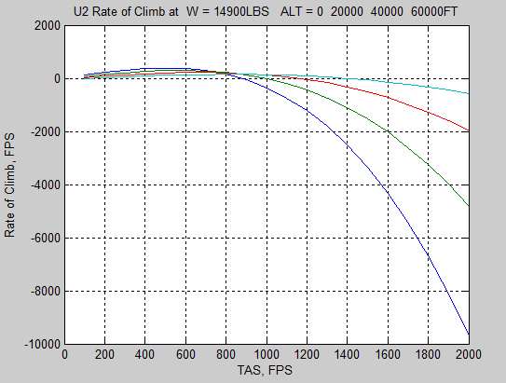

### Figure 8: Variation of the Rate of Climb with velocity at different altitudes.

From the figure 7, it is evident that the effect of increasing altitude is to decrease the rate of climb. This is due to the fact that the thrust decreases with increase in altitude, which also makes the rate of climb to decrease. It should also be recognized that the maximum rate of climb is achieved when the difference between the power available and power required is at its maximum, which is approximately at 500 ft/s.

An even more useful plot is the hodograph which is a plot of the aircraft vertical velocity Vv versus the horizontal velocity VH which is shown in figure 8.

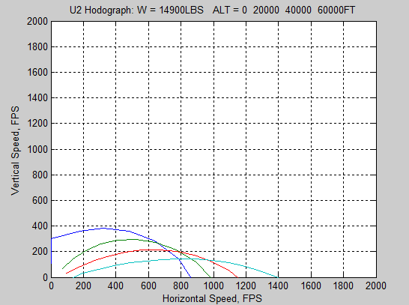

### Figure 9: Hodograph diagram for climb performance of the U-2R aircraft at different altitudes

From this diagram it is possible to calculate the climb angle for maximum Rate Of Climb( ROC).

### Maximum Climb Angle

The maximum climb angle is the maximum angle that the aircraft makes with the horizontal axis. This can be calculated from the hodograph in figure 8.It is highly important when the pilot wants to clear an obstacle while covering the minimum horizontal distance along the ground. On the other hand the maximum Rate of Climb is important when one wants to achieve a certain altitude in a minimum amount of time.

### Time to Climb

The time to climb is the time taken by an aircraft to reach a certain altitude.

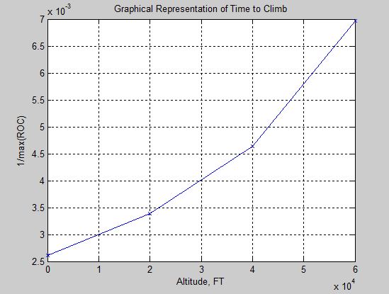

### Figure 10: Graphical representation of the time to climb to 10000 ft.

In order to calculate the time to climb, we use the formula:

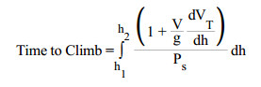 (7)

The time to climb is simply the area under the curve.

## GLIDING FLIGHT (UNPOWERED)

Whenever an airplane is flying such that the power required is larger than the power available, then it will descend rather that climb. When there is no power available at all, it is said that the airplane is in gliding or unpowered flight. The smallest equilibrium angle for glide is given by the formula:

Tan theta=1/L/D

Where theta is the smallest equilibrium angle, which occurs at (L/D)max.

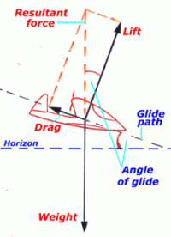

### Figure 11: Diagram showing glide forces

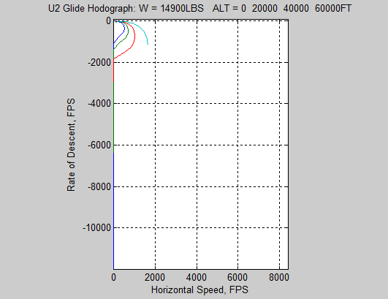

### Figure 12: Representation of the rate of descent of U-2 aircraft.

## RANGE

Range is the total distance (measured with respect to the ground) traversed by an airplane on one load of fuel. It is denoted by R. We consider the following weights:

* W0-gross weight of the airplane including everything; fuel payload, crew, structure.
* Wf-weight of fuel; this is an instantaneous value, and it changes as fuel is consumed during flight.
* W1-weight of the airplane when the fuel tanks are empty.

## ENDURANCE

Endurance is the amount of time that an airplane can stay in the air on one load of fuel. The flight conditions for maximum endurance are those for maximum range. To maximize endurance, the U-2 should correspond to the following conditions:

* Fly at maximum L/D
* Have the lowest possible thrust specific fuel consumption
* Have the highest possible ratio of w0 TO W1 (carry a lot of fuel).

## LEVEL TURN

A level turn is one in which the curved flight path is in horizontal plane parallel to the plane of the ground; that is , in a level turn the altitude remains constant.

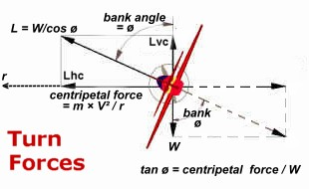

### Figure 13: Figure showing turn forces

 When an aircraft is airborne maintaining a constant velocity and altitude — the total lift produced equals the aircraft's weight and that lift force is expressed as being equivalent to a '1g' load. Similarly, when the aircraft is parked on the ground, the load on the aircraft wheels (its weight) is a 1g load.   
  
Any time an aircraft's velocity is changed; there are positive or negative acceleration forces applied to the aircraft and felt by its occupants. The resultant maneuvering load is normally expressed in terms of g load, which is the ratio of all the aerodynamic forces experienced during the acceleration to the aerodynamic forces existing at the normal 1g level flight state.

The two greatest performance characteristics in turning flight are:

* Turn radius
* The turn rate which is simply the local angular velocity of the airplane along the curved flight path.

Since U-2R is a fighting airplane it should have the smallest possible turn radius R and the fastest possible turn rate.

 When an aircraft is airborne maintaining a constant velocity and altitude — the total lift produced equals the aircraft's weight and that lift force is expressed as being equivalent to a '1g' load. Similarly, when the aircraft is parked on the ground, the load on the aircraft wheels (its weight) is a 1g load.   
  
Any time an aircraft's velocity is changed, there are positive or negative acceleration forces applied to the aircraft and felt by its occupants. The resultant maneuvering load is normally expressed in terms of g load, which is the ratio of all the aerodynamic forces experienced during the acceleration to the aerodynamic forces existing at the normal 1g level flight state.

In order to obtain the largest turn radius, we want:

* The highest possible load factor.
* The lowest possible velocity.

In order to achieve minimum turn radius we differentiate the turn radius and set it equal to zero, inorder to maximize it. Similarly, in order to attain maximum turn rate, we need to differentiate the turn rate and set it equal to zero in order to maximize it.

## TAKEOFF PERFORMANCE

In this subsection, we want to study the distance covered by the airplane along the runway before it lifts off into the air. This distance is called the ground roll, denoted by sg..The takeoff distance also includes the extra distance covered over the ground after the airplane is airborne but before it clears an obstacle of a specified height, which is denoted by sa.The height of obstacle is specified as 50 ft for military aircrafts such as U-2R.

The takeoff distance is generally calculated for maximum weight in a standard atmosphere. In addition, usually the worst case scenario is also calculated which is maximum weight, high altitude, and a standard “hot” day. My total take off distance is 1.6192e+03 ftwhich is a reasonable distance for the military aircraft in order for it to be air borne.

## LANDING PERFORMANCE

The opposite of the takeoff procedure is the landing procedure. Just as in the takeoff, the landing maneuver consists of two parts:

1. The terminal glide over a 50 ft obstacle to touchdown

2. The landing ground run

The velocity of the airplane at the instant it clears the obstacle, denoted by Va is required to be equal to 1.2Vstall for military airplanes like U-2S. The distance measured along the ground from the obstacle to the point of initiation of the flare is the approach distance sa. Touchdown occurs when the wheels touch the ground. The distance over the ground covered during the flare is the flare distance sf. The touchdown velocity should be 1.1Vstall foe military airplanes such as U-2R. The distance that the airplane rolls on the ground from touchdown to the point where the velocity goes to zero is called the ground roll sg .I am going to calculate the approach distance, flare distance and ground roll, then add them up to get the total landing distance. The total landing distance from my program is 1.7767e+03 which is a reasonable distance for the military aircraft in order for it to be air borne.

From the matlab codes that are in the appendix, I achieved the following results:

# RESULTS

U2: W = 14300.00LBS, ALT = 0.0FT

Minimum Thrust Required = 1008.94 LBS

Velocity at the Minimum Thrust Required = 150.00 FPS

Maximum L/D by Graphical Method = 14.17

Maximum L/D by Analytical Method = 14.20

Velocity at the Maximum L/D by Graphical Method = 150.00 FPS

Maximum CL/CD by Graphical Method = 14.17

Maximum CL/CD by Analytical Method = 14.20

Velocity at the Maximum CL/CD by Graphical Method = 150.00 FPS

Velocity at the Maximum CL/CD by Analytical Method = 145.55 FPS

Maximum CL^0.5/CD by Graphical Method = 21.47

Maximum CL^0.5/CD by Analytical Method = 21.47

Velocity at the Maximum CL^0.5/CD by Graphical Method = 190.00 FPS

Velocity at the Maximum CL^0.5/CD by Analytical Method = 191.56 FPS

Maximum CL^1.5/CD by Graphical Method = 12.20

Maximum CL^1.5/CD by Analytical Method = 12.20

Velocity at the Maximum CL^1.5/CD by Graphical Method = 110.00 FPS

Velocity at the Maximum CL^1.5/CD by Analytical Method = 110.60 FPS

Minimum Power Required by Graphical Method = 233.85 HP

Minimum Power Required by Analytical Method = 233.84 HP

Velocity at the Minimum Power Required by Graphical Method = 110.00 FPS

Velocity at the Minimum Power Required by Analytical Method = 110.60 FPS

Minimum Velocity using TA & TR Curves = 26.54 FPS

Minimum Velocity using PA & PR CUrves = 25.57 FPS

Maximum Velocity using TA & TR Curves = 845.32 FPS

Maximum Velocity using PA & PR CUrves = 845.29 FPS

g = 32.2000

n_Rmin = 1.4017

Rmin = 103.0898

Vinf_Rmin = 57.1016

n_wmax = 3.1087

wmax = 0.7188

Vinf_wmax =131.8529

t_min_a = 4.3505e-05

Vf = 306.4015

R = 1.4578e+04

hf = 19.9786

sa = 572.8434

sf = 762.9501

sg = 440.8833

Ld = 1.7767e+03

sg1 = 494.3276

Rt = 1.6771e+04

theta1 = 0.0772

sat = 1.1249e+03

Td = 1.6192e+03

====================================================

U2 Performance Analysis at W = 14900.00LBS

====================================================

ALT(ft) Max(CL/CD) V at maxCL/CD(fps)

--------------------------------------------

0 16.5791 100.0

20000 18.7847 200.0

40000 18.6090 300.0

60000 19.0094 400.0

ALT(ft) Max(CL^1.5/CD) V at max (CL^1.5/CD)(fps)

-------------------------------------------------------

0 18.5638 100.0

20000 16.4910 100.0

40000 18.5624 200.0

60000 18.3964 300.0

ALT(ft) Max(CL^0.5/CD) V at max (CL^0.5/CD)(fps)

-------------------------------------------------------

0 25.0479 200.0

20000 24.5045 200.0

40000 25.0967 400.0

60000 25.5912 600.0

==================================================================

Minimum & Maximum Velocity from PA and PR Curves

==================================================================

ALT(ft) Max Velocity(fps) Min Velocity(fps)

---------------------------------------------------

0 868.3776 868.4

20000 986.8842 986.9

40000 1148.6004 1148.6

60000 1389.3456 139.5

==================================================================

Climb Performance : Maximum Rate of Climb & Corresponding Velocity

==================================================================

ALT(ft) Max ROC(fps)-Graphical V at max ROC(fps)-Graphical

-------------------------------------------------------------------

0 382.1251 500.0000

20000 295.3249 600.0000

40000 215.5654 700.0000

60000 143.4617 800.000

ALT(ft) Max ROC(fps)-Analytical V at max ROC(fps)-Analytical

--------------------------------------------------------------------

0 381.8570 500.0000

20000 296.3568 600.0000

40000 216.1337 700.0000

60000 143.4161 800.0000

================================================================

Climb Performance : Maximum Climb Angle & Corresponding Velocity

================================================================

ALT(ft) Max AOC(DEG)-Graphical V at max AOC(fps)-Graphical

-------------------------------------------------------------------

0 NaN 0.0000

20000 NaN 0.0000

40000 NaN 0.0000

60000 NaN 0.0000

ALT(ft) Max AOC(DEG)-Graphical V at max AOC(fps)-Graphical

--------------------------------------------------------------------

0 90.0000 59.6674

20000 46.8245 149.3400

40000 26.0820 251.2802

60000 13.0259 422.1306

====================================================================

Gliding Performance : Minimum Gliding Angle, Maximum Range, Velocity

Graphical Results

====================================================================

ALT(ft) Min Gliding Angle(DEG) Max Range(ft) Velocity(fps)

-------------------------------------------------------------------

0 NaN NaN 0.00

20000 NaN NaN 0.00

40000 NaN NaN 0.00

60000 NaN NaN 0.00

====================================================================

Gliding Performance : Minimum Gliding Angle, Maximum Range, Velocity

Analytical Results

====================================================================

ALT(ft) Min Gliding Angle(DEG) Max Range(ft) Velocity(fps)

-------------------------------------------------------------------

0 -3.4517 0.00 100.00

20000 -3.0473 -211382.82 200.00

40000 -3.0760 -608599.08 300.00

60000 -3.0113 -457901.17 400.00

==========================================================================

Gliding Performance : Minimum Rate of Descent, Descent Angle & Velocity

Graphical Results

==========================================================================

ALT(ft) Min ROD(FPS) Angle(DEG) Velocity(fps)

------------------------------------------------------------------

0 6.0317 -3.4580 100.00

20000 9.2970 -5.3345 100.00

40000 12.1300 -3.4771 200.00

60000 19.7419 -3.7732 300.00

========================================================================

Ceilings: Absolute Ceiling & Service Ceiling

==========================================================================

Absolute Ceiling = 95139FT, Max ROC = 0.000FPS extrapolated from Analytical Method for ROC

Service Ceiling = 94719FT, Max ROC = 1.670FPS extrapolated from Analytical Method Results

# CONCLUSION

This is an airplane suited for combat since it has a high endurance and a high range as well. Its turn radius is also small and therefore it is suitable for use in the military. The results from the matlab program that was used to calculate the various performance parameters which were considered for analysis is authentic to some level. This is because from the comparison of the analytical and the graphical results, the percentage error is almost negligible. Therefore graphical solutions can be used to perform performance analysis on an aircraft. One major downside was lack of enough information about the airplane since it is for the US army. All in all I have learnt a lot about performance and also I have learnt a lot about this plane. The U2-R is the toughest plane to land; this is because of the large wing span which makes it easy to fly. Another current issue developing is that the U.S government wants to do away with U2 because of the cost of its services and also because there are other planes that can be used for the same function as U2-R which is surveillance.

# REFERENCES:

<http://www.af.mil/information/factsheets/factsheet.asp?id=129>

<http://www.bubbasoft.com/military/U2.htm>

<http://www.globalsecurity.org/intell/systems/u-2-specs.htm>

Anderson, John D. *Aircraft Performance and Design*. Boston, Mass: WCB/McGraw-Hill, 1999. Print

# APPENDICES

U2-R SPECIFICATIONS

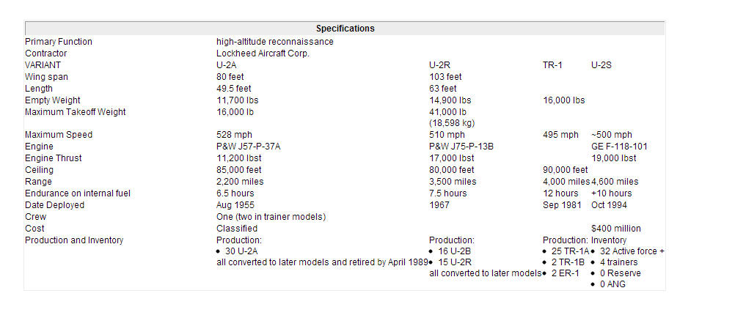

U2-R 2D DRAWINGS

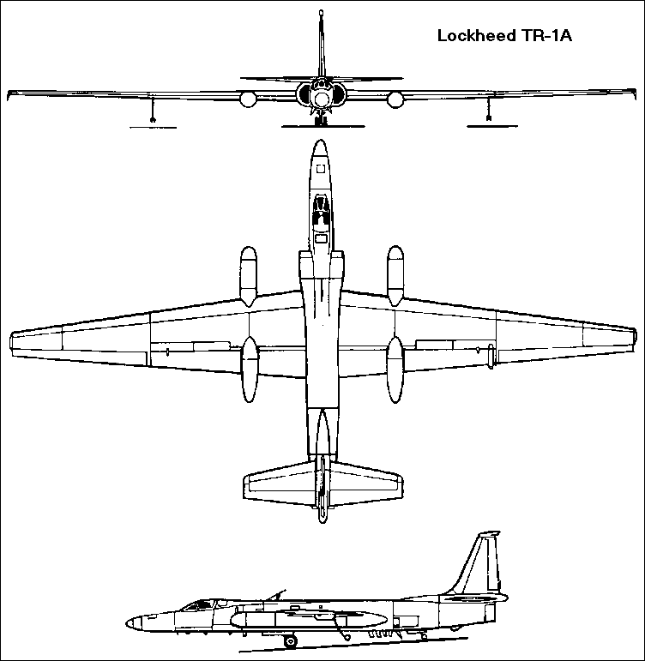

U2-R drawings [http://www.aviastar.org/pictures/usa/lok_tr-1.gif]

MATLAB CODES:

clc

clear all

close all

%-- conversion factor

knot_to_fps = 1.6878099; % knot to ft/sec

fps_to_knot = 1/knot_to_fps; % ft/sec to know

ft_to_meter = 0.3048; % ft to meter

meter_to_ft = 1./ft_to_meter; % meter to ft

slug_to_kg = 14.594; % slug to kg

kg_to_slug = 1./slug_to_kg; % kg to slug

lb_to_N = 4.448; % lb to Newton

N_to_lb = 1./lb_to_N; % Newton to lb

atm_to_lbft2 = 2116; % Atm to lb/(ft*ft)

lbft2_to_atm = 1./atm_to_lbft2; % lb/(ft*ft) to atm

atm_to_Nm2 = 1.01e5; % Atm to N/(m*m)

Nm2_to_atm = 1./atm_to_Nm2; % N/(m*m) to Atm

K_to_R = 1.8; % Kelvin to Rankin

R_to_K = 1./K_to_R; % Rankin to Kelvin

%-- aircraft data

W = 14300; % Aircraft Weight, lbs

S = 1000; % Wing Area, ft^2

b = 103; % wing span

AR = b^2/S; % Aspect Ratio

ALT0 = 0.0000; % Sea Level Altitude, ft

ALT = 0; % Cruise Altitude, ft

e = 0.83; %Oswald efficiency factor

CD0 = 0.02; % Zero-lift Drag Coefficient

K = 0.062; % K value for drag-due-to-lift

X = tsa(ALT,'eng'); % TSA Properties

RHO = X(3); % Density

SOS = X(5); % Speed of Sound

X = tsa(ALT0,'eng'); % TSA Properties at Sea Level

RHO0 = X(3); % Sea Level Density

SOS0 = X(5); % Sea Level Speed of Sound

Vinf = 0:10:1600; % Aircraft True Airspeed

Minf = zeros(size(Vinf));

CL = zeros(size(Vinf));

CD = zeros(size(Vinf));

CL12_over_CD = zeros(size(Vinf));

CL23_over_CD = zeros(size(Vinf));

TA =zeros(size(Vinf));

D = zeros(size(Vinf));

for i = 1:length(Vinf)

%-- coefficients

CL(i) = W/(0.5*RHO*Vinf(i)^2*S);

CD(i) = CD0 + K*CL(i)^2;

TA(i)=10100*(RHO/0.023769);

%-- lift & drag

D0(i) = (0.5*RHO*Vinf(i)^2*S)*CD0; % zero lift drag

D_lift(i) = (0.5*RHO*Vinf(i)^2*S)*K*CL(i)^2; % drag due to lift

D(i) = (0.5*RHO*Vinf(i)^2*S)*CD(i); % total drag

%-- lift value

L(i) = (0.5*RHO*Vinf(i)^2*S)*CL(i); % Lift

%-- lift over drag ratio

L_over_D(i) = L(i)/D(i); % Lift over Drag

CL_over_CD(i) = CL(i)/CD(i);

CL12_over_CD(i) = (CL(i)^(1/2))/CD(i);

CLp32_over_CD(i) = (CL(i)^(3/2))/CD(i);

end

%-- Thrust Required (Drag)

TR = D; % Thrust Required

%-- Minimum Thrust Required & Velocity at the Minimum Thrust Required

minTR_g = min(TR);

i = 1;

while TR(i) ~= minTR_g;

i = i+1;

end

V_minTR_g = Vinf(:,i);

figure(1)

plot(Vinf*fps_to_knot,TR)

xlabel('Speed, kts'),ylabel('Thrust Required, lbs')

title(['TR Curve for U2:, W = ', num2str(W),' lbs , ','ALT = ', num2str(ALT),' ft']),grid

%-- L/D Plot and Maximum L/D value and Corresponding Velocity

maxLD_g = max(L_over_D);

i = 1;

while L_over_D(i) ~= maxLD_g;

i = i+1;

end

V_maxLD_g = Vinf(:,i);

figure(2)

plot(Vinf*fps_to_knot,L_over_D)

xlabel('Speed, kts'),ylabel('L/D')

title(['L/D for U2: W = ', num2str(W),' lbs , ','ALT = ', num2str(ALT),' ft']),grid

%-- Maximum L/D value by analytical method

maxLD_a = sqrt(1/(4*CD0*K)); % equation 5.30

%-- CL^1.5/CD, CL/CD, CL^0.5/CD plots

figure(3)

plot(Vinf*fps_to_knot,CL_over_CD,'-o',...

Vinf*fps_to_knot,CL12_over_CD,'-x',...

Vinf*fps_to_knot,CLp32_over_CD,'-d');

legend(['CL/CD'],['CL^{0.5}/CD'],['CL^{1.5}/CD'])

xlabel('TAS, Kts'), ylabel(['L/D, ','L^{0.5}/D, ','L^{1.5}/D']),grid

title(['Variation of CL/CD, CL^{0.5}/CD, CL^{1.5}/CD with Velocity for U2: W = ',...

num2str(W),' LBS , ','ALT = ', num2str(ALT),' FT'])

%======================================================================

% Maximum Values of CL^1.5/CD, CL/CD, CL^0.5/CD and velocities by

% Graphical methods

%======================================================================

%- CL/CD

maxCLCD_g = max(CL_over_CD);

i = 1;

while CL_over_CD(i) ~= maxCLCD_g;

i = i+1;

end

V_maxCLCD_g = Vinf(:,i);

%- CL^0.5/CD

maxCL12CD_g = max(CL12_over_CD);

i = 1;

while CL12_over_CD(i) ~= maxCL12CD_g;

i = i+1;

end

V_maxCL12CD_g = Vinf(:,i);

%- CL^1.5/CD

maxCL32CD_g = max(CLp32_over_CD);

i = 1;

while CLp32_over_CD(i) ~= maxCL32CD_g;

i = i+1;

end

V_maxCL32CD_g = Vinf(:,i);

%======================================================================

% Maximum Values of CL^1.5/CD, CL/CD, CL^0.5/CD and velocities by

% Analytical methods

%======================================================================

%- CL/CD

maxCLCD_a = sqrt(1/(4*CD0*K)); % EQ 5.30

maxCL32CD_a = (1/4)*(3/(K*CD0^(1/3)))^(3/4); % EQ 5.38

maxCL12CD_a = (3/4)*(1/(3*K*CD0^3))^(1/4); % EQ 5.44

V_maxCLCD_a = sqrt((2/RHO)*sqrt(K/CD0)*(W/S)); % EQ 5.34

V_maxCL32CD_a = sqrt((2/RHO)*sqrt(K/(3*CD0))*(W/S)); % EQ 5.41

V_maxCL12CD_a = sqrt((2/RHO)*sqrt(3*K/CD0)*(W/S)); % EQ 5.44

disp(sprintf('\n'));

disp(sprintf('U2: W = %7.2fLBS, ALT = %5.1fFT\n',W, ALT'))

disp(sprintf('Minimum Thrust Required = %6.2f LBS',minTR_g));

disp(sprintf('Velocity at the Minimum Thrust Required = %6.2f FPS',V_minTR_g));

disp(sprintf('\n'));

disp(sprintf('Maximum L/D by Graphical Method = %6.2f',maxLD_g));

disp(sprintf('Maximum L/D by Analytical Method = %6.2f',maxLD_a));

disp(sprintf('Velocity at the Maximum L/D by Graphical Method = %6.2f FPS',V_maxLD_g));

disp(sprintf('\n'));

disp(sprintf('Maximum CL/CD by Graphical Method = %6.2f',maxCLCD_g));

disp(sprintf('Maximum CL/CD by Analytical Method = %6.2f',maxCLCD_a));

disp(sprintf('Velocity at the Maximum CL/CD by Graphical Method = %6.2f FPS', V_maxCLCD_g));

disp(sprintf('Velocity at the Maximum CL/CD by Analytical Method = %6.2f FPS',V_maxCLCD_a));

disp(sprintf('\n'));

disp(sprintf('Maximum CL^0.5/CD by Graphical Method = %6.2f',maxCL12CD_g));

disp(sprintf('Maximum CL^0.5/CD by Analytical Method = %6.2f',maxCL12CD_a));

disp(sprintf('Velocity at the Maximum CL^0.5/CD by Graphical Method = %6.2f FPS', V_maxCL12CD_g));

disp(sprintf('Velocity at the Maximum CL^0.5/CD by Analytical Method = %6.2f FPS',V_maxCL12CD_a));

disp(sprintf('\n'));

disp(sprintf('Maximum CL^1.5/CD by Graphical Method = %6.2f',maxCL32CD_g));

disp(sprintf('Maximum CL^1.5/CD by Analytical Method = %6.2f',maxCL32CD_a));

disp(sprintf('Velocity at the Maximum CL^1.5/CD by Graphical Method = %6.2f FPS', V_maxCL32CD_g));

disp(sprintf('Velocity at the Maximum CL^1.5/CD by Analytical Method = %6.2f FPS',V_maxCL32CD_a));

%-- Power Required by Graphical Method

PR = TR.*Vinf;

PR_hp = (1/550).*PR;

figure(4)

plot(Vinf*fps_to_knot,PR_hp)

xlabel('Speed, kts'),ylabel('Power Required, hp')

title(['PR Curve for U2:, W = ', num2str(W),' HP, ','ALT = ', num2str(ALT),' FT']),grid

minPR_g = min(PR_hp);

i = 1;

while PR_hp(i) ~= minPR_g

i = i+1;

end

V_minPR_g = Vinf(:,i);

%-- Power Required by Analytical Method

CD2_over_CL3_min = (1/maxCL32CD_a)^2;

minPR_a = sqrt(2*W^3*CD2_over_CL3_min/(RHO*S))/550;

V_minPR_a = V_maxCL32CD_a;

disp(sprintf('\n'));

disp(sprintf('Minimum Power Required by Graphical Method = %6.2f HP',minPR_g));

disp(sprintf('Minimum Power Required by Analytical Method = %6.2f HP',minPR_a));

disp(sprintf('Velocity at the Minimum Power Required by Graphical Method = %6.2f FPS', V_minPR_g));

disp(sprintf('Velocity at the Minimum Power Required by Analytical Method = %6.2f FPS',V_minPR_a));

%===========================

% TA, PA, TR, PR & Max Speed

%===========================

%-- Turbofan Engine

TA0 = 17000; % Sea Level Static Thrust

TA = TA0*(RHO/RHO0); % Thrust Variation due to Altitude Change

TA = TA*ones(size(Vinf)); % Single Engine

TAssl = TA0*ones(size(Vinf)); % Single Engine

%-- TA, TR & Maximum Velocity

figure(5)

plot(Vinf*fps_to_knot,TR,'-b',Vinf*fps_to_knot,TA,'-r')

title(['TR vs. TA for U2: W = ',num2str(W),' lbs , ','ALT = ', num2str(ALT),' ft'])

xlabel('Speed, kts'),ylabel('TR & TA, lbs'),grid

[velocity,thrust] = my_bisection(Vinf,TR,TA);

maxV_T_g = max(velocity);

minV_T_g = min(velocity);

num = (max(TA)/W)*(W/S) + (W/S)*sqrt((max(TA)/W)^2-4*CD0*K);

den = RHO*CD0;

maxV_T_a = sqrt(num/den); % Maximum Speed by Analytical Method (EQ 5.50)

%-- PA, PR & Maximum Velocity (Graphical Method)

PR = TR.*Vinf;

PR_hp = (1/550).*PR;

PA = TA0*(RHO/RHO0)^0.6*Vinf;

PA_hp = PA/550;

figure(6)

plot(Vinf*fps_to_knot,PR_hp,Vinf*fps_to_knot,PA_hp),grid

title(['PR vs. PA for U2 : W = ', num2str(W),' lbs , ','ALT = ', num2str(ALT),' ft'])

xlabel('Velocity, kts'),ylabel('PR & PA, hp')

[velocity,thrust] = my_bisection(Vinf,PR_hp,PA_hp);

maxV_P_g = max(velocity);

minV_P_g = min(velocity);

disp(sprintf('\n'));

disp(sprintf('Minimum Velocity using TA & TR Curves = %6.2f FPS',minV_T_g));

disp(sprintf('Minimum Velocity using PA & PR CUrves = %6.2f FPS',minV_P_g));

disp(sprintf('Maximum Velocity using TA & TR Curves = %6.2f FPS',maxV_T_g));

disp(sprintf('Maximum Velocity using PA & PR CUrves = %6.2f FPS',maxV_P_g));

clc

clear all

close all

%== Conversion Factor

D2R = pi/180;

R2D = 180/pi;

%== U2-R Aircraft Data

W = 14900; % Defines Aircraft Weight, lbs

S = 1000; %Defines the Wing Area, ft^2

b = 103; % Defines the wing span

AR = b^2/S; %Defines the Aspect Ratio

WovS = W/S; % Defines the Wing Loading

CD0 = 0.0188; %Defines the Zero-lift Drag Coefficient

e = 0.83 %Defines the Oswald coefficient

K = 1/(pi*AR*e); %Defines the K value for drag-due-to-lift

TA0 = 17000; % Defines the Sea Level Static Thrust (twin jet), lbs

CLmax = 1.7; % Defines the CLmax 40deg Flap (Landing Conf)

%== Flight Condition

ALT0 = 0.0000; % Defines the Sea Level Altitude, ft

X = tsa(ALT0,'eng'); % Defines the TSA Properties at Sea Level

RHO0 = X(3); % Defines the Sea Level Density

SOS0 = X(5); % Defines the Sea Level Speed of Sound

ALT = [0:20000:70000]; % Defines the Density

Vinf = [0:100:2000]; %Defines the Aircraft True Airspeed

%-- variable initialization

m = length(Vinf);

n = length(ALT);

for j = 1:n % Defines the altitude loop

X = tsa(ALT(j),'eng');

RHO(j) = X(3);

sigma(j) = X(4);

SOS(j) = X(5);

for i = 1:m % Defines the velocity loop

%-- coefficients

CL(i,j) = W/(0.5*RHO(j)*Vinf(i)^2*S);

CD(i,j) = CD0 + K*CL(i,j)^2;

%-- lift & drag at different altitudes

L(i,j) = (0.5*RHO(j)*Vinf(i)^2*S)*CL(i,j);

D(i,j) = (0.5*RHO(j)*Vinf(i)^2*S)*CD(i,j);

L_over_D(i,j) = L(i,j)/D(i,j);

%-- lift over drag ratio at different altitudes

CL_over_CD(i,j) = CL(i,j)/CD(i,j);

CLp12_over_CD(i,j) = (CL(i,j)^(1/2))/CD(i,j);

CLp32_over_CD(i,j) = (CL(i,j)^(3/2))/CD(i,j);

%-- Thrust & Power Required at defferent altitudes

TR(i,j) = D(i,j);

PR(i,j) = TR(i,j)*Vinf(i);

%-- Thurst & Power Available at different altitudes

TA(i,j) = TA0*(RHO(j)/RHO0)^0.6;

PA(i,j) = TA(i,j)*Vinf(i);

%-- Local Mach Number at different altitudes

Minf(i,j) = Vinf(i)/SOS(j);

end

Vstall(j) = sqrt((2/RHO(j))*(W/S)*(1/CLmax))

end

%-- Minimum Thrust Required & Velocity at the Minimum Thrust Required at

%different altitudes

minTR_g = zeros(size(ALT));

for j = 1:n

minTR_g(j) = min(TR(:,j));

kk = 1;

while TR(kk,j) ~= minTR_g(j);

kk = kk+1;

end

V_minTR_g(j) = Vinf(:,kk);

end

%-- Minimum Power Required & Velocity at the Minimum Thrust Required

PR_hp = PR/550;

minPR_g = zeros(size(ALT));

for j = 1:n

minPR_g(j) = min(PR_hp(:,j));

kk = 1;

while PR_hp(kk,j) ~= minPR_g(j);

kk = kk+1;

end

V_minPR_g(j) = Vinf(:,kk);

end

%-- CL/CD, CL^(1/2)/CD, CL^(3/2)/CD

maxCLCD = zeros(size(ALT));

maxCL12CD = zeros(size(ALT));

maxCL32CD = zeros(size(ALT));

for j = 1:n

maxCLCD(j) = max(CL_over_CD(:,j));

kk = 1;

while CL_over_CD(kk,j) ~= maxCLCD(j);

kk = kk+1;

end

VmaxCLCD(j) = Vinf(:,kk);

end

for j = 1:n

maxCL12CD(j) = max(CLp12_over_CD(:,j));

kk = 1;

while CLp12_over_CD(kk,j) ~= maxCL12CD(j);

kk = kk+1;

end

VmaxCL12CD(j) = Vinf(:,kk);

end

for j = 1:n

maxCL32CD(j) = max(CLp32_over_CD(:,j));

kk = 1;

while CLp32_over_CD(kk,j) ~= maxCL32CD(j);

kk = kk+1;

end

VmaxCL32CD(j) = Vinf(:,kk);

end

%-- Maximum Velocity

for j = 1:n

[velocity,thrust] = my_bisection(Vinf,TA(:,j),TR(:,j));

maxV_T_g(j) = max(velocity);

minV_T_g(j) = min(velocity);

end

for j = 1:n

[velocity,thrust] = my_bisection(Vinf,PA(:,j),PR(:,j));

maxV_P_g(j) = max(velocity);

minV_P_g(j) = min(velocity);

end

%==== Rate of Climb (R/C) Analysis

EP = PA - PR;

ROC = EP./W;

VV = zeros(size(ROC));

VH = zeros(size(ROC));

%-- computing rate of climb & horizontal velocity

for i = 1:n

VV = ROC(:,i);

VH(:,i) = real(sqrt(Vinf'.*Vinf' - VV.*VV));

end

%-- finding the maximum rate of climb & corresponding speed

for j = 1:n

%-- graphical method

maxROC_g(j) = max(ROC(:,j));

kk = 1;

while ROC(kk,j) ~= maxROC_g(j)

kk = kk+1;

end

V_maxROC_g(j) = Vinf(:,kk);

%-- analytical method

TovW(j) = TA(1,j)/W;

Z = 1 + sqrt( 1 + 3/(maxCLCD(j)^2)*(TovW(j)^2));

maxROC_a(j) = sqrt((WovS*Z)/(3*RHO(j)*CD0))* TovW(j)^1.5*(1-(Z/6)-(3/(2*TovW(j)^2*maxCLCD(j)^2*Z)));

V_maxROC_a(j) = sqrt( (TovW(j)*WovS)/(3*RHO(j)*CD0) * (1 + sqrt(1 + 3/(TovW(j)^2*maxCLCD(j)^2))) );

end

%-- finding the maximum climb angle & corresponding speed

for j = 1:n

for i =1:m

AOC(i,j) = R2D*atan(ROC(i,j)/VH(i,j));

end

rr = 1;

while AOC(rr,j) <= AOC(rr+1,j)

rr = rr + 1;

end

%-- graphical method

maxAOC_g(j) = AOC(rr,j);

V_maxAOC_g(j) = Vinf(rr);

%-- analytical method

TovW(j) = TA(1,j)/W;

maxAOC_a(j) = R2D*asin(TovW(j) - 1/maxCLCD(j));

V_maxAOC_a(j) = sqrt((2/RHO(j))*(K/CD0)^(0.5)*(WovS)*cos(D2R*maxAOC_a(j)));

end

figure(1)

plot(Vinf,ROC),grid

title(['U2-R Rate of Climb at W = ',num2str(W),'LBS ALT = ',num2str(ALT),'FT'])

xlabel('TAS, FPS'),ylabel('Rate of Climb, FPS')

figure(2)

plot(VH,ROC)

%axis equal

grid

t = axis;axis([0,t(1,2),0,t(1,4)]);

title(['U2-R Hodograph: W = ',num2str(W),'LBS ALT = ',num2str(ALT),'FT'])

xlabel('Horizontal Speed(VH), FPS'),ylabel('Vertical Speed(VV), FPS')

%==== Gliding Performance Analysis

ROD = PR./W;

for j = 1:n

%-- gliding angle for maximum gliding distance: analytical method

gamma_min_a(j) = R2D*(atan(-1/maxCLCD(j)));

%-- maximum gliding distance: obtained from analytically computed gliding angle

maxR_a(j) = ALT(j)/tan(-gamma_min_a(j));

%-- corresponding velocity

V_maxR_a(j) = VmaxCLCD(j);

end

%-- minimum rate of descent (sink rate): graphical method

for j = 1:n

VV = ROD(:,j);

VH(:,j) = real(sqrt(Vinf'.*Vinf' - VV.*VV));

end

for j = 1:n

%-- graphical method for minimum glide angle & max range (from hodograph)

for i =1:m

AOD(i,j) = R2D*atan(-ROD(i,j)/VH(i,j));

end

rr = 1;

while AOD(rr,j) <= AOD(rr+1,j)

rr = rr + 1;

end

gamma_min_g(j) = AOD(rr,j);

V_maxR_g(j) = Vinf(rr);

maxR_g(j) = ALT(j)/tan(-gamma_min_g(j));

%-- minimum rate of descent

minROD_g(j) = min(ROD(:,j));

minROD_a(j) = sqrt((2/RHO(j))*(W/S)*(1/maxCL32CD(j)^2));

%-- velocity & gliding angle at the minimum rate of descent

kk = 1;

while ROD(kk,j) ~= minROD_g(j);

kk = kk + 1;

end

V_minROD_g(j) = Vinf(kk);

gamma_minROD_g(j) = R2D*atan(-minROD_g(j)/VH(kk,j));

end

figure(3)

plot(Vinf,-ROD),grid

title(['U2-R Rate of Descent at W = ',num2str(W),'LBS ALT = ',num2str(ALT),'FT'])

xlabel('TAS, FPS'),ylabel('Rate of Descent, FPS')

figure(4)

plot(VH,-ROD),grid

axis equal

t = axis;axis([0,t(1,2),t(1,3),100]);

title(['U2-R Glide Hodograph: W = ',num2str(W),'LBS ALT = ',num2str(ALT),'FT'])

xlabel('Horizontal Speed, FPS'),ylabel('Rate of Descent, FPS')

%==== Ceiling

p = polyfit(maxROC_a,ALT,1); % polynomial fitting for extrapolation

roc = [0.0:10:max(maxROC_a)];

h = p(1).*roc + p(2).*ones(size(roc));

roc_ceiling = [0,1.67];

ceiling = p(1).*roc_ceiling + p(2).*ones(size(roc_ceiling));

figure(5)

plot(roc,h,'-',maxROC_g,ALT,':o',maxROC_a,ALT,'--x'),hold on

legend('Extrapolated from Analytical R/C','Graphical ROC','Analytical ROC')

plot(roc_ceiling,ceiling,'s'),grid

title('Altitude Variation of Maximum R/C')

xlabel('Maximum ROC, FPS'),ylabel('Altitude,FT')

figure(6)

plot(V_maxROC_a,ALT,'--o',V_maxROC_g,ALT,':x',SOS,ALT,'-s')

legend('Analytical Max R/C','Graphical Max R/C', 'Speed of Sound')

xlabel('Maximum R/C, FPS'),ylabel('Altitude,FT')

title('Altitude Variation of Velocity for Maximum Rate of Climb')

%==== Minimum Time to Climb by Trapezoidal Integration

figure(7)

plot(ALT,1./maxROC_g,'-x')

title('Graphical Representation of Time to Climb');

xlabel('Altitude, FT'),ylabel('1/max(R/C)'),grid

% Range

wf = 8965.25

T = (0.000139/0.002377)*TA0

ct = wf/T; %Defines the thrust specific tuel consumption

W1 = 14900; % Empty weight of the U2-R

Wo = 41000; %Gross weight of U2-R

p = 1.917e-4

R = (2/ct) * (2/(0.000139*S))^0.5 * ((3/4)*(1/(3*K*CD0^3))^(1/4))*(Wo^0.5-W1^0.5) %Defines the maximum range

figure(8)

plot(RHO(j),R,'-x')

title('Range');

xlabel('Density'),ylabel('Range'),grid

% Endurance

%Calculation of Endurance

E = 1/ct * 14.42 * reallog(Wo-W1)

figure(9)

plot(RHO(j),E,'-x')

title('Endurance');

xlabel('Density'),ylabel('Endurance'),grid

clc

% Turn

g = 32.2 %defines the gravitationaal force in ft*lbm/s^2

n_Rmin = sqrt(2-((4*K*CD0)/(TovW(j)^2))) %Defines the load factor for minimum radius

Rmin = (4*K*WovS)/(g*RHO0*TovW(j)*sqrt(1-(4*K*CD0)/(TovW(j)^2))) %Defines the minimum radius

Vinf_Rmin = sqrt((4*K*WovS)/(RHO0*TovW(j))) %Defines the velocity for minimum turning radius

n_wmax = sqrt((TovW(j)/sqrt(K*CD0))-1) %Defines the load factor for maximum turn rate

wmax = g*sqrt(RHO0/WovS*((TovW(j)/(2*K))-(sqrt(CD0/K)))) %defines the maximum turn rate

Vinf_wmax = sqrt(2*WovS/RHO0)*(K/CD0)^(1/4) %Defines the velocity for maximum turn rate

h2 = 60000; %Defines the height used in the calculation of minimum time taken

t_min_a = (p(1))*( log( max(maxROC_a) + (1/p(1))*h2 ) - log(max(maxROC_a)))/60

% Landing performance

%Landing distances calculations

theta = (3/180)*pi; %Defines the approach angle in radians

Vf = 1.1*Vstall(j) %Defines the flare speed

R = (Vf)^2/(0.2*g) %Defines the turn radius

hf = R * (1-cos(theta)) %Defines the flare height,h

sa = (50-hf)/(tan(theta)) %Defines the approach distance

sf = R*sin(theta) %Defines the flare distance

sg = 1.1*1*sqrt((2/RHO0)*(WovS)*(1/CLmax)) + ((1.1^2*(WovS))/(g*RHO0*CLmax*0.4)) % Defines the ground roll

Ld = sa+sf+sg %Defines the total landing distance

% Take off distances calculations

sg1 = (1.2*(WovS))/(g*RHO0*(CLmax)*(TovW(j)))%Defines the take off ground roll

Rt = 6.96*(Vstall(j))^2/g % Defines the turn radius during take off

theta1 = acos(1-(50/Rt)) %Defines the take off approach angle

sat = R*sin(theta1) %Defines the airborne distance

Td = sg1 + sat %Defines the total take off distance

%=================%

% Results Display %

%=================%

% clc

disp(sprintf('\n'));

disp(sprintf('===================================================='));

disp(sprintf('U2 Performance Analysis at W = %7.2fLBS ',W));

disp(sprintf('===================================================='));

disp(sprintf('\n'));

disp(' ALT(ft) Max(CL/CD) V at maxCL/CD(fps)');

disp('--------------------------------------------');

for i = 1:length(ALT)

disp(sprintf('%10.0f %10.4f %15.1f',ALT(i),maxCLCD(i),VmaxCLCD(i)));

end

disp(sprintf('\n'));

disp(' ALT(ft) Max(CL^1.5/CD) V at max (CL^1.5/CD)(fps)');

disp('-------------------------------------------------------');

for i = 1:length(ALT)

disp(sprintf('%10.0f %10.4f %15.1f',ALT(i),maxCL32CD(i),VmaxCL32CD(i)));

end

disp(sprintf('\n'));

disp(' ALT(ft) Max(CL^0.5/CD) V at max (CL^0.5/CD)(fps)');

disp('-------------------------------------------------------');

for i = 1:length(ALT)

disp(sprintf('%10.0f %10.4f %15.1f',ALT(i),maxCL12CD(i),VmaxCL12CD(i)));

end

disp(sprintf('\n'));

disp('==================================================================');

disp('Minimum & Maximum Velocity from PA and PR Curves ');

disp('==================================================================');

disp(' ALT(ft) Max Velocity(fps) Min Velocity(fps)');

disp('---------------------------------------------------');

for i = 1:length(ALT)

disp(sprintf('%10.0f %15.4f %15.1f',ALT(i),maxV_P_g(i),minV_P_g(i)));

end

disp(sprintf('\n'));

disp('==================================================================');

disp('Climb Performance : Maximum Rate of Climb & Corresponding Velocity');

disp('==================================================================');

disp(' ALT(ft) Max ROC(fps)-Graphical V at max ROC(fps)-Graphical');

disp('-------------------------------------------------------------------');

for i = 1:length(ALT)

disp(sprintf('%10.0f %20.4f %20.4f',ALT(i),maxROC_g(i),V_maxROC_g(i)));

end

disp(sprintf('\n'));

disp(' ALT(ft) Max ROC(fps)-Analytical V at max ROC(fps)-Analytical');

disp('--------------------------------------------------------------------');

for i = 1:length(ALT)

disp(sprintf('%10.0f %20.4f %20.4f',ALT(i),maxROC_a(i),V_maxROC_g(i)));

end

disp(sprintf('\n'));

disp('================================================================');

disp('Climb Performance : Maximum Climb Angle & Corresponding Velocity');

disp('================================================================');

disp(' ALT(ft) Max AOC(DEG)-Graphical V at max AOC(fps)-Graphical');

disp('-------------------------------------------------------------------');

for i = 1:length(ALT)

disp(sprintf('%10.0f %20.4f %20.4f',ALT(i),maxAOC_g(i),V_maxAOC_g(i)));

end

disp(sprintf('\n'));

disp(' ALT(ft) Max AOC(DEG)-Graphical V at max AOC(fps)-Graphical');

disp('--------------------------------------------------------------------');

for i = 1:length(ALT)

disp(sprintf('%10.0f %20.4f %20.4f',ALT(i),maxAOC_a(i),V_maxAOC_a(i)));

end

disp(sprintf('\n'));

disp('====================================================================');

disp('Gliding Performance : Minimum Gliding Angle, Maximum Range, Velocity');

disp('Graphical Results ');

disp('====================================================================');

disp(' ALT(ft) Min Gliding Angle(DEG) Max Range(ft) Velocity(fps)');

disp('-------------------------------------------------------------------');

for i = 1:length(ALT)

disp(sprintf('%10.0f %15.4f %20.2f %17.2f',ALT(i),gamma_min_g(i),maxR_g(i),V_maxR_g(i)));

end

disp(sprintf('\n'));

disp('====================================================================');

disp('Gliding Performance : Minimum Gliding Angle, Maximum Range, Velocity');

disp('Analytical Results ');

disp('====================================================================');

disp(' ALT(ft) Min Gliding Angle(DEG) Max Range(ft) Velocity(fps)');

disp('-------------------------------------------------------------------');

for i = 1:length(ALT)

disp(sprintf('%10.0f %15.4f %20.2f %17.2f',ALT(i),gamma_min_a(i),maxR_a(i),V_maxR_a(i)));

end

disp(sprintf('\n'));

disp('==========================================================================');

disp('Gliding Performance : Minimum Rate of Descent, Descent Angle & Velocity');

disp('Graphical Results ');

disp('==========================================================================');

disp(' ALT(ft) Min ROD(FPS) Angle(DEG) Velocity(fps)');

disp('-------------------------------------------------------------------');

for i = 1:length(ALT)

disp(sprintf('%10.0f %15.4f %15.4f %17.2f',ALT(i),minROD_g(i),gamma_minROD_g(i), V_minROD_g(i)));

end

disp(sprintf('\n'));

disp('==========================================================================');

disp('Ceilings: Absolute Ceiling & Service Ceiling ');

disp('==========================================================================');

disp(sprintf('Absolute Ceiling = %5.0fFT, Max ROC = %5.3fFPS extrapolated from Analytical Method for ROC\n'...

,ceiling(1),roc_ceiling(1)));

disp(sprintf('Service Ceiling = %5.0fFT, Max ROC = %5.3fFPS extrapolated from Analytical Method Results\n'...

,ceiling(2), roc_ceiling(2)));

disp(sprintf('\n'));

disp('==========================================================================');

disp('Time to Climb ');

disp('==========================================================================');

disp(sprintf('The minimum time to climb to ALT = %5.1f by analytical method: T = %4.3fMIN',h2,t_min_a));