**IDEAL TURBOJET PERFORMANCE ANALYSIS**

BRIAN OMONDI ASIMBA

WESTERN MICHIGAN UNIVERSITY

10/28/2012

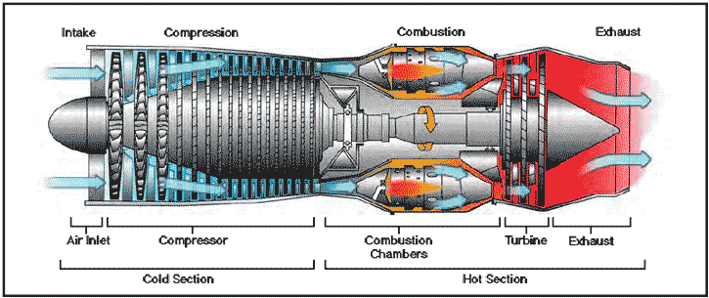 Turbojet Engine showing component parts[<http://www.salvatoreaiello.com/main.shtml>]

ABSTRACT:

The goal of this project is to determine the variation of performance curves with the design parameters and flight conditions. A program that calculates the specific Thrust, Thrust Specific Fuel Consumption, propulsive efficiency and thermal efficiency is written for two cases. In the first case, calculations are done while varying compressor pressure ratios ranging from 5 to 60 and in the second case the compressor pressure ratio is held constant at 20 while the turbine inlet temperature is varied between 5 and 9. The results are then plotted and analyzed.

Contents

ABSTRACT 1

NOMENCLATURE 2

INTRODUCTION 3

RESULTS AND DISCUSSIONS 3

Table 1 4

Fig.2: Specific Thrust variation vs. compressor pressure ratio………………………………………………………………6

Fig. 3: Thrust Specific Fuel Consumption vs. compressor pressure ratio 6

Fig. 4: Propulsive efficiency vs. compressor pressure ratio 7

Fig. 5: Thermal efficiency vs. compressor pressure ratio 7

Table 2 8

Fig. 6: Specific Thrust vs. turbine stagnation temperature 10

Fig. 7: Thrust Specific Fuel Consumption vs. turbine stagnation temperature ratio 11

CONCLUSION: 11

REFERENCE: 12

APPENDIX: 13

# 

# NOMENCLATURE

* M = Mach Number
* Tualambda (Τλ)= Turbine Stagnation Temperature Ratio
* T0 = Atmospheric Air Temperature (K)
* Cp (*Cp*)= Specific Heat At Constant Pressure
* Hpr (*Hpr*)= Low Heating Value Of Fuel
* Gamma γ = Ratio Of Specific Heat/Angle
* R = Gas Constant
* Gc = Newton’s Constant
* piC= Compressor Pressure Ratio
* A0 = Speed Of Sound
* Tr (Τr)= Total/Static Temperature Ratio
* Tc (Τc)= Compressor Temperature Ratio
* Tt (Τt)= Turbine Temperature Ratio
* ST = Specific Thrust
* F = Fuel/Air Ratio
* TSFC = Thrust Specific Fuel Consumption
* Np (Ηp)= Propulsive Efficiency
* Nth (Ηt)= Thermal Efficiency

# INTRODUCTION

A turbojet engine consists of an inlet, compressor, combustor, turbine and a nozzle. The inlet decreases the incoming air for entry into the engine; the compressor increases the stagnation pressure and stagnation temperature of the flow, the combustor increases or adds energy to the flow through the combustion of fuel while the turbine extracts work from the flow in order to drive the compressor and finally the nozzle which can be convergent or divergent accelerates the flow from subsonic conditions which subsequently increases the thrust. A turbojet engine has three design variables: compressor pressure ratio, fan pressure ratio and bypass ratio. The goal of this analysis was to understand how the Thrust and Thrust Specific Fuel Consumption of the turbojet engine varied as the compressor pressure ratio is changed and also how they change with changes in turbine inlet temperature. This was be done by writing a program in Matlab and running to generate plots which were then analyzed.

RESULTS AND DISCUSSIONS:

Given Inputs:

The following are the input that we were given:

Problem 1:

Combustor pressure ratio (πc):5-60

Turbine stagnation pressure ratio (τ λ):7

Problem 2:

Turbine stagnation pressure ratio (τ λ): 5 – 9

Combustor pressure ratio (πc): 20

Other parameters given:

Flight Mach number (M0): 2

Atmospheric air pressure (TO): 222.2K

cp =1004.5 J/(kg K)

hPR  = 4.4194 x 107 J/kg

Output data:

The output data from the computer program were:

Specific Thrust

Thrust Specific Fuel Consumption

Propulsive efficiency

Thermal efficiency

The Specific Thrust, Thrust Specific Fuel Consumption, propulsive efficiency, thermal efficiency were then plotted against the varying combustor pressure ratio for problem 1 and for Problem 2 the Specific Thrust and the Thrust Specific Fuel Consumption were plotted against the turbine stagnation temperature ratio.

I used MATLAB program to analyze the turbojet parameters as they relate to the mechanisms for turbine engines and the following are my results:

Table 1:

|  |  |  |  |  |
| --- | --- | --- | --- | --- |
| **πc** | **nth** | **np** | **TSFC** | **ST** |
| **5** | 0.6492 | 0.6473 | 32.1896 | 651.2461 |
| **6** | 0.667 | 0.649 | 31.2458 | 646.2654 |
| **7** | 0.6814 | 0.6513 | 30.484 | 640.0041 |
| **8** | 0.6933 | 0.6537 | 29.8457 | 633.029 |
| **9** | 0.7035 | 0.6564 | 29.2964 | 625.6523 |
| **10** | 0.7123 | 0.6591 | 28.814 | 618.0563 |
| **11** | 0.72 | 0.662 | 28.3835 | 610.3525 |
| **12** | 0.7269 | 0.6648 | 27.9945 | 602.6104 |
| **13** | 0.733 | 0.6677 | 27.6392 | 594.875 |
| **14** | 0.7386 | 0.6706 | 27.3119 | 587.1751 |
| **15** | 0.7437 | 0.6735 | 27.0082 | 579.5294 |
| **16** | 0.7484 | 0.6763 | 26.7246 | 571.9498 |
| **17** | 0.7527 | 0.6792 | 26.4583 | 564.4438 |
| **18** | 0.7567 | 0.6821 | 26.2072 | 557.0155 |
| **19** | 0.7605 | 0.685 | 25.9693 | 549.6672 |
| **20** | 0.7639 | 0.6878 | 25.7432 | 542.3994 |
| **21** | 0.7672 | 0.6907 | 25.5275 | 535.2118 |
| **22** | 0.7703 | 0.6935 | 25.3212 | 528.1033 |
| **23** | 0.7732 | 0.6964 | 25.1233 | 521.0724 |
| **24** | 0.7759 | 0.6992 | 24.9331 | 514.1172 |
| **25** | 0.7785 | 0.7021 | 24.7499 | 507.2355 |
| **26** | 0.781 | 0.7049 | 24.573 | 500.4252 |
| **27** | 0.7833 | 0.7077 | 24.4019 | 493.684 |
| **28** | 0.7856 | 0.7105 | 24.2361 | 487.0095 |
| **29** | 0.7877 | 0.7133 | 24.0754 | 480.3995 |
| **30** | 0.7898 | 0.7161 | 23.9191 | 473.8516 |
| **31** | 0.7917 | 0.7189 | 23.7672 | 467.3636 |
| **32** | 0.7936 | 0.7217 | 23.6191 | 460.9334 |
| **33** | 0.7954 | 0.7245 | 23.4748 | 454.5588 |
| **34** | 0.7972 | 0.7273 | 23.3339 | 448.2378 |
| **35** | 0.7988 | 0.73 | 23.1962 | 441.9683 |
| **36** | 0.8004 | 0.7328 | 23.0615 | 435.7485 |
| **37** | 0.802 | 0.7356 | 22.9296 | 429.5764 |
| **38** | 0.8035 | 0.7384 | 22.8005 | 423.4504 |
| **39** | 0.805 | 0.7412 | 22.6738 | 417.3685 |
| **40** | 0.8064 | 0.744 | 22.5495 | 411.3293 |
| **41** | 0.8077 | 0.7468 | 22.4274 | 405.331 |
| **42** | 0.809 | 0.7495 | 22.3075 | 399.3722 |
| **43** | 0.8103 | 0.7523 | 22.1896 | 393.4513 |
| **44** | 0.8116 | 0.7551 | 22.0736 | 387.5669 |
| **45** | 0.8128 | 0.7579 | 21.9594 | 381.7176 |
| **46** | 0.8139 | 0.7607 | 21.8469 | 375.9021 |
| **47** | 0.8151 | 0.7635 | 21.736 | 370.119 |
| **48** | 0.8162 | 0.7664 | 21.6267 | 364.3671 |
| **49** | 0.8173 | 0.7692 | 21.5189 | 358.6453 |
| **50** | 0.8183 | 0.772 | 21.4125 | 352.9523 |
| **51** | 0.8193 | 0.7749 | 21.3075 | 347.2869 |
| **52** | 0.8203 | 0.7777 | 21.2037 | 341.6482 |
| **53** | 0.8213 | 0.7805 | 21.1012 | 336.035 |
| **54** | 0.8223 | 0.7834 | 20.9998 | 330.4464 |
| **55** | 0.8232 | 0.7863 | 20.8996 | 324.8812 |
| **56** | 0.8241 | 0.7891 | 20.8005 | 319.3386 |
| **57** | 0.825 | 0.792 | 20.7023 | 313.8175 |
| **58** | 0.8259 | 0.7949 | 20.6052 | 308.3171 |
| **59** | 0.8267 | 0.7978 | 20.509 | 302.8365 |
| **60** | 0.8275 | 0.8008 | 20.4138 | 297.3748 |

Problem 1 plots:

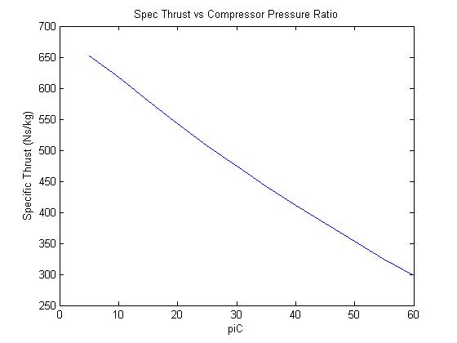  
Fig. 2: Specific Thrust variation vs. compressor pressure ratio

From this graph we can see that as the compressor pressure ratio increases, the Specific Thrust decreases, this is because as we increase the compressor pressure ratio, we increase the compressor temperature ratio which subsequently decreases the Specific Thrust.

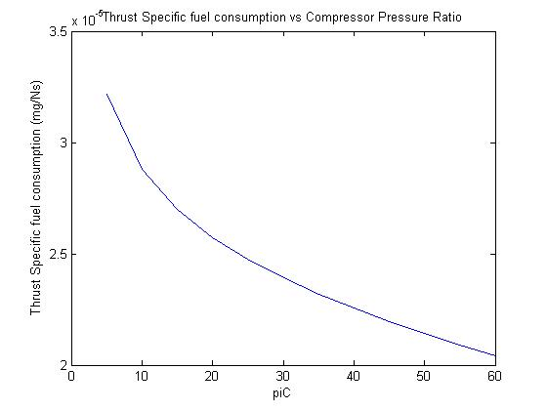

## Fig. 3: Thrust Specific Fuel Consumption vs. compressor pressure ratio

From this graph, we can see that as we increase the compressor pressure ratio ,we also increase the compressor temperature ratio, which in turn decreases the Thrust Specific Fuel Consumption non linearly which also agrees with the TSFC equation.

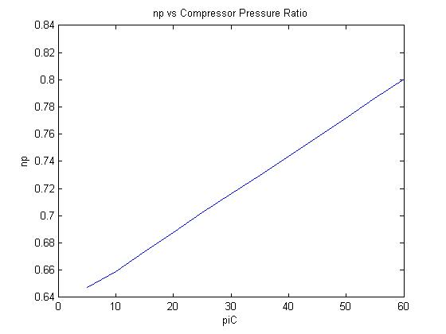

## Fig. 4: Propulsive efficiency vs. compressor pressure ratio

From the figure below we can see that as we increase the compressor pressure ratio, the propulsive efficiency increases as M9 increases which increases as combustor pressure ratio (piC) increases, this is because it increases the combustor temperature ratio which increases the velocity at 9 which increases the propulsive efficiency as expected from the propulsive efficiency formula.

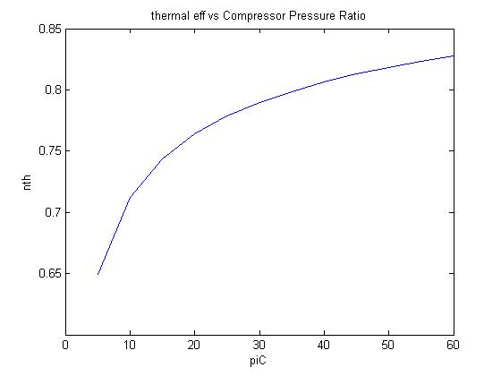

## Fig. 5: Thermal efficiency vs. compressor pressure ratio

From the figure below, we can see that the thermal efficiency increases as the combustor pressure ratio increases. This is because as the pressure ratio is increased the combustor temperature ratio increases too but non-linearly, which is as expected from the thermal efficiency formula.

Table 2:

1. **TSFC for πc = 20 and Turbine inlet temperature from 5 to 9**

|  |  |  |
| --- | --- | --- |
| **τλ** | **ST** | **TSFC** |
| **5.0** | 188.2379 | 20.4961 |
| **5.1** | 209.6447 | 20.8133 |
| **5.2** | 230.4984 | 21.1222 |
| **5.3** | 250.8397 | 21.4236 |
| **5.4** | 270.7045 | 21.7179 |
| **5.5** | 290.125 | 22.0056 |
| **5.6** | 309.1296 | 22.2872 |
| **5.7** | 327.7439 | 22.5630 |
| **5.8** | 345.9912 | 22.8333 |
| **5.9** | 363.8922 | 23.0985 |
| **6.0** | 381.4659 | 23.3589 |
| **6.1** | 398.7297 | 23.6146 |
| **6.2** | 415.6994 | 23.8661 |
| **6.3** | 432.3896 | 24.1133 |
| **6.4** | 448.8136 | 24.3567 |
| **6.5** | 464.9838 | 24.5962 |
| **6.6** | 480.9116 | 24.8322 |
| **6.7** | 496.6075 | 25.0647 |
| **6.8** | 512.0814 | 25.2940 |
| **6.9** | 527.3426 | 25.5201 |
| **7.0** | 542.3994 | 25.7432 |
| **7.1** | 557.2599 | 25.9633 |
| **7.2** | 571.9317 | 26.1807 |
| **7.3** | 586.4216 | 26.3954 |
| **7.4** | 600.7363 | 26.6075 |
| **7.5** | 614.8821 | 26.8170 |
| **7.6** | 628.8647 | 27.0242 |
| **7.7** | 642.6897 | 27.2290 |
| **7.8** | 656.3622 | 27.4316 |
| **7.9** | 669.8873 | 27.6320 |
| **8.0** | 683.2696 | 27.8302 |
| **8.1** | 696.5135 | 28.0264 |
| **8.2** | 709.6232 | 28.2207 |
| **8.3** | 722.6028 | 28.4130 |
| **8.4** | 735.456 | 28.6034 |
| **8.5** | 748.1864 | 28.7920 |
| **8.6** | 760.7976 | 28.9788 |
| **8.7** | 773.2927 | 29.1640 |
| **8.8** | 785.6749 | 29.3474 |
| **8.9** | 797.9473 | 29.5292 |
| **9.0** | 810.1128 | 29.7095 |

Problem 2 Plots:

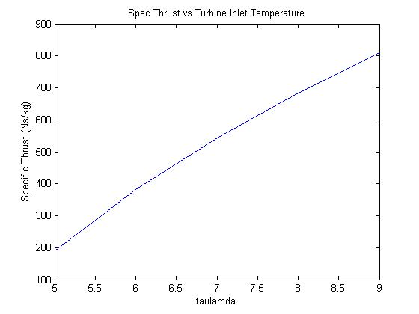

## Fig. 6: Specific Thrust vs. turbine stagnation temperature

From the figure below, the Specific Thrust increases as the turbine stagnation temperature which is because it varies linearly with the stagnation temperature and hence the increase of the specific thrust with increase in turbine stagnation temperature (taulambda).

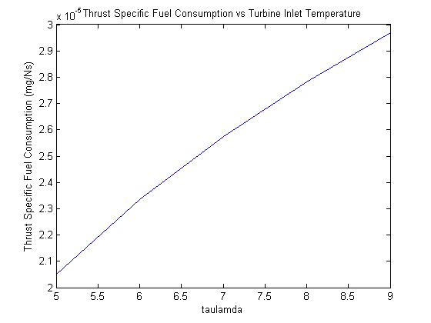

## Fig. 7: Thrust Specific Fuel Consumption vs. turbine stagnation temperature ratio

From the figure below, we can see that the TSFC of the turbine engine increases as the turbine stagnation temperature because as we increase the TSFC, we increase the Specific Thrust from the increase of the turbine stagnation temperature ratio which coincides with the formula for TSFC.

# CONCLUSION:

In this computer project, I learned one of the turbojet engine design variables which were the compressor pressure ratio and the thermal pressure ratio. I observed the variation of performance curves with the design parameters and flight conditions. First of all I examined the effect of change in compressor pressure ratio to the Specific Fuel, Thrust Specific Fuel Consumption, propulsive efficiency and thermal efficiency. Then I finally studied the effect of temperature compressor ratio on the Specific Thrust and Thrust Specific Fuel Consumption where I kept the compressor pressure ratio constant. I finally generated the plots and analyzed the results from the plots.

# 

# REFERENCE:

Jack D. Mattingly (2006). Element of Propulsion: Gas Turbine and Rockets. Virginia: American Institute of Aeronautics. 240-260

[www.nutsandboltsguide.com/apa.html](http://www.nutsandboltsguide.com/apa.html)

<http://www.salvatoreaiello.com/main.shtml>

# 

# APPENDIX:

For problem 1:

%Designer:BRIAN OMONDI 10/26/2012 Homework 4:Due 10/29/2012

%Definition of variables

M0=2; %defines the Flight Mach Number

taulambda=7; %defines the Turbine stagnation ratio

T0=222.2; %defines the atmospheric air temperature in K

cp=1004.9; %defines specific heat at constant pressure in J/(Kg/K)

hPR=4.4194e7; %defines the specific heat

gamma=1.4; %defines the ratio of cp/cv

R=((gamma-1)/gamma)*cp;

%%Problem 1).Finding the Specific Thrust,Thrust Specifiv Fuel Consumption,

%Propulsive efficiency,thermal efficiency and Ratio of total pressure

%leaving the combustor to total pressure entering the combustor

%calculations:

piC = 5:5:60; %defines ratio of total inlet pressure to total outlet pressure

tauR = 1+((gamma-1)/2)*M0^2;

tauC=piC.^((gamma-1)/gamma);

tauT=1.-(tauR./taulambda)*(tauC-1);

a0=sqrt(gamma*R.*T0);

M9=sqrt(2/(gamma-1)*(taulambda./(tauR.*tauC)).*(tauR.*tauC.*tauT-1));

T9 = T0*(taulambda./(tauR.*tauC-1));

V9=M9.*sqrt(gamma*R.*T9);

V0=M0*a0;

ST=a0*(M9-M0) %defines Specific Thrust

disp([num2str(ST([1])) ' Ns/kg']) %defines thrust at piC=5

f=(cp*T0*(taulambda-(tauR*tauC)))/hPR; %defines the fuel air ratio

TSFC=f./ST %defines the Thrust Specific Fuel Consumption

disp([num2str(1000*TSFC([1])) ' kg/Ns']) %defines TSFC at piC=5

np=(2*M0)./(M9+M0) %defines the propulsive efficiency

np([1])

nth=1-(1./(tauR.*tauC)) %defines the Thermal efficiency

nth([1])

figure (1)

plot(piC, ST)

title('Spec Thrust vs Compressor Pressure Ratio')

ylabel ('Specific Thrust (Ns/kg)')

xlabel ('piC')

figure (2)

plot(piC,TSFC)

title('Thrust Specific fuel consumption vs Compressor Pressure Ratio')

ylabel ('Thrust Specific fuel consumption (mg/Ns)')

xlabel ('piC')

figure (3)

plot(piC,np)

title('np vs Compressor Pressure Ratio')

ylabel('np')

xlabel('piC')

figure (4)

plot(piC,nth)

title('thermal eff vs Compressor Pressure Ratio')

ylabel('nth')

xlabel('piC')

xlswrite('HW4Results.xls',piC','HW4question1', 'A2');

xlswrite('HW4Results.xls',ST', 'HW4question1', 'B2');

xlswrite('HW4Results.xls',np', 'HW4question1', 'C2');

xlswrite('HW4Results.xls',nth', 'HW4question1', 'D2');

xlswrite('HW4Results.xls',TSFC', 'HW4question1', 'E2');

Problem 2

%Designer:BRIAN OMONDI 10/26/2012 Homework 4:Due 10/29/2012

%Definition of variables

M0=2; %defines the Flight Mach Number

taulambda=5:1:9; %defines the Turbine stagnation ratio

T0=222.2; %defines the atmospheric air temperature in K

cp=1004.9; %defines specific heat at constant pressure in J/(Kg/K)

hPR=4.4194e7; %defines the specific heat

gamma=1.4; %defines the ratio of cp/cv

R=((gamma-1)/gamma)*cp;

%%Problem 2).Finding the Specific Thrust,Thrust Specifiv Fuel Consumption,

%Propulsive efficiency

piC=20;

tauR = 1+((gamma-1)/2)*M0^2;

tauC=piC.^((gamma-1)/gamma);

tauT=1.-(tauR./taulambda)*(tauC-1);

a0=sqrt(gamma*R.*T0);

M9=sqrt(2/(gamma-1)*(taulambda./(tauR.*tauC)).*(tauR.*tauC.*tauT-1));

T9 = T0*(taulambda./(tauR.*tauC-1));

V9=M9.*sqrt(gamma*R.*T9);

V0=M0*a0;

ST=a0*(M9-M0) %defines Specific Thrust

disp([num2str(ST([1])) ' Ns/kg']) %defines thrust at piC=5

f=(cp*T0*(taulambda-(tauR*tauC)))/hPR; %defines the fuel air ratio

TSFC=f./ST %defines the Thrust Specific Fuel Consumption

disp([num2str(1000*TSFC([1])) ' kg/Ns']) %defines TSFC at piC=5

np=(2*M0)./(M9+M0) %defines the propulsive efficiency

np([1])

nth=1-(1./(tauR.*tauC)) %defines the Thermal efficiency

nth([1])

figure (1)

plot(taulambda,ST)

title('Spec Thrust vs Turbine Inlet Temperature')

ylabel('Specific Thrust (Ns/kg)')

xlabel('taulamda')

figure (2)

plot(taulambda,TSFC)

title('Thrust Specific Fuel Consumption vs Turbine Inlet Temperature')

ylabel('Thrust Specific Fuel Consumption (mg/Ns)')

xlabel('taulamda')

xlswrite('HW4Results.xls',taulambda','HW4question2', 'A2');

xlswrite('HW4Results.xls',ST', 'HW4question2', 'B2');

xlswrite('HW4Results.xls',TSFC', 'HW4question2', 'C2');