Gearbox Design

Project #2

By:

Brian Omondi

Ben Arseneau

ME 3650

Spring 2012

Dr Judah Ari-Gur, D.Sc., M.Sc., B.Sc.

Department of Mechanical and Aeronautical Engineering

Western Michigan University

April 7,2012

Abstract

Background:

The objective of the project is to design a gearbox with the condition that it is compact and quiet. The designed gearbox is required to include all the transmission devices except for the gearbox casting. The design of the gearbox is obligated to be done in the Romax software.

Results:

The expected result of the design is that the transmission is able to operate for 1000 hours. The gearbox is to have an input of 2500 RPM with an output shaft of 1400 RPM for speed one and 1750 RPM for speed two and reverse. The transmission design chosen was quiet as well as compact and fit the criteria for the project assigned.

Conclusion:

To meet the demand of the customer in designing a gearbox that was compact and quiet, helical type gears were used because of their quite qualities. An Idler gear was also placed in the gearbox in order for the shaft to be able to achieve a reverse gear.

Table of Contents

1 Recognition of Need 4

2 Problem Definition 4

3 Designs 4

Figure 1 : Decision Making Flow Chart 5

3.1 Design 1 5

3.1.1 Design Overview 5

Figure 2: An example of a helical gear 6

3.2 Design 2 6

3.2.1 Design Overview 6

Equation 1 : Law of Cosines 6

Figure 2: Triangles with side a, b & c 7

Figure 3 : Right side view of design 2 7

Figure 4 : Isometric view of final design 8

3.2.2 Design Specification 8

Equation 2 : Finding diameter 8

Table 1 : Gear information 9

Table 2 : Information on shafts 9

Figure 5 : Sections of shaft 10

Table 3 : Types of bearings 10

4 Results 10

4.1 Modified damage 10

Table 4: Modified life for the bearings of the design (2500 RPM) 10

Table 5: Modified life for the bearings of the design (3600 RPM) 11

Figure 7: Percentage damage(2500 RPM) 11

Figure 8: Percentage damage(3600 RPM) 12

Figure 9 : Modified life of design(2500 RPM) 13

Figure 10: Modified life of design(3600 RPM) 13

4.2 Natural frequencies 14

Table 6 : Frequencies of the shafts (2500 RPM) 14

Table 7: Frequencies of the shafts (3600 RPM) 14

Table 8: Frequencies of gears (2500 RPM) 14

Table 9 : Frequencies of gears (3600 RPM) 14

Table 10: Natural Frequency(2500 RPM) 15

Table 11: Natural Frequency(3600 RPM 15

4.3 Gear summary 16

Table 12: Gear summary (2500 RPM) 16

Table 13: Gear summary (3600 RPM) 16

Figure 11:Input Shaft Stress (2500 RPM) 17

Figure 12: Transfer Shaft Stress (2500 RPM) 17

Figure 13: Idler Shaft Stress (2500 RPM) 17

Figure 14: Output Shaft Stress (2500 RPM) 17

Figure 15: Input Shaft Stress (3600 RPM) 18

Figure 16: Transfer Shaft Stress (3600 RPM) 18

Figure 17: Idler Shaft Stress (3600 RPM) 18

Figure 18: Output Shaft Stress (3600 RPM) 18

5 Conclusion 18

Appendix A: 19

Appendix B 20

Appendix C 20

Equation 3 : Normal module 20

Equation 4 : Ratio of diameters & the number of teeth 20

Equation 5 : Frequency formula 21

# Recognition of Need

A customer informed us with a need for a gearbox that has 1000 hours of operation with the input of 2500 RPM and outputs of 1750 RPM and 1000 RPM. The output of 1000 RPM was required for rotation in counter clockwise and clockwise. Other requirements include that is of compact size and can run with a minimal sound. Also, no part of the transmission will fail before 1000 hours of operation is complete.

# Problem Definition

A gearbox with the ability to have three gears where two of them are in the forward direction, and one is in reverse. The reverse gear requires and idler gear to give it the capability to turn in the correct direction. A minimum of 4 pinions and 4 wheels are needed for the transmission to operate. The design also has to have an operation life of around 1000 hours for all aspects of the transmission.

# Designs

Before the gearbox design could begin, there were several design aspects that needed to be calculated and thoroughly thought about. Figure 1 shows a flow chart of the ideas and decisions that were made when designing the gearbox.

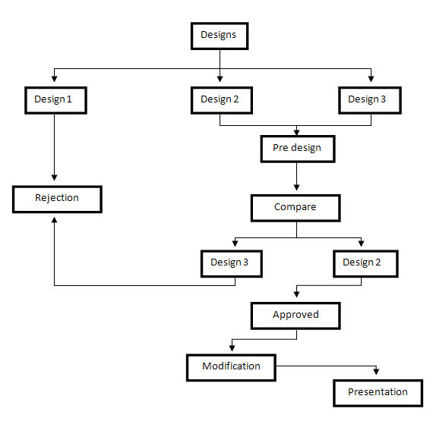

# Figure 1 : Decision Making Flow Chart

## Design 1

### Design Overview

The first design was to create a transmission using spur gears. Spur gears is known to be low cost in manufacturing and considered to be more efficient compared to other types of gears. After several discussions, the ideas of using spur gears were rejected because they are known to create much more sound than a helical gear, which can be seen in Figure 2. Since the requirement was to have a quiet gearbox, this type of gear is not suitable.

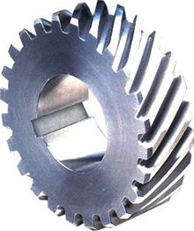

# Figure 2: An example of a helical gear

## Design 2

### Design Overview

For the second design, helical gears were used due to its ability to carry higher loads than spur gears and operate much quieter. Since the Idling gear was place between Pinion and Wheel 5, it needs to be located at a particular angle for the gear set to work. The dimensions of the idler gear were determined using equation 1 with respect to figure 3. The input, output, and transfer shafts are positioned in parallel with each other, while the idler shaft is located off of the x-axis with respect to the others.

# Equation 1 : Law of Cosines



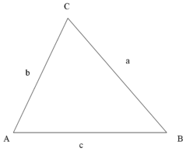

# Figure 2: Triangles with side a, b & c

Certain difficulties arise from the design. The most difficult problem was to find an angle that would give the best mesh between the pinion, idler and wheel 5. When modifying the angle of the idler shaft, both the pinion and wheel 5 were effected, hence the problem lies in finding the position that will give optimum mesh between the three. If the most favorable idler shaft location cannot be obtained, the percentage of the total damage of gearbox is high hence the gearbox does not meet the minimum hours of operation of 1000 hours. Figure 4 below shows the desired positions of the transfer shaft, output shaft and idler shaft.

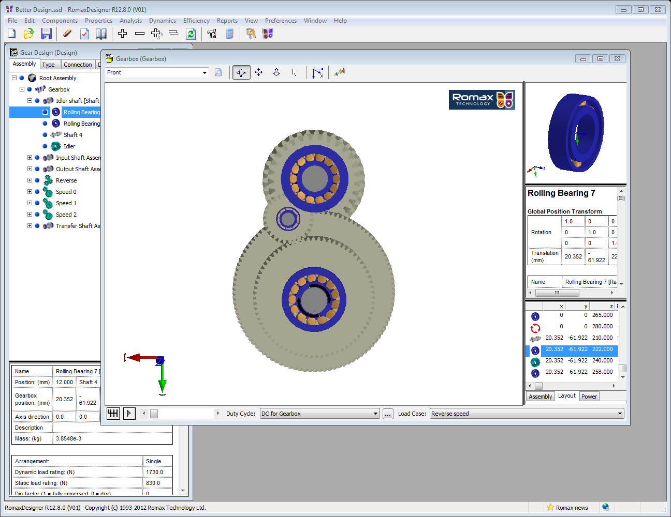

# Figure 3 : Right side view of design 2

After certain adjustments were made to the design, the gears were successfully meshed with optimum contact ratio which can be seen in figure 5. The first thing that was adjusted in the design was the number of teeth in the pinion and the wheel. By maintaining the normal module, changing the number of teeth would alter the diameter of the gears. Other modifications that were made were the adjustment of the tip diameter, root diameter and face width of the gear. Face width alteration were essential as the program required a minimum contact of 1. In order for the design to meet this condition, the face width was increased to a certain value. The addendum and dedendum were adjusted to minimize or maximize the contact between gears and eliminate unwanted errors.

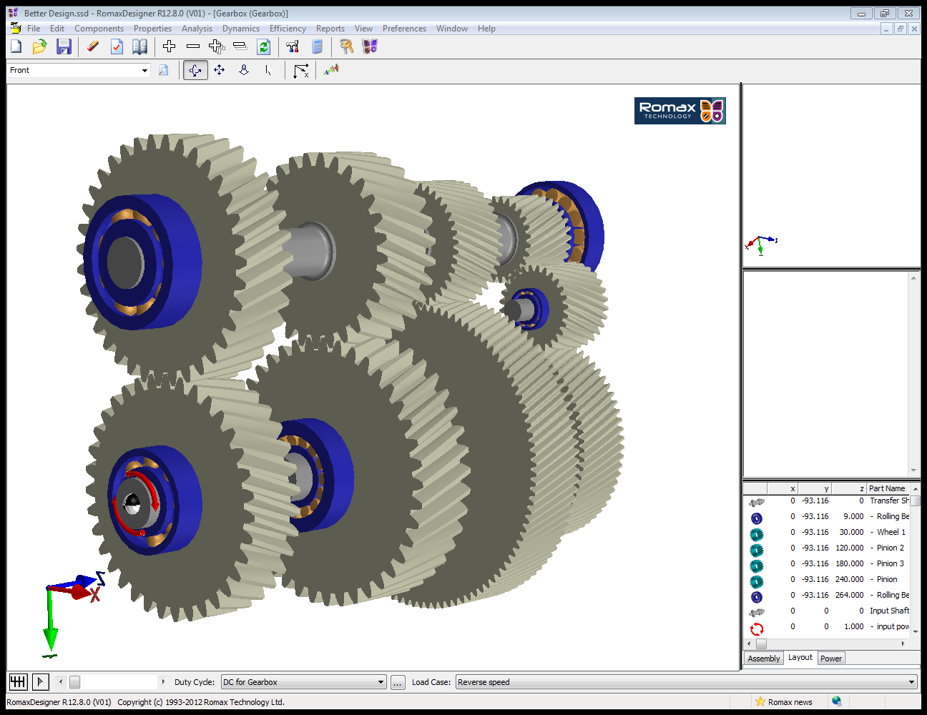

# Figure 4 : Isometric view of final design

### Design Specification

The transmission was created with a very specific number of shafts, gears, and bearings. Detailed information can be seen in the table below. When designing the gearbox, the first thing that needed to be calculated was the diameters of the gears. The diameters (d) of the gears were determined by calculating the number of teeth (N) on the gear and multiplying it with the normal module (m) seen in Equation 2. Table 1 represents the modules that were used for each speed, number of teeth, type of gear, material used, and the face width. Pressure angle and helix angle were kept to 20 degrees for all speed because of the standard that was determined by American Gear Manufacturers Association (AGMA).

# Equation 2 : Finding diameter



# Table 1 : Gear information



Shafts were also created which are labeled below in Table 2. It shows the shafts lengths by section, diameters by section and the (x,y,z) coordinates of the shafts.

# Table 2 : Information on shafts



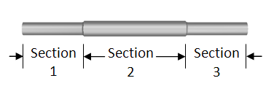

# Figure 5 : Sections of shaft

Bearings were also added to the design with the purpose to decrease the amount of load on the shaft hence increasing the life of the shaft and performance of the transmission. Table 3 illustrates the type of bearings that were used in the design.

# Table 3 : Types of bearings



# Results

## Modified damage

Figure 7 illustrates the modified life of the bearings of our design. The design has a modified life close to 1000 hours. The design can be seen to have a maximum operation life of 3377.2045 hours. From table 4 it can be seen that all the bearings failed after approximately 1000 hours. Two bearings had infinite life because they had no torque in them so there was no means of reducing their life. Very cheap bearings were used on the idler shaft because it was not necessary to use more expensive bearings because of their infinite life.

# Table 4: Modified life for the bearings of the design (2500 RPM)

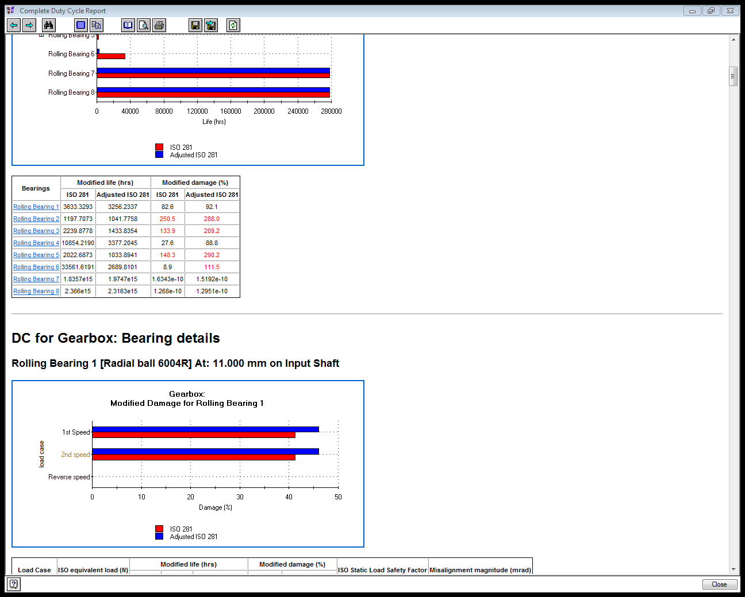

# Table 5: Modified life for the bearings of the design (3600 RPM)

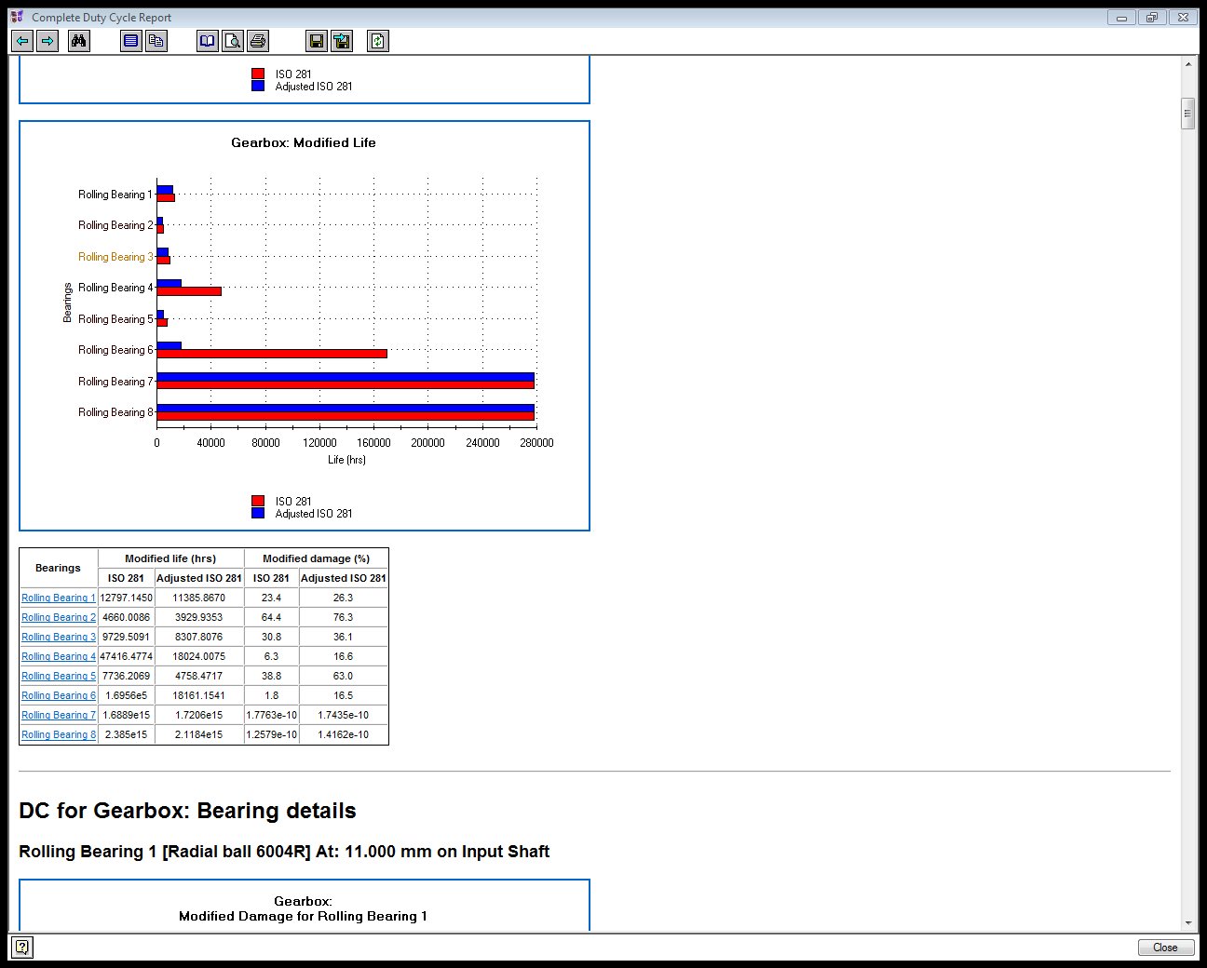

# Figure 7: Percentage damage(2500 RPM)

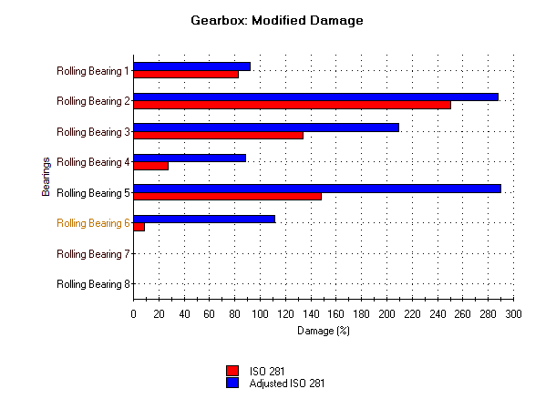

# Figure 8: Percentage damage(3600 RPM)

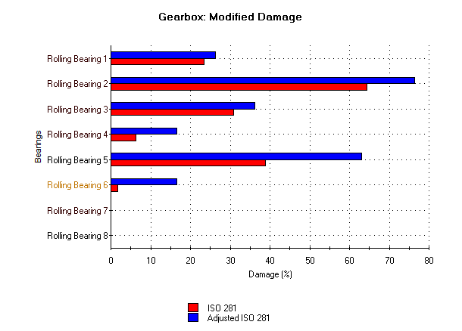

Following the completion of our design, the percentage damage of each bearing of the gearbox is plotted on a chart and compared to the standard ISO 281.

# Figure 9 : Modified life of design(2500 RPM)

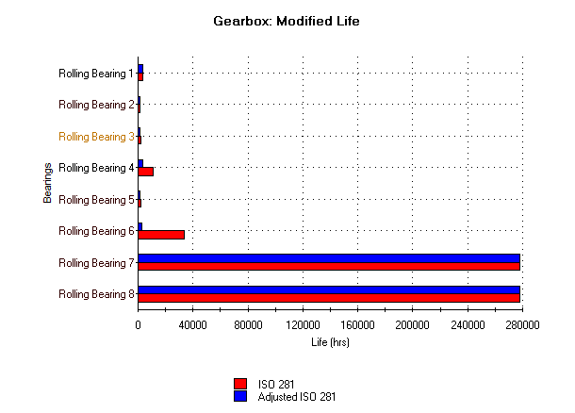

# Figure 10: Modified life of design(3600 RPM)

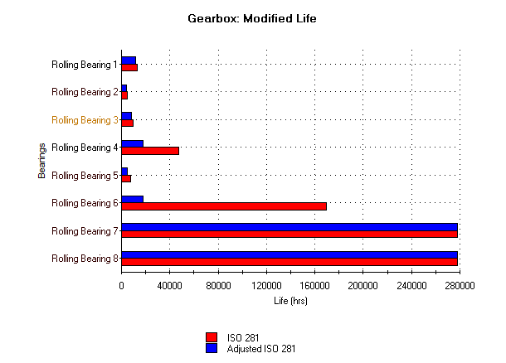

## Natural frequencies

The frequencies for each gear and shaft are calculated using equation 5 (Appendix C). The calculated frequencies are then placed into the tables below and compared to the shafts and gears frequencies. The purpose of this is to see if there are any shaft or gear frequencies that fall within about ±10% of the natural frequencies.

# Table 6 : Frequencies of the shafts (2500 RPM)



# Table 7: Frequencies of the shafts (3600 RPM)



# Table 8: Frequencies of gears (2500 RPM)



# Table 9 : Frequencies of gears (3600 RPM)



# Table 10: Natural Frequency(2500 RPM)

Speed 1 Speed 2 Reverse Speed

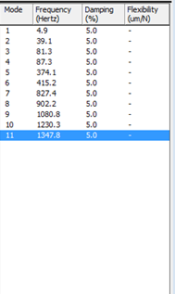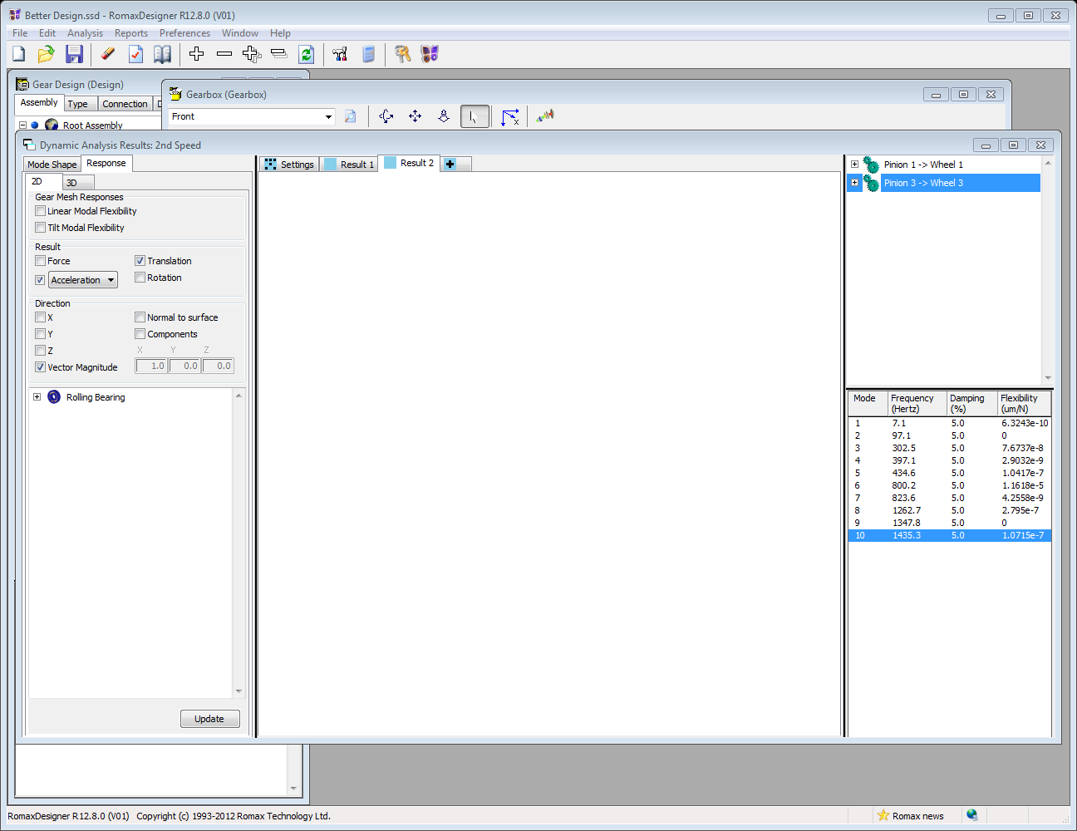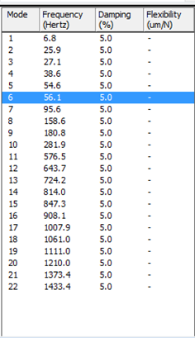

# Table 11: Natural Frequency(3600 RPM

Speed 1 Speed 2 Reverse Speed

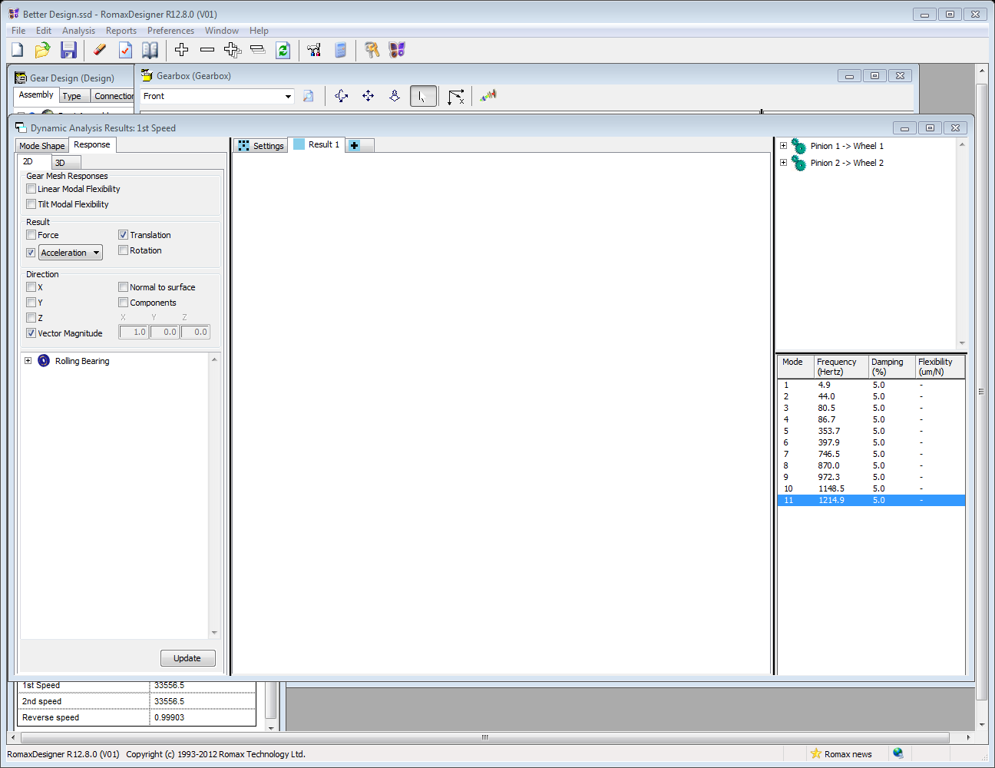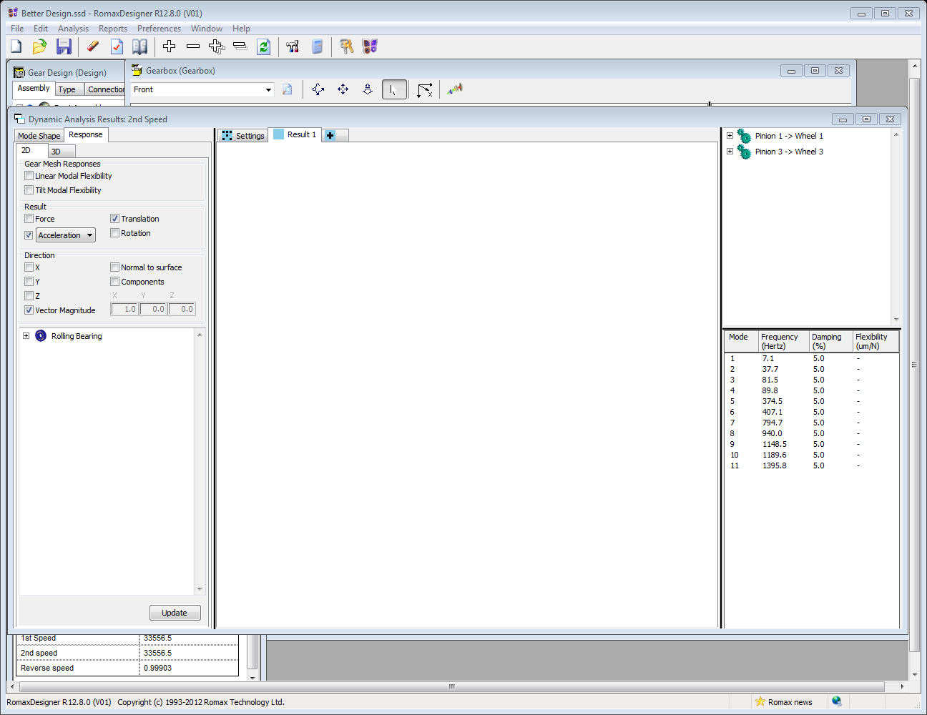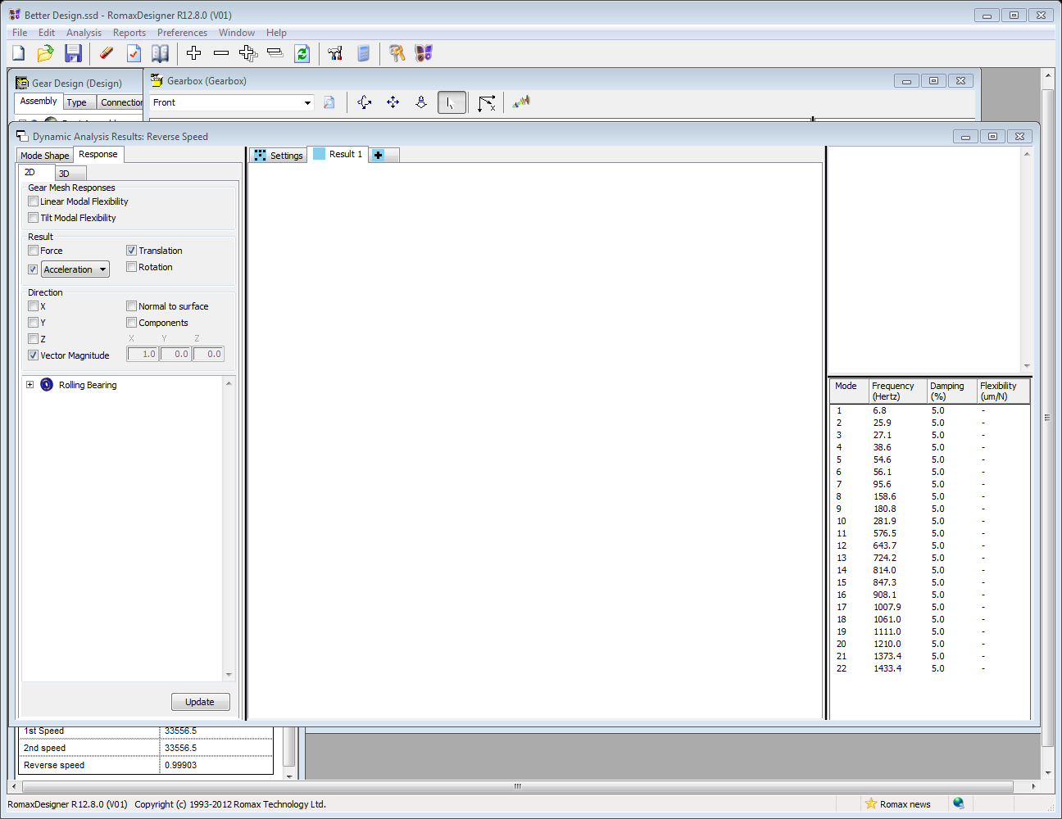

## Gear summary

Based on the analysis, all of the gears are able to operate more than the required operation life of 1000 hours. Table 9 shows the summary of the gears that Romax has produced.

# Table 12: Gear summary (2500 RPM)

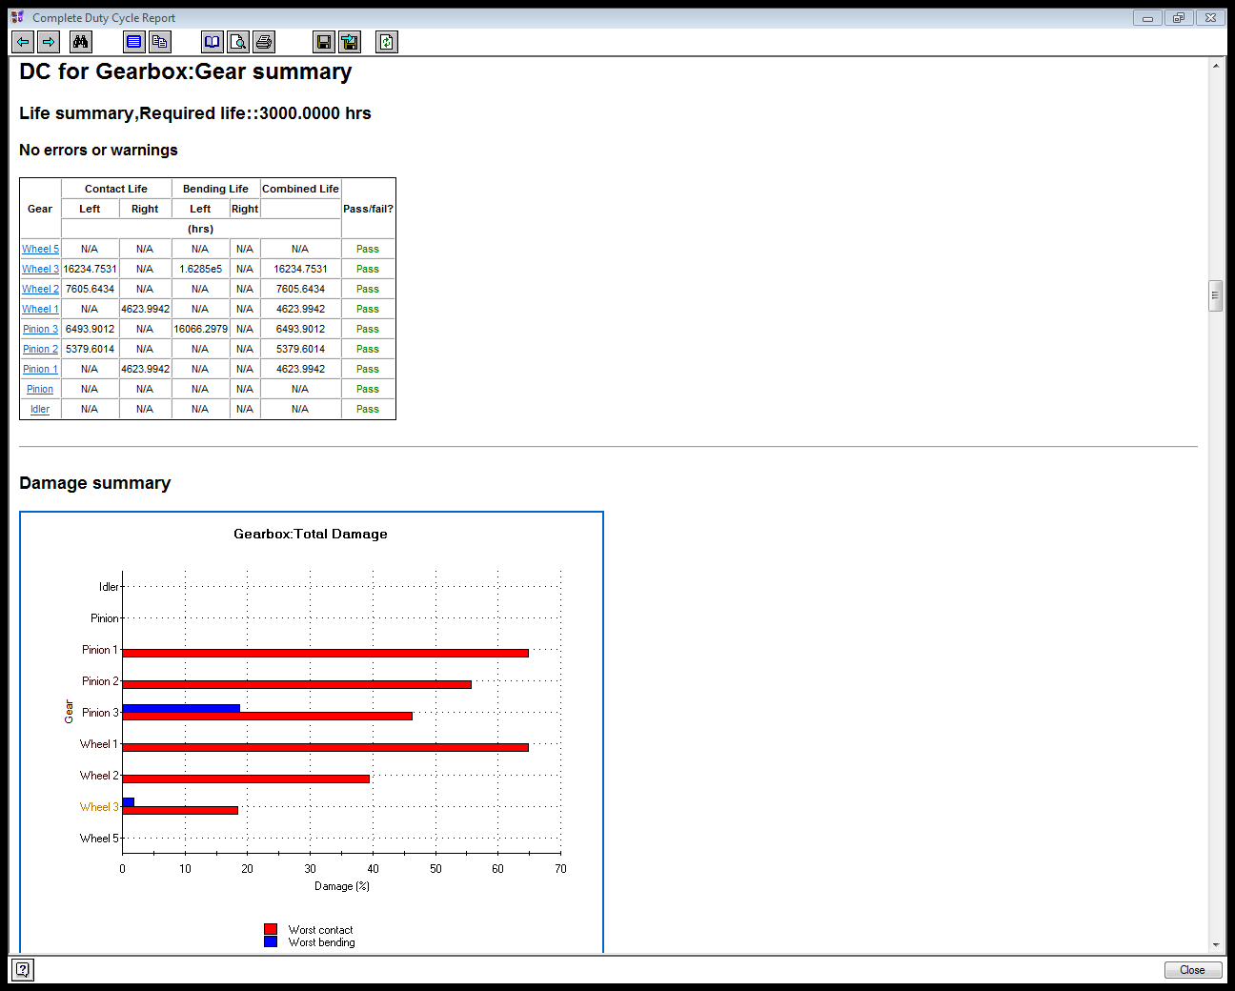

# Table 13: Gear summary (3600 RPM)

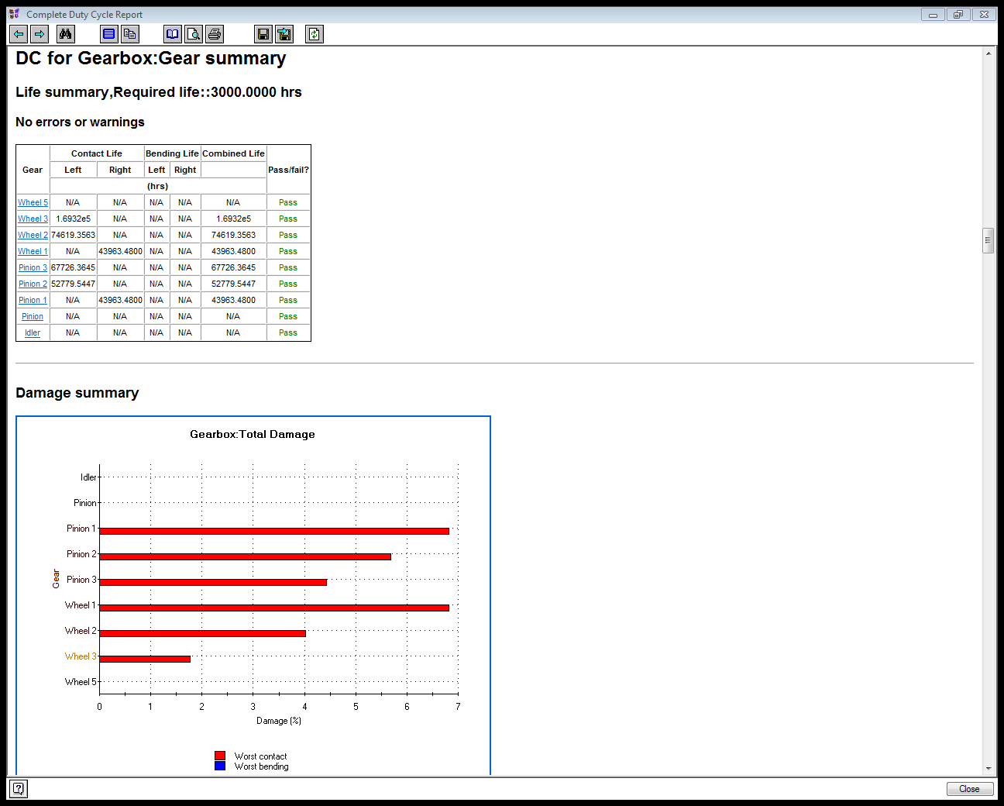

# Figure 11:Input Shaft Stress (2500 RPM)

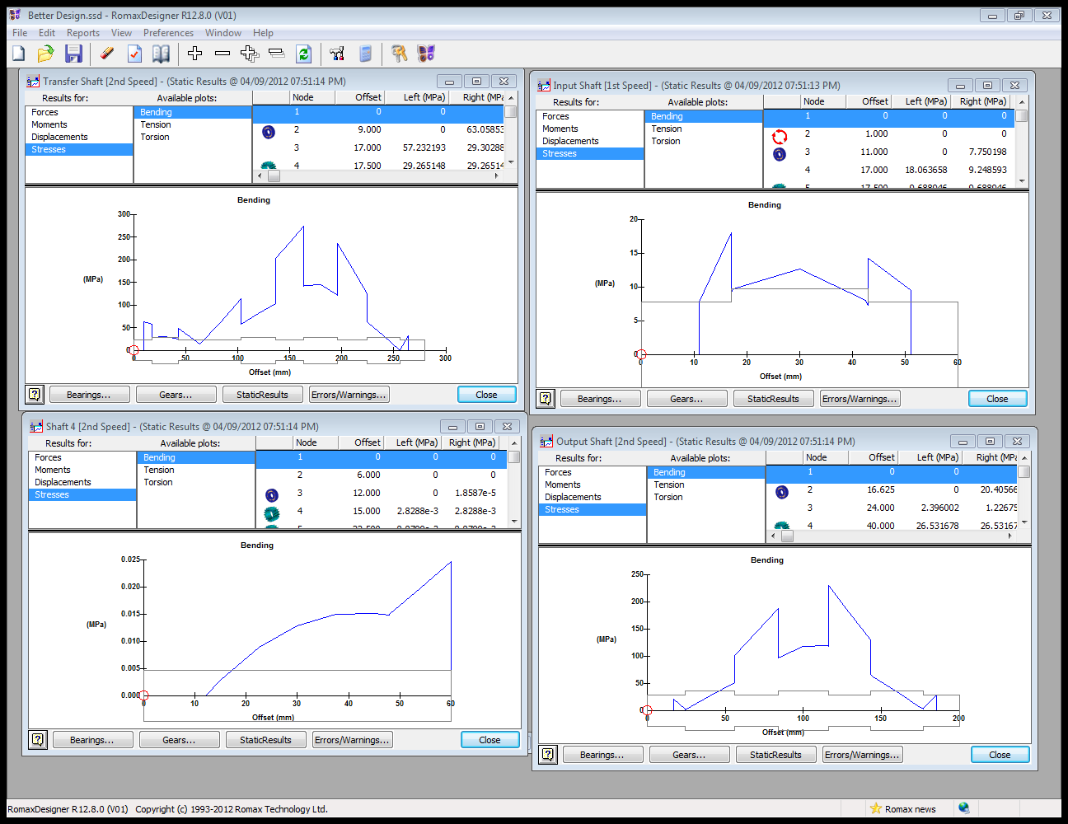

# Figure 12: Transfer Shaft Stress (2500 RPM)

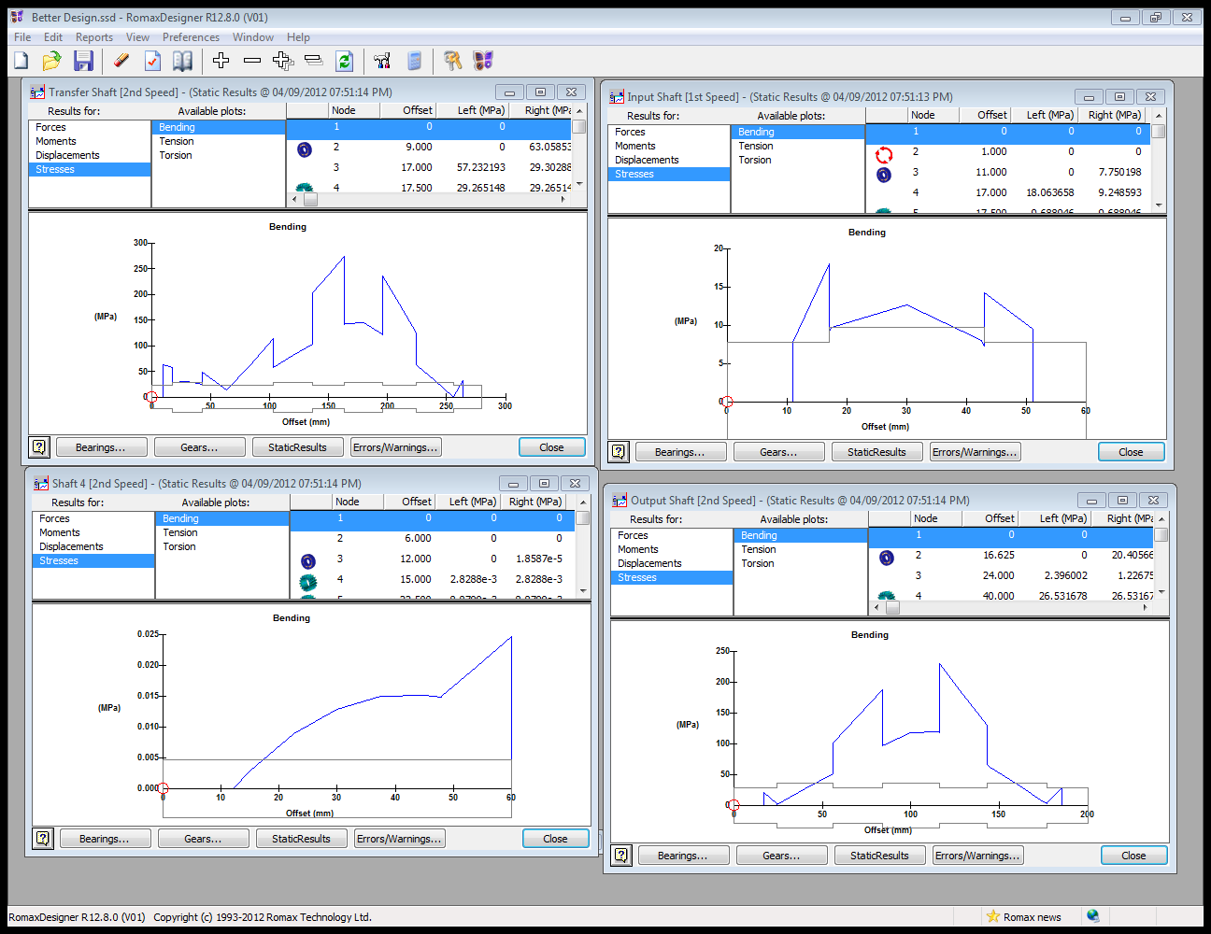

# Figure 13: Idler Shaft Stress (2500 RPM)

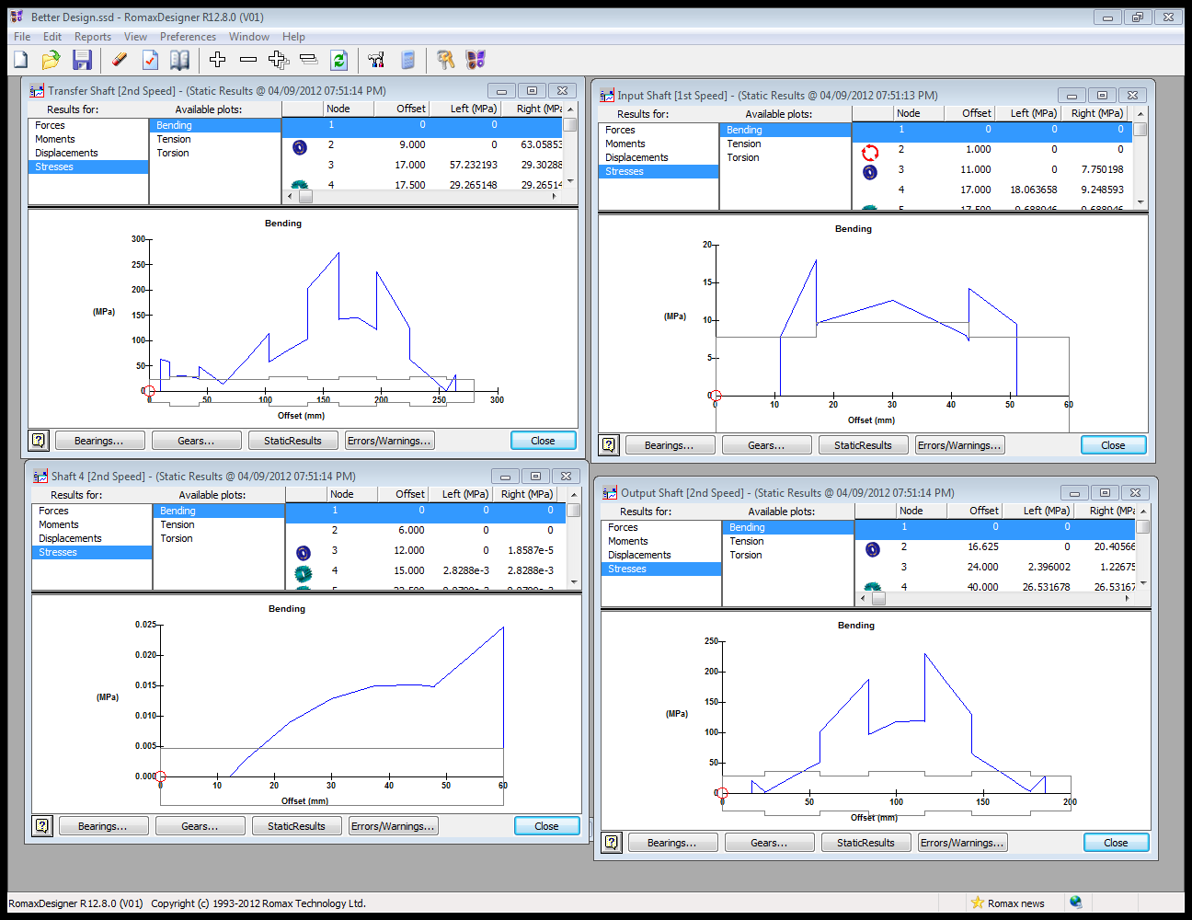

# Figure 14: Output Shaft Stress (2500 RPM)

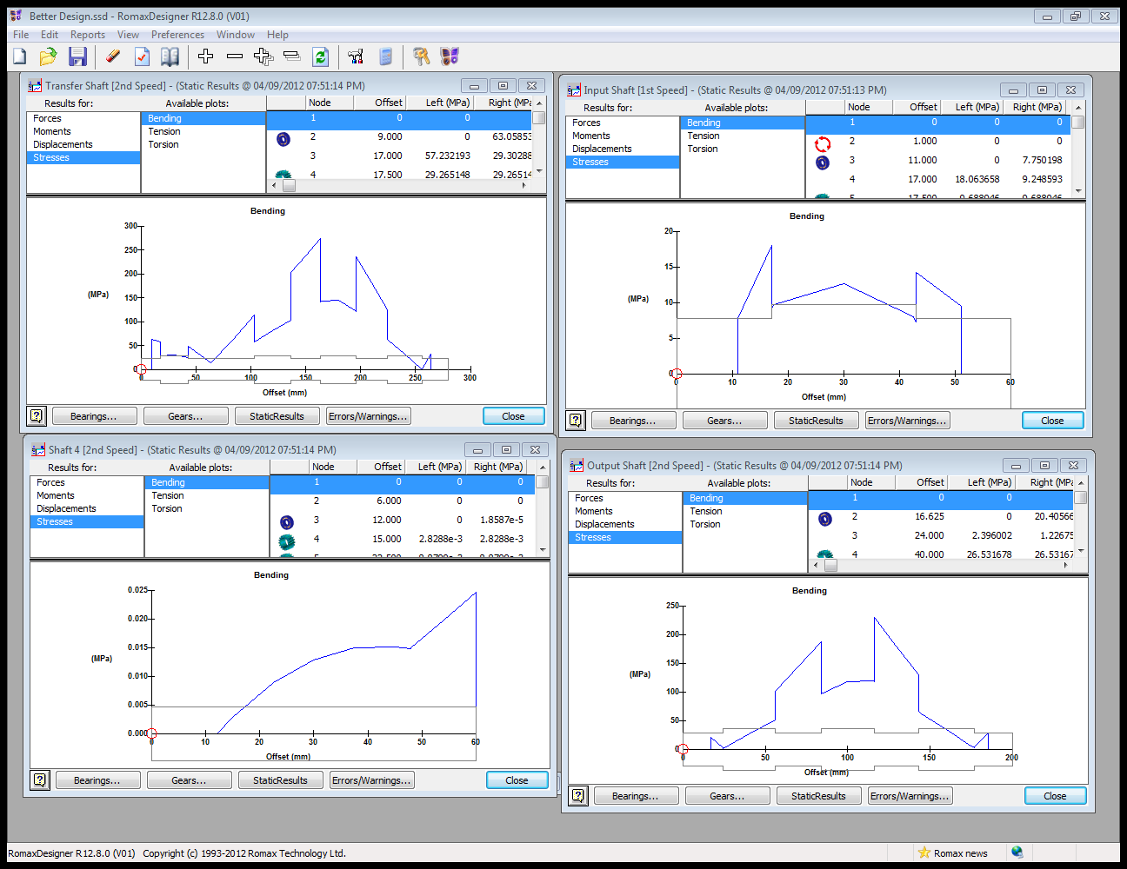

# Figure 15: Input Shaft Stress (3600 RPM)

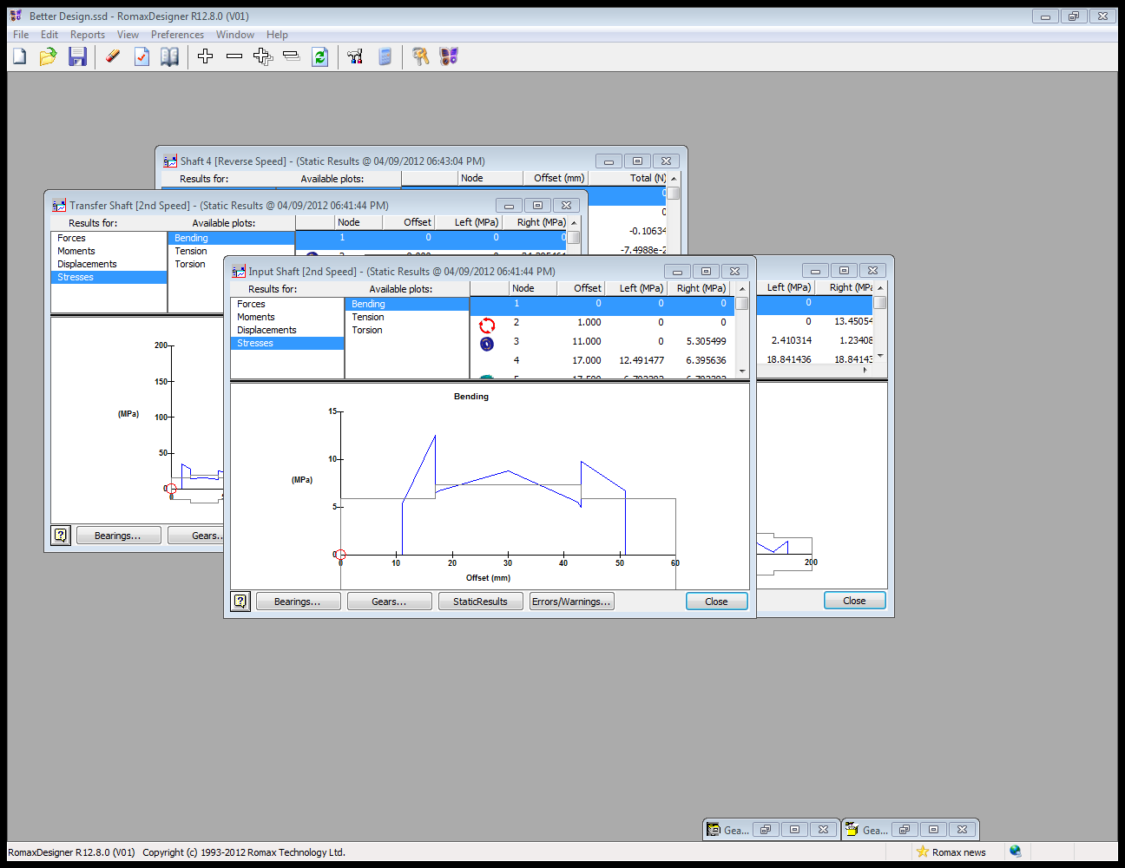

# Figure 16: Transfer Shaft Stress (3600 RPM)

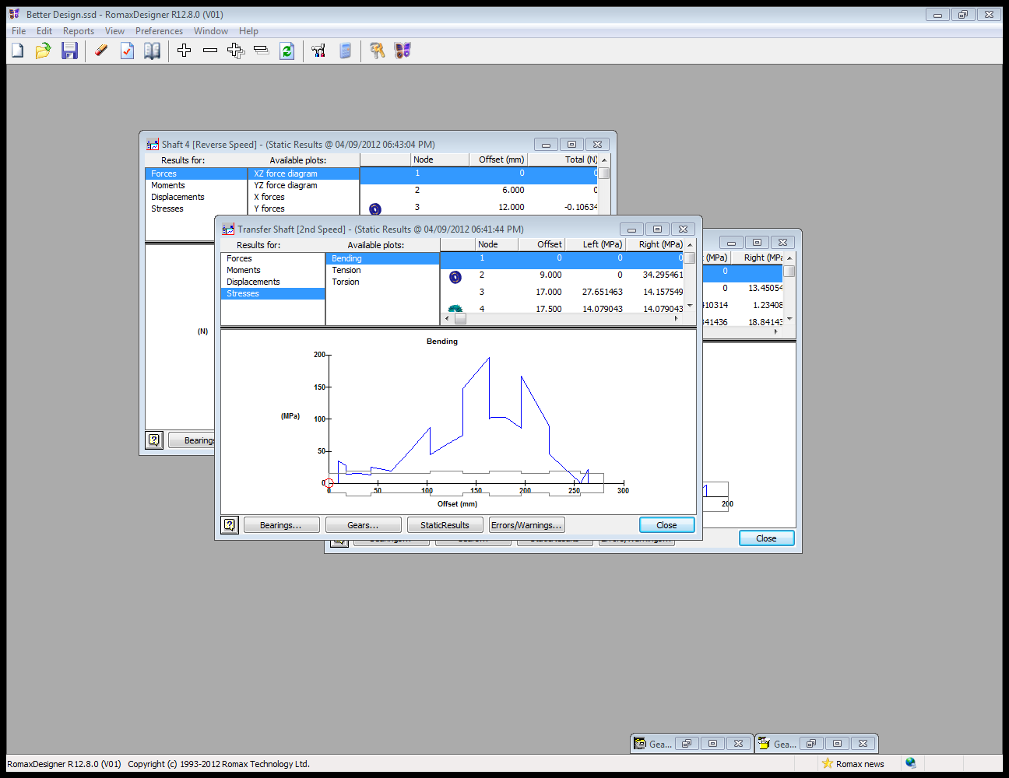

# Figure 17: Idler Shaft Stress (3600 RPM)

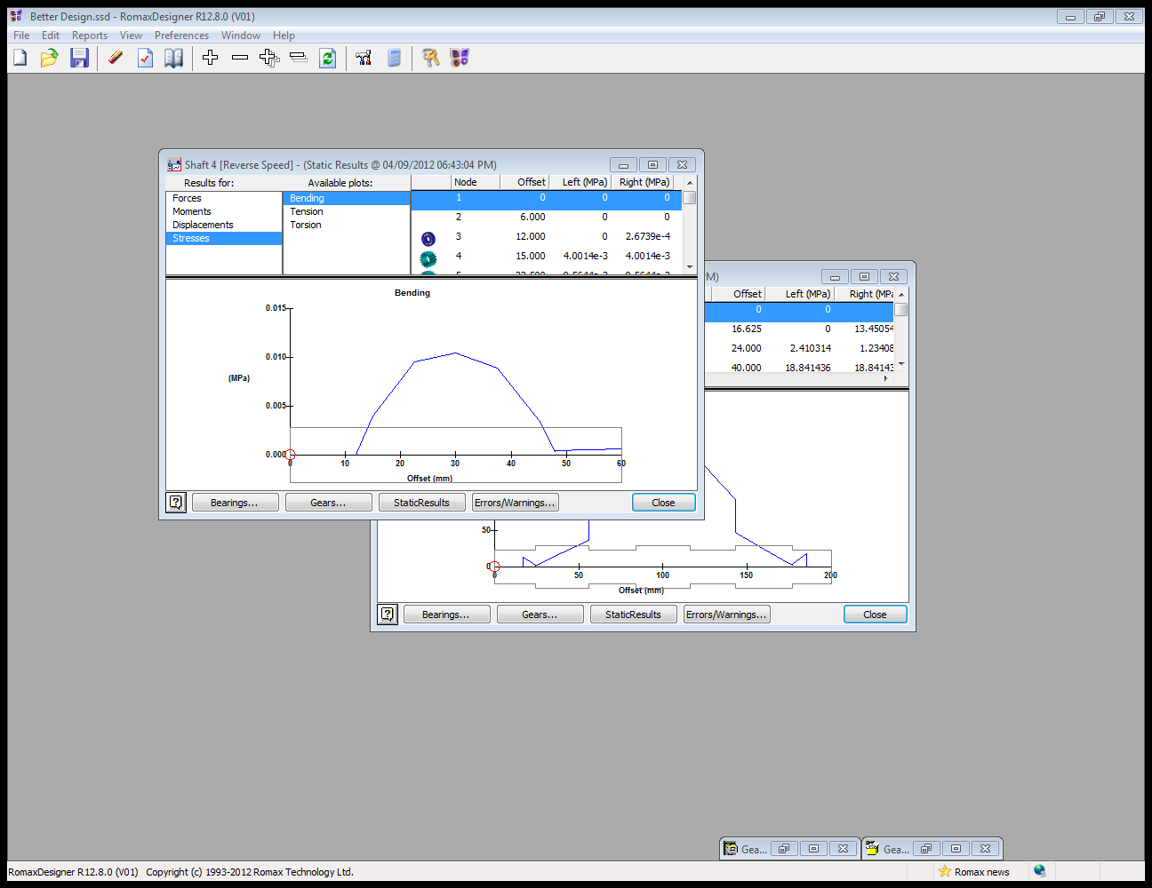

# Figure 18: Output Shaft Stress (3600 RPM)

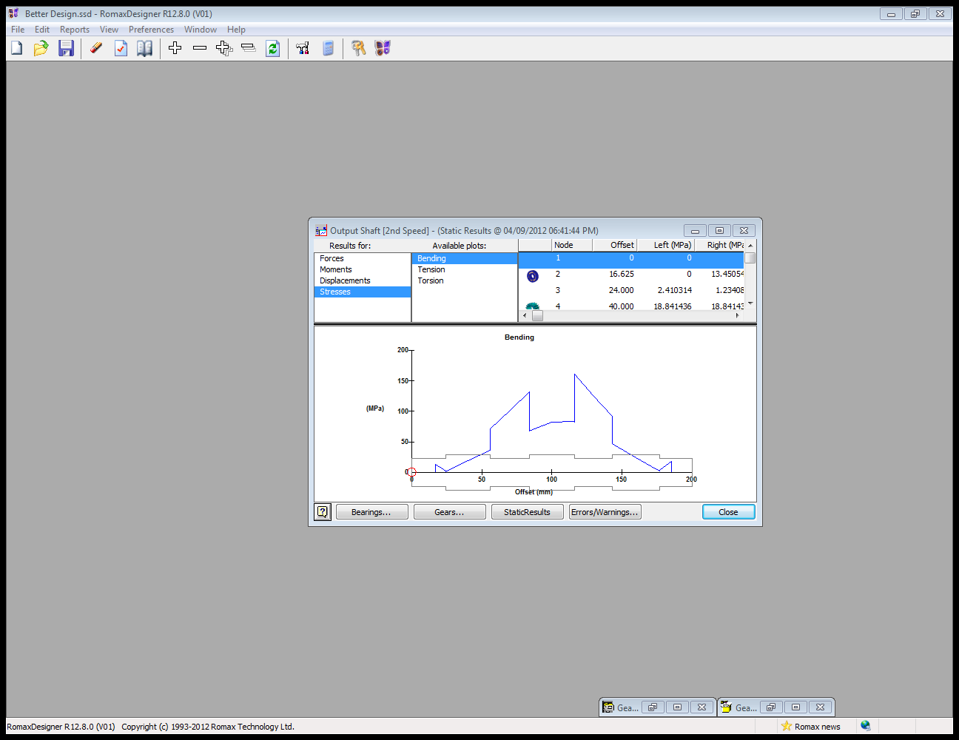

# Conclusion

The design of a transmission is a systematic process that requires many calculations and the use of powerful software to meet the specifications required by a customer. Through collaboration between the group members and calculations, an optimal design was achieved for a gearbox that needed to fulfill certain conditions in terms of life, size, and speed distribution between the gears. The most difficult task when designing the transmission was fulfilling the life conditions parameters, but with teamwork and determination, the objective was met and a gearbox was designed that performed according to most of the specifications required.

A few recommendations can be made on the design. Since the design has an operation life higher than that required, modification can be made so that overdesign does not occur. Shafts on the designs can be adjusted in order to decrease the life operation of the bearings. Bearing type may also be changed to reduce the operating life. Different type of lubrication besides SAE 75w (gear) oil may be used to get a better results on the designs. Material can also be changed to reduce the manufacturing cost of the product.

Bibliography:

Juvinall, Robert C., and Kurt M. Marshek. *Fundamentals of Machine Component Design*. Hoboken, NJ: John Wiley & Sons, 2006. Print.

Davis, J. R. *Gear Materials, Properties, and Manufacture*s. ASM International, OH, 2005.

# Appendix A:

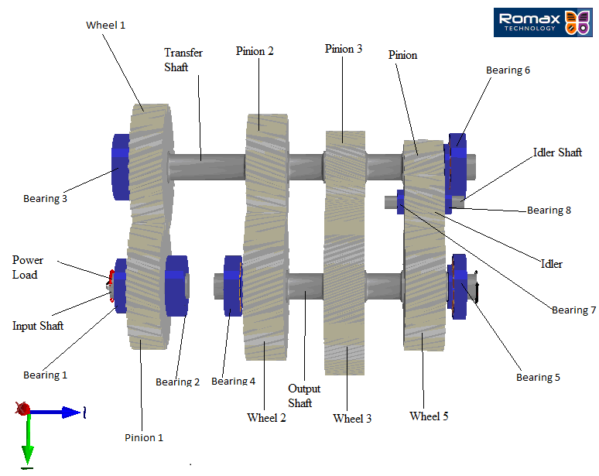

# Appendix B

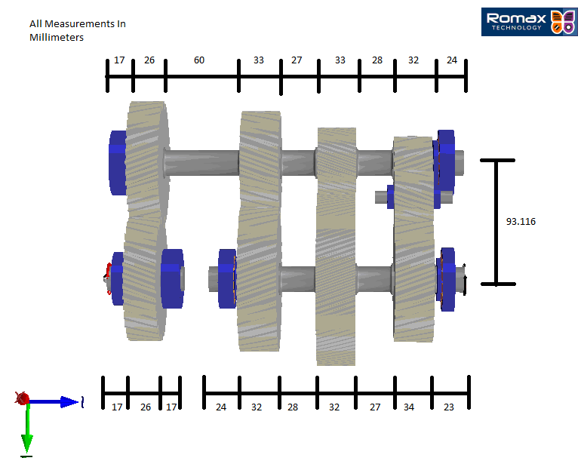

# Appendix C

# Equation 3 : Normal module

m = normal module

D = diameter (mm)

N = number of teeth

# Equation 4 : Ratio of diameters & the number of teeth

ω = angular velocity (RPM)

D = diameter (mm)

N = number of teeth

# Equation 5 : Frequency formula

f = frequency (Hz)

ω = angular velocity (RPM)

N = Number of Teeth