Half Report

**2013**

Atreya Biswas

Brian Omondi

Charles Monari

Western Michigan University

3/11/2013

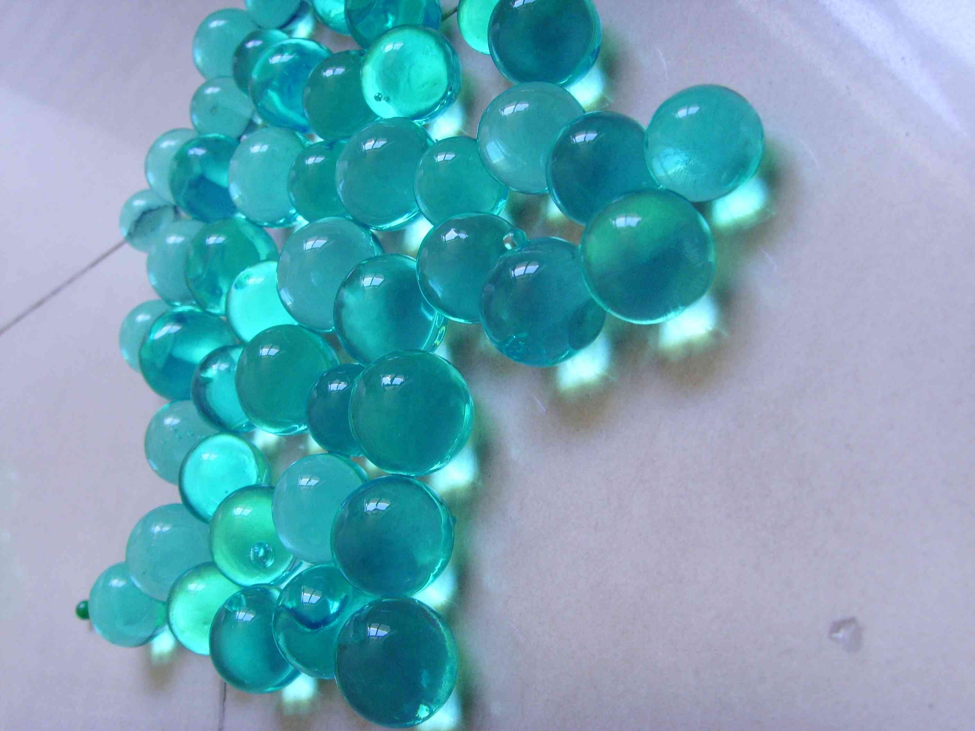

Table of Contents

1 Introduction 3

1.1 Hydrogel 4

1.2 Ferrogel 8

1.3 Project Overview 10

2 Literature Review 11

2.1 Hydrogel Simulations 13

2.2 Experimental Synthesis 14

2.3 Characterization 16

3. SIMULATION OF THE HYDROGEL 18

3.1 Theoretical Formulation of Chemo- Electro- Mechanical Behavior 20

3.1.1 Nernst Planck Equation 20

3.1.2 Poisson’s Equation 22

3.1.3 Mechanical Equilibrium Equation 23

3.2 Finite Element Method Formulation in COMSOL 25

3.2.1 26

3.3 pH Sensitive Hydrogel 31

# Introduction

With current technology advancements, nanoparticle and nanoparticle based substances such as hydrogels are under severe research due to their promising applications such as nanotechnology, biomedical applications, chemical sensing and micro electro mechanical systems.

Hydrogels are a class of cross-linked polymers that, due to their hydrophilic nature, can absorb large quantities of water without dissolving in it. Their ability to dissolve water is due to the presence of hydrophilic groups in the polymeric backbone. A fully swollen hydrogel can contain up to 99% water. The cross linking helps to prevent the hydrogel from dissolving in the buffer solution while the liquid part help prevents it from collapsing.

The hydrogels are responsive to various external stimuli such as temperature, pH, electric field, magnetic field, light by undergoing dramatic volume phase transition. This is dependent on the molecular weight and chemical composition. Due to their chemical properties, when applied to stimuli they take long to respond, which may be attributed to their low dissociation constant.

In order to utilize hydrogels in various applications, it is crucial to understand their physical and chemical characteristics of their response to various conditions. Even though lots of researches and theoretical works have been done concerning hydrogels, the responsive behavioral characteristics remain poorly understood.

## Hydrogel

Hydrogels are three-dimensional, hydrophilic, polymeric networks capable of absorbing large amounts of water or biological fluids. In its original state it is a solid polymer and semi-solid in swollen state.

They can absorb water due to the presence of hydrophilic ions such as –COOH,-SOOH,-OH etc. There is a considerable variety of materials in either naturally existing or synthesizing, as examples of swellable hydrated polymeric gels. Synthetic monomers used in tissue engineering include, among others, poly(ethyleneglycol) (PEG), poly(vinyl alcohol) (PVA), and polyacrylates such as poly(2-hydroxyethyl methacrylate) (PHEMA). Biological hydrogels have been formed from agarose, alginate, chitosan, hyaluronan, fibrin, and collagen, as well as many others.

It is desirable to fabricate hydrogels with high mechanical strength and transparency. This will enable the hydrogels to absorb large amounts of water. In order to synthesize hydrogels with high mechanical strength and swelling ratio, it is desirable to fabricate the hydrogel with both hydrophobic and hydrophilic co-monomers.

Figure 1 a) and b) show the cross linked polymer in both unswollen and swollen states. All the interconnected lines are conforming network chains, while crosslinking is represented by big black spots at their intersections. The empty space holds the interstitial fluid. The fixed charges are represented by the empty circles or the empty circles with inscribed negative signs. The arrow indicates the direction of mobile ions, which are either into or outside the hydrogel.

The gel is affected by changes in pH, temperature, solvents and other factors in the surroundings. The hydrogel shrinks or swells showing a volume phase transition. Figure 1 (b) represents the actual swollen hydrogel. The positive ions of the buffer solution interact with the fixed negative charges ions on the polymer network after equilibrium is established. The buffer solution increases the external ions inside the hydrogel, which increases the osmotic pressure. Osmotic pressure causes the hydrogel to network to swell. As the hydrogel expands, there is an elastic force due to the cross linking that opposes the osmotic pressure. The hydrogel swells until the osmotic pressure and the elastic force are equal, after which there is no more swelling and the hydrogel is said to be saturated. As the pH is increased the hydrogel swelling also increases.

These hydrogels exhibit a thermodynamic capability with water, which allow them to swell in aqueous media. Hydrogels show a swelling behavior dependent on the external environment. These polymers are physiologically responsive hydrogels, where polymer complexes can be swollen as a result of the changing external environment. These systems show drastic changes in their swelling behavior. Stimuli-sensitive hydrogels have been stimulated by pH, ionic strength, temperature and electromagnetic radiations. Some stimuli-sensitive polymers contain pendant acidic or basic groups that either accept or release protons in response to stimuli, i.e. changes in environmental pH. Swelling of hydrogels increases as the external pH increases in case of weakly acidic (anionic) groups, but decreases if the polymer contains weakly basic (cationic) groups. Most of the anionic pH-sensitive polymers are based on polyacrylic acid (carbopol) or its derivatives.

Hydrogels These materials uniquely offer moderate-to-high physical, chemical, and mechanical stability in their swollen state. The structure of a hydrogels can be designed for a specific application by selecting proper starting materials and processing techniques. Since the equilibrium swelling capacity of a hydrogels is a balance between swelling and elastic forces, hydrogels with different swelling capacities can be designed by modulating the contribution of individual forces. Certain hydrogels respond to the changes in environmental factors by altering their swelling behavior.

Hydrogels can be divided into two categories based on the chemical or physical nature of the crosslink junctions. Chemically crosslinked networks have permanent junctions, while physical networks have transient junctions that arise from either polymer chain entanglements or physical interactions such as ionic interactions, hydrogen bonds, or hydrophobic interactions. Hydrogels can also be separated into two groups based on their natural or synthetic origins. Hydrogel-forming natural polymers include proteins such as collagen and gelatin, and polysaccharides such as alginate and agarose. Synthetic polymers that form hydrogels are traditionally prepared using chemical polymerization methods.

## Ferrogel

A ferrogel is an intelligent magnetic field sensitive gel which is generally comprised of a chemically cross-linked polymer network swollen by a ferrofiuid which is a colloidal dispersion of mono-domain magnetic particles. It is composed of microscopic magnetic grains ﬁrmly embedded in an elastic cross-linked polymer gel matrix. A ferrogel changes its physical behaviors by applying a magnetic field which is a remote control input without any physical connection with the sample. Such an advantage of ferrogels can be a great value in the industries which require non-contacts between a smart material and control input. Likewise, it is certain that characterization and optimization of ferrogel behaviors can be a technical breakthrough in the engineering fields as well as medical applications.

The difference between other smart materials and ferrogels is a range of stiffness because they have been considered as high modulus magnetic materials, while ferrogels are low-modulus magnetic materials leading to enhanced magnetic and mechanical responses to external stimuli. Among low-modulus magnetic materials, there are Magneto-Rheological (MR) Fluids and Magneto-Rheological Elastomers (MRE). They change their viscosity or modulus when they are exposed to magnetic fields, respectively. Comparing with those two smart magnetic materials, ferrogels show a difference because it focuses on actuator behaviors controlled by a magnetic field rather than viscosity and modulus changes. The coupling between magnetic and mechanical properties leads to a large number of functionalities and applications.

Ferrogels can be used as soft actuators in which magnetic stimuli leads to deformations which can be used in applications like localized hyperthermic treatment and drug delivery. Stresses, strains, temperature changes, and chemical stimuli (such as changes in pH and ionic strength or the addition of swelling agents) act primarily on the polymer-gel matrix but lead to changes in the magnetic susceptibility and so a ferrogel may also function as a sensor.

The properties of ferrogels depend on the preparation conditions (solvent, concentration of cross linking, concentration of magnetic particles). Preparing ferrogels in an external magnetic ﬁeld, one can obtain large columns of magnetic particles, the length of which is much larger than the mesh size of the network. The coupling of magnetostriction (ﬁeld-induced deformation leading to a change in magnetic susceptibility), magnetostatics (interactions between magnetic dipoles), and the elastic properties of the polymer-gel matrix also determines the properties of hydrogels. A manifestation of this coupling can be observed in the deformation of a macroscopic ferrogel body in a uniform magnetic ﬁeld. Since a uniform magnetic ﬁeld exerts no net force on a magnetic dipole, the deformation is driven entirely by interaction of the above mentioned effects, and the result depends rather sensitively on the geometry of the ferrogel body. The most dramatic deformations can be achieved with the application of magnetic-ﬁeld gradients. Although such deformations can be rationalized from a relatively simple treatment of the magnetic interactions and the elastic extension of the polymer gel matrix, there are plenty of non trivial effects magnetic and mechanical which require more detailed microscopic descriptions.

## Project Overview

The main goal of the research project is to study how numerous parameters, during and after fabrication, affect the mechanical properties and characteristics of a ferrogel. The main focus was placed on the time taken for the hydrogel to form, gelation time. The problems that we expect to have include uneven distribution of nanoparticles in the hydrogel which might cause undesirable and unpredictable characteristics throughout the hydrogel or ferrogel and convergence problem due to the non-linearity of the chemo-electro-mechanical equations being coupled.

The second major goal was to characterize the mechanical properties of the ferrogel samples. Previously, there was not much data for the properties of ferrogels. In order for a material to be used in industry, the properties of the material must be known.

The third major goal is to test a computer model that accurately predicts the hydrogel response to solutions of varying pH and varying time steps between pH 3-7. Previously formulated mathematical models were found to predict the hydrogel expansion accurately, which is in agreement with experimentation results. Hence a commercial Multiphysics program (COMSOL) was used to perform the simulation of the gel expansion in response to pH of the buffer solution for a normal geometry as well as an arbitrary geometry, after which the range of pH hydrogel expansion takes place.

# Literature Review

Through extensive research of various databases, it was found that the best suitable program to use for hydrogel simulation was COMSOL Multiphysics. It utilizes the following governing equations: Nernst-Planck Equation, Poisson’s Equation and Mechanical Field Equation. The Nernst-Planck equation defines the relation between the concentrations of the various mobile species in the buffer solution. The Poisson’s equation is used to understand the spatial distribution of the electric potential (ψ) and satisfies the electro neutrality condition. The Mechanical Field Equation is used to calculate the gel expansion where it is represented by a second-order partial-differential equation of motion in time. The simulation of hydrogel involves using four modules in COMSOL Multiphysics: Nernst-Planck without electro-neutrality (Chemical Engineering Module), Conductive Media DC (AC/DC Module) for Poisson’s Equation, Plane Strain (Structural Mechanics Module) for Mechanical Field Equation. In addition to the three modules, the moving mesh module was also used due to the large hydrogel deformations which makes it impossible to use normal meshes. These modules will be coupled to study the physics of hydrogel both in steady state and transient conditions.

Also from research it was found that in order to fabricate hydrogels one needs four major components:

1. Monomer-NIPAM:This is the monomer form of acrylamide, which is a temperature responsive polymer.
2. Cross linker-BIS-This is used as a cross linking agent for the polymerization process. It creates an environment conducive for cross linking of the polymer chains.
3. Catalyst-TEMED:Used with ammonium persulfate to catalyze the polymerization process.
4. Ferrofluid: Ferrofluid is a mixture of magnetic nanoparticles and DI water. Magnetic nanoparticles were FE3O4 material, which is also known as magnetic or ferrous ferric oxide or gild nanoparticles.

## Hydrogel Simulations

Simulation of hydrogel response to environmental conditions in steady state as well as in transient conditions is essential to understand their general behavior. Chemo-electro-mechanical behavior of hydrogel is simulated in response to the change in pH of the buffer solution that surrounds it. In the steady state, simulation will be carried out to understand the effect of variation of disassociation constant and hydrogel young’s modulus on gel expansion. Transient simulation will be done to determine the response of the hydrogel to pH with incremental time steps. Further, simulations will be done for arbitrary geometry to understand the effect of variation of fixed charge density on the hydrogel and the concentration change of mobile ions in the hydrogel and compared to the experimental results, which helps in validating the simulation results. These simulations will be done using COMSOL Multiphysics using different modules including structural mechanics, reaction engineering and AC/DC modules along with moving mesh that can take into account the large changes in gel geometry.

## Experimental Synthesis

Polymerization/cross-linking, suspension polymerization, polymerization by radiation, chemically cross-linking, and physical cross-linking are methods of hydrogel synthesis by utilization of different monomer, polymer as well as copolymers. Cross-linked networks of synthetic polymers such as polyethylene oxide (PEO), polyvinyl pyrollidone (PVP), polylactic acid (PLA , polyacrylic acid (PAA), polymethacrylate (PMA), polyethylene glycol (PEG) , or natural biopolymers such as alginate, chitosan, carrageenan, hyaluronan, and carboxymethyl cellulose (CMC) are used widely and various synthesis techniques which have been adopted are physical crosslinking, chemical cross-linking, grafting polymerisation, and radiation cross-linking. Such modifications can improve the mechanical properties and viscoelasticity for applications in engineering, biomedical and pharmaceutical fields.

Physical cross-linking has been an increased interest in physical or reversible gels due to relative ease of production and the advantage of not using cross-linking agents. These agents affect the integrity of substances to be entrapped (e.g. cell, proteins, etc.) as well as the need for their removal before application. Careful selection of hydrocolloid type, concentration and pH can lead to the formation of a broad range of gel textures and is currently an area receiving considerable attention, particularly in the food industry. The various methods used to obtain physically cross-linked hydrogels are-Heating/cooling a polymer solution, Ionic interaction, Complex coacervation, H-bonding, Maturation (heat induced aggregation), Freeze-thawing, etc. Chemical cross-linking involves grafting of monomers on the backbone of the polymers or the use of a cross-linking agent to link two polymer chains. The cross-linking of natural and synthetic polymers can be achieved through the reaction of their functional groups (such as OH, COOH, and NH2) with cross-linkers such as aldehyde (e.g. glutaraldehyde, adipic acid dihydrazide). There are a number of methods reported used to obtain chemically cross-linked permanent hydrogels. Among other chemical cross-linking methods, IPN (polymerise a monomer within another solid polymer to form interpenetrating network structure) and hydrophobic interactions (incorporating a polar hydrophilic group by hydrolysis or oxidation followed by covalent cross-linking) are also used to obtain chemically cross-linked permanent hydrogels. The major chemical methods used to produce hydrogels from a range of natural polymers are chemical crosslinkers, grafting, and radiation in solid and/or aqueous state. Radiation cross-linking is widely used technique since it does not involve the use of chemical additives and therefore retaining the biocompatibility of the biopolymer. Also, the modification and sterilization can be achieved in single step and hence it is a cost effective process to modify biopolymers having their end-use specifically in biomedical application. The technique mainly relies on producing free radicals in the polymer following the exposure to the high energy source such as gamma ray, x-ray or electron beam. The action of radiation (direct or indirect) will depend on the polymer environment (i.e. dilute solution, concentrated solution, solid state).

## Characterization

The following results of gelation time were obtained from the fabrication of hydrogel and ferrogel with varying N,N'-Methylenbisacrylamide (BIS) concentrations. It can be observed that with the increase in the BIS concentration, the gelation time goes down. However these results are not accurate or precise and are only approximate. Further experiments and research will be done at a later stage.

|  |  |  |  |
| --- | --- | --- | --- |
| 90% Gelation Time | | | |
| *Sample* | *BIS Concentration* | *Hydrogel Gelation Time* | Ferrogel Gelation Time |
| *(2ml)* | *(mg)* | *(sec)* | *(sec)* |
|  |  |  |  |
| x1 | 3.44 | 50 | 76 |
| a1 | 6.97 | 45 | 51 |
| b1 | 11.33 | 38 | 48 |
| c1 | 23.65 | 36 | 45 |

|  |  |  |  |
| --- | --- | --- | --- |
| 100% Gelation Time | | | |
| *Sample* | *BIS Concentration* | *Hydrogel Gelation Time* | Ferrogel Gelation Time |
| *(2ml)* | *(mg)* | *(sec)* | *(sec)* |
|  |  |  |  |
| x2 | 3.44 | 81 | 100 |
| a2 | 6.97 | 65 | 71 |
| b2 | 11.33 | 45 | 66 |
| c2 | 23.65 | 38 | 49 |

# 3. SIMULATION OF THE HYDROGEL

There is a need to develop simple software tools that can be used in analyzing and understanding the mechanism of gel swelling and deswelling in response to different environmental stimuli. This is because in the past scientists developed their own programs in their laboratories which they used to analyze the hydrogel expansion. The model in terms of the hydrogel shape, procedures to follow in the simulation of a swelling hydrogel of circular shape in both steady state as well as transient condition and arbitrary geometry in steady state are presented emphasizing their response to variation of pH. The numerical equations used as well as the simulations will be described in greater detail. In these simulations, a finite element program, COMSOL Multiphysics 4.3 was used. The effect of the Young’s modulus, fixed charges, and buffer solution with variation of pH (2-12) was then studied for the different simulations. Finally the results were compared with experimental results to determine their credibility.

The chemo-electro-mechanical behavior of hydrogel was simulated in response to changes in pH of the buffer solution, as in the normal geometry, or by applying the mobile ions in the hydrogel boundaries as in the arbitrary geometry. The model simulation uses three partial differential equations (PDE’S):

1. Nernst-Planck Equation
2. Poisson’s Equation
3. Mechanical Equilibrium Equation

The first two equations are highly non- linear. The third is non-linear due to the rapid swelling of the hydrogel that introduces rapid changes in the modulus of elasticity of the hydrogel. Due to these highly non-linear system of equations, very sophisticated programs with sophisticated solvers are required to solve them. Due to this many researchers have developed their own software to help them in the simulations. Our main focus is to develop a simulation using commercially available program, COMSOL. This will improve research in the hydrogel simulations as the program is easily accessible. These simulations focus on the effect of pH on the hydrogel swelling under steady state and transient conditions. The swelling of a square hydrogel with response to pH is also simulated.

# Theoretical Formulation of Chemo- Electro- Mechanical Behavior

Chemo-electro-mechanical behavior of the hydrogel in response to pH of the buffer solution or with response to the mobile ions at the hydrogel boundaries require considering the mathematical representation of the different interaction mechanisms and the resultant changes. Three important normally considered simulations are the chemical, electrical and mechanical in nature1. The Nernst- Planck, Poisson and Mechanical Equilibrium Equations are commonly used in the determination of these changes.

### Nernst Planck Equation

The Nernst-Planck Equation is used to define the relation between the concentrations of the concentrations of the various mobile species, Na+,Cl-, H+, species in the buffer solution of hydrogel boundary. Applying the continuity equation, the change in concentration flux with respect to space is equated with the rate of change of concentration flux with respect to space is equated with the rate of change of concentration which is given by:

 (1)

If the equation is modified to include the flux due to diffusion of mobile ions which are mainly due to the concentration gradient and migration flux because of electric potential and hence it can be written as:

 (2)

Equation 2 was used in the transient simulation. In the steady state simulations, the first term, concentration gradient with respect to time, is neglected. Hence the equation was written as:

 (3)

The final equation for the steady state is thus written as:

 (4)

Where, μi is the mobility of the ith ion.

 (5)

In the equation (2), the first term represents the diffusive flux due to the gradient of the concentration and the second term represents the migration flux arising from the gradient of the electric potential which is calculated using the electro neutrality condition when the equation is coupled with the Poisson’s Equation.

Where: Di, ci, zi, F, R, T and ψ are the diffusion co-efficient of the ith ion, the concentration of the ith ion, valence of the ith ion, the faraday constant, the universal gas constant, temperature and the electric potential respectively.

### 3.1.2 Poisson’s Equation

The Poisson’s Equation is used to describe the spatial distribution of the electric potential (ψ) and to satisfy the electro-neutrality condition. It is given by:

 (6)

Where ρ is the charge density in the hydrogel, $ϵ_{o}$ is the dielectric constant of the vacuum and $ϵ$ is the relative dielectric constant of the solvent.



(7)

Where Zf and Cf are the valence and fixed charge concentration in the hydrogel.

The fixed charges concentration in the hydrogel is calculated using the formula:

 (8)

Where, $c_{mo}^{s},$ K, *CH* and *H* are the ionizable charge concentration, dissociation constant, hydrogen ion concentration and hydration, respectively. The hydration state of the hydrogel is the ratio of the volume of the fluid to the volume of the solid in the gel. It is determined from the Jacobian of the deformation tensor.

In the equation the cf is represented as a function of the surrounding pH, where both H and CH are both used in defining the changing ionic concentrations in the hydrogel as a result of the diffusion of mobile ions into the hydrogel. Since the hydrogel hydration, H changes as the pH changes, the swelling also changes. As a result the cf was updated in every pH and time iterations in the steady state and transient simulations respectively.

### 3.1.3 Mechanical Equilibrium Equation

The gel non-linear geometric expansion is calculated using the Mechanical Equilibrium Equation. The change in hydrogel expansion with time is given by Biot’s theory, which states that the internal pressure is restored by the elastic property of the hydrogel which can be given by mechanical Equilibrium Equation which can then be used to determine the deformation. The deformation process is given by the partial differential equation written as:

 (9)

Where ρ is the density, f is the friction coefficient, u is the displacement of the gel and B is the body force.

Since there is no body force, the equation is simplified to:

 (10)

For the steady state, the inertial term can be neglected and thus the steady state equation for mechanical deformation is given by:

 (11)

Where: [C], *E*, and *I* are the material elasticity matrix, Green strain tensor, and identity matrix respectively. There is an osmotic pressure at the interface between hydrogel and the buffer solution or the mobile ions. It is given as a force term that is calculated using:

 (12)

Where *n* is number of ions, *ci* is the concentration of *i*th ion in the hydrogel, and is at the *ith* ion concentration outside the hydrogel at the initial condition.

Finally, due to the large deformation of hydrogel, which can be up to 300   
% of the original size, the moving mesh is used to calculate the hydrogel expansion. It is also used because of the plane strain which was used in the calculation of deformation in the hydrogel which is based on small strains (deformations).

## Finite Element Method Formulation in COMSOL

In this simulation a hydrogel of 500 µm was used with the NaCl buffer solution immersing completely. Since the hydrogel is circular, symmetry was assumed and only a quarter of the hydrogel was simulated instead of the complete hydrogel. In order to study its chemo- electro- mechanical properties, it was simulated in response to pH of the buffer for the circular hydrogel and mobile ions for the square hydrogel surrounding it using COMSOL (version 4.3) with the following modules:

1. Nernst-Planck without electro-neutrality (Chemical Engineering Module)
2. Conductive Media DC(AC/DC Module) for Poisson’s Equation
3. Plane Strain (Structural Mechanics Module) for Mechanical Equilibrium Equation
4. Moving Mesh (ALE)

In the simulations, two frames were used, namely, the fixed frame and the moving frame. The chemical diffusion and electrostatic physics are considered in the moving mesh to evaluate swelling at different conditions, while the mechanical Equilibrium physics is considered in the fixed frame with large deformations to calculate the large expansion with pH variation.

3.2.1 Boundary conditions for circular hydrogel

The following are the boundary conditions used in the normal (circular) hydrogel simulation.

Subdomain 1:

Material: Hydrogel

Physics Equation

Chemical Diffusion Nernst-Planck

Electrostatics Poisson’s equation

Swelling Mechanical field

With Moving mesh

Subdomain 2:

Material: Buffer

Physics Equation

Chemical Diffusion Nernst Planck

Moving boundaries Mechanical field

Equation

moving mesh frame

Boundary $Γ_{Ω1}$ ΓΩ1 Type: Insulation/symmetric

 = 0 : NP equation

= 0 : Poisson’s equation

The moving mesh frame equilibrium equations are:

u = 0, v = free; on vertical symmetric side

u = free, v = 0; on horizontal symmetric side

Boundary ΓΩ2

Type: Interface between the hydrogel and buffer

Ck = continuous : NP equation

ψ = 0 : Poisson’s equation

N (ε+εij) = P_osmotic : Poisson’s equation

X = x + u, Y = y + v : Moving mesh frame

Boundary ΓΩ3

Type: Buffer far-field

ck = cki : NP equation

u = 0, v = 0 : Poisson’s equation

The algorithm used for pH simulation is shown in the figure 1. The fixed charge densities together with the Poisson’s dependent variable (ψ) were used to couple the NP and Poisson’s equations. The fixed charge density is updated after each iteration due to the change in mobile ions inside the hydrogel. The mechanical field equation uses the osmotic pressure to calculate the deformation of the hydrogel which is found from the moving mesh in the x and y direction. As the pH changes the hydrogel expansion changes, hence the hydration is also updated in every iteration.

No

Input: (1) chemical and physical parameters ; (2). Boundary conditions

Calculate fixed charge density, cf

Solve for the Poisson-Nernst Planck equations

Update Ck and ψ

Convergence?

Solve for Hydration from the Mechanical Equilibrium Equation

Update u

Convergence?

Output

No

Yes

Yes

Figure 1: Flowchart showing the algorithm used to solve the hydrogel response to pH variation in steady state.

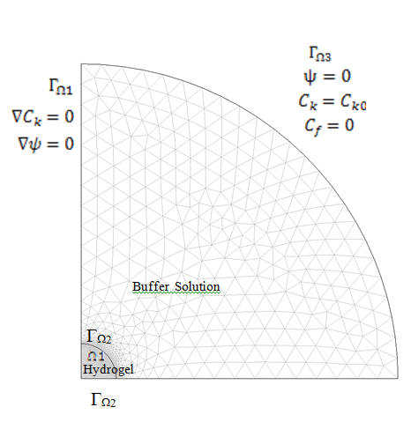

Figure 2: Meshed model of the circular hydrogel

Figure two shows the circular hydrogel and the surrounding buffer solution (NaCl solution). The mobile ions taken into consideration are the Na+, Cl- and H+ ions, which sum up the dependent variables to 10. These simulations consist of three dependent variables from Nernst Planck Equation (CNa, CCl, CH), the electric potential (ψ) from the Poisson’s Equation, the displacements (u and v) from the Mechanical Equilibrium Equation, and the x and y coordinates (X & Y) and two weak constraint variables from the moving mesh module. The whole domain consists of 1810 mesh elements and 22724 degrees of freedom.

The meshed model of the gel and surrounding buffer solution is depicted in figure. 2. The mobile ions, Na+, Cl- and H+ are considered in the simulation consisting of 10 dependent variables. In this simulation, three dependent variables from Nernst-Planck equation (CNa, CCl, CH), the electric potential (ψ) from the Poisson’s equation, the displacements (u, v) from the mechanical field equation, and the x and y coordinates (X & Y) and two weak constraint variables from the moving mesh module. The whole domain consisted of 1810 mesh elements with 22742 degrees of freedom.

In this simulation, electroneutrality condition was satisfied by Poisson’s equation with the hydrogel taken as an isotropic material. The pH was varied from 2-12 with a step change of 0.03 with the error convergence criterion fixed at 1 x 10-4.

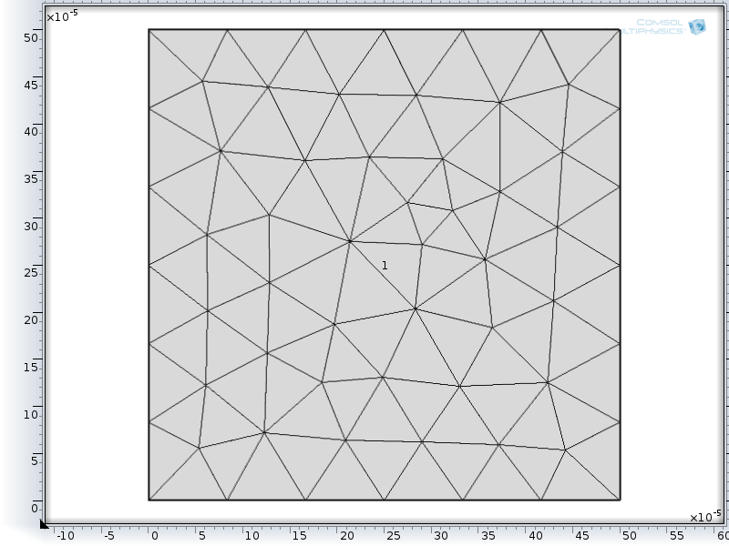

Figure 3: Meshed model of the square hydrogel

Figure two shows the square hydrogel. The mobile ions that were taken into consideration during the simulation were the Na+, Cl- and H+ ions which were

The algorithm used for pH simulation is shown in the figure 1. The fixed charge densities together with the Poisson’s dependent variable (ψ) were used to couple the NP and Poisson’s equations. The fixed charge density is updated after each iteration due to the change in mobile ions inside the hydrogel. The mechanical field equation uses the osmotic pressure to calculate the deformation of the hydrogel which is found from the moving mesh in the x and y direction. As the pH changes the hydrogel expansion changes, hence the hydration is also updated in every iteration

## 3.3 pH Sensitive Hydrogel

When a hydrogel in dried condition is placed in ionic solution, ions diffused from the buffer solution or the boundary into the hydrogel. Upon small increments in the pH of the buffer solution, mobile ions diffuse into the hydrogel and bind to the fixed charges inside the hydrogel polymer backbone. This diffusion is driven by the concentration gradient between the buffer solution and the hydrogel which creates an osmotic pressure between the buffer solution and the hydrogel. In response to this internal pressure, the hydrogel structure counteracts with an elastic force and tries to equilibrate. As the gel expands the fixed charges redistribute themselves inside the hydrogel, which results to new fixed charge sites in the diffusion which promotes more diffusion. The swelling will continue until the osmotic pressure and the elastic force are equal. This increases the Na+ ions concentration within the hydrogel. The interface between the hydrogel and the buffer solution has a steep concentration gradient. Due to this, a Heaviside function. Which is a smoothing function was used to help in the convergence of the simulation to a solution.

In order to ensure the validity of our simulations, as reported earlier we have also compared our simulation results with existing experimental values and found an excellent agreement between the two. It should be noted that the simulation was done at 500 µm diameter HEMA hydrogel to match with the experimental gel dimensions, with the buffer concentration fixed at 300 mM [3,4].

3.4 Kinetic Modeling of the Simulation

In the transient simulation, the Nernst Planck equation is solved to understand the kinetics of gel swelling using equation 2, which is repeated below.



The flow chart used to solve the transient simulation analysis is shown in figure 6. It is similar to the steady state algorithm, except for the fact that the iterative process is implemented within a time loop with the incremental time steps which provide the output in the transient conditions. The simulation was done by first of all solving the steady state simulation till pH 3, after which the transient simulation physics is added as well as the time parameters needed for the transient simulation. The pH is also changed to 6. The initial conditions such as the fixed charges were taken at pH 3. Unfortunately, the transient simulation was not thoroughly completed because of the time consumed by the steady state simulations. It also requires a substantial amount of time. However, there were some results which will be presented in the results sections later.

Simulation of Arbitrary Hydrogel Geometry

The Arbitrary hydrogel geometry was modeled by using a square hydrogel that had similar dimensions with the circular hydrogel in order to allow for comparison of the results. Figure 4 shows the meshed square hydrogel geometry.



Figure 3: Meshed model of the square hydrogel

The simulation of the arbitrary geometry in steady state uses the same equations that were couples for the normal geometry, repeated here: Nernst Planck Equation, Poisson’s Equation, Mechanical Equilibrium and finally the moving mesh. However there were many modifications that were made in the arbitrary geometry compared to the normal geometry. This is going to be discussed in greater detail next.

Modifications

There were many modifications made in the arbitrary geometry. Here are some of the major changes:

1. The buffer solution was stripped off and instead the ions were places at the boundary of the hydrogel. Thus the hydrogel swells when ions diffuse inside from the boundary as opposed to a buffer solution. Also in the Nernst Planck physics, the ground was removed since there was no buffer solution being used.
2. The electric insulation which was used in the normal geometry all around the hydrogel and buffer solution was only used in the horizontal and left boundary of the hydrogel. This is because it inhibits current to flow in between the boundaries where it is used and so it could not be used in the hydrogel boundaries that were supposed to swell as it would prevent the ions from diffusing inside the hydrogel from the boundary condition into the hydrogel. Instead an electric potential was introduced to enable the transfer of mobile ions across the boundary conditions of the hydrogel.
3. Instead of using a part of the hydrogel as was done in the normal geometry by assuming it to be axisymmetric, there was no symmetry assumed for the arbitrary geometry hydrogel. This is because the whole hydrogel was being simulated, not a fraction of it.
4. The plane strain used in the normal hydrogel was replaced by plane stress in the solid mechanics physics to calculate displacement. This is explained below using figure 4.

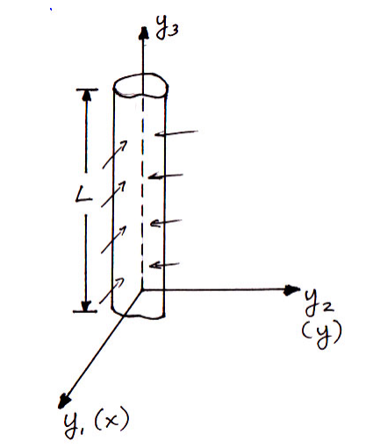

Figure 4: Figure used to show plane stress and plane strain physics used in the hydrogel

This is because the hydrogel is assumed to have y3 ≪ in-planedimensions (y1,y2) as opposed to the normal geometry where it is assumed to have length y3 >> in-plane dimensions (y1, y2). Therefore in the normal geometry the hydrogel swells in the y1 and y2 directions with negligible change in the y3 displacement, while in the arbitrary geometry it swells in the y3 and y2 directions with negligible displacement in the y1 direction.

1. The Heaviside smoothing function was also stripped out because it creates inaccuracies in the simulation. Hence, all the simulations that were going to be done henceforth were done without the Heaviside function.

Comments

It is worth noting that every time the fixed charges were changed in the arbitrary geometry problem, there was an error the first time the simulation was run. It however run seamlessly when it was reran. The error might be because the setup of the simulation is difficult for the COMSOL 4.3 solver and hence the re-run every time a parameter was changed. This will be investigated further by notifying the COMSOL support to try and figure out why it is behaving that way.

Simulation Results

Results for the Normal and Arbitrary Geometries

From the simulation, certain parameters were studied for comparison to the results from the normal geometry results. These were the effect of fixed charge concentration, buffer solution and Young’s Modulus on the hydrogel with change in pH of the mobile ions in the hydrogel boundary.

Fig. 5: Figure shows the effect of buffer solution on hydrogel swelling with variation of pH from 2-12.

From figure 5 the shape of the graph is due to the fact that the mobile ions diffuse into the hydrogel until pH of about 7 when the hydrogel is saturated and hence there are no more free fixed charges in the hydrogel. This trend is followed for both the normal geometry and the arbitrary geometry.From the graph it is also evident that as the buffer solution increases in the hydrogel boundary, less mobile ions diffuse into the hydrogel. This can be attributed to the fact that the hydrogel swelling is due to osmotic pressure difference between the hydrogel and the mobile ions. As the buffer solution is increased, there is less difference between the ions in the hydrogel and the ions outside the hydrogel is because as the buffer solution increases, the osmotic pressure between the hydrogel and the mobile ions outside the hydrogel boundary increases and hence the decrease in hydrogel swelling with increase in buffer solution concentration. This is also shown by equation 12. It is also ecident that the arbitrary geometry swells approximately twice as much as the normal geometry swelling. This can be attributed to the fact that the arbitrary geometry, being of a square shape, the hydrogel has more volume and hence a larger area for the mobile ions to diffuse. This is true for all hydrogel concentrations.

Figure 6 shows the variation of hydrogel swelling with fixed charge density as the pH changes.

For a given fixed charge density, the maximum gel expansion is constant. As the pH increases, the diffusion of mobile ions into the hydrogel from the buffer solution is promoted resulting in the swelling of the hydrogel until around pH of 7.5 where all the fixed charge sites have been associated with mobile ions from the buffer solution. After pH 7.5, there is no significant change in the hydrogel expansion because the hydrogel is saturated and there are no more fixed charge sites for both the normal and arbitrary geometry. However with increase in the fixed charge density, the expansion is also increased. This can be attributed to the fact that as the number of fixed charges is increased, there are more fixed charges which translates to more mobile ions being attracted to the polymer network and hence the increased swelling. The difference in swelling between the normal geometry and the buffer solution with the same fixed charge concentration is that the arbitrary geometry has a larger volume than the normal geometry hydrogel and hence there might be a larger space between the fixed charges which enables more ions to remain in the hydrogel. This might also be due to the fact that the arbitrary hydrogel being larger than the normal hydrogel, requires more ions to diffuse into the hydrogel for the hydrogel to be in a saturated state where the osmotic pressure and the elastic force are balanced.

Figure 6: Figure showing the effect of Young’s modulus on the hydrogel displacement with change in pH for arbitrary geometry.

Figure 7: Figure showing the effect of Young’s modulus on the hydrogel displacement with change in pH for normal geometry.

From figures 6 and 7, it is evident that both the hydrogels swell till pH of about 7. After pH 7, there is no substantial change in the displacement of the hydrogel size. This can be attributed to the fact that as the Young’s modulus changes the stiffness of the hydrogel structure is changed. When a hydrogel is placed in a buffer solution, it expands due to the diffusion of mobile ions from the buffer solution. As it swells, there is a restoring force inside the hydrogel that counters the osmotic pressure. This is enables by the cross linker inside the hydrogel. As the young’s modulus is increased there is more resistance to the swelling and as a result, the hydrogel will not swell as much as it would have with a lower young’s modulus. Both the normal and arbitrary hydrogel follow the same trend. The difference between the Young’s modulus may be due to more ions being present in the arbitrary geometry which necessitates a larger swelling than for the normal geometry for the hydrogel to be in equilibrium.

Transient Simulation

The transient simulation was also done to learn how the hydrogel changes overtime to change in pH in the buffer solution in the normal geometry. In this simulation the same equations which were used in the Nernst Planck Equation were used. The difference is that Equation 2 was used for the Nernst Planck physics as opposed to Equation3 for the steady state. This simulation was not completed to the expectations that it was supposed to. Here is the flowchart that was used in the simulation of the transient simulation.

No

Input: (1) chemical and physical parameters ; (2). Boundary conditions

Calculate fixed charge density, cf

Solve for the Poisson-Nernst Planck equations

Update Ck and ψ

Convergence?

Solve for Hydration from the Mechanical Equilibrium Equation

Update u

Convergence?

Next Time step

No

Yes

Yes

Figure 6: Flowchart showing the algorithm used to solve the hydrogel response to pH variation in transient condition.

The simulation was done by first running the steady state simulation till pH 3, in order to get initial conditions that would be used in the transient conditions. Also the heaviside function, flcfun, used in the steady state simulation was stripped off due to the reasons I stated earlier. After the solution was found for pH 3 in the steady state, transient physics was introduced and the pH changed to pH 7.5 since most hydrogels swell till pH 7.5 after which they are constant with any change in pH in the buffer solution. The simulation will be complete at a later date.