Numerical simulation of pH-sensitive Hydrogel response in different conditions

Brian O. Asimba, Andrew K. Shigoli, Kamlesh J. Suthar*, Muralidhar K. Ghantasala and Derrick. C. Mancini*
Department of Mechanical and Aeronautical Engineering
Western Michigan University, 1903, West Michigan Ave., Kalamazoo, MI-49008
* Advanced Photon Source, Argonne National Laboratory, 9700, S. Cass Ave, Argonne, IL – 60439

Abstract:
The understanding of pH-sensitive hydrogel swelling response in different buffer environmental condition is essential for its use in different practical applications. This necessitates its simulation in steady state and transient conditions. This paper mainly deals with the details of the numerical simulation performed by developing coupled formulation of chemo-electro-mechanical behavior of the hydrogel in response to changing pH of the surrounding solution. Simulations were performed to determine the response of hydrogel with varying pH of the surrounding solution in a wide range of pH (2-12). The investigation of the responsiveness of the hydrogels is focused mainly on the study of effect of variation of pKa and Young’s Modulus of the gel. The methodology used for this finite element based simulation is presented. The swelling characteristics of the hydrogel obtained under steady state conditions in these investigations are compared with previous simulations using other models/methods. This analysis is carried out using COMSOL and the effects of fixed charge density, buffer solution pH and Young’s modulus on the swelling were studied in different simulations. These simulation results are compared with available experimental evidence to show the accuracy of the model.

Keywords: Hydrogel, multiphysics models, COMSOL, swelling, fixed charge density.

- Introduction

Hydrogels are polymers that respond to environmental factors such as temperature, pH, electric potential and light by either swelling or deswelling. Their ability to absorb water is attributed to presence of hydrophilic functional groups which are attached to the polymeric network, while the crosslinking prevent complete mixing of the hydrogel from dissolving in the solvent by producing an elastic restoring force that counters the expansion of the network.

The study of swelling and deswelling mechanisms of the hydrogels has been carried-out by few research groups world over, by developing different mathematical models and using finite element based software [1-6]. However, the software in most cases was custom developed for this application, which is not available to all researchers. This has prompted us to start working on developing the appropriate models for using widely available COMSOL software [6-7].

In this paper, we modeled hydrogel swelling and deswelling in response to surrounding pH changes using chemo-electro-mechanical coupling of three partial non-linear differential equations representing ionic diffusion into the gel, potential changes due to the redistribution of charges within and outside the gel and continuity equation respectively. These simulations were done using COMSOL Multiphysics and employing moving mesh in a 2-dimensional field. The main focus of these simulations is to understand the effect of variation of young’s modulus of the gel along with the pka of the buffer.

- Governing Equations

Simulation of Hydrogel swelling/ deswelling characteristics require considering the mathematical representation of different interaction mechanisms (between the gel and a solution) and the resultant changes. Three important changes normally considered in these simulations are chemical, electrical and mechanical in nature. The Nernst Planck, Poisson and mechanical deformation equations are commonly used to determine these changes.

Nernst Planck Equation

The Nernst-Planck equation defines the relation between the concentrations of the various mobile species in the buffer solution. Applying continuity equation, the change in concentration flux with respect to space is equated with the rate of change of concentration which is given by:

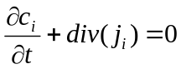

If we modify this equation to include flux due to diffusion of ions which is mainly due to two factors: diffusion due to concentration gradient and migration flux because of electric potential and hence it can be modified as:

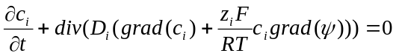(1)

In this equation, the first term represents the diffusive flux due to the concentration gradient and the second term which is coupled with the Poisson’s equation is the migration flux which is due to the electric potential gradient.

Where: D_{i}, c_{i}, z_{i}, F, R, T and ψ are the diffusion co-efficient of the i^{th} ion, the concentration of the i^{th} ion, valence of the i^{th} ion, the faraday constant, the universal gas constant, temperature and the electric potential respectively.

Since we are considering steady state, the Nernst-Planck equation is written as:

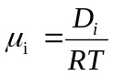

Where, μ_{i} is the mobility of the i^{th} ion.

Poisson’s Equation

The Poisson’s equation is used to understand the spatial distribution of the electric potential (ψ) and satisfies the electroneutrality condition. It is given by the equation:
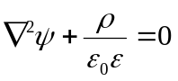
(2)

Where ρ is the charge density in the hydrogel, is the dielectric constant of the vacuum and is the relative dielectric constant of the solvent.

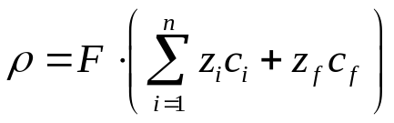

(3)

Where Z_{f} and C_{f} are the valence and fixed charge concentration in the hydrogel.
The fixed charge concentration within the hydrogel is calculated using the relation,

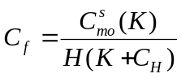

Where, K, C_{H} and H are the ionizable charge concentration, dissociation constant, hydrogen ion concentration and hydration, respectively. The hydration state of the hydrogel is the ratio of the volume of the fluid to the volume of the solid in the gel [8].

In this equation c_{f} is represented as a function of the surrounding pH, where both H and C_{H} are used in defining changing ionic conditions within the hydrogel, which is due to the mobile ions diffusing into the hydrogel. Due to the change in the fixed charge concentration with changes in pH, the c_{f} and initial conditions are updated in every iteration.

Mechanical Field Equation

The gel expansion is represented by a second-order partial-differential equation of motion in time. The inertial term is neglected for steady state models. The mechanical field equation is thus represented as:

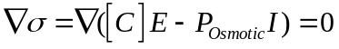
(4)

Where: [C], E, and I are the material elasticity matrix, Green strain tensor, and identity matrix respectively. At the interface of the hydrogel mixture and the solution bath, the osmotic pressure is given as a force term, which is represented by:
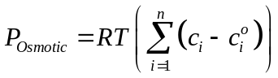
(5)

Where n is number of ions, c_{i} is the concentration of i^{th} ion in the hydrogel, and 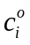is at the i^{th} ion concentration outside the hydrogel at the initial condition.

In this simulation, moving mesh was used due to the large hydrogel deformations which are due to the hydrogel expansion, which is up to 300% its initial size. It is also used because the plain strain was used to calculate mechanical deformations in the hydrogel are based only on small strains.

- Simulation

In this simulation, a hydrogel radius of 300µm was used with the buffer solution immersing the gel sample completely. Assuming a symmetric system, only a quarter of the sample was used instead of a complete circular hydrogel. Its chemo-electro-mechanical behavior was simulated in response to the pH of the buffer solution surrounding it using COMSOL (ver. 3.5a) with following modules:

- Nernst-Planck without electro-neutrality (Chemical Engineering Module)
- Conductive Media DC(AC/DC Module) for Poisson’s Equation
- Plane Strain (Structural Mechanics Module) for Mechanical Field Equation
- Moving Mesh (ALE)

In this simulation two frames were used, namely: the fixed frame and the moving mesh frame. The chemical diffusion and electrostatic physics are considered in the moving mesh to evaluate swelling at different conditions, while the mechanical equilibrium physics is considered in the fixed frame with large deformation to calculate the large expansion with a change in pH.

Boundary conditions

The following are the boundary conditions used in the simulation.

Subdomain 1:

Material: Hydrogel

Physics Equation
Chemical Diffusion Nernst-Planck
Electrostatics Poisson’s equation
Swelling Mechanical field
With Moving mesh

Subdomain 2:

Material: Buffer

Physics Equation
Chemical Diffusion Nernst Planck
Moving boundaries Mechanical field
Equation, moving mesh frame
Boundary _{1} Type: Insulation/symmetric
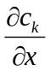 = 0 : NP equation

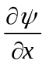= 0 : Poisson’s equation
The moving mesh frame equilibrium equations are:
u = 0, v = free; on vertical symmetric side
u = free, v = 0; on horizontal symmetric side
Boundary Γ_{Ω2}
Type: Interface between the hydrogel and buffer
C_{k} = continuous : NP equation
ψ = 0 : Poisson’s equation
N (ε+ε_{ij}) = P_osmotic: Poisson’s equation

X = x + u, Y = y + v : Moving mesh frame

Boundary Γ_{Ω3}

Type: Buffer far-field

c_{k} = c_{ki} : NP equation

u = 0, v = 0 : Poisson’s equation

The algorithm used for pH simulation is shown in the figure 1.The fixed charge density together with the Poisson’s dependent variable (ψ) were used to couple the NP and Poisson’s equations. The fixed charge density is updated after each iteration. The mechanical field equation uses the osmotic pressure in the calculation of the displacement, which is found from the moving mesh in the x and y direction. Due to the continuous expansion in response to pH changes, hydration is also updated after every iteration in moving mesh.

No
Input: (1) chemical and physical parameters ; (2). Boundary conditions
Calculate fixed charge density, c_{f}
Solve for the Poisson-Nernst Planck equations
Update C_{k} and ψ
Convergence?
Solve for Hydration from the Mechanical Equilibrium Equation
Update u
Convergence?
Output
No
Yes
Yes

Figure 1: Flow chart of the algorithm used to solve the hydrogel response to pH variation in steady state.

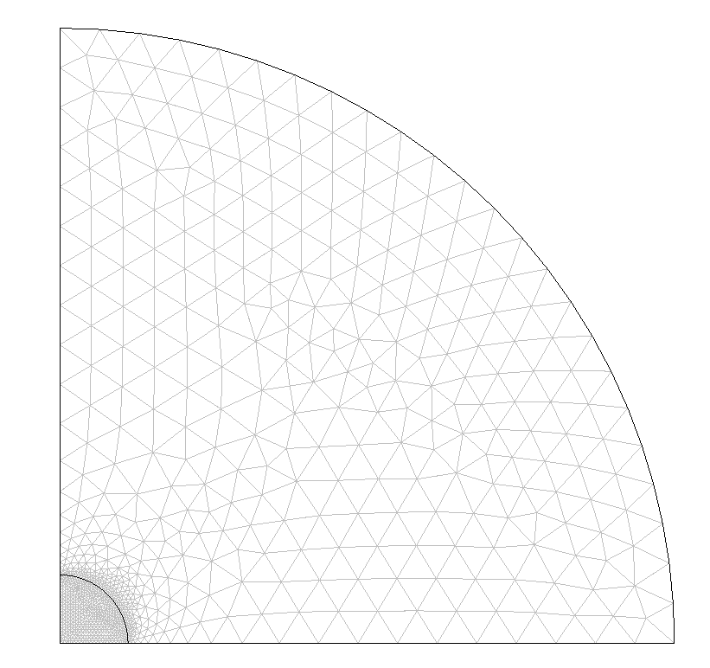
Γ_{Ω2}

Buffer Solution

Hydrogel
Γ_{Ω2}

Figure.2. Meshed model of the gel sample

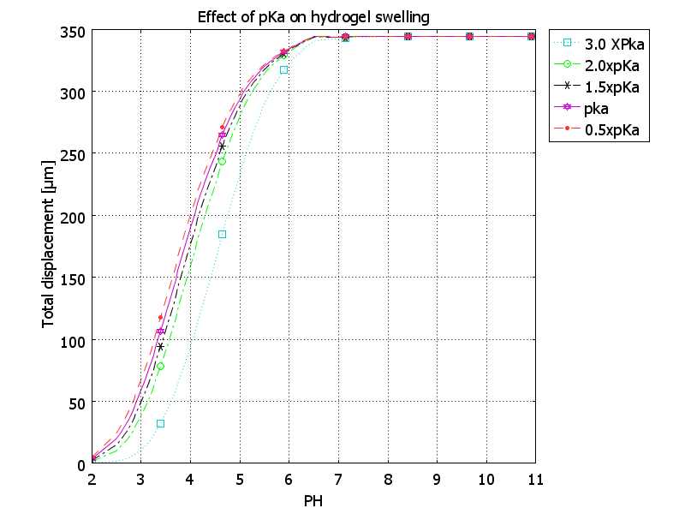
The meshed model of the gel and surrounding buffer solution is depicted in figure. 2. The mobile ions, Na⁺, Cl⁻ and H⁺ are considered in the simulation consisting of 10 dependent variables. In this simulation, three dependent variables from Nernst-Planck equation (C_{Na}, C_{Cl}, C_{H}), the electric potential (ψ) from the Poisson’s equation, the displacements (u, v) from the mechanical field equation, and the x and y coordinates (X & Y) and two weak constraint variables from the moving mesh module. The whole domain consisted of 1810 mesh elements with 22742 degrees of freedom.

In the simulation, electroneutrality condition was satisfied by Poisson’s equation with the hydrogel taken as an isotropic material. The pH was then varied from 2-12 with a step size of 0.025 with the error convergence criterion was fixed at 1x10⁻⁴. The modulus of elasticity is 0.29 Mpa for pH<5.5 and 0.23 for pH>7.5, with a linear variation profile assumed between these two pH values, except for the case where effect of the modulus of elasticity is investigated. A Poisson’s ratio of 0.43 was assumed for the entire range of pH. Static equilibrium is used as the final convergence criterion using the stationary Direct-PARADISO linear system solver. Parametric effects were studied using plain strain configuration.

4. Results and Discussion

These studies mainly focused on the variation of concentration and pKa of the buffer solution, fixed charge density and young’s modulus of the gel on ‘gel expansion’.

Figure 3: The effect of pKa on hydrogel swelling with varying pH

Figure 3 shows the effect of variation of the disassociation constant (pKa) on swelling of the gel. From figure 3, it can be seen that as the dissociation constant increases, the gel swells rapidly at a given pH within the range 3.5 to 7.5. However, beyond this pH range (>7.5), the gel becomes saturated resulting in no further swelling. It is well known that the phase transition of the gels occurs close to its pKa, which is identical to the pKa of ionizable group [9]. The swelling process ceases, when the gel reaches an equilibrium state within a given buffer environment.
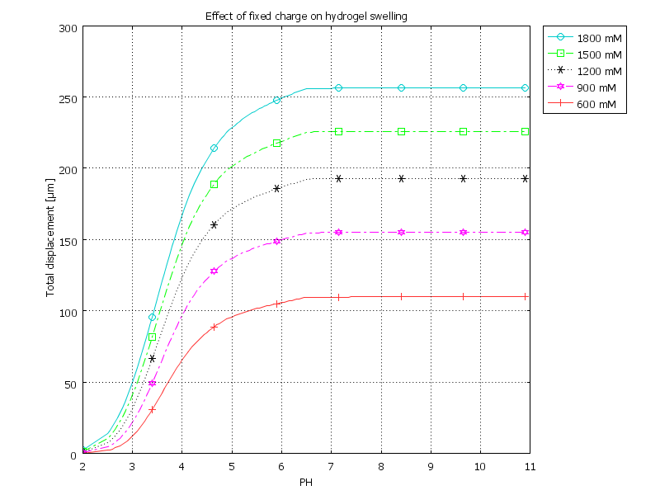

Figure 4: Effect of fixed charge density on hydrogel swelling with change in pH

Figure.4 shows the effect of fixed charge density on the hydrogel swelling at various pH values. For a given gel volume, the fixed charge density is constant. As the pH increases, diffusion of mobile ions from the buffer solution to the hydrogel is promoted resulting in hydrogel expansion until the pH reaches around 8, where all the fixed charge sites might have reached an equilibrium state with buffer solution ions. Hence, there is no further change in gel swelling beyond this value of pH at any fixed charge density. However, as the fixed charge density is increased, the hydrogel swelling also enhanced. This can be explained by the fact that as it increases the availability of fixed charge sites increase proportionally. This possibly attracts more mobile ions to associate with fixed charge sites in the gel polymer network and hence the increase in hydrogel swelling.

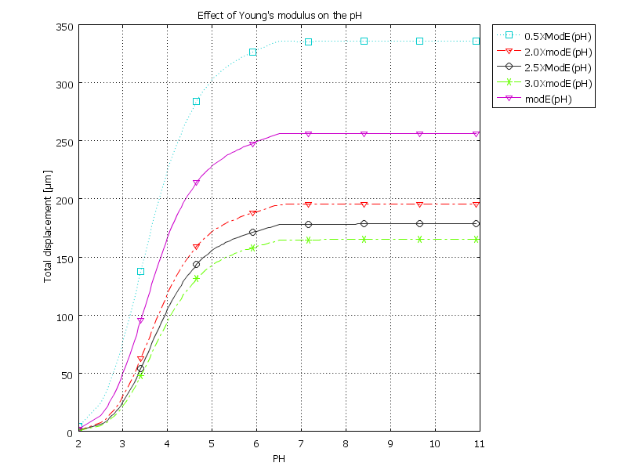

Figure 5: Gel expansion with varying Young’s modulus as a function of pH

Hydrogels with high Young’s modulus have exhibited relatively lower expansion. This can be attributed to the fact that hydrogels with high Young’s modulus has low strain and hence decreased swelling. Young’s modulus is used in the calculation of the elastic force that is due to the osmotic pressure change between the hydrogel and the solution, thus the degree of swelling of the hydrogel is highly dependent on the Young’s modulus as evident from figure.5. It may also be observed from figure. 5, the degree of swelling is lower at higher pH values. A similar variation was also observed by Hua Li et al [4] earlier. This clearly shows the validity of our model as well as simulation.

In order to ensure the validity of our simulations, as reported earlier we have also compared our simulation results with existing experimental values and found an excellent agreement between the two. It should be noted that the simulation was done at 300 µm diameter HEMA hydrogel to match with the experimental gel dimensions, with the buffer concentration fixed at 300 mM [8, 10].

- Conclusions
In this paper, we demonstrated the use of COMSOL for the simulation of hydrogel swelling behavior with respect to the variations in the pH of surrounding buffer solution, disassocia-tion constant (pKa) and young’s modulus(E) of the gel. Our results were compared with some of the previous simulations performed using other models in the literature. Further, to ensure the validation of our model as well as methodology, simulation results were compared with existing experimental results. These simulations showed that the variation of dis-association constant as well as Young’s Modulus has significant effect on the gel swelling behavior.

6. References
1.Grimshaw, P.E., Electrical control of solute transport across polyelectrolyte membranes. 1989.
2. Grimshaw, P.E., et al., Kinetics of electrically and chemically induced swelling in polyelectrolyte gels. The Journal of Chemical Physics, 93(6), 1990, p. 4462-4472.

3. De, S.K., et al., Equilibrium swelling and kinetics of pH-responsive hydrogels: Models, experiments, and simulations. Journal of Microelectromechanical Systems, 11(5), 2002, p. 544-555.

4.Li, H., et al., Modeling and Simulation of the Swelling Behavior of pH-Stimulus-Responsive Hydrogels. Bio-macromolecules, 6(1), 2005, p. 109-120.

5.Wallmersperger, T., B. Kroplin, and R.W. Gulch, Coupled chemo-electro-mechanical formulation for ionic polymer gels--numerical and experimental investigations. Mechanics of Materials, 36(5-6), 2004, p. 411-420.

6. Suthar, K.J., M. K. Ghantasala, and D. C. Mancini. Steady State Simulation of the chemo-electro-mechanical Behavior of Hydrogels, 30(3), 2010, 396-404

7. Suthar, K.J., M.K. Ghantasala, and D.C. Mancini. Simulation of hydrogel micro-actuation. In Microelectronics: Design, Technology, and Packaging III, 2007, 67980P-9-67980P-9 ; Kamlesh J. Suthar, Derrick C. Mancini, Muralidhar K. Ghantasala, Simulation of the effect of different parameters on the swelling characteristics of a pH-sensitive hydrogel Published in SPIE Proceedings Volume 7644: Behavior and Mechanics of Multifunctional Materials and Composites, March- 2010.
8. De, S.K. and N.R. Aluru, A chemo-electro-mechanical mathematical model for simulation of pH sensitive hydrogels. Mechanics of Materials, 36(5-6), 2004, p. 395-410.

9. Andreas Richter et al., Review of Hydrogel based pH Sensors and Micro-sensors, Sensors, 8, 2008, 561-581
10. Luo, R., H. Li, and K. Y. Lam, Modeling and simulation of the chemo-electro-mechanical behavior of pH-electric-sensitive hydrogel, Analytical and Bioanalytical Chemistry, 389 (3), 2007, 863-873.

