Assignment 1: Compiling Linux Kernel and Adding Custom System Calls

311552067 劉承熙

1. **results of executing *uname* -a and *cat /etc/os-release* commands**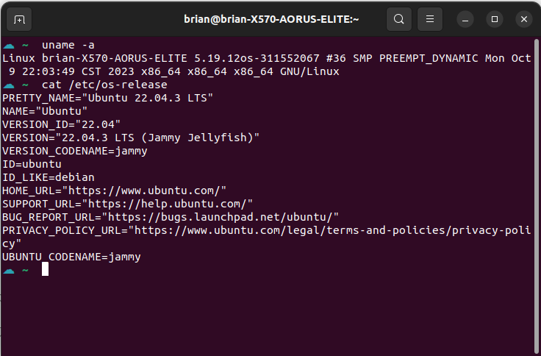
2. **Which kernel sources did you modifiy? What do they do?**
3. Add syscall function code and Makefile for each new syscalls
   * Makefile is to ensure that the c file is compiled and included in the kernel source code
4. Add new syscall folder in Makefile of Linux Kernel
   * This is to tell the compiler that the source files of new syscalls are in present in the new syscall directory
5. Add new syscall to syscall table_64
   * Define syscall number for syscall function and name
6. Add new syscall to syscall header file
   * Defines the prototype of the function of system call
7. Compile kernel code, install and update kernel
8. **Each system call implemented (Source code)**

Add syscall function code and Makefile for each new syscalls

// linux-5.19.12/hello/hello.c

#include <linux/kernel.h>

#include <linux/syscalls.h>

SYSCALL_DEFINE0(hello){

printk("Hello world!\n");

printk("311552067\n");

return 0;

}

// linux-5.19.12/hello/Makefile

obj-y := hello.o

// linux-5.19.12/linux-5.19.12/revstr/revstr.c

#include <linux/kernel.h>

#include <linux/syscalls.h>

#include <linux/string.h>

#include <linux/uaccess.h>

SYSCALL_DEFINE2(revstr, int, len, char __user *, src){

char str_in[100];

char reverse[100];

if( copy_from_user(str_in, src, len)){

return -EFAULT;

}

for(int i=0; i<len; i++){

reverse[i] = str_in[(len-1) - i];

}

str_in[len] = '\0';

reverse[len] = '\0';

printk("The origin string: %s\n", str_in);

printk("The reversed string: %s\n", reverse);

return 0;

}

// linux-5.19.12/revstr/Makefile

obj-y := revstr.o

Add new syscall folder in Makefile of Linux Kernel

// linux-5.19.12/Makefile

core-y += kernel/ certs/ mm/ fs/ ipc/ security/ crypto/

//add new syscalls folder(hello/ revstr/)

core-y += kernel/ certs/ mm/ fs/ ipc/ security/ crypto/ hello/ revstr/

Add new syscall to syscall table_64

// linux-5.19.12/arch/x86/entry/syscalls/syscall_64.tbl

548 64 hello sys_hello

549 64 revstr sys_revstr

Add new syscall to syscall header file

// linux-5.19.12/include/linux/syscalls.h

asmlinkage long sys_hello(void);

asmlinkage long sys_revstr(int len, char __user *src);

compile

sudo make

sudo make modules_install

sudo make install

1. **Result**

