Assignment 2: Scheduling Policy Demonstration Program

311552067 劉承熙

1. Describe how you implemented the program in detail

* Using library to parse the argument

/* 1. Parse program arguments */

int opt;

static struct option long_options[] = {

{"num_threads", 1, 0, 'n'},

{"time_wait", 1, 0, 't'},

{"policies", 1, 0, 's'},

{"priorities", 1, 0, 'p'},

{"help", 0, 0, '?'},

{0 ,0, 0, 0}

};

int num_threads = 0;

string policies = "";

string priorities = "";

while ((opt = getopt_long(argc, argv, "n:t:s:p:h", long_options,NULL)) != EOF) {

switch (opt) {

case 'n':

num_threads = atoi(optarg);

break;

case 't':

time_wait = atof(optarg);

break;

case 's':

policies = optarg;

break;

case 'p':

priorities = optarg;

break;

case 'h':

usage(argv[0]);

default:

usage(argv[0]);

return 1;

}

}

void usage(const char* progname) {

cout << "Usage: "<< progname <<" [options]\n";

cout << "Program Options:\n";

cout << " -n <num_threads>: number of threads to run simultaneously\n";

cout << " -t <time_wait>: duration of \"busy\" period\n";

cout << " -s <policies>: scheduling policy for each thread, SCHED_FIFO or SCHED_NORMAL\n";

cout << " -p <priorities>: real-time thread priority for real-time threads\n";

}

* Define thread and thread attribute, then set affinity, schedule_policy and schedule_priority for any thread.  
  pthread_attr_init — for initial thread attribute  
  pthread_attr_setaffinity_np — set cpuset (all thread using same core) to thread attribute  
  pthread_attr_setschedpolicy — set schedule_policy (SCHED_FIFO or SCHED_OTHER) to thread attribute   
  pthread_attr_setschedparam — set sched_priority to thread attribute pthread_attr_setinheritsched — set PTHREAD_EXPLICIT_SCHED to thread attribute, ensure thread will create by our setting

pthread_t threads[num_threads];

int thread_id[num_threads];

pthread_attr_t thread_attr[num_threads];

/* 3. Set CPU affinity */

cpu_set_t cpuset;

CPU_ZERO(&cpuset);

CPU_SET(3, &cpuset); // Set affinity to CPU 0

for (int i = 0; i < num_threads; i++) {

/* 4. Set the attributes to each thread */

pthread_attr_init(&thread_attr[i]);

thread_id[i] = i;

size_t pos = policies.find(",");

string policy_str = policies.substr(0, pos);

int sched_policy = (policy_str == "FIFO") ? SCHED_FIFO : SCHED_OTHER;

policies.erase(0, pos + 1);

pos = priorities.find(",");

string priority_str = priorities.substr(0, pos);

int sched_priority = stoi(priority_str);

priorities.erase(0, pos + 1);

if (pthread_attr_setaffinity_np(&thread_attr[i], sizeof(cpu_set_t), &cpuset) != 0) {

perror("Error setting CPU affinity");

pthread_exit(NULL);

}

if (pthread_attr_setschedpolicy(&thread_attr[i], sched_policy) != 0) {

perror("Error setting scheduling policy");

pthread_exit(NULL);

}

if(sched_priority != -1){

struct sched_param param;

param.sched_priority = sched_priority;

if (pthread_attr_setschedparam(&thread_attr[i], &param) != 0) {

perror("Error setting scheduling parameters");

pthread_exit(NULL);

}

}

pthread_attr_setinheritsched(&thread_attr[i],PTHREAD_EXPLICIT_SCHED);

}

* pthread_barrier_init — set barrier for waitting threas, then start all threads at once  
  Create thread with the previously configured thread attributes

/* 2. Create <num_threads> worker threads */

/* 5. Start all threads at once */

pthread_barrier_init(&barrier, NULL, num_threads);

for (int i = 0; i < num_threads; i++) {

if (pthread_create(&threads[i], &thread_attr[i], thread_func, &thread_id[i]) != 0) {

perror("Error creating thread");

exit(EXIT_FAILURE);

}

}

* pthread_barrier_wait — set barrier for making start all threads at once

void *thread_func(void *arg)

{

/* 1. Wait until all threads are ready */

pthread_barrier_wait(&barrier);

/* 2. Do the task */

for (int i = 0; i < 3; i++) {

printf("Thread %d is running\n", *(int*)(arg));

/* Busy for <time_wait> seconds */

busy_wait(time_wait);

}

/* 3. Exit the function */

pthread_exit(NULL);

}

* Waitting all thread finishing execution  
  pthread_attr_destroy — for delete all thread attribute pthread_barrier_destroy — for delete barrier

/* 6. Wait for all threads to finish */

for (int i = 0; i < num_threads; i++) {

if (pthread_join(threads[i], NULL) != 0) {

perror("Error joining thread");

exit(EXIT_FAILURE);

}

}

for (int i = 0; i < num_threads; i++) {

pthread_attr_destroy(&thread_attr[i]);

}

pthread_barrier_destroy(&barrier);

1. Describe the results of ./sched_demo -n 3 -t 1.0 -s NORMAL,FIFO,FIFO -p -1,10,30 and what causes that

Threat 2 and Thread 1 are scheduled using the SCHED_FIFO (Real-Time scheduling policies). Therefore, they are both prioritized and processed based on their assigned priorities. Since Thread 2 has a higher priority number, it takes precedence in utilizing the core, and only after Thread 2 completes its execution, Thread 1 is scheduled

Thread 0 is scheduled using SCHED_NORMAL (Fair scheduling policies). Since there are no other SCHED_NORMAL threads, it completes its execution directly

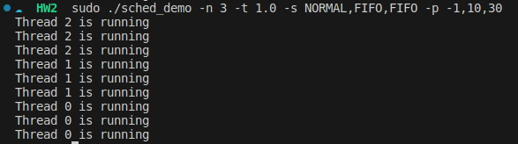

1. Describe the results of ./sched_demo -n 4 -t 0.5 -s NORMAL,FIFO,NORMAL,FIFO -p -1,10,-1,30, and what causes that

Threat 3 and Thread 1 are scheduled using the SCHED_FIFO (Real-Time scheduling policies). Therefore, they are both prioritized and processed based on their assigned priorities. Since Thread 3 has a higher priority number, it takes precedence in utilizing the core, and only after Thread 3 completes its execution, Thread 1 is scheduled

Thread 0 and Thread 2 use the SCHED_NORMAL (Fair scheduling policies), so they will use the CPU after SCHED_FIFO threads. They will take turns utilizing the CPU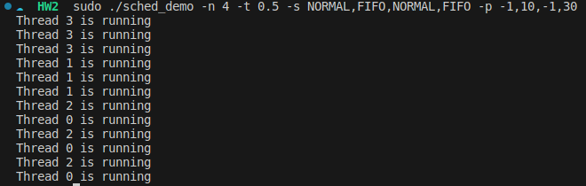

1. Describe how did you implement n-second-busy-waiting

Using the <ctime> library's clock() function, calculate whether the required seconds have elapsed within a while loop.

void busy_wait(double seconds) {

double start_time = (double)clock() / CLOCKS_PER_SEC;

double current_time;

do {

current_time = (double)clock() / CLOCKS_PER_SEC;

} while ((current_time - start_time) < seconds);

}