**Physiological consequences of changes in photoperiod intensity on cisco (*Coregonus artedi*) egg development and larval growth**

**Introduction:** Cisco (*Coregonus artedi*) and other related deepwater Coregonus species (*C. hoyi, C. kiyi, C. zenithicus, C. nigripinnis*) were once the most abundant and commercially valuable fish in the Laurentian Great Lakes (Schmidt et al. 2009, Stockwell et al. 2009). Through a combination of overfishing and habitat changes, Great Lakes coregonid fisheries collapsed in the early 20th century and currently large-scale commercial fisheries only operate in Lake Superior (Eshenroder et al. 2016). Failing coregonid populations are not restricted to the Great Lakes nor the historical past (Nyberg et al. 2001). Coregonid fisheries worldwide have experienced population declines due to fishing pressure. Inland fisheries contribute over 40% to the world’s reported finfish production, are growing at a rate of 3% per year, and provide food for billions and livelihoods for millions of people worldwide (Lynch et al. 2016). In addition to facing increasing harvest, Lake Superior coregonid stocks have also been plagued by poor recruitment with just a few year-classes (1998, 2003, 2005, and 2009) present in the current population, as measured by annual spring age-1 coregonid surveys and age analyses of the adult population from agency assessments and commercial fishery catches (Myers et al. 2015). The reason for declining recruitment is unknown, but winter conditions appear to play a role in recruitment success (Nyberg et al. 2001).

Cisco spawn in the fall and eggs develop over the winter with hatching occurring soon after ice-out (Stockwell et al. 2009). Water temperature and ice cover, however, are changing in the Great Lakes (Austin and Colman 2008). Such changes may influence the quantity and quality of light penetration to the lake bed and thus may potentially impact the phenology and development rate of cisco eggs via photosensitive organs (*e.g.,* retina and pineal organ) (Downing and Litvak 2002). A lack of literature on the effect of light during embryogenesis is present; however, previous studies have shown that 95% of photosynthetically active radiation can get through clear ice but snow cover quickly diminishes light attenuation (Bolsenga and Vanderploeg 1992). Developmental response of cisco eggs to changing winter light regimes may impact life history characteristics, and thus synchrony with spring algae and zooplankton blooms. The objective of this study was to identify mechanisms underlying how changes in winter severity (*e.g.,* winter water temperatures and light intensity via ice cover) may impact physiological development thresholds of cisco eggs and larval growth and survival. We hypothesized that egg exposure to higher light levels will accelerate development resulting in earlier hatching, smaller yolk-sac area and larger larvae at hatch, and faster larval growth. Understanding how coregonids will respond to changing environments will help forecast population dynamics of these ecologically and economically important species.

**Methods:** A pilot study laboratory experiment was conducted to test the effect of photoperiod on egg development and hatching of cisco the 2016-2017 winter. Adult cisco were captured using a 365-m gillnet with 7.62-cm mesh deployed overnight off of Madeline Island, Lake Superior (46.74495° N, 90.59283° W) on December 1, 2016. Captured cisco were removed from the net, sorted by sex, total length (snout to the end of the tail; mm) and weight (g) was recorded, and otoliths were extracted for age estimation. An adipose fin clip was removed for genetic testing. Morbid cisco and bycatch was measured, weighed, and discarded.

(a) Experimental design

The adult cisco were held for up to 2-hours in a live-well prior to fertilization. Adults were anesthetized with eugenol and dried with a towel to remove excess water at time of fertilization. Eggs and milt were expressed using gentle pressure to the abdomen of the fish into a dry, plastic container. Lake water was added to activate fertilization while gently being stirred with a small brush for 1-minute. After fertilization, eggs were rinsed then sterilized with beta-iodine (100ppm) for a minimum of 10-minutes. Fertilized gametes were shipped overnight on ice. Upon arrival, all eggs were additionally treated with beta-iodine (100ppm) for a minimum of 10-minutes to prevent horizontal spread of pathogens. All adult cisco used for fertilizations were sampled for health inspections, bacteriology and virology, completed by the U.S. Fish and Wildlife Service - LaCrosse Fish Health Center to eliminate vertical spread of pathogens.

A total of 5 females and 3 males were crossed to produce an estimated 33,000 fertilized gametes. Eggs were homogenized and equally split into three treatment groups and placed in 115-liter oval tanks with recirculating water held at 2.5°C. A sample of eggs (n = 90) from each treatment was measured to ensure equal variance in egg size (diameter) and quality (weight) within and among treatments. Upon hatching, all larvae were transferred into 570-liter oval tanks with recirculating water where all incubation treatments were under the same constant light, water temperature, and feeding conditions.

(i) Light

Fertilized cisco eggs were exposed to three light treatments: continuous and seasonal diel photoperiod of high-intensity white (full-spectrum) light and continuous darkness. Treatment light levels were determined by historical assessment data from Lake Superior, contemporary *in-situ* measurements, and modeled future climatic scenarios. Deployment of light and temperature sensors in Lake Superior and Lake Champlain provided data on contemporary winter conditions as a control.

(ii) Life-history traits

Cisco embryonic development rates (*e.g.,* yolk consumption and incubation period) were quantified to measure the adaptability and survival of eggs to light intensity treatments. Incubation period was calculated as the number of days post fertilization (dpf). Total number of hatched larvae each day was recorded. A sample of up to 30 newly hatched larvae per day from each treatment were anaesthetized with 0.4 ml per liter eugenol (clove oil diluted 1:10 into 95% ethanol) and photographed. Total length and yolk-sac area (YSA) were measured off of imaged larvae using Image-Pro (<http://www.mediacy.com/imagepropremier>). YSA was calculated assuming the shape of an ellipse: YSA = $π*a*b$ (with a, major radius and b, minor radius). Growth rate of larval cisco was calculated to assess the influence of light intensity during incubation on early life survival. Total length was measured from 30 larvae every 3-weeks. Yolk-sac absorption and food presence was recorded.

(b) Statistical analyses

The relationship between life-history traits and treatments was analyzed using generalized linear models in a Bayesian setting. Length-at-hatching, YSA, and growth were analyzed with a normal distribution whereas incubation period was analyzed with a negative binomial distribution. Length-at-hatching, YSA, and growth models were fit using Markov chain Monte Carlo (MCMC) simulations whereas the incubation period model was fit by optimizing negative log-likelihood estimation. MCMC diagnostics (*i.e.,* chain convergence and autocorrelation) were checked graphically using CODA (Best et al. 1995) and burn-in was achieved after discarding the first 1000 of the saved samples. The significance of each explanatory variable was tested by comparing highest posterior density intervals among treatments.

**Results:** Light significantly influenced incubation period with shorter periods occurring with higher levels of light. Incubation period was shorter at continuous light levels than at photoperiod and no light levels. At continuous light, incubation was 7.5 and 7.8 days shorter than the incubation periods of photoperiod and no light treatments, respectively, when 50% of larvae emerged. Photoperiod and no light level incubations were equivalent with a difference of 0.35 days at 50% hatch (Figure 1).

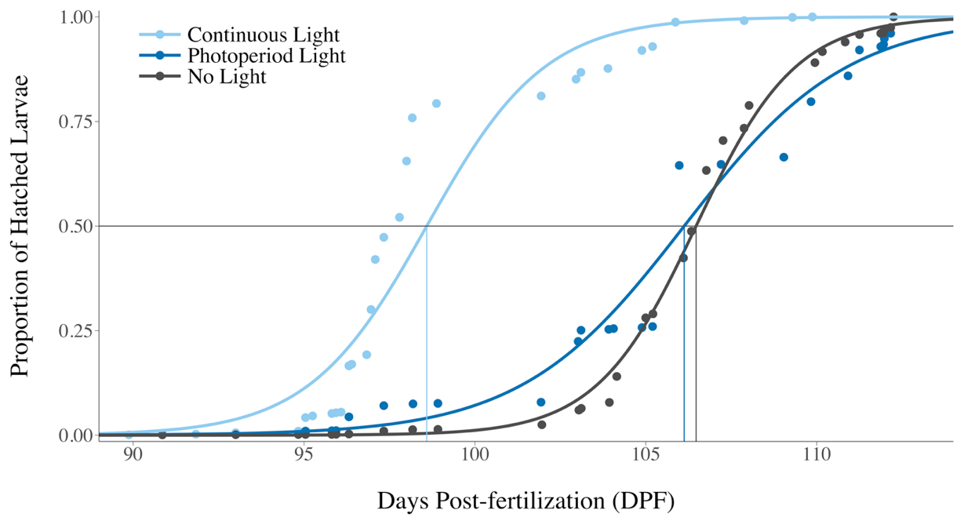

Figure 1. Relationship between incubation period (days) and light treatment. Horizontal line represents 50% hatching of cisco.

YSAs were significantly different according to light treatments, with hatched larvae having larger yolk-sacs from the no light and photoperiod treatments than from the continuous light treatment. Embryos reared under photoperiod light had statistically equal sized yolk-sacs then those from the no light treatment (Figure 2). The continuous presence of light during embryogenesis produced larvae with the smallest YSA (mean = 0.767, SE = 0.017) whereas the absence of light produced larvae with the largest YSA (mean = 0.966, SE = 0.028).

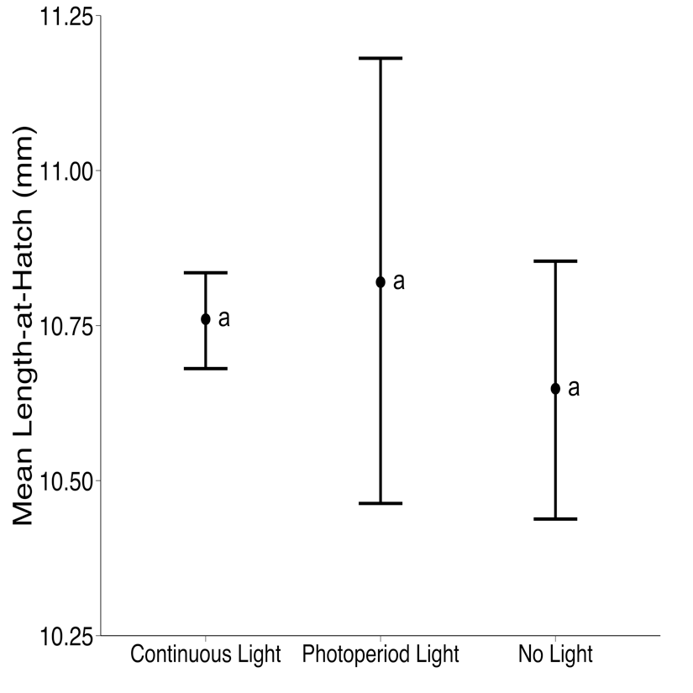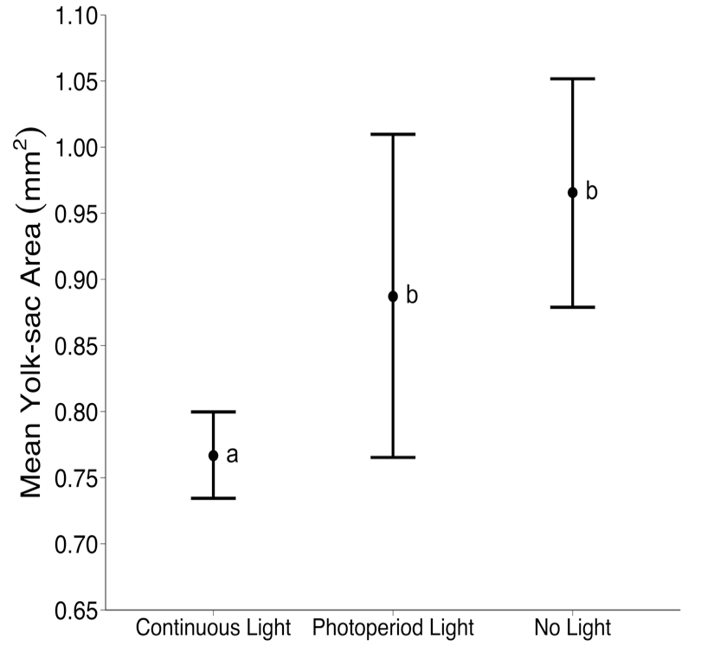Lengths of hatched embryos were not different among light treatments. Embryos reared at continuous light conditions were statistically equal to the lengths of embryos from those of the photoperiod and no light treatments (Figure 2). No statistical difference was found in length-at-hatch between the photoperiod and no light treatments (figure 2).

Figure 2. Mean yolk-sac area (left) and length-at-hatch (right) of newly hatched larvae with highest posterior density intervals under each light treatment. Letters represent significance groups from pairwise comparisons.

Light exposure during incubation significantly increases growth rates in larval cisco when reared under constant feeding regimes and water temperatures (Figure 3). Growth rates differed significantly between the no light treatment and the photoperiod and continuous light treatments, with the highest average growth (0.063 mm day−1) in larvae reared under photoperiod light and the lowest growth (0.044 mm day−1) in larvae reared in the absence of light (Table 1). No statistical difference in larval growth was present between the photoperiod and no light treatments.

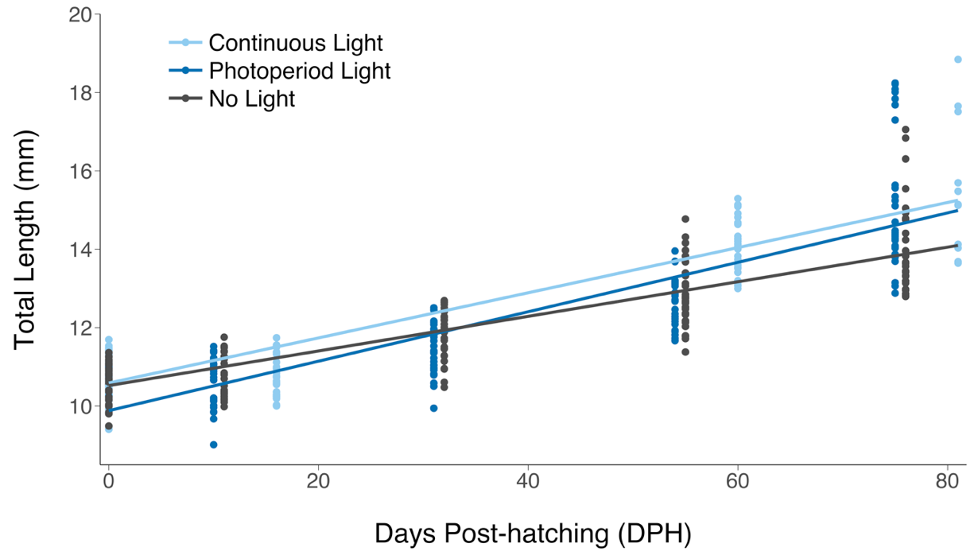

Figure 3. Scatterplot between the number of days post-hatch and total length of larval under each incubation light treatment with superimposed best-fit regressions.

Table 1. Linear regression coefficients and 95% confidence intervals between the number of days post-hatch and total length of larval under each incubation light treatment

|  |  |  |  |  |  |  |  |
| --- | --- | --- | --- | --- | --- | --- | --- |
|  | Intercept | | |  | Slope | | |
| Treatment | Estimate | 95% Lower CI | 95% Upper CI |  | Estimate | 95% Lower CI | 95% Upper CI |
| Continuous Light | 10.585 | 10.454 | 10.712 |  | 0.058 | 0.053 | 0.061 |
| Photoperiod Light | 9.881 | 9.533 | 10.235 |  | 0.063 | 0.056 | 0.070 |
| No Light | 10.521 | 10.367 | 10.675 |  | 0.044 | 0.040 | 0.048 |

**Discussion:** Higher light exposure was associated with a shorter incubation period, smaller YSA, and similar embryo size compared with individuals exposed to only light during a seasonal diel period and absence of light. These findings are consistent with previous studies on the impact of temperature on coregonid egg development and metabolic rates (Edsall and Colby 1970, Colby and Brooke 1973, Karjalainen et al. 2015, Karjalainen et al. 2016).

In addition, increasing light exposure during incubation led to faster growth in larvae. Higher growth rates could be reflected by a higher yolk consumption rate and conversion efficiency of yolk into tissues. In this experiment, environmental constraints from light seemingly induced a partitioning of yolk consumption towards maintaining elevated levels of cellular activity from photosensitive organs instead of development and growth, which ultimately accelerated hatching.

Our study demonstrates for the first time that light exposure during incubation potentially intensifies the known impact of temperature on coregonid embryonic life-history traits, as reflected by the significant effects of light on incubation period and yolk-sac consumption. This suggests a potential synergistic relationship between temperature and light and the existence of a critical threshold on light tolerance during incubation. In coregonids, winter severity (*i.e.,* water temperatures and ice cover) and subsequent inter-annual changes in light attenuation is likely to be critical in determining the response of climate change in early-life stages.

Environmental conditions experienced during embryogenesis can have compounding effects that influence later life-history traits, survival, and reproductive success (Jonsson and Jonsson 2014). In fish, smaller young-of-year have a lower overall fitness than their larger conspecifics (Kamler 2008). Larval emergence with a smaller YSA can be associated with reduced condition (*i.e.,* lipid content) and survival, high vulnerability to predators, and reduced performance in intraspecific competition (Louhi et al. 2011). Hence, further consequences during the first season of growth are expected and should be further explored.

Overall, our results demonstrate a relationship between light exposure and life-history traits, such that exposure to light would be considered to have dramatic impacts on the embryonic development and survival of larval cisco. As we used an extreme, unnatural range of light exposure, additional studies of light intensity naturally experienced by the species in Lake Superior would have important implications for the conservation of this population and beyond. In light of climate change, these results advocate the necessity for future studies to re-examine the effects of common stressors in freshwater species under different thermal scenarios.

**References:**

Austin, J., and S. Colman. 2008. A century of temperature variability in Lake Superior. Limnology and Oceanography **53**:2724-2730.

Best, N., M. K. Cowles, and K. Vines. 1995. CODA: Convergence diagnosis and output analysis software for Gibbs sampling output, Version 0.30. MRC Biostatistics Unit, Cambridge **52**.

Bolsenga, S. J., and H. A. Vanderploeg. 1992. Estimating photosynthetically available radiation into open and ice-covered freshwater lakes from surface characteristics; a high transmittance case study. Hydrobiologia **243-244**:95-104.

Colby, P. J., and L. T. Brooke. 1973. Effects of Temperature on Embryonic Development of Lake Herring (*Coregonus artedii*). Journal of the Fisheries Research Board of Canada **30**:799-810.

Downing, G., and M. K. Litvak. 2002. Effects of light intensity, spectral composition and photoperiod on development and hatching of haddock (*Melanogrammus aeglefinus*) embryos. Aquaculture **213**:265-278.

Edsall, T. A., and P. J. Colby. 1970. Temperature Tolerance of Young-of-the-Year Cisco, Coregonus artedii. Transactions of the American Fisheries Society **99**:526-531.

Eshenroder, R. L., P. Vecsei, O. T. Gorman, D. Yule, T. C. Pratt, N. E. Mandrak, D. B. Bunnell, and A. M. Muir. 2016. Ciscoes (Coregonus, subgenus Leucichthys) of the Laurentian Great Lakes and Lake Nipigon. Great Lakes Fishery Commission.

Jonsson, B., and N. Jonsson. 2014. Early environment influences later performance in fishes. Journal of Fish Biology **85**:151-188.

Kamler, E. 2008. Resource allocation in yolk-feeding fish. Reviews in Fish biology and Fisheries **18**:143.

Karjalainen, J., L. Jokinen, T. Keskinen, and T. J. Marjomaki. 2016. Environmental and genetic effects on larval hatching time in two coregonids. Hydrobiologia **780**:135-143.

Karjalainen, J., T. Keskinen, M. Pulkkanen, and T. Marjomaki. 2015. Climate change alters the egg development dynamics in cold-water adapted coregonids. Environmental Biology of Fishes **98**:979-991.

Louhi, P., M. Ovaska, A. Mäki-Petäys, J. Erkinaro, and T. Muotka. 2011. Does fine sediment constrain salmonid alevin development and survival? Canadian Journal of Fisheries and Aquatic Sciences **68**:1819-1826.

Lynch, A. J., S. J. Cooke, A. M. Deines, S. D. Bower, D. B. Bunnell, I. G. Cowx, V. M. Nguyen, J. Nohner, K. Phouthavong, B. Riley, M. W. Rogers, W. W. Taylor, W. Woelmer, S. J. Youn, and T. D. Beard. 2016. The social, economic, and environmental importance of inland fish and fisheries. Environmental Reviews **24**:115-121.

Myers, J. T., D. L. Yule, M. L. Jones, T. D. Ahrenstorff, T. R. Hrabik, R. M. Claramunt, M. P. Ebener, and E. Berglund. 2015. Spatial synchrony in cisco recruitment. Fisheries Research **165**:11-21.

Nyberg, P., E. Bergstrand, E. Degerman, and O. Enderlein. 2001. Recruitment of pelagic fish in an unstable climate: studies in Sweden's four largest lakes. Ambio **30**:559-564.

Schmidt, S. N., M. J. Vander Zanden, and J. F. Kitchell. 2009. Long-term food web change in Lake Superior. Canadian Journal of Fisheries and Aquatic Sciences **66**:2118-2129.

Stockwell, J. D., M. P. Ebener, J. A. Black, O. T. Gorman, T. R. Hrabik, R. E. Kinnunen, W. P. Mattes, J. K. Oyadomari, S. T. Schram, D. R. Schreiner, M. J. Seider, S. P. Sitar, and D. L. Yule. 2009. A Synthesis of Cisco Recovery in Lake Superior: Implications for Native Fish Rehabilitation in the Laurentian Great Lakes. North American Journal of Fisheries Management **29**:626-652.