Heart disease is the leading cause of death in America, accounting for nearly 30% of all deaths annually. Unfortunately, the first indication many people have that they have heart disease when they have a heart attack or other similar incident. Better screening could save lives, but tests can be expensive and doctors can have difficulty gaining patient compliance if the procedures are inconvenient or uncomfortable.

My project proposal is to create a risk estimate for presence of heart disease, so doctors and hospitals can identify patients who should undergo further testing, and to identify which tests provide the best indications of the presence or absence of heart disease. My goal is to create an algorithm that would accept any number of the attributes as inputs, then predict the presence or absence of heart disease in a patient. Patients frequently have incomplete data, so an important part of the process will be how the algorithm handles missing values, especially where tests such as a thallium stress test or cardiac fluoroscopy are concerned, since they are likely to be a very strong predictor of heart disease, but are more expensive, inconvenient, or potentially a dangerous procedures, and therefore more likely to be missing from a patient's information.

The data came in four parts, containing patient information from the Hungarian Institute of Cardiology, two university hospitals in Switzerland, a V.A. Medical center in Long Beach, and the Cleveland Clinic. I started my data wrangling by loading the four datasets into python and combining them into one dataframe. The data set has 76 patient attributes, 14 of which are of particular interest. Some of them would be available to a medical professional immediately (age, sex, presence of chest pain, blood pressure), some with routine lab work (fasting blood sugar, cholesterol), and some that would only be known after specialized testing (such as an ECG or cardiac fluoroscopy).

Many patients within the datasets had incomplete information, with a “?” used as a placeholder to indicate unknown measurements. I changed those to a NaN, along with any zeroes in columns where a zero was meaningless. I also changed the column that indicates the presence of heart disease in four categories (labeled as 0 for no heart disease, and 1, 2, 3, or 4 for different types of heart disease) into a simpler 0 or 1 for heart disease absent or present.

Four of the columns contained categorical data, such as the chest pain type column. This column used integer labels (1=typical angina, 2 = atypical angina, 3 = non anginal pain, 4 = asymptomatic), but the data itself is not ordinal. The distance from 1 to 4 is not greater than the distance from 3 to 4. I broke each of those columns up into multiple columns that gave a 0 or 1 value for each label in the original column so any calculations done on that information would weight each classification equally.

Finally, I filled in the NaNs in the table with KNN imputation. This takes rows in my data that have missing values, then fills in the holes using averages from the 7 most similar rows that have a value for the missing column.

As part of my data exploration, I made a table of correlation coefficients for the variables in my dataset. My attention first went to the 'pred' column, which is which is the variable I'll be trying to predict: absence (0) or presence (1) of heart disease. I wanted to check if the variable behavior in my dataset aligned with expectations. Below is a comparison of correlation coefficients for each column with the prediction variable.

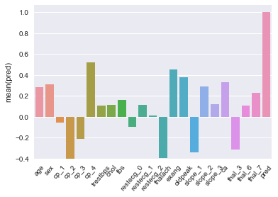
The first thing I noticed was that the chest pain categories were doing the opposite of what I had expected. Cp_1 (typical angina) was near zero, cp_2 (atypical angina) and cp_3 (non-anginal chest pain) were negatively correlated with heart disease, and cp_4 (no chest pain) was positively correlated with the presence of heart disease. This baffled me for a bit, until I considered that my dataset is only of patients at cardiac clinics or other similar facilities. This data is not representative of the general population, rather it's representative of a subset of people whom doctors might have had reason to suspect had heart disease. Persons with no chest pain are likely in this data set because of the presence of some other symptom.

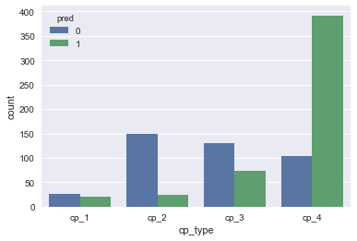
Accoriding to the CDC, about 11.7% of adults have some form of diagnosed heart disease, but 55% of this dataset does. This is going to be an important limitation of the dataset to consider while going forward. My initial plan to make a screening algorithm for the general population might not be feasible here, since the data has such a heavy selection bias towards patients with heart disease. The chest pain data will likely still be of use, though. The heart disease rate for cp_2 (atypical-angina) in this dataset is 13.7%, which leads me to believe the cp_1, cp_2, and cp_3 columns might be accurate reflections of those populations, and the only complication to consider is the heavily skewed cp_4 category. Ideally, I would like to have data from the general population to combine with this dataset so that it is more representative of the average patient walking through the door of a family practice, but even in the absence of that data I can still write code that would be able to learn off it.

Otherwise, the variables in the dataset do approximately what one would expect them to. There's no single variable that fully explains the response variable (it would be a rather dull project if one did) but many of the variables behave much like thalach (the heartrate achieved in a thallium stress test) does in the display below.

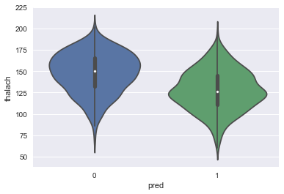
There's considerable overlap between the two groups (with a Cohen's D of 0.857), but the difference in shape and center for the two groups is noticeable. A two sample T-test resulted in a t-score of 12.93, which is gargantuan for a sample of 920. This gives me hope that, with machine learning, the combination of other similar strength relationships will generate a reliable predictor.

