As part of my data exploration, I made a table of correlation coefficients for the variables in my dataset. My attention first went to the 'pred' column, which is which is the variable I'll be trying to predict: absence (0) or presence (1) of heart disease.

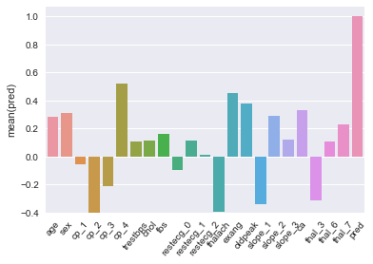
The first thing I noticed was that the chest pain categories were doing the opposite of what I had expected. Cp_1 (typical angina) was near zero, cp_2 (atypical angina) and cp_3 (non-anginal chest pain) were negatively correlated with heart disease, and cp_4 (no chest pain) was positively correlated with the presence of heart disease. This baffled me for a bit, until I considered that my dataset is only of patients at cardiac clinics or other similar facilities. This data is not representative of the general population, rather it's representative of a subset of people whom doctors might have had reason to suspect had heart disease. Persons with no chest pain are likely in this data set because of the presence of some other symptom. My initial suspicion is in the exang column (exercise induced angina).

To find out, I did a chi-square test for independence.

Observed | Cp_4: False | Cp_4: True |  |  | Expected | Cp_4: False | Cp_4: True
Exang: False | 354 | 207 | 561 |  | Exang: False | 258.5 | 302.5 | 561
Exang: True | 70 | 289 | 359 |  | Exang: True | 165.5 | 193.5 | 359
 | 424 | 496 | 920 |  |  | 424 | 496 | 920

This gave a chi-square of 165.8, and a p-value of essentially zero. Specifially, the (false, false) and (true, true) observations are higher than expected, showing that the presence of one is tied to the presence of another. Doing similar tests for other explanatory variables would likely chip away more at the 207 patients that are Cp_4: true but Exang: false.

Another interesting correlation with 'pred' is 'thalach', the heart rate achieved by the patient in a thallium stress test. Next to 'exang', it was the strongest predictor of heart disease, with a correlation coefficient of -0.34. That 's not a spectacularly strong relationship, but there does appear to be a difference between the populations.

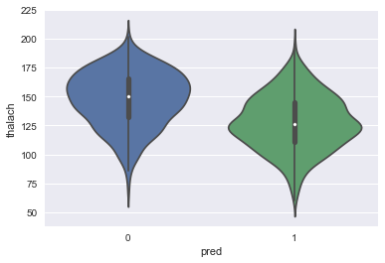
To compare the two populations, I ran a two sample T-Test.

With a t statistic of 12.93 and 918 degrees of freedom, we get a p-value in the neighborhood of 10^-35. We can reject the null hypothesis of equal population means.

In the spirit of the lecture I that spent the majority of the video emphasizing how flawed p-values are, I decided to compute a Cohen's d as well.

This, as expected, is not an earth shattering number, but it does indicate that 'thalach' will be a useful variable for the final prediciton.

