INTRODUCTION:

NAME :J BrianBojoyou
DEPARTMENT:Computer Science and Business Systems
COLLEGE :Rajalakshmi Engineering College,Thandalam,Chennai.
YEAR :First Year
EMAIL :211401015@rajalakshmi.edu.in
PH.no :8056751319
GITHUB :https://github.com/brianbojoyou0306

MAJOR PROJECT 1

AIM :
Creating a web app by which an individual's gender can be identified by using height and weight of an individual.

CODE:
import pandas as pd
df=pd.read_csv('/content/Training set.csv')
df
df.info()
x=df.iloc[:,0:2].values
y=df.iloc[:,2].values
k=5
pred = [177.35,40]
from sklearn.neighbors import KNeighborsClassifier
model=KNeighborsClassifier(n_neighbors=k,metric='euclidean')
model.fit(x,y)
y_pred=model.predict([pred])
y_pred
!pip install streamlit --quiet
import joblib
joblib.dump(model,"gender")
%%writefile app.py
import streamlit as st
import joblib
model = joblib.load('gender')
import numpy as np
st.title('GENDER CLASSIFIER')
ip1 = st.number_input('Enter the height')
ip2 = st.number_input('enter the weight')
ls=np.append(ip1,ip2)
op = model.predict([ls])
if st.button('predict'):
st.title(op[0])
streamlit run app.py & npx localtunnel --port 8501

HEROKU DETAILS:

LINK:http://genderprediction03.herokuapp.com/#gender-classifier

GITHUB LINK:

https://github.com/brianbojoyou0306/rinexproj1

SCREENSHOTS OF OUTPUTS:
1.

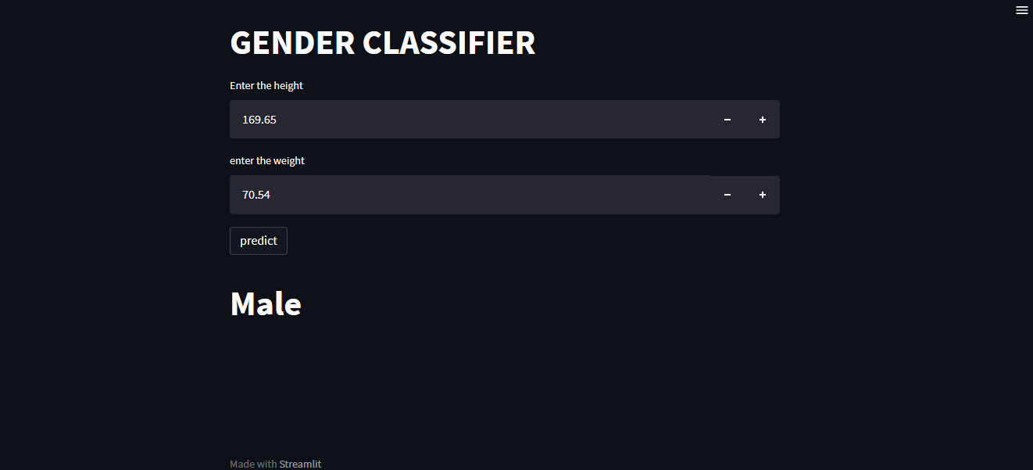

2.

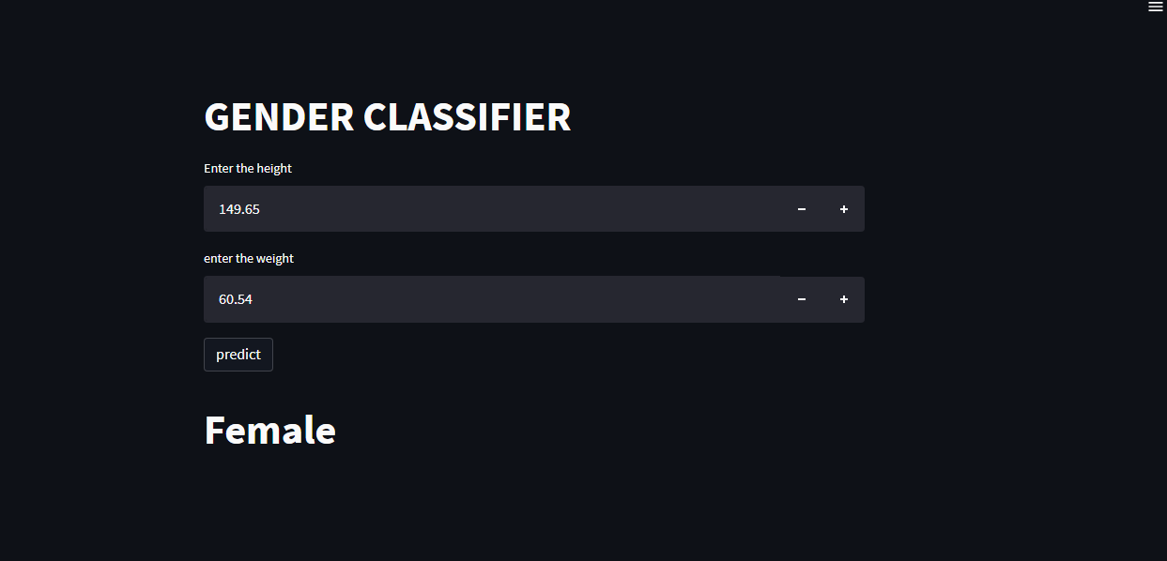

MAJOR PROJECT 2

AIM :
Implementing a program which can detect face and eye of individuals from an image.

CODE:

#FACE AND EYE RECOGNITION
import cv2
face_cascade = cv2.CascadeClassifier('haarcascade_frontalface_default.xml')
eye_cascade = cv2.CascadeClassifier('haarcascade_eye.xml')
img = cv2.imread('abc.jpg') #reading the image
faces = face_cascade.detectMultiScale(img,scaleFactor = 1.1,minNeighbors =9)
eyes = eye_cascade.detectMultiScale(img,scaleFactor = 1.1,minNeighbors =20)
for x,y,w,h in faces:
cv2.rectangle(img,(x,y),(x+w,y+h),(0,255,0),2)
cv2.imshow('FACE RECOGNITION',img)
#w and h are height and width
for x,y,w,h in eyes:
img = cv2.rectangle(img,(x,y),(x+w,y+h),(255,255,0),2)
cv2.imshow('FACE RECOGNITION',img)
cv2.waitKey(0)
cv2.destroyAllWindows()

GITHUB LINK:

https://github.com/brianbojoyou0306/Face-and-Eye-detection-in-an-image/tree/main

SCREENSNIP OF OUTPUTS:
1.
