GAM 3333-01 SL

Meaningful Game Design Studio

Fall 2023 Syllabus and Course Calendar

Course Description

Students will work with a client to design and develop a video game or interactive media to help promote or communicate the client’s message or agenda. Students will meet with a client to understand a complex problem, research the problem systemically through academic research and site visits with appropriate community members, and design an engaging game or interactive media experience to meet the client’s needs. No prior knowledge of game design or development is necessary or expected. *Four Credits.*

Service learning Description: Potential Course Example: Leslie’s House

The Client

Because the client, client goals, and systemic issues will be different for each course, this sample syllabus assumes we could be working with the Leslie’s House in High Point, NC, a program that provides services for women without housing.

Students will meet with a representative from the program as soon as possible, so that the client can share their mission, their needs, and the message they want us to help them communicate. We will also discuss their target demographic. For instance, Leslie’s House might want us to help them develop a game or simulation to help their own clients understand the services that Leslie’s House provides. But our client might also want us to help illuminate a systemic issue for their donors or potential donors. Each of those examples would lead to very different games or interactive experiences.

Research

After meeting with the clients, students will study 1) the numerous types of serious games, 2) low-fidelity prototyping (such as using cardboard cutouts), and 3) the systemic issues or problems that the client wants us to work on. Students will use all three areas of research as fodder for in-class design sessions as we work toward potential games or simulations to present to our client.

Service

For service requirements, the instructor will find meaningful placements that can help students engage with the systemic problems related to our client’s needs. For instance, if our client’s work centers on homelessness, students could go on site visits to homeless shelters in addition to Leslie’s House, and possibly organize activities to assist homeless shelters (such as a drive for baggies of necessities, or fundraising). Additionally, students could volunteer consistent hours at a local homeless shelter or food pantry.

Deliverable

Students will meet with the client every few weeks to present their game and interactive experience prototypes, which will provide great opportunity for feedback. By the end of the semester, students will have designed and developed a short game or interactive media experience similar to an interactive google doodle, that the client can easily host on their own website.

Service Learning Requirements

All students in the course are required to spend 25 hours in service to the organization with which they are paired in the course. Before beginning your service hours, you will be introduced to representatives of the organization, receive an orientation to service learning as a pedagogy, agree to the Service Learning Code of Professional and Ethical Behavior, and sign a Partnership Agreement. You must begin your service-learning experience by the beginning of the third week of class, as it is necessary for your first reflection.

All students in the course will be required to abide by the policies set forth by the HPU Service Learning Program in its Service Learning Code of Professional and Ethical Behavior and Partnership Agreement. Failure to abide by these policies will be treated as a breach of the University’s Honor Code and you may be referred to the Honor Council for punishment.

You are expected to take the initiative to complete your required service hours and you are responsible for the penalties to your grade if you do not complete the hours.

Service learning is not an internship or simply volunteering – it is a pedagogical model that will deepen your understanding of the course material by exposing you first-hand to the ethical issues we discuss in class. You will perform service work that aids our local community and that service work will advance your thinking about ethics and education.

The following Venn Diagram illustrates the three central components of a service learning pedagogy and how it is different from other activities. The Diagram is a synthesis of two sources: <http://www.csus.edu/cec/director_msg.stm> and <http://mgmoses.com/Jumpstart/SectionII/Chap1%20Overview%20SL/Defining_SL.html>

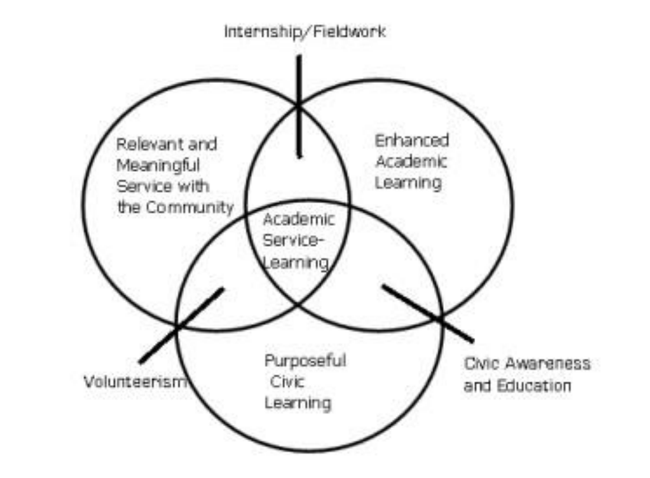

Course Objectives

|  |  |  |
| --- | --- | --- |
| Student Learning Outcomes: | **By the end of the course, students should be able to:** | **Method for Assessing this Learning Outcome** |
| Engage in relevant research to understand a problem systemically and by using an interdisciplinary approach. | Issue Analysis assignment |
| Communicate appropriately with a client to effectively understand problems and present a range of solutions. | Pitch assignment |
| Apply game design theories to break down and communicate complex problems. | Prototype assignment |
| Engage in collaborative video game development by creating and adding assets to a group game project. | Final Game Assets assignment |

|  |  |  |
| --- | --- | --- |
| Service Learning Outcomes: | Integrate the course material and service experience and apply it through the creation of some product. | Assessed by Prototype assignment; Final Game Assets assignment |
| Identify complex ethical issues pertaining to a problem that our local community faces, entertain different perspectives on them, and evaluate one's own position. | Assessed by Weekly Reflections |
| Develop students' compassion for others or an understanding of differences through engagement with people from different situations. | Assessed by Weekly Reflections |

Course Materials

**Text**

Fullerton, T. (2019). *Game Design Workshop: A playcentric approach to creating innovative games*. CRC Press.

**Articles:**

All articles will be accessible through High Point’s library system and will be linked from blackboard.

Assignments and grading

* **Issue Analysis (15% of grade) –** Students will develop an original viewpoint as to what our main deliverable should focus on and which systemic concepts to include. Students will use discussions with clients, research and readings, and an understanding of basic game design principles to develop their unique approach to meeting our clients needs. **Deliverable**: Individual Assignment - 5 – page paper with citations.
* **Pitches (15% of grade) –** Students will develop a slide deck to professionally pitch their game idea to our client. **Deliverable:** Individual Assignment **-** oral presentation with slides.
* **Prototype (25% of grade) –** Students will work together to develop both a low-fidelity paper prototype and a high-fidelity digital prototype (instructor of the course will assist with digital prototype if necessary). The paper prototype will be a chance for students to walk the client through the concept for the game or interactive experience, and the digital prototype will be an opportunity for students to show the client the proof-of-concept for digital web version of the game. **Deliverable:** Group Project - paper prototype experience & digital playable prototype
* **Final Game Assets (15% of grade) –** Students will be assigned specific tasks to complete to create final assets for the digital game deliverable. Areas to work on include writing text, image editing, audio editing, programming, and more. If necessary, Instructor of the course will oversee main programming of the final game. **Deliverable:** Individual Assignmetn - assets for final playable game
* **Weekly Reflections (30% of grade) –** Students will write short blog posts where they reflect meaningfully on a prompt provided by the Instructor. **Deliverable:** Individual Assignment – blog post responses.

Expectations for out-of-class work

|  |  |
| --- | --- |
| Out-of-Class Work: | In addition to attending class and completing all course requirements, students are expected to spend at least 2 hours each week engaged in out-of class work (i.e., reading, studying, doing homework, working on projects, etc.) for every hour of credit earned in this course. |

According to HPU’s accreditation guidelines, for every 1 hour of credit earned in a course, students are expected to spend at least 2 hours each week engaged in out-of-class work (i.e., reading, studying, doing homework, working on projects, etc.). Therefore, in a 4-credit course, students are expected to commit an average of at least eight hours per week outside of class. (In a 2-credit course that meets for half of the semester, you are still expected to commit to an average of eight hours per week.) The estimates listed below reflect the out-of-class time expectations for a typical student – some students might need more or less time on these assignments.

* Assigned Readings & Videos & Reflections – approx. 30 hrs out of class
* Issue Analysis – approx. 24 hrs out of class
* Pitches - approx. 18 hrs out of class
* Prototype - approx. 18 hrs out of class
* Final Game Assets - approx. 30 hrs out of class

Deadlines

See School of Communication policy at end of this document (short version = late work loses one letter grade per day; no late work is accepted after three days).

Grading

Grades are assigned as follows (there is no “rounding” of grades):

|  |  |  |  |  |
| --- | --- | --- | --- | --- |
| A (superior) –superior quality (90-100%) | B (excellent) –clearly above average (80-89%) | C (average) satisfactory work (70-79%) | D (inferior) –good enough to credit (60-69%) | F (failure) –work fails to meet the minimum expectations (0-59.9%) |
| A+ (97 - 100) | B+ (87 - 89.9) | C+ (77 - 79.9) | D+ (67 - 69.9) | F (0-59.9%) |
| A (93 - 96.9) | B (83 - 86.9) | C (73 - 76.9) | D (63 - 66.9) |
| A-(90 - 92.9) | B-(80 - 82.9) | C-(70 - 72.9) | D-(60 - 62.9) |

Please note that simply completing all required elements of an assignment does not entitle you to an A. Acceptable work of average quality earns a C. You must go above average expectations to receive an above average grade. This mimics the professional world of communication, where basic proficiency might get you in the door at the entry level, but creative thinking and a willingness to go beyond the minimum expectations are necessary to get noticed and advance.

Blackboard Blackboard Blackboard Blackboard Blackboard

I am a self-avowed blackboard nut and evangelist. I use blackboard for all of my class administration, and therefore you MUST use blackboard as well. If you have never used Blackboard before, it will become your friend. If Blackboard is already your friend, you will become BFFs. If you dislike Blackboard, then please come see me and I will evangelize to you appropriately. The following is how I use Blackboard:

**Assignments:** All assignments will be hosted and explained in Blackboard. Every major assignment will have a rubric attached to it in Blackboard, which will help you understand how assignments will be assessed.

For every assignment, you MUST submit something through Blackboard. If you complete an assignment and do not submit it to Blackboard, it is as if you have not completed it and it will be counted as late.

**Assignment Calendar:** Blackboard has an amazing assignment calendar associated with it. When you go to the Blackboard assignment calendar, you will be able to see EVERY assignment and quiz that is assigned so you won’t ever forget!

**Syllabus:** This syllabus will also be hosted on Blackboard.

**Blackboard is Master:** Blackboard assignment dates and descriptions take precedence over all dates/descriptions on this syllabus.

**Feedback:** Feedback for ALL assignments (including final assignments) will be conducted through blackboard rubrics.

Problems with Blackboard: Please contact IT IMMEDIATELY if you do not have access to our class blackboard page. I cannot help you, only IT can help you. It is your responsibility to remedy the problem ASAP so you can participate in the course.

Writing styles

Professional work should be written in the latest revisions of the Associated Press (AP) Style Manuals for print and broadcast. (Yes, AP also has a style manual for broadcast.) The School requires academic papers to be written in the latest revision of the American Psychological Association (APA) style. If you’re unfamiliar with this style, please see the Chair or the Dean. Other academic styles are not accepted unless the student work is written for a publication or event that requires a different format. Having students learn multiple writing styles only confuses them.

Absences and tardies

After two unexcused absences you will receive a Probation Notice. After a fifth absence you will be dropped from the class. Exceptions will only be granted for university-sanctioned events (with prior notice) or hospitalization (with a doctor’s note). Tardies are also unacceptable. Be on time. Better yet, be early. Two tardies will equal an absence. Students will not be permitted to make up grades for work missed due to an unexcused absence or tardy.

Copyright, Plagiarism, and cheating

Each of you signed the HPU Honor Code and it is your responsibility to abide by it. Cheating or plagiarism can result in failure for the course. Theft of intellectual property (such as images, audio, or video) is equivalent to plagiarism. See the School of Communication policies on plagiarism and copyright at the end of this document.

On occasion, the professor will provide media/materials for use in class.  These materials may include photos, video/audio files, scripts, and design templates.  These items are copyrighted (by the professor and others) and may only be used in classroom exercises as specified by the professor.  Consequently, students may not use media supplied by the professor in their projects unless they have been given permission to do so. Student projects containing unauthorized material provided by the professor may be penalized or disqualified.  Students also may not share, distribute, or post online any media that contains media elements provided by the professor.

In addition, the professor holds the copyright on all course materials including lectures, PowerPoint presentations, handouts, video/audio media, etc.  Consequently, course sessions and materials cannot be recorded, copied, or distributed in any form without the written permission of the professor.

Plagiarism involves copying the work of others and/or representing it as your own without attribution. Students should not use any media created by another student or outside entity (e.g. downloaded online) in their assignments without prior permission from the professor.  In addition, students should not copy edited sequences, documents, sessions, or projects and represent them as their own. Incidents of copyright infringement and plagiarism will be treated as University Honor Code violations.

Exam Block

At High Point University, every course is expected to use its designated exam block. While I try to clearly mark the exam block date and time on this syllabus and on Blackboard, please note that if it is incorrect for any reason, it is expected that ALL STUDENTS verify the correct date and time using the Registrar’s website.

In this course, we will use the exam block for a gathering to reflect meaningfully on the semester.

STARFISH SYLLABUS STATEMENT

High Point University cares about your success!

This course is part of a HPU initiative that utilizes Starfish Connect, a communication tool for students and faculty. Through Starfish, instructors, coaches, and advisors provide feedback to you about course progress by emailing you about your academic performance. The emails are designed to be helpful by identifying strategies that increase your success in courses. Be sure to open any emails you receive and follow the recommendations.

Your instructor, coach, or advisor may also recommend that you contact a specific campus resource, such as the Learning Lab or Counseling Center. If an instructor makes a referral, you may also be contacted directly by this campus service as a follow-­‐up.

Starfish also allows you to schedule appointments with various offices and individuals across campus and request help on a variety of topics.

Tentative schedule

This is a tentative schedule that is subject to change. Details for each week’s assignments will be posted on Blackboard.

|  |  |  |  |
| --- | --- | --- | --- |
| Week | Day | Agenda | Estimated Hours |
| 1 | Tuesday | **Preface / Introduction to the course**  Videos: Game Engine Tutorial  Reading SL: Starfish story Reading SL: Why Service Learning is Bad | Readings & Response: 2 hrs  Game Engine Tutorial: 6 hrs |
| Thursday |
| 2 | Tuesday | **Intro to Game Design** Reading: Game Design Workshop: The Role of the Game Designer  SL Reading: Homelessness and Incarceration: A Reciprocal Relationship?  **\* Meet with Community Partner** | Readings & Responses: 2 hrs  Issue Analysis: 6 hrs |
| Thursday |
| 3 | Tuesday | **Brainstorming Sessions**  Reading: Game Design Workshop: Chapter 6 - Conceptualization  SL Reading: 6 Serious Games Formulas to Engage Players with Serious Content  *Issue Analysis Due end of week* | Readings & Responses: 2 hrs  Issue Analysis: 6 hrs |
| Thursday |
| 4 | Tuesday | **Paper Prototyping**  Reading: Game Design Workshop: Chapter 7 - Prototyping  SL Reading: Cultivating Virtual Stereotypes?: The Impact of Video Game Play on Racial / Ethnic Stereotypes | Readings & Responses: 2 hrs  Pitch: 6 hrs |
| Thursday |
| 5 | Tuesday | **Refining and Playtesting**  Reading: Game Design Workshop: Chapter 9 - Playtesting  SL Reading: Pathways Into Homelessness Among LGBTQ2S Adults  **\* Meet with Community Partner** *Students pitch ideas to client; client chooses which ideas move forward.* | Readings & Responses: 2 hrs  Pitch: 6 hrs |
| Thursday |
| 6 | Tuesday | **Prototyping**  SL Reading: SL Reading: Serious Games for Sustainable Development | Readings & Responses: 2 hrs  Prototype (paper): 6 hrs |
| Thursday |
| 7 | Tuesday | **Digitization**  Reading: Game Design Workshop: Chapter 8 - Digital Prototyping  SL Reading: Serious games: video games for good?  **\* Meet with Community Partner to playtest paper prototypes** | Readings & Responses: 2 hrs  Prototype (paper): 6 hrs |
| Thursday |
| BREAK | Tuesday |  | |
| Thursday |
| 8 | Tuesday | **Game Refinement**  Students will begin refining and reiterating the game concept throughout the rest of the semester.  Reading: Game Design Workshop: Chapter 9 – Playtesting (Conducting a Playtesting Session)  SL Reading: The health challenges of families experiencing homelessness | Readings & Responses: 2 hrs  Prototype (digital): 6 hrs |
| Thursday |
| 9 | Tuesday | **Game Refinement (continued)**  Reading: Game Design Workshop: Chapter 9 – Playtesting (Methods of Playtesting; Taking Notes)  SL Reading: A Critical Analysis of Media Representation of Disabled People  * Meet with client to playtest digital prototype, solicit feedback  *(Digital Prototype due for in-class client meeting)* | Readings & Responses: 2 hrs  Prototype (digital): 6 hrs |
| Thursday |
| 10 | Tuesday | **Game Refinement (continued)**  Reading: Game Design Workshop: Chapter 10 – Functionality, Completeness, and Balance (Functionality)  SL Reading: Keep Your Politics Out Of My Video Games | Readings & Responses: 2 hrs  Prototype (digital): 6 hrs |
| Thursday |
| 11 | Tuesday | **Game Refinement (continued)**  Reading: Game Design Workshop: Chapter 10 – Functionality, Completeness, and Balance (Completeness)  SL Reading: Supporting Homeless Youth: Perspectives and Preferences | Readings & Responses: 2 hrs  Prototype (digital): 6 hrs |
| Thursday |
| 12 | Tuesday | **Game Refinement (continued)**  Reading: Game Design Workshop: Chapter 10 – Functionality, Completeness, and Balance (Balance)  SL Reading: The Case for Giving Homes to the Homeless  * Meet with client to playtest game | Readings & Responses: 2 hrs  Prototype (digital): 6 hrs |
| Thursday |
| 13 | Tuesday | **Bug Squashing**  From this point on, no new features will be added to the game, we will be focused on fixing errors in the code and finalizing assets.  SL Reading: Silenced Voices and Structured Survival Battered Women’s Help Seeking | Readings & Responses: 2 hrs  Final Game Assets: 6 hrs |
| Thursday |
| 14 | Tuesday | **Bug Squashing (continued)**  SL Reading: Serious games for mental health | Readings & Responses: 2 hrs  Final Game Assets: 6 hrs |
| Thursday |
| 15 | Tuesday | **Bug Squashing (continued)**  SL Reading: Serious Games Are Not All Serious | Readings & Responses: 2 hrs  Final Game Assets: 6 hrs |
|  | Thursday |
| Exam Block | | Game Presentation with Community Partner |  |

**School of Communication Policies, Practices and Expectations**

Students are expected to adhere to all standards outlined in the School of Communication’s Policies, Practices, and Expectations (located at  [http://www.highpoint.edu/communication/files/nqsc_syllabus_policies.pdf](https://mobile.highpoint.edu/owa/redir.aspx?C=JyyBBLgH4fYmI71qL7W8GyxmheTK83O7pgF3_zLiu7DsPhTIQFTVCA..&URL=http%3a%2f%2fwww.highpoint.edu%2fcommunication%2ffiles%2fnqsc_syllabus_policies.pdf)) unless alternate standards are specifically outlined elsewhere in this syllabus.