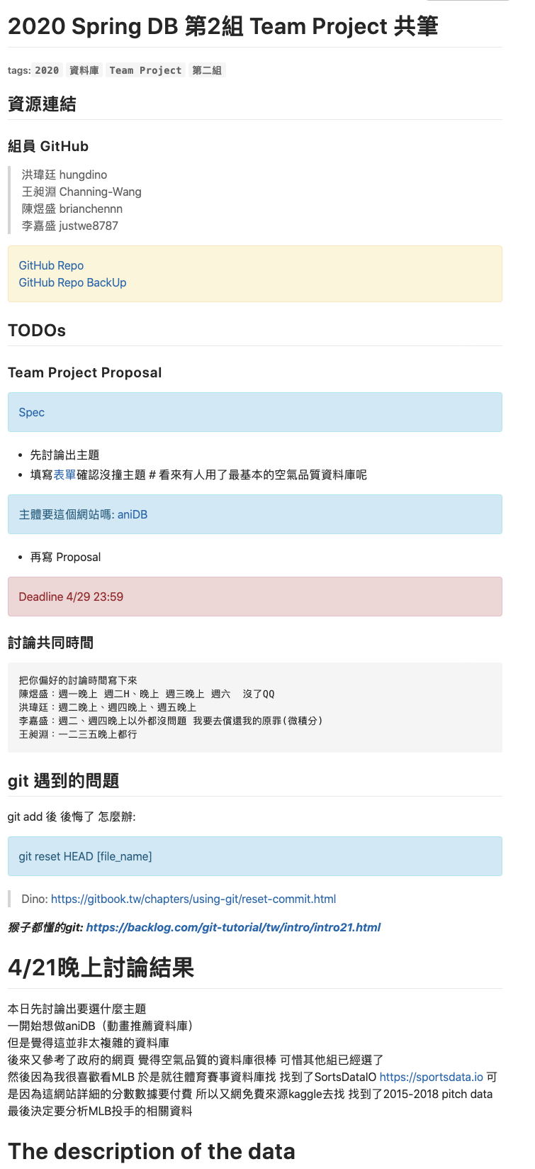

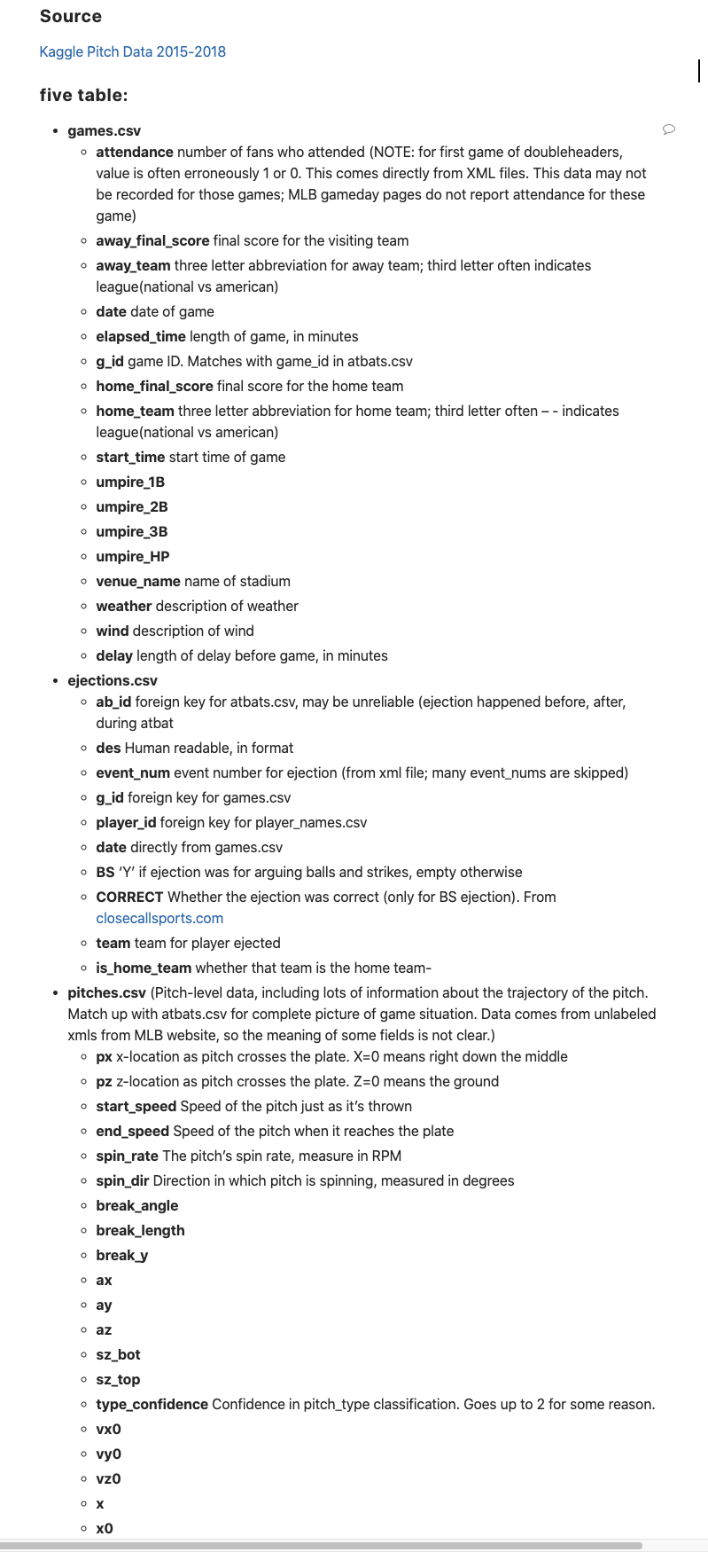

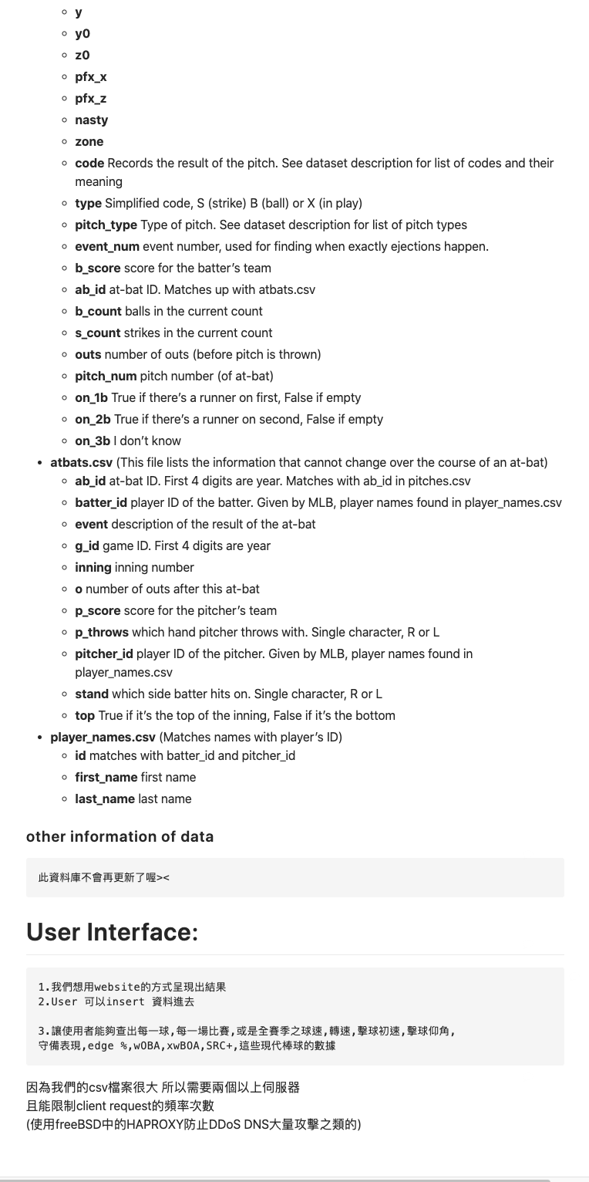

以上內容來自HackMD: <https://hackmd.io/GFo9xYfMRNCeQgr_60Z1gg?view>

請助教不要外流這連接喔^ ^

Github: <https://github.com/brianchennn/Database_Team_Project>