**2020 DB Term Project Report 02組**

Github: <https://github.com/brianchennn/Database_Team_Project>

HackMD: <https://hackmd.io/GFo9xYfMRNCeQgr_60Z1gg?view>

/***剩下部分

database： database的maintain(應該不會再有其他更新?)、如何連結database和application

application：application的interface和function及實踐方法***/

# Data

### ****Source****

[Kaggle Pitch Data 2015-2018](https://www.kaggle.com/pschale/mlb-pitch-data-20152018#ejections.csv)

### ****Five Tables From Kaggle****

* **games**
  + **attendance** number of fans who attended (NOTE: for first game of doubleheaders, value is often erroneously 1 or 0. This comes directly from XML files. This data may not be recorded for those games; MLB gameday pages do not report attendance for these game)
  + **away_final_score** final score for the visiting team
  + **away_team** three letter abbreviation for away team; third letter often indicates league(national vs american)
  + **date** date of game
  + **elapsed_time** length of game, in minutes
  + **g_id** game ID. Matches with game_id in atbats.csv
  + **home_final_score** final score for the home team
  + **home_team** three letter abbreviation for home team; third letter often – - indicates league(national vs american)
  + **start_time** start time of game
  + **umpire_1B** umpire of 1B
  + **umpire_2B** umpire of 2B
  + **umpire_3B** umpire of 3B
  + **umpire_HP** umpire of HP
  + **venue_name** name of stadium
  + **weather** description of weather
  + **wind** description of wind
  + **delay** length of delay before game, in minutes
* **ejections**
  + **ab_id** foreign key for atbats.csv, may be unreliable (ejection happened before, after, during atbat
  + **des** Human readable, in format
  + **event_num** event number for ejection (from xml file; many event_nums are skipped)
  + **g_id** foreign key for games.csv
  + **player_id** foreign key for player_names.csv
  + **date** directly from games.csv
  + **BS** ‘Y’ if ejection was for arguing balls and strikes, empty otherwise
  + **CORRECT** Whether the ejection was correct (only for BS ejection). From [closecallsports.com](http://closecallsports.com/)
  + **team** team for player ejected
  + **is_home_team** whether that team is the home team-
* **pitches.** (Pitch-level data, including lots of information about the trajectory of the pitch. Match up with atbats.csv for complete picture of game situation. Data comes from unlabeled xmls from MLB website, so the meaning of some fields is not clear.)
  + **px** x-location as pitch crosses the plate. X=0 means right down the middle
  + **pz** z-location as pitch crosses the plate. Z=0 means the ground
  + **start_speed** Speed of the pitch just as it’s thrown
  + **end_speed** Speed of the pitch when it reaches the plate
  + **spin_rate** The pitch’s spin rate, measure in RPM
  + **spin_dir** Direction in which pitch is spinning, measured in degrees
  + **break_angle**
  + **break_length**
  + **break_y**
  + **ax**
  + **ay**
  + **az**
  + **sz_bot**
  + **sz_top**
  + **type_confidence** Confidence in pitch_type classification. Goes up to 2 for some reason.
  + **vx0**
  + **vy0**
  + **vz0**
  + **x**
  + **x0**
  + **y**
  + **y0**
  + **z0**
  + **pfx_x**
  + **pfx_z**
  + **nasty**
  + **zone**
  + **code** Records the result of the pitch. See dataset description for list of codes and their meaning
  + **type** Simplified code, S (strike) B (ball) or X (in play)
  + **pitch_type** Type of pitch. See dataset description for list of pitch types
  + **event_num** event number, used for finding when exactly ejections happen.
  + **b_score** score for the batter’s team
  + **ab_id** at-bat ID. Matches up with atbats.csv
  + **b_count** balls in the current count
  + **s_count** strikes in the current count
  + **outs** number of outs (before pitch is thrown)
  + **pitch_num** pitch number (of at-bat)
  + **on_1b** True if there’s a runner on first, False if empty
  + **on_2b** True if there’s a runner on second, False if empty
  + **on_3b** I don’t know
* **atbats.** (This file lists the information that cannot change over the course of an at-bat)
  + **ab_id** at-bat ID. First 4 digits are year. Matches with ab_id in pitches.csv
  + **batter_id** player ID of the batter. Given by MLB, player names found in player_names.csv
  + **event** description of the result of the at-bat
  + **g_id** game ID. First 4 digits are year
  + **inning** inning number
  + **o** number of outs after this at-bat
  + **p_score** score for the pitcher’s team
  + **p_throws** which hand pitcher throws with. Single character, R or L
  + **pitcher_id** player ID of the pitcher. Given by MLB, player names found in player_names.csv
  + **stand** which side batter hits on. Single character, R or L
  + **top** True if it’s the top of the inning, False if it’s the bottom
* **player_names** (Matches names with player’s ID)
  + **id** matches with batter_id and pitcher_id
  + **first_name** first name
  + **last_name** last name

### ****ER Diagram****

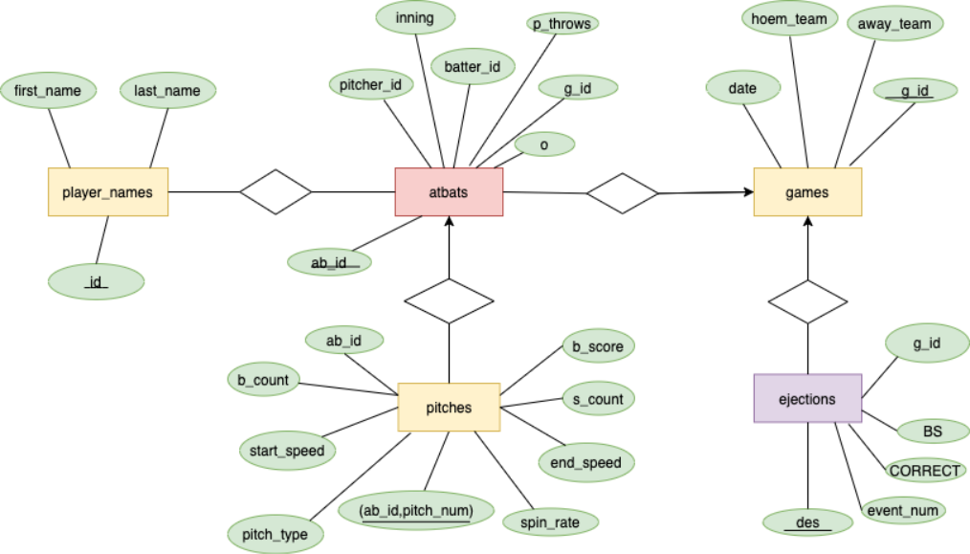

### Other Tables Extend From The Tables Above

* **batter_create_table_per_game** (每場比賽各打者的各種資料)
  + **years** 年度
  + **id** 對應player_id
  + **first_name** first name
  + **last_name** last name
  + **g_id** game ID
  + **PA** 擔任打席次數
  + **AB** 打數
  + **Single** 一壘安打數
  + **DDouble** 二壘安打數
  + **Triple** 三壘安打數
  + **HR** 全壘打數
  + **K** 三振次數
  + **BB** 四壞球次數
  + **HBP** 觸身球次數
  + **IBB** 故意四壞球次數
  + **GDP**滾地球雙殺次數
* **batter_create_table_per_year** (每年度各打者的各種資料)
  + **years** 年度
  + **id** 對應player_id
  + **first_name** first name
  + **last_name** last name
  + **PA** 擔任打席次數
  + **AB** 打數
  + **Single** 一壘安打數
  + **DDouble** 二壘安打數
  + **Triple** 三壘安打數
  + **HR** 全壘打數
  + **K** 三振次數
  + **BB** 四壞球次數
  + **IBB** 故意四壞球次數
  + **DP**滾地球雙殺次數
  + **AVG** 打擊率
  + **OBP** 上壘率
  + **SLG** 長打率
  + **OPS** 整體攻擊指數
  + **BABIP** 場內安打率
* **pitcher_create_table_per_game** (每場比賽各投手的各種資料)
  + **years** 年度
  + **id** 對應player_id
  + **first_name** first name
  + **last_name** last name
  + **g_id** game ID
  + **Single** 一壘安打數
  + **DDouble** 二壘安打數
  + **Triple** 三壘安打數
  + **HR** 全壘打數
  + **IP** 投球局數
  + **Pitch_per_Game** 用球數
  + **K** 三振數
  + **BB** 保送數
  + **HBP** 觸身球數
  + **DP** 雙殺數
  + **Ground** 滾地球數
  + **Fly** 飛球數
  + **ground_fly_ratio** 滾飛比(滾地球跟飛球的比例)
* **pitcher_create_table_per_year** (每年度各投手的各種資料)
  + **years** 年度
  + **id** 對應player_id
  + **first_name** first name
  + **last_name** last name
  + **IP** 投球局數
  + **pitch_num** 用球數
  + **Single** 一壘安打數
  + **DDouble** 二壘安打數
  + **Triple** 三壘安打數
  + **HR** 全壘打數
  + **K** 三振數
  + **BB** 保送數
  + **HBP** 觸身球數
  + **Ground_into_DP** 雙殺數
  + **ground_fly_ratio** 滾飛比(滾地球跟飛球的比例)
  + **FIP** FIP
  + **BABIP** 場內被安打率
  + **WHIP** 每局被上壘率
* **pitch_type_create_table_per_game** (每場比賽各投手的各球種資料)
  + **years** 年度
  + **id** 對應player_id
  + **first_name** first name
  + **last_name** last name
  + **g_id** game ID
  + **pitch_type** 球種
  + **v0_avg** 初速平均
  + **v_delta_avg** 速度變化平均
  + **y_delta_avg** y軸變化平均
  + **spin_rate_avg** 轉速平均
* **pitch_type_create_table_per_year** (每年度各投手的各球種資料)
  + **years** 年度
  + **id** 對應player_id
  + **first_name** first name
  + **last_name** last name
  + **pitch_type** 球種
  + **v0_avg** 初速平均
  + **v_delta_avg** 速度變化平均
  + **y_delta_avg** y軸變化平均
  + **spin_rate_avg** 轉速平均
* **pitch_type_ratio**(每年度各選手的各球種使用比例)
  + **year** 年度
  + **id** 對應player_id
  + **first_name** first name
  + **last_name** last name
  + **pitch_type** 球種
  + **ratio** 使用比例
* **pitcher_payoff_pitch_ratio** (每年度, 2好球後各投手的球種使用比例及當下的好壞球數)
  + **year** 年度
  + **id** 對應player_id
  + **first_name** first name
  + **last_name** last name
  + **ball_strike** 好壞球比數
  + **pitch_type** 球種
  + **ratio** 使用比例
* **pitcher_spin_strike_rate** (轉速與好球率的關係)
  + **year** 年度
  + **first_name** first name
  + **last_name** last name
  + **pitcher_throws** 投手站位
  + **batter_stand** 打者站位
  + **pitch_type** 球種
  + **Spin** 轉速
  + **strike_ratio** 好球率
* **pitcher_take_strike_rate** (每年度各投手的奪好球率)
  + **year** 年度
  + **first_name** first name
  + **last_name** last name
  + **pitch_type** 球種
  + **ratio** 奪好球率(swing_strike + call_strike + 非兩好球時的界外)/某球種總球數
  + **total** 總球數
* **pitcher_strkiout_ratio_for_every_pitch** (每年度各投手所有的三振中各球種使用比例)
  + **year** 年度
  + **id** 對應player_id
  + **first_name** first name
  + **last_name** last name
  + **ball_strike** 好壞球比數
  + **pitch_type** 球種
  + **ratio** 使用比例
* **pitcher_strike_ratio_for_every_pitch_type** (每年度各投手各球種的使用比例及當下的好壞球數)
  + **year** 年度
  + **id** 對應player_id
  + **first_name** first name
  + **last_name** last name
  + **ball_strike** 好壞球比數
  + **pitch_type** 球種
  + **ratio** 使用比例
* **team_final_score** (所有對戰的比分)
  + **g_id** game ID
  + **date** 日期
  + **year** 年度
  + **home_team** home team
  + **away_team** away team
  + **home_final_score** 主隊最終分數
  + **away_final_score** 客隊最終分數
* **team_region_status** (所有年度, 所有聯盟分區的戰績)
  + **year** 年度
  + **team** 隊伍
  + **League** 聯盟
  + **Division** 分區
  + **win** 勝場
  + **total** 總比賽場次
  + **win_rate** 勝率
* **team_opponent** (某球隊每場比賽的相關資訊)
  + **g_id** game ID
  + **home_or_away** 該隊伍在這場比賽是主隊或客隊
  + **opponent** 對手
  + **score** 該隊伍在這場比賽的分數
  + **opponent_score** 對手在這場比賽的分數
* **team_first_inning_run_ratio** (所有球隊每一年的首局得分率，首局總得分數)
  + **year** 年度
  + **team** 隊伍
  + **total_game** 比賽場次數
  + **scoring_rate** 首局得分率
  + **total_score** 首局總得分數
* **team_LLRR** (左投或右投對左打或右打的打擊率)
  + **year** 年度
  + **pitcher_batter_stand** 投手和打者的站位
  + **cnt_baserun** 安打數
  + **cnt_atbat** 打數
  + **AVG** 打擊率
* **ejection_game**(單場比賽驅逐出場次數大於等於3次的場次)
  + **date** 日期
  + **g_id** game ID
  + **home_team** home team
  + **away_team** away team
  + **ejection_cnt** 驅逐出場次數
* **ejection_max_player**(每年度驅逐出場次數最多的選手)
  + **year** 年度
  + **id** 對應player_id
  + **first_name** first name
  + **last_name** last name
  + **cnt** 驅逐出場次數
* **ejection_team**(每年度所有隊伍的驅逐出場次數，若次數為0的話不會顯示在table裡)
  + **year** 年度
  + **team** 隊伍
  + **cnt** 驅逐出場次數

### ****Data Normalization****

我們為了分析更多資料於是由原始的table中再延伸了許多table，而過程中因想增加可識別度及方便被其他table使用的關係，所以有滿多table都有部分功能相依的狀況(如主鍵為<year, id>時，first_name及last_name只相依於id)，因此我們的data在包含新增的table的情況下並沒有滿足2NF

# Database

### ****Database We USE****

MySQL

### ****How Do We Maintain Our Database****

### ****How Do We Connect Our Database To Our Application****

# Application

### ****Interface****

### ****Function****

# Others

### ****Progress****

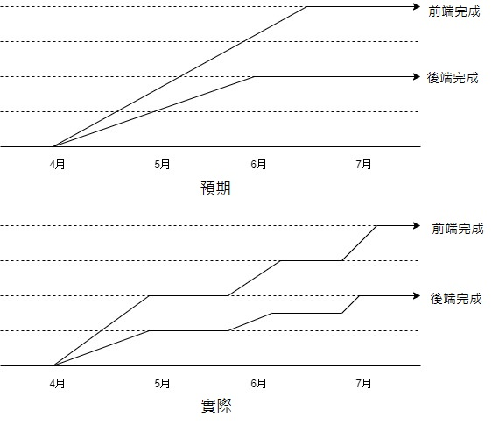

我們在4/21訂出題目並找好source，4/23建好基礎的table

計畫在6月中前完成後端開發並與前端連結，6月底前就能完成project

但實際上因段考期間大家都很忙，中途斷斷續續的進度停滯了一段時間

最後收尾及驗收的部分到了7月才漸漸完成

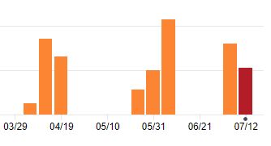

🡩從Github的commit數量也能看得出來

### ****Problems and Solves****

• group by後count為0的event不會顯示出來

🡪先把所有event列出來後left join，再用ifnull把count換成0

• 比較ratio時可能會有data筆數過少導致數值過度異常

🡪把data筆數也加入條件篩選

• 無法確認sql的結果是否正確

🡪與其他現有網站交叉比對

• data太大導致sql執行時間太長

🡪將常使用的sql直接製成table

• 製成table後join仍很花時間

🡪加上primary key

• data豐富度比不上其它現有網站

🡪分析其他有趣的data(如驅逐出場次數等)

### ****Contribution****