Pohatu is a stone spirit. He is immensely strong and can literally move mountains. Pohatu can cause massive rocks to explode like bombs, or roll with great precision towards any attacker. His huge feet contain great power, destroying even the toughest rocks with a single kick!
Pohatu is liked by all the Toa for his kind nature and for his rock-solid dependability. He's slow, but friendly and dependable. He's not good at snap decisions, but when he makes a decision to do something, he sticks with it until the end--and you DON'T get in his way! Whenever there is trouble, Pohatu will always be there behind you, an immovable force that few enemies can dislodge. His only fear is water: he cannot swim, and he sinks…like a stone.
Pohatu inhabits the foothills of Mount Ihu, moving slowly but sure-footedly among the rocks and boulders at the base of the great mountain.

 | The great Mask of Speed; allows the user to cover great distances in the blink of an eye.

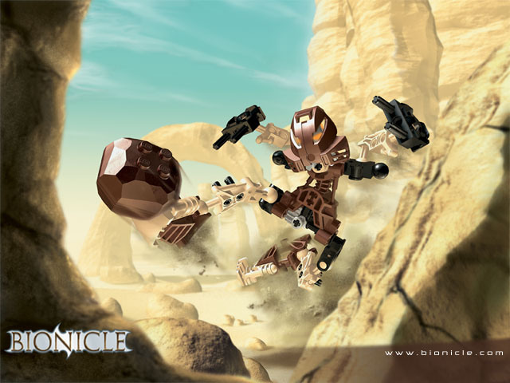
Onua is an Earth spirit, and was created by the Great Beings when the continents of the planet were forming from the fiery molten lava.
Onua is at home below ground: with his huge hands, he scrapes out tunnels in the rocky cliffs over Papu Niho Reef. His low, squat body and head allow him to move quickly in tunnels and his infrared eyes give him amazing night vision.
In normal daylight his eyesight is poor, although he compensates with amazingly powerful hearing. He is slower on open land than underground, but has incredible strength and surprising dexterity.
Onua is at one with the land. He can hear trouble coming from miles away, and on occasion can even persuade the landscape to do his bidding - very useful when under attack.

 | The Great Mask of Strength; increases the user's brute physical power.

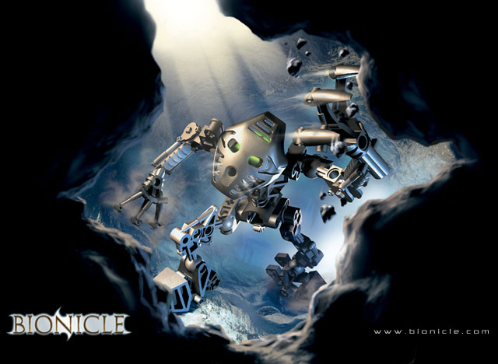
Gali is the spirit of the water, and the only female Toa. She is young but incredibly wise - wiser, possibly, than all the other five Toa put together.
The Tohunga worship her more than any of the others. They believe she is the sustainer of life - but if she gets angry, look out! Tidal waves and rainstorms flood the island!
Gali is the most agile and gymnastic of the six Toa. She has incredible jumping abilities and her own brand of acrobatic self-defence. The only things that slow her down are excessively hot and dry conditions.
Gali is at home both in and near the waters of Lake Naho. Here she can swim and move quickly around the waterfalls that plunge down into the icy water, using her two hooked arms to grab onto rocks and cliffs. She works in harmony with the waters, which help to protect her in times of danger.

 | The Great Mask of Water; allows the user to breathe underwater.

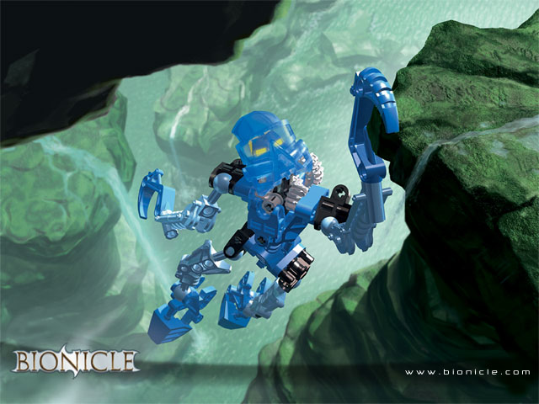
Lewa is the spirit of the air, the youngest of the six Toa. The Tohunga believe Lewa controls the skies - the clouds and the wind. Lewa is almost monkey-like, and prefers to inhabit the treetops of the Jungles around Kauae Bay.
Lewa's axe cuts easily through trees and vines as he climbs and jumps through his jungle. He's supremely competent with aerial activities, and can even glide through the air when jumping from tree to tree.
Lewa is always ready to jump to conclusions - and he's the first to get into trouble. But his instincts are good, and his hunches often turn out to be right. If there's a fight, he's always the first one in, protecting others before himself.

 | The Great Mask of Levitation; allows the user to float and glide on air.

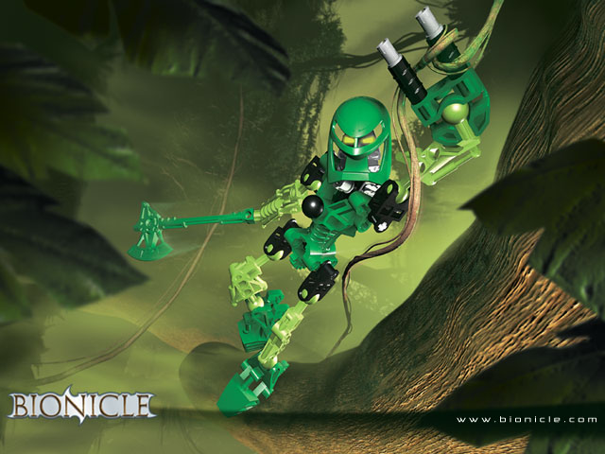
Tahu is the oldest of the Toa, the fire spirit created by The Great Beings when the planet was first forming. He is the fiercest of the six Toa, and the most feared - you don't want to get into a fight with Tahu if you can help it.
Tahu is most at home in the hot molten world of the Mangai Volcano where he surfs on lava flows, using his sword of flames to cut through rocks and keep the lava moving down towards the ocean.
He is hot-headed and irrational, with a flaming temper. He has the least patience of all of the Toa, and often jumps into a situation without thinking, which often gets him and the other Toa into trouble!

 | The Great Mask of Shielding; provides protection against any attack the user is aware of, but not against ambush.

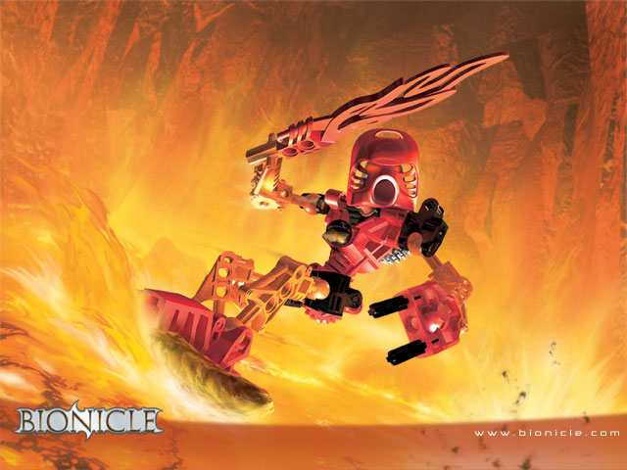
Kopaka is the spirit of ice. He is cool, calculating, and coldly methodical in his actions. His long ice blade cuts and melts through the ice; one skillful swipe of it can cause avalanches or instantly freeze anything it touches.
Kopaka prefers to work alone. He is the least communicative of the Toa, and will only join forces with the others if it's necessary for his own survival.
The Tohunga both fear and respect Kopaka a great deal. They believe that he brings the winters, and the long cold nights...but they also know that his power strikes a balance against the presence of the fire spirit Tahu.
Kopaka is most at home on the ice and snow of Mount Ihu, skiing up and down the slopes with amazing speed and skill.

 | The Great Mask of X-Ray Vision; allows the user to see through walls and discover that which is hidden.

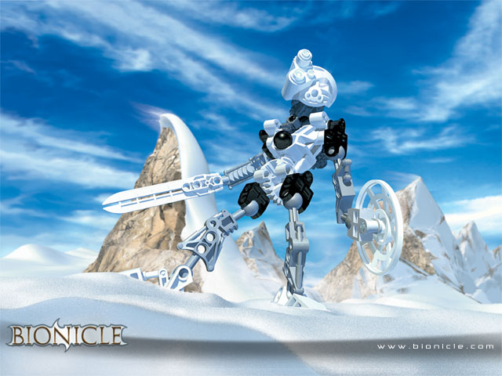

Turaga Onewa is the protector of Pohatu's legend. Like all of his tribe he is sure-footed and swift over loose ground. Onewa is known among his tribe as "The Referee," as his decisions are never argued (even though he sometimes takes forever to make them!).
Onewa's mask is the Kanohi Komau and his tool is a mighty stone hammer.

Mask | 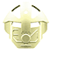 | The Noble Mask of Mind Control; allows the user to command others to do the user's bidding!
Vilage | 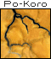

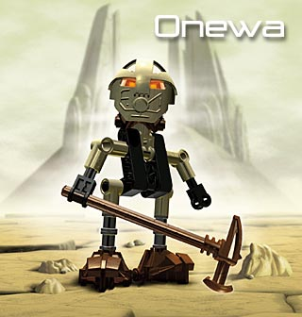
Turaga Whenua is the protector of Onua's legend. He oversees the work in the rockquarry and the vast, complex tunnels, always seeing problems a day before they occur. Whenua is known to all on Mata Nui for his fairness, good judgement, wisdom and honesty. He should always be listened to with care and respect.

Whenua's mask is the Kanohi Ruru and his tool is the Drill of Onua.

Mask |  | The Noble Mask of Night Vision; gives the user the power to see in any level of darkness.
Vilage | 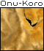

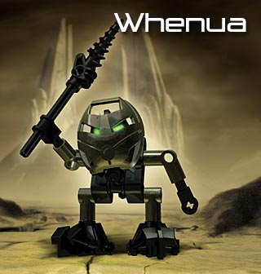
Turaga Nokama is the protector of Gali's legend. She knows more about the ways of the oceans and rivers than anyone but Gali herself. Nokama has a reputation for resolving disagreements and bringing the Turaga together with her practical logic. All of the Turaga respect the way she listens to all sides of any discussion.
Nokama's mask is the Kanohi Rau and her tool is an enormous fork-shaped staff.

Mask |  | The Noble Mask of Translation; allows the user to read the ancient languages, runes and symbols.
Vilage | 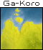

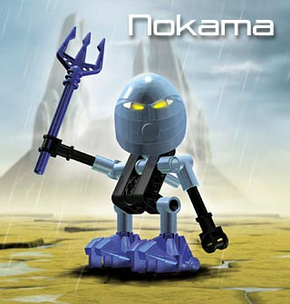
Turaga Matau is the protector of Lewa's legend. When he is among his people, Matau is like the silence at the centre of a tornado, calm, stable and paternal. But you'd better watch him carefully, or you'll be the victim of one of his jokes! He is also a brave warrior and a leader who receives the utmost of loyalty. The tribe repays him with great courage.
Matau's mask is the Kanohi Mahiki and his tool is the Kau Kau Staff.

Mask |  | The Noble Mask of Illusion; allows the user to create illusions to deceive an opponent or escape detection.
Vilage | 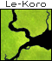

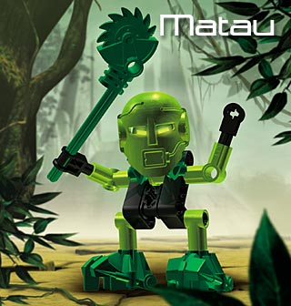
Turaga Vakama is the holder of the Great Firestaff and protector of Tahu's legend. He is famous for his quick temper and great courage. Vakama doesn't mess around: he has no time for nonsense and practical jokes, but his fearlessness could get him into trouble.
Vakama's mask is the Kanohi Huna and his tool is the ancient Firestaff.

Mask |  | The Noble Mask of Concealment; allows the user to turn invisible
Vilage | 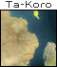

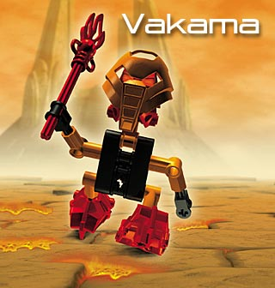
Turaga Nuju is the protector of Kopaka's legend. Nuju has great sight and seems to have more time to react than anybody else. His Kanohi Matatu (mask of telekinesis) amplifies these gifts, allowing him to move objects with his mind. It is said that he can tell stories that last for days, using only gestures and whistles that none but his Tohunga Matoro can interpret. Some find Nuju aloof and uncaring, but he just shows his feelings in different ways -- like through his generous deeds.
Nuju's tool is a huge ice pick.

Mask | 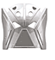 | The Noble Mask of Telekinesis; allows the user to move objects and project force by thought. The stronger the thought, the stronger the power!
Vilage | 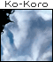

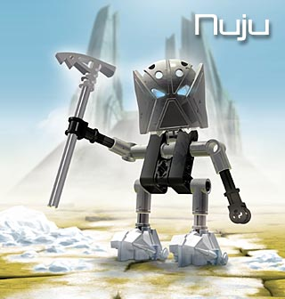
Huki, who stands on Onewa's right side, lives in the desert village of Po-Koro. He is the greatest goal scorer of all time at Koli and one of the few Tohunga able to crush boulders with both his feet and his head. It is said that he learnt this skill after Maku soaked his mask during a practical joke. (Maku must have known that followers of Pohatu cannot swim and hate water.)
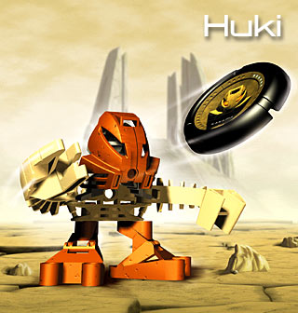

To the right of Whenua stands Onepu. Onepu lives in the underground village of Onu-Koro. Though he appears small, he has incredible strength in is his short, dense body, and can lift many times his own weight. He's clumsy, but enthusiastic -- if his friends need protection, you'll find him at the front of the pack (probably falling over his own feet to get there!).
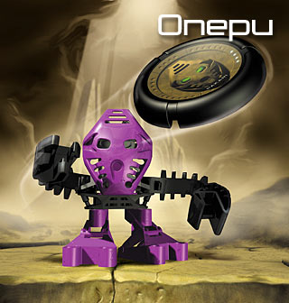

Maku lives in the village of Ga-Koro. Her skill at canoe racing is legendary among all Tohunga. Her sense of direction is flawless--she can navigate through the waters surrounding Mata Nui in even the worst conditions. Her skills in swimming and disc throwing are remarkable, making her a favorite in the local Tohunga games competition. Maku often gets in trouble for dissapearing from the village, paddling upstream in her canoe to spy on Huki the Koli champion. She has a kind heart, but she is too trusting of others.
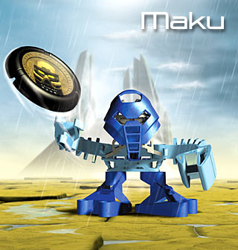

Kongu is one of the most talented residents in his treetop village of Le-Koro. Swinging on vines, he travels from tree-top to tree-top with such speed that it looks like he's on fire. But the truth is that Kongu's afraid of heights! This is why he travels so fast -- to avoid looking down! He keeps quiet about it for fear of being removed from Matau's right side in the Great Takara. Also, Kongu loves birds so much and handles them so naturally that he has become one of Le-Koro's great bird wranglers.
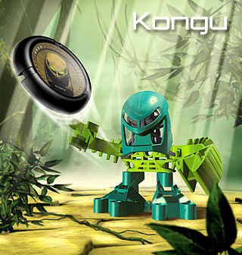

Jala's athletic ability and no-nonsense manner make him the obvious choice to stand at Vakama's right hand. As captain of the guard, it's his job to protect their village of Ta-Koro and organize its warriors. The founder of Jala's clan, Lhii, was once the greatest surfer Mata Nui has known since Tahu last walked upon the land. Jala has much to live up to, but he is dedicated and works hard.
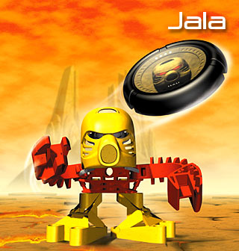

Matoro is the sole interpreter of Nuju's stories, following the meaning of his movement and tones. He always stands motionless to Nuju's right during storytelling, in his narrator pose: legs apart, head back and using his deep and booming voice. Matoro has a tendency to show off, which makes him look really conceited. As a result, the other natives of his village, Ko-Koro, like to play practical jokes on him -- but he takes them in good spirit.
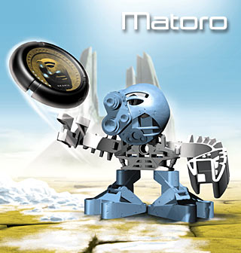

Hafu lives in PO-KORO, the stone village of Mata Nui. Hafu is best known for his skill at carving. Where others can tell moving, powerful tales with words, Hafu shares them through his beautiful carvings. Not all his time is spent on art, though - he has a wicked sense of humor and loves to send others out in search of plants, animals, or treasures that exist only in his imagination.
Rumour has it that Hafu has an incredible skill with a disk. He can make it return just like a boomerang.
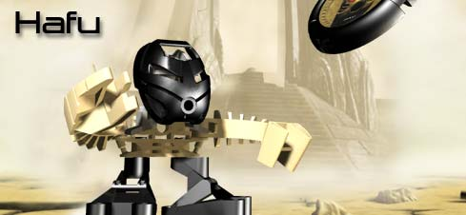

Kanohi Rua
The Toa Kaita Whairhua, a more powerful Toa formed by merging of Tahu, Pohatu, and Onua, wears the Silver Mask of Valor. The Silver Mask combines the powers of the Great Masks of Strength, Speed, and Shielding, making the wearer extremely difficult to harm.
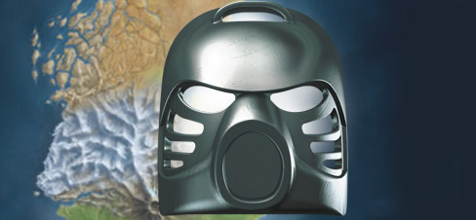

When Kanohi Masks of Power are tainted by Makuta, they become "infected masks". Infected masks appear scarred, pitted, and rusted. Wearers become slaves of Makuta, and remain so until the mask is removed.
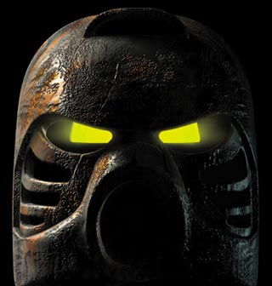

Each Toa must collect six Great Masks of Power, so that together they can defeat Makuta and fulfill their destiny. Each mask grants the wearer new power and wisdom.
Noble Masks do not posses as much energy as the Great Masks of Power, but they too are vital to the Toa's quest. The Noble Masks can be worn by both the Toa and Turaga, and each Toa must collect six Noble Masks.
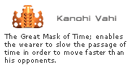

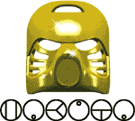

Color | Power | Worn by
Bright Red | Levitation | Tahu
Brown | Levitation | Pohatu
Black | Levitation | Onua
Bright Blue | Levitation | Gali
Green | Levitation | Lewa
White | Levitation | Kopaka
Bluish Green | ? | Kongu
Color | Power |  | Worn by
Bright Red | X-Ray Vision |  | Tahu
Brown | X-Ray Vision |  | Pohatu
Black | X-Ray Vision |  | Onua
Bright Blue | X-Ray Vision |  | Gali
Green | X-Ray Vision |  | Lewa
White | X-Ray Vision |  | Kopaka
Sand Blue | ? |  | Matoro
Color | Power |  |  | Worn by
Transparent Red | Water Breathing |  |  | Tahu
Transparent Orange | Water Breathing |  |  | Pohatu
Transparent Brown | Water Breathing |  |  | Onua
Transparent Blue | Water Breathing |  |  | Gali
Transparent Green | Water Breathing |  |  | Lewa
Transparent | Water Breathing |  |  | Kopaka
Transparent Fluorescent Blue | ? |  |  | ?
Transparent Fluorescent Yellow | ? |  |  | ?
Color | Power |  |  | Worn by
Bright Red | Shielding |  |  | Tahu
Brown | Shielding |  |  | Pohatu
Black | Shielding |  |  | Onua
Bright Blue | Shielding |  |  | Gali
Green | Shielding |  |  | Lewa
White | Shielding |  |  | Kopaka
Yellow | ? |  |  | Jala
Gold | ? |  |  | ?
Silver | ? |  |  | ?
Infected | ? |  |  | Muaka, ?
Color | Power |  |  | Worn by
Bright Red | Strength |  |  | Tahu
Brown | Strength |  |  | Pohatu
Black | Strength |  |  | Onua
Bright Blue | Strength |  |  | Gali
Green | Strength |  |  | Lewa
White | Strength |  |  | Kopaka
Bright Violet | ? |  |  | Onepu, Nui-Jaga
Medium Blue | ? |  |  | Nui-Jaga
Bright Blue | ? |  |  | Tarakava
Color | Power |  |  | Worn by
Bright Red | Speed |  |  | Tahu
Brown | Speed |  |  | Pohatu
Black | Speed |  |  | Onua
Bright Blue | Speed |  |  | Gali
Green | Speed |  |  | Lewa
White | Speed |  |  | Kopaka
Dark Orange | ? |  |  | Huki
Bluish Green | ? |  |  | Tarakava
Color | Power |  |  | Worn by
Bright Orange | Illusion |  |  | Vakama
Grey | Illusion |  |  | Nuju
Brick Yellow | Illusion |  |  | Onewa
Dark Grey | Illusion |  |  | Whenua
Medium Blue | Illusion |  |  | Nokama
Yellowish Green | Illusion |  |  | Matau
Color | Power |  |  | Worn by
Bright Orange | Telekinesis |  |  | Vakama
Grey | Telekinesis |  |  | Nuju
Brick Yellow | Telekinesis |  |  | Onewa
Dark Grey | Telekinesis |  |  | Whenua
Medium Blue | Telekinesis |  |  | Nokama
Yellowish Green | Telekinesis |  |  | Matau
Bright Red | ? |  |  | ?
Brown | ? |  |  | ?
Black | ? |  |  | ?
Bright Blue | ? |  |  | ?
Green | ? |  |  | ?
White | ? |  |  | ?
Color | Power |  |  | Worn by
Bright Orange | Translation |  |  | Vakama
Grey | Translation |  |  | Nuju
Brick Yellow | Translation |  |  | Onewa
Dark Grey | Translation |  |  | Whenua
Medium Blue | Translation |  |  | Nokama
Yellowish Green | Translation |  |  | Matau
Color | Power |  |  | Worn by
Bright Orange | Concealment |  |  | Vakama
Grey | Concealment |  |  | Nuju
Brick Yellow | Concealment |  |  | Onewa
Dark Grey | Concealment |  |  | Whenua
Medium Blue | Concealment |  |  | Nokama
Yellowish Green | Concealment |  |  | Matau
Medium Blue | ? |  |  | Maku
Black | ? |  |  | Kane-ra
Color | Power |  |  | Worn by
Bright Orange | Night Vision |  |  | Vakama
Grey | Night Vision |  |  | Nuju
Brick Yellow | Night Vision |  |  | Onewa
Dark Grey | Night Vision |  |  | Whenua
Medium Blue | Night Vision |  |  | Nokama
Yellowish Green | Night Vision |  |  | Matau
Bright Red | ? |  |  | ?
Brown | ? |  |  | ?
Bright Blue | ? |  |  | ?
Green | ? |  |  | ?
White | ? |  |  | ?
Black | ? |  |  | Hafu
Transparent Blue | ? |  |  | Nui-Rama
Color | Power |  |  | Worn by
Bright Orange | Mind Control |  |  | Vakama
Grey | Mind Control |  |  | Nuju
Brick Yellow | Mind Control |  |  | Onewa
Dark Grey | Mind Control |  |  | Whenua
Medium Blue | Mind Control |  |  | Nokama
Yellowish Green | Mind Control |  |  | Matau

 |  | 
 |  | 
 | 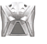 | 
 |  | 

No creature that speaks has seen the Makuta and returned. His lair could be in every shadow, every scrap of darkness. Some say he has three heads. Others say he can change into many forms. Only one thing is known for sure: if he is not stopped, his power and evil will grow to dominate all of Mata Nui.
The legend says the Makuta is a whirling, kicking, screaming, clawing beast. He--or IT-- could be many things at once - cobra, tiger, hawk. Each must be defeated before the Makuta emerges from deep inside the surface of Mata Nui and replicates into a vicious swarm of separate and equally deadly beasts. And if this happens, the beings of Mata Nui will know untold harm. So the legend says.
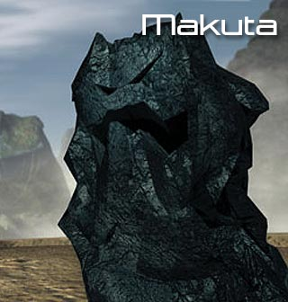
The Nui-Rama resemble large, flying insects. They can be found throughout Mata Nui, though it is believed they make their nests in Lewa’s jungles. Nui-Rama spend most of their time in the air, spying on the Toa for Makuta or stalking their prey.
Natural Tools: The Nui-Rama can make their buzzing wings flip forward to dislodge an opponent’s mask. They can fly at great speed and often use hit-and-run tactics to keep their enemies off-balance.
Danger Level: Although Nui-Rama are not as powerful as Toa, they have one very large advantage over the heroes: they can fly. The Mask of Levitation allows a Toa to float on the air, but none of the Toa have the power of flight. This gives the Nui-Rama a huge edge and makes them a real threat to the Toa and the tribes of Mata Nui.
Like all Rahi, the Nui-Rama are controlled by the infected masks they wear. If the masks are removed, the Nui-Rama will cease fighting and can sometimes even be tamed.
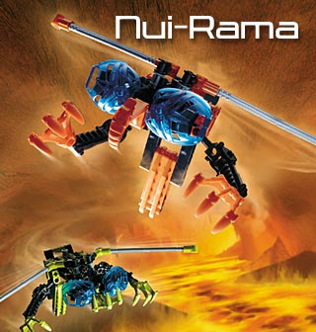
The Nui-Jaga are huge, scorpion-like creatures. They can be found primarily in the deserts of Mata Nui, though they have been spotted in the jungles and along the coast as well. Nui-Jaga normally hunt in pairs.
Natural Tools: Nui-Jaga rely on their strong claws and their powerful stinger. A single well-placed blow from a stinger can knock off an opponent’s mask. They have also been known to work with other Rahi, using their stingers to “herd” enemies into ambushes.
Danger Level: The best way to survive an encounter with a Nui-Jaga is to stay out its way. Their speed, their stingers, and their cunning make them dangerous opponents. The Toa most successful at battling Nui-Jaga is Lewa, who can take to the trees and stay out of range of their stingers.
Like all Rahi, the Nui-Jaga are controlled by the infected masks they wear. If the masks are removed, the Nui-Jaga will cease fighting and can sometimes even be tamed.
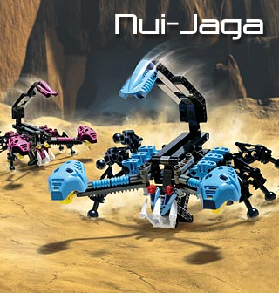
Tarakava live in the oceans and rivers of Mata Nui, preferring the shallows close to the shoreline. They are huge, lizard-like creatures and virtually always hunt in pairs. Those Tohunga who sail the waters of Mata Nui have learned to fear the Tarakava more than any other Rahi.
Natural Tools: Tarakava are amphibious. They can stay underwater for prolonged periods of time, waiting for a chance to strike. When prey comes near, their use their powerful arms to stun their target. They have also been known to attack Tohunga boats, capsizing them.
Danger Level: Like the Nui-Rama, the Tarakava are comfortable in an element unfamiliar to most Toa: water. Gali, the Toa of water, is the best equipped to battle Tarakava, and even she is wary of them. Pohatu and Lewa, both of whom dislike water, are at the biggest disadvantage when facing Tarakava.
Like all Rahi, Tarakava are controlled by the infected masks they wear. If the masks are removed, they will cease fighting and can sometimes even be tamed.
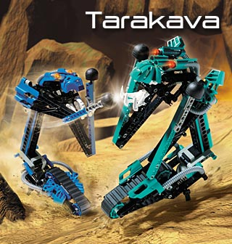
Although they are very different creatures, Muaka and Kane-Ra work together because Makuta wishes them to do so. Muaka is a large tiger-like creature and Kane-Ra resembles a great bull. They are two of the most powerful Rahi!
Natural Tools: Both Muaka and Kane-Ra are capable of extending their necks a great distance, making it easier for them to corner and catch prey. Muaka relies on his snapping jaws, Kane-Ra on his sharp horns. Muaka and Kane-Ra are both very fast and rely on surprise.
Danger Level: Many a Tohunga has made the mistake of thinking that because Muaka or Kane-Ra was far away, there was no danger. Their ability to extend their necks means you can never be sure where an attack will come from. Often, Muaka hides in the jungle and will suddenly shoot his head forward to grab something on the path, while his body stays concealed.
Like all Rahi, Muaka and Kane-Ra are controlled by the infected masks they wear. If the masks are removed, the two will cease fighting and can sometimes even be tamed.
