Name | Abb. | Song | Bird | Flower | Capital | Largest City | Date United | Land Area | # of Counties | Pop. | Motto | Nickname | Flag
Alabama | AL | Alabama | Yellowhammer | Camellia | Montgomery | Birmingham | 1819 12/14 | 50,750 | 67 | 4,447,100 | Audemus jura nostra defendere (We dare defend our rights) | Yellowhammer State | 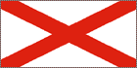
Alaska | AK | Alaska's Flag | Willow Ptarmigan | Forget-me-not | Juneau | Anchorage | 1959 01/03 | 570,374 | 16 | 626,932 | North to the Future | The state is commonly called “The Last Frontier” or “Land of the Midnight Sun” | 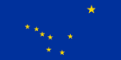
Arizona | AZ | Arizona | Cactus Wren | Saguaro Cactus Blossom | Phoenix | Phoenix | 1912 02/13 | 114,000 | 15 | 5,130,632 | Ditat Deus (God enriches) | Grand Canyon State | 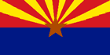
Arkansas | AR | Arkansas, Oh, Arkansas | Mockingbird | Apple Blossom | Little Rock | Little Rock | 1836 06/15 | 52,075 | 75 | 2,673,400 | Regnat populus (The people rule) | The Natural State | 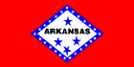
California | CA | I Love You, California | California Valley Quail | Golden Poppy | Sacramento | Los Angeles | 1850 09/09 | 155,973 | 58 | 33,871,648 | Eureka (I have found it) | Golden State | 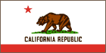
Colorado | CO | Where the Columbines Grow | Lark Bunting | Columbine | Denver | Denver | 1876 08/01 | 103,730 | 63 | 4,301,261 | Nil sine Numine (Nothing without Providence) | Centennial State | 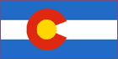
Connecticut | CT | Yankee Doodle | American Robin | Mountain Laurel | Hartford | Bridgeport | 1788 01/09 | 4,845 | 8 | 3,405,565 | Qui transtulit sustinet (He who transplanted still sustains) | Constitution State (official, 1959); Nutmeg State | 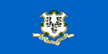
Delaware | DE | Our Delaware | Blue Hen Chicken | Peach Blossom | Dover | Wilmington | 1787 12/07 | 1,982 | 3 | 783,600 | Liberty and independence | Diamond State; First State; Small Wonder | 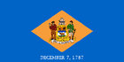
Florida | FL | Swanee River, Florida, My Florida | Mockingbird | Orange Blossom | Tallahassee | Jacksonville | 1845 03/03 | 53,997 | 67 | 15,982,378 | In God we trust (1868) | Sunshine State (1970) | 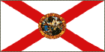
Georgia | GA | Georgia on My Mind | Brown Thrasher | Cherokee Rose | Atlanta | Atlanta | 1788 01/02 | 57,919 | 159 | 8,186,453 | Wisdom, justice, and moderation | Peach State, Empire State of the South | 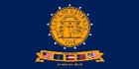
Hawaii | HI | Hawaii Ponoi | Nene (Hawaiian Goose) | Hibiscus | Honolulu | Honolulu | 1959 08/21 | 6,243 | 5 | 1,211,537 | Ua Mau Ke Ea O Ka Aina I Ka Pono (The life of the land is perpetuated in righteousness) | Aloha State (1959) | 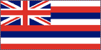
Idaho | ID | Here We Have Idaho | Mountain Bluebird | Syringa | Boise | Boise | 1890 07/03 | 82,751 | 44 | 1,293,953 | Esto perpetua (It is forever) | Gem State | 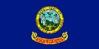
Illinois | IL | Illinois | Cardinal | Native violet | Springfield | Chicago | 1818 12/03 | 55,593 | 102 | 12,419,293 | State sovereignty, national union | Prairie State | 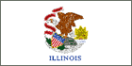
Indiana | IN | On the banks of the Wabash | Cardinal | Peony | Indianapolis | Indianapolis | 1816 12/11 | 35,870 | 92 | 6,080,485 | The Crossroads of America | Hoosier State | 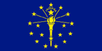
Iowa | IA | The Song of Iowa | Eastern Goldfinch | Wild Rose | Des Moines | Des Moines | 1846 12/28 | 55,875 | 99 | 2,926,324 | Our liberties we prize and our rights we will maintain | Hawkeye State | 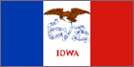
Kansas | KS | Home on the Range | Western Meadowlark | Native Sunflower | Topeka | Wichita | 1861 01/29 | 81,823 | 105 | 2,688,418 | Ad astra per aspera (To the stars through difficulties) | Sunflower State; Jayhawk State | 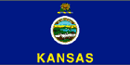
Kentucky | KY | My Old Kentucky Home | Kentucky Cardinal | Goldenrod | Frankfort | Louisville | 1792 06/01 | 39,732 | 120 | 4,041,769 | United we stand, divided we fall | Bluegrass State | 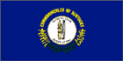
Louisiana | LA | Give Me Louisiana, You Are My Sunshine | Pelican | Magnolia | Baton Rouge | New Orleans | 1812 04/30 | 43,566 | 64 | 4,468,976 | Union, justice, and confidence | Pelican State | 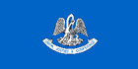
Maine | ME | State Song of Maine | Chickadee | White Pine Cone and Tassel | Augusta | Portland | 1820 03/15 | 30,865 | 39 | 1,274,923 | Dirigo (I lead) | Pine Tree State | 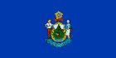
Maryland | MD | Maryland My Maryland | Baltimore Oriole | Black-Eyed Susan | Annapolis | Baltimore | 1788 04/28 | 9,775 | 23 | 5,296,486 | Fatti maschii, parole femine (Manly deeds, womanly words) | Free State; Old Line State | 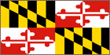
Massachusetts | MA | Hail Massachusetts | Chickadee | Mayflower | Boston | Boston | 1788 02/06 | 7,838 | 14 | 6,349,097 | Ense petit placidam sub libertate quietem (By the sword we seek peace, but peace only under liberty) | Bay State; Old Colony State | 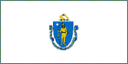
Michigan | MI | Michigan, My Michigan | Robin | Apple Blossom | Lansing | Detroit | 1837 01/26 | 58,110 | 83 | 9,938,444 | Si quaeris peninsulam amoenam circumspice (If you seek a pleasant peninsula, look around you) | Wolverine State | 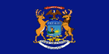
Minnesota | MN | Hail! Minnesota | Common Loon | Pink and White Lady's Slipper | St. Paul | Minneapolis | 1858 05/11 | 79,617 | 87 | 4,919,479 | L'Étoile du Nord (The North Star) | North Star State; Gopher State; Land of 10,000 Lakes | 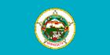
Mississippi | MS | Go Mis-sis-sip-pi | Mockingbird | Magnolia | Jackson | Jackson | 1817 12/10 | 46,914 | 82 | 2,844,658 | Virtute et armis (By valor and arms) | Magnolia State | 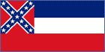
Missouri | MO | Missouri Waltz | Bluebird | Hawthorn | Jefferson City | Kansas City | 1821 08/10 | 68,898 | 114 | 5,595,211 | Salus populi suprema lex esto (The welfare of the people shall be the supreme law) | Show-me State | 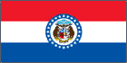
Montana | MT | Montana, Montana Melody | Western Meadowlark | Bitterroot | Helena | Billings | 1889 11/08 | 145,556 | 56 | 902,195 | Oro y plata (Gold and silver) | Treasure State | 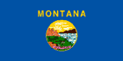
Nebraska | NE | Beautiful Nebraska | Western Meadowlark | Goldenrod | Lincoln | Omaha | 1867 03/01 | 76,664 | 93 | 1,711,263 | Equality before the law | Cornhusker State (1945); Beef State | 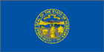
Nevada | NV | Home Means Nevada | Mountain Bluebird | Sagebrush | Carson City | Las Vegas | 1864 10/31 | 109,806 | 16 | 1,998,257 | All for Our Country | Sagebrush State; Silver State; Battle Born State | 
New Hampshire | NH | Old New Hampshire | Purple Finch | Purple Lilac | Concord | Manchester | 1788 06/21 | 8,969 | 10 | 1,235,786 | Live free or die | Granite State | 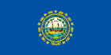
New Jersey | NJ | I'm From New Jersey | Eastern Goldfinch | Purple Violet | Trenton | Newark | 1787 12/18 | 7,419 | 21 | 8,414,350 | Liberty and prosperity | Garden State | 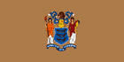
New Mexico | NM | O, Fair New Mexico | Roadrunner | Yucca Flower | Santa Fe | Albuquerque | 1912 01/06 | 121,365 | 33 | 1,819,046 | Crescit eundo (It grows as it goes) | Land of Enchantment (1999) | 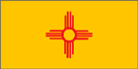
New York | NY | I love New York | Bluebird | Rose | Albany | New York City | 1788 07/26 | 47,224 | 62 | 18,976,457 | Excelsior (Ever upward) | Empire State | 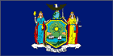
North Carolina | NC | The Old North State | Cardinal | Dogwood | Raleigh | Charlotte | 1789 11/21 | 48,718 | 100 | 8,049,313 | Esse quam videri (To be rather than to seem) | Tar Heel State | 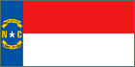
North Dakota | ND | North Dakota Hymn | Western Meadowlark | Wild Prairie Rose | Bismark | Fargo | 1889 11/02 | 68,994 | 53 | 642,200 | Liberty and union, now and forever: one and inseparable | Sioux State; Flickertail State; Peace Garden State; Rough Rider State | 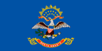
Ohio | OH | Beautiful Ohio | Cardinal | Scarlet Carnation | Columbus | Columbus | 1803 03/01 | 40,953 | 86 | 11,353,140 | With God all things are possible | Buckeye State | 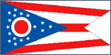
Oklahoma | OK | Oklahoma | Scissor-Tailed Flycatcher | Mistletoe | Oklahoma City | Oklahoma City | 1907 11/16 | 68,679 | 77 | 3,450,654 | Labor omnia vincit (Labor conquers all things) | Sooner State | 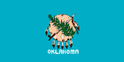
Oregon | OR | Oregon, My Oregon | Western Meadowlark | Oregon Grape | Salem | Portland | 1859 02/14 | 96,003 | 36 | 3,421,399 | Alis volat Propriis (She flies with her own wings) (1987) | Beaver State | 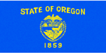
Pennsylvania | PA | Pennsylvania | Ruffed Grouse | Mountain Laurel | Harrisburg | Philadelphia | 1787 12/12 | 44,820 | 67 | 12,281,054 | Virtue, liberty, and independence | Keystone State | 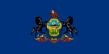
Rhode Island | RI | Rhode Island It's for me | Rhode Island Red | Violet | Providence | Providence | 1790 05/29 | 1,045 | 5 | 1,048,319 | Hope | The Ocean State | 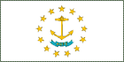
South Carolina | SC | Carolina | Carolina Wren | Yellow Jessamine | Columbia | Columbia | 1788 05/23 | 30,111 | 46 | 4,012,012 | Animis opibusque parati (Prepared in mind and resources) and Dum spiro spero (While I breathe, I hope) | Palmetto State | 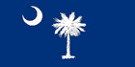
South Dakota | SD | Hail, South Dakota | Ring-Necked Pheasant | American Pasqueflower | Pierre | Sioux Falls | 1889 11/02 | 75,898 | 67 | 754,844 | Under God the people rule | Mount Rushmore State; Coyote State | 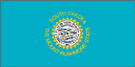
Tennessee | TN | My Homeland Tennessee, When It's Iris Time In Tennessee, My Tennessee, The Tennessee Waltz, Rocky Top, Tennessee | Mockingbird | Iris | Nashville | Memphis | 1796 06/01 | 41,220 | 95 | 5,689,283 | Agriculture and Commerce (1987) | Volunteer State | 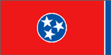
Texas | TX | Texas, Our Texas | Mockingbird | Bluebonnet | Austin | Houston | 1845 12/29 | 261,914 | 254 | 20,851,820 | Friendship | Lone Star State | 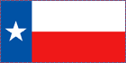
Utah | UT | Utah, We Love Thee | California Gull | Sego Lily | Salt Lake City | Salt Lake City | 1896 01/04 | 82,168 | 29 | 2,233,169 | Industry | Beehive State | 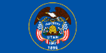
Vermont | VT | Hail, Vermont | Hermit Thrush | Red Clover | Montpelier | Burlington | 1791 03/04 | 9,249 | 14 | 608,827 | Vermont, Freedom and Unity | Green Mountain State | 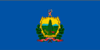
Virginia | VA | Carry Me Back to Old Virginia | Cardinal | Dogwood | Richmond | Virginia Beach | 1788 06/25 | 39,598 | 95 | 7,078,515 | Sic semper tyrannis (Thus always to tyrants) | The Old Dominion; Mother of Presidents | 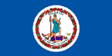
Washington | WA | Washington, My Home | Willow Goldfinch | Western Rhododendron | Olympia | Seattle | 1889 11/11 | 66,582 | 39 | 5,894,121 | Al-Ki (Indian word meaning “by and by”) | Evergreen State | 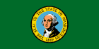
West Virginia | WV | The West Virginia Hills, This Is My West Virginia, West Virginia My Home | Cardinal | Big Rhododendron | Charleston | Charleston | 1863 06/20 | 24,087 | 55 | 1,808,344 | Montani semper liberi (Mountaineers are always free) | Mountain State | 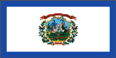
Wisconsin | WI | On Wisconsin | Robin | Wood Violet | Madison | Milwaukee | 1848 05/29 | 54,314 | 72 | 5,363,675 | Forward | Badger State | 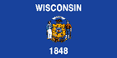
Wyoming | WY | Wyoming | Meadowlark | Indian Paintbrush | Cheyenne | Cheyenne | 1890 07/10 | 97,105 | 23 | 493,782 | Equal rights (1955) | Equality State | 