Timeline

1872 - Federal Mining Law; First claims at Morenci; town of Clifton founded
1874 - Detroit Copper Mining Company organized
1875 - First smelter (led to first railroad in Arizona)
1881 - Phelps, Dodge & Co. invests in new smelter for Detroit Copper
1884 - Arizona Copper Company organized
1886 - Bonanza ores exhausted; First concentrator in Arizona built
1892 - James Colquhoun appointed General Manager of a struggling Arizona Copper Co.; he institutes leaching of porphyry copper with sulfuric acid, leads to company's first profits
1897 - Phelps, Dodge & Co. buys Detroit Copper Mining Co.
1922 - Phelps, Dodge & Co. buys Arizona Copper Co. (with its Metcalf mine)
1932 - All mining temporarily halted due to the Great Depression
1937 - Phelps Dodge begins open-pit mining at Morenci
1942 - New concentrator and smelter built between Morenci and Clifton; large-scale mining begins in earnest
1948 - Molybdenum separator added
1974 - New Metcalf concentrator built
1985 - Phelps Dodge Inc. sells 15% of Morenci to Sumitomo Metal Mining, of Japan
1987 - New SX / EW plant constructed
1989 - Movable in-pit crushers and conveyors transport ore more efficiently

Pictures

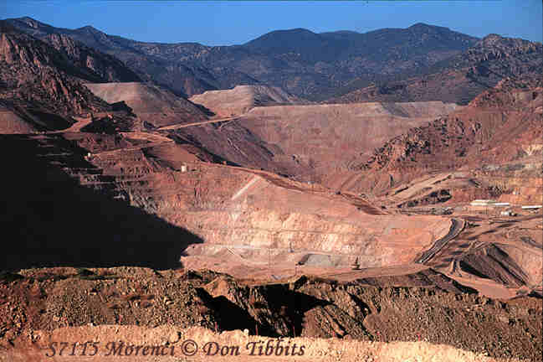
The Mine
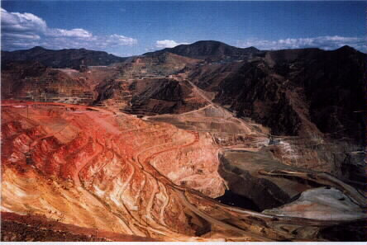
(Notice the layers of the mine where the rock was dug out)
Morenci Copper Mines
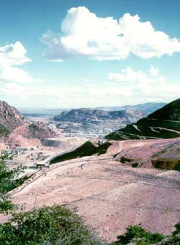

The second largest copper mines in all of north america

History

Arizona's extensive deposits of copper-bearing rock have made it the largest copper producing state in the U.S., with more production than all the other states combined. The oldest and most productive mine in the state is located at Morenci, near the New Mexico border. Copper was first mined at Morenci in 1872
As early as 1893 a struggling Arizona Copper Co. had to consider mining the low-grade porphyry copper at Morenci. The term porphyry refers to igneous rock containing conspicuous crystals (phenocrysts) in a fine-grained groundmass.
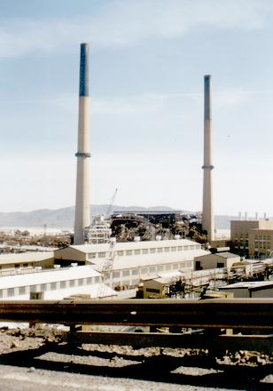
Open pit mining commenced at Morenci in 1937, and large-scale exploitation of the ore body began in 1942 with the construction of a new concentration facility. To profitably extract the copper from the deposit, it is necessary to remove great amounts (up to 2.5 parts) of waste rock to get to good ore.
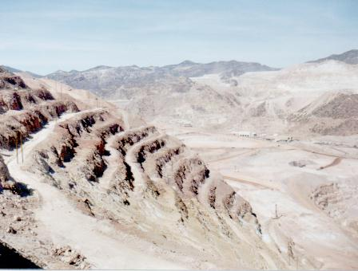

The Location
This is the second largest copper mine in all of North America, ranking third largest in the world. Accessed through the Globe area from the south, and Springerville, via Alpine from the north, Morenci is located 123 miles south of Springerville on the Coronado Trail. Now U.S. Hwy. 191, it was once Route 666, also called the "Devil's Highway." Laced with numerous switchbacks and precipitous drop-offs, it is one of the most scenic and rugged routes in the state -- perhaps in the nation.

Machinery
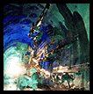
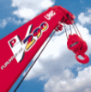
This particular copper mine uses the strip-mining technique. Strip-mining means they dig out layers of rock at a time then hull it off to be searched for copper. Great diesel trucks, arguably one of the most significant developments in open pit mining, are used to haul the ore out of the huge chasm, up to 190 tons per load. They also move the minerals with huge trains.

Products
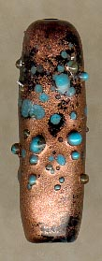
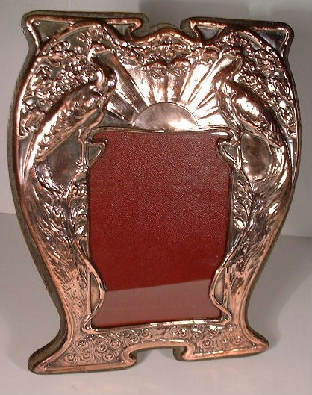
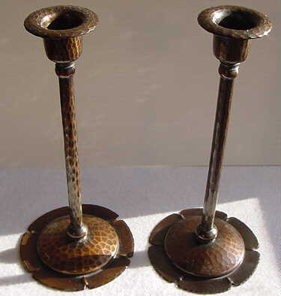
The materials they get from the mine can be made into numerous different things. One being postcards. Sometimes products aren’t worth sacrificing the land.
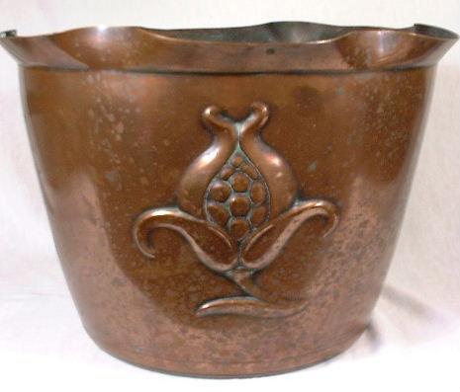

Products

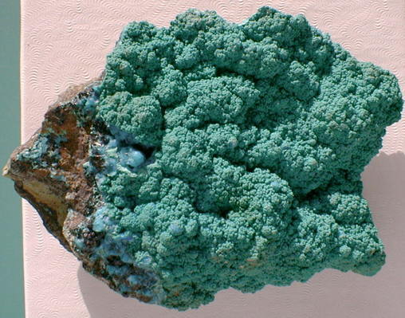
Malachite
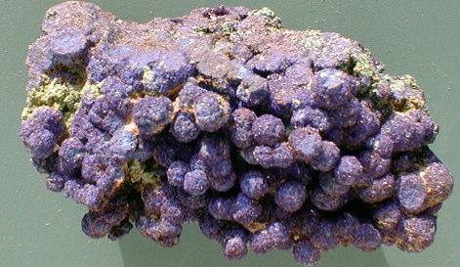
Azurite
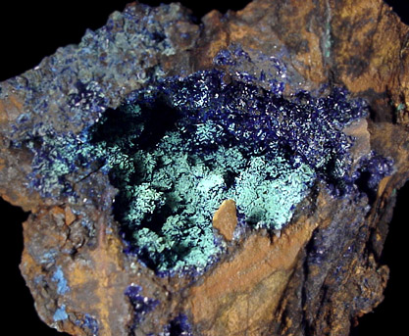
- This is the second largest copper mine in all of North America, ranking third largest in the world.
- As early as 1893 a struggling Arizona Copper Co. had to consider mining the low-grade porphyry copper at Morenci.
- Open pit mining commenced at Morenci in 1937, and large-scale exploitation of the ore body began in 1942 with the construction of a new concentration facility.
- Accessed through the Globe area from the south, and Springerville, via Alpine from the north, Morenci is located 123 miles south of Springerville on the Coronado Trail. Now U.S. Hwy. 191, it was once Route 666, also called the "Devil's Highway."
- Strip-mining means they dig out layers of rock at a time then hull it off to be searched for copper.
- Great diesel trucks, arguably one of the most significant developments in open pit mining, are used to haul the ore out of the huge chasm, up to 190 tons per load.
- The materials they get from the mine can be made into numerous different things.
- 1872 - Federal Mining Law; First claims at Morenci; town of Clifton founded
- 1874 - Detroit Copper Mining Company organized
- 1884 - Arizona Copper Company organized
- 1897 - Phelps, Dodge & Co. buys Detroit Copper Mining Co.
- 1932 - All mining temporarily halted due to the Great Depression
- 1985 - Phelps Dodge Inc. sells 15% of Morenci to Sumitomo Metal Mining, of Japan
- 1989 - Movable in-pit crushers and conveyors transport ore more efficiently

