Advanced UNIX Programming Final Exam Report
105062620 Wen-Chih Lo

- Question 2, user-defined sleep_us function:
  - This function, sleep_us, which is similar to sleep function, however, it waits for a specified number of microseconds. I use the timeval structure to store the waiting time, which is inputted from user manually. Then using the select function to monitor the file descriptor, and waiting until one or more of (here is one) the file descriptors become "ready" for some class of I/O operation.
  - How to run my program?
At first, you need to compile the program by using the commands below.
```
make
```
or
```
make clean all
```
Then, use the time command to measure whether the sleep_us function returns in the precise time.
```
time ./sleep_us <microseconds>
```
In the end, it will run successfully and look like this:
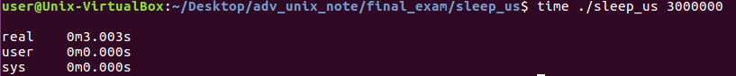

- Question 3, an alarm which is implemented by a single timer:
  - Use a single timer to implement a set of functions that enables a process to set and clear any number of timers. In this program, I use the sigaction structure to examine and change a signal action and signal set operations sigemptyset which initializes the signal set given by set to empty, with all signals excluded from the set. Then using the link list to store all the alarm which are set by user. Besides, using function alarm to set an alarm clock for delivery of a signal. Finally, clear all the pending alarms by using alarm(0).

  - How to run my program?
At first, you need to compile the program by using the commands below.
```
make
```
or
```
make clean all
```
Then, use the time command to measure whether the sleep_us function returns in the precise time.
```
./alarm
```
In the end, it will run successfully and look like this:
