TP1 Image Processing :
Basic Image Processing
Naël Briand
Quentin de La Chaise

1 – HARRIS CORNER DETECTOR
The Harris corner detector is a method used to identify corners within an image. Conceptually, when a small window is shifted across an image region, the presence of a corner results in a significant change in intensity, regardless of the direction of the shift.
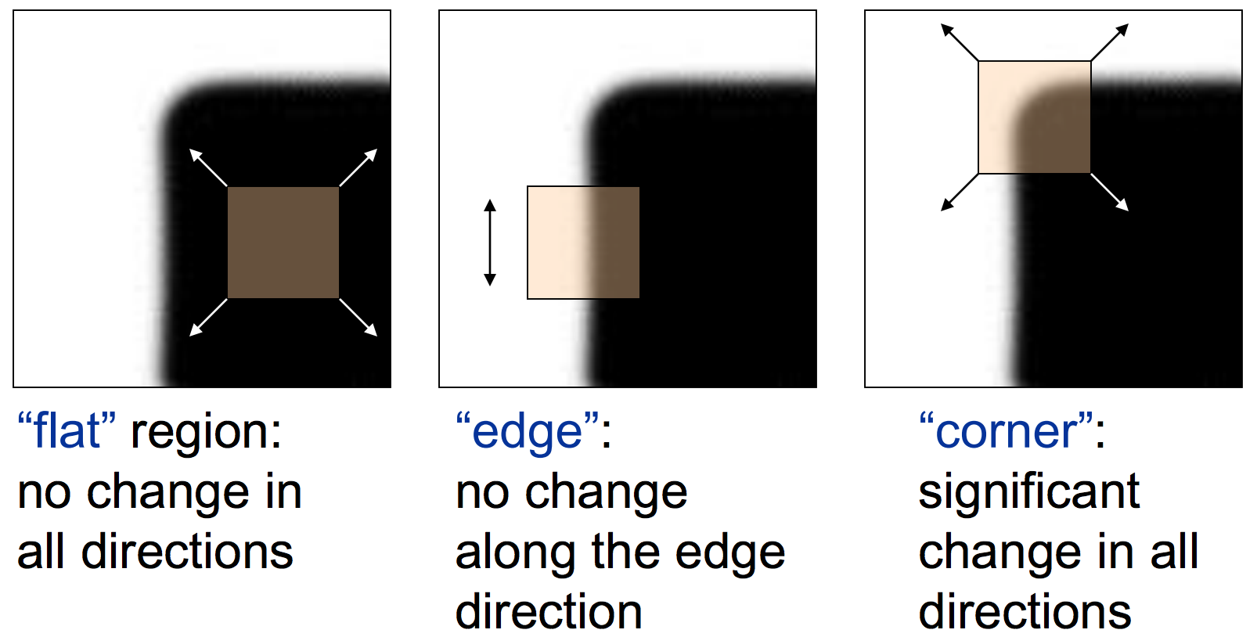
For our analysis, we selected two images: a simple one and another one more complex. The first image (image 1) allows us to validate the effectiveness of our algorithms, as it offers easily recognizable shapes, corners, and gradients. The second image (image 2) provides more challenging work, helping us to test the limits of the algorithms and explore the parameters of the techniques we apply.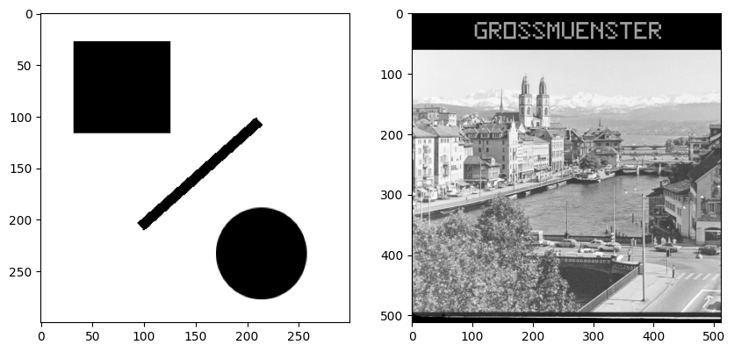
Image 1 | Image 2

Step 1:
We apply Sobel filter to the images (represented as NumPy matrices) to approximate the image gradients Ix and Iy thanks to the advanced library “cv2” for better performance.

The Sobel filter is an image processing method used for edge detection normally. It calculates the gradient of the intensity at each pixel in both directions x and y. This helps determine the direction of the strongest change in brightness (moreover here we will work with gray scale images rather than RGB images to make manipulation simpler). By identifying sudden shifts in intensity, we can detect edges and their orientations, which is crucial for locating corners because we can consider a corner as 2 perpendicular edges, as previously explained.
We can see clearly the edges of the first image horizontally and vertically but this harder to distinguish them in the second image due to more nuanced changes. However, in the 2 cases the filter worked well, we can detecting edges and their orientation effectively.
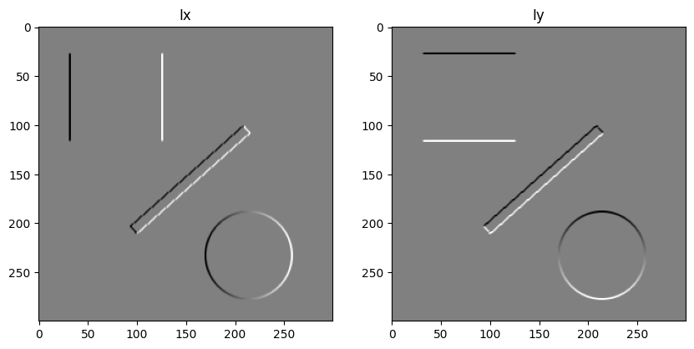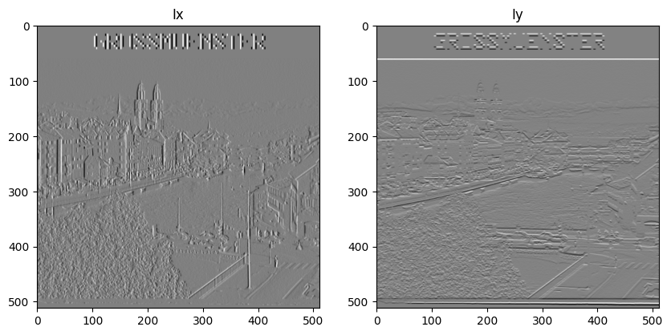
Step 2:
We move on to the next stage by constructing the matrices A and H with the computations of the intermediate values Ix2, Iy2, and Ixy, which are essential. In this step, we simply perform element-wise multiplications of the gradient matrices. For example, each element of Ixy is calculated by multiplying the corresponding elements of Ix and Iy (e.g., Ixy[1][1] = Ix[1][1] * Iy[1][1]).
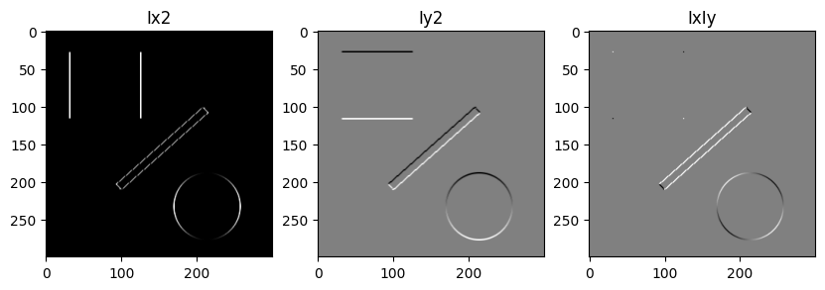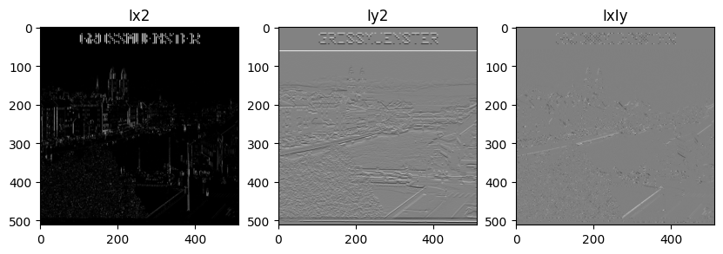
Step 3:
Now we want smoothed version of our matrices, so we apply a Gaussian filter. The filter's parameter can be provided as an input to our Harris Corner function, but if not specified, it defaults to a value of sigma_w = 1. After conducting several tests, where it consistently produced the most favorable results, we selected 1 as the default 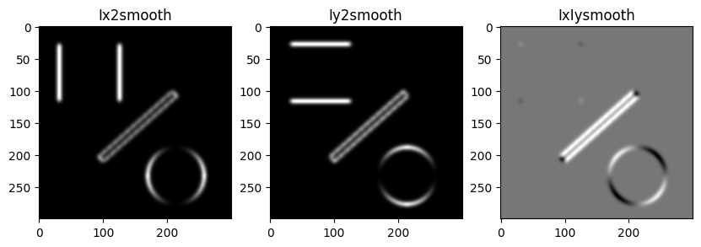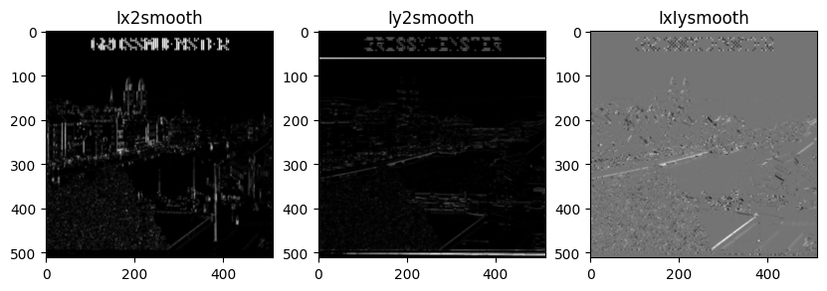

Step 4:
In step 4, we build the matrix H using the previously computed matrices Ixx, Ixy, and Iyy, which are organized into a matrix A. Initially, we set the parameter k to 0.04 as a starting point to observe the results (usual value of k, the other possibility is 0.06). From there, we experiment with different values of H to obtain more refined outcomes. Below are the results with k = 0.04. It's important to note that the H matrix reveals all the prominent edges of the image by utilizing the gradients.
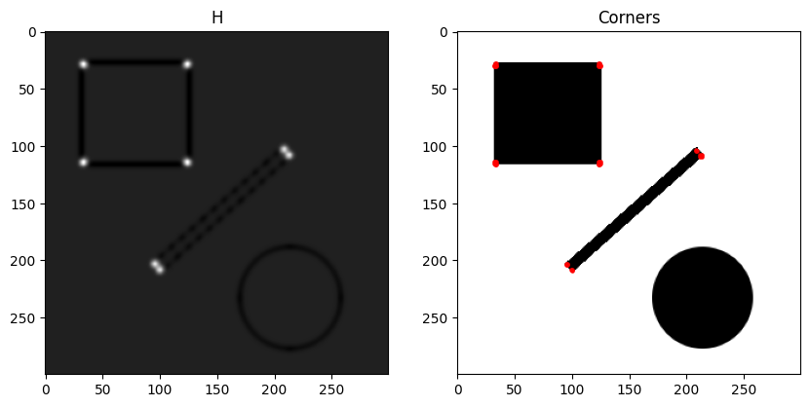Thesecond image have a H response particularly complicated to visualized with very low gray shades, so we try several choices of teta with slight increase.
With a threshold detection at teta = 0.1:
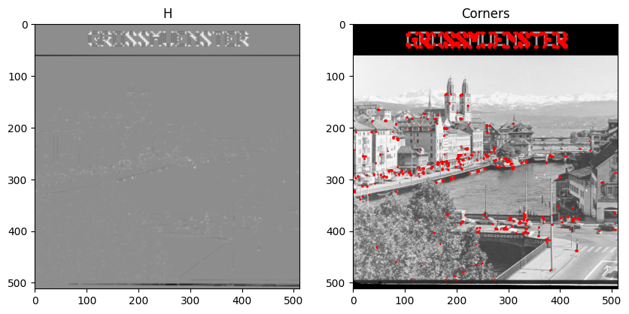
With a threshold detection at teta = 0.15:
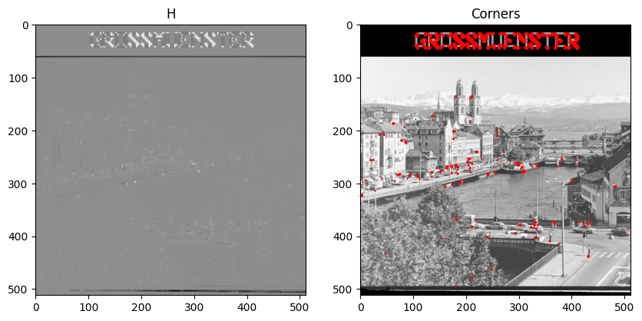
With a threshold detection at teta = 0.20: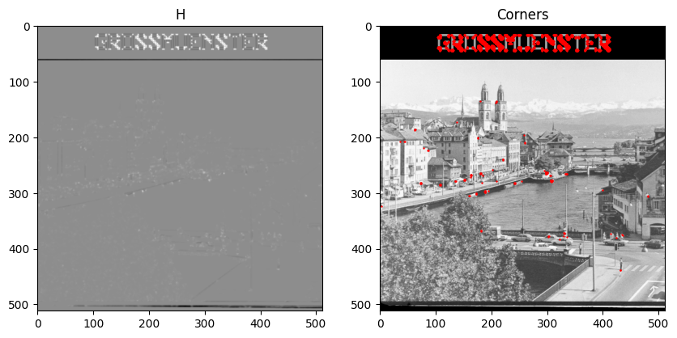
QUESTIONS:

- Is the Harris corner detector robust with respect to intensity shifts and intensity scalings ?

Yes, the Harris detector is robust to intensity shifts. Intensity shifts involve adding a constant value to all the pixel intensities in the image. For example, when the brightness is increased. The Harris detector calculates gradients and second-order moments based on intensity differences, which are unaffected by intensity shifts because gradients measure changes rather than absolute values.
However, intensity scaling involves multiplying all the pixel values by a constant factor. High scaling factors can exaggerate the response, while low factors can decrease it, making the detector sensitive to intensity scales.
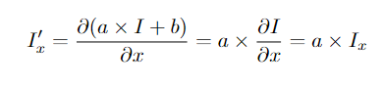
Here we see that shift has no effect unlike scaling.
The shift :
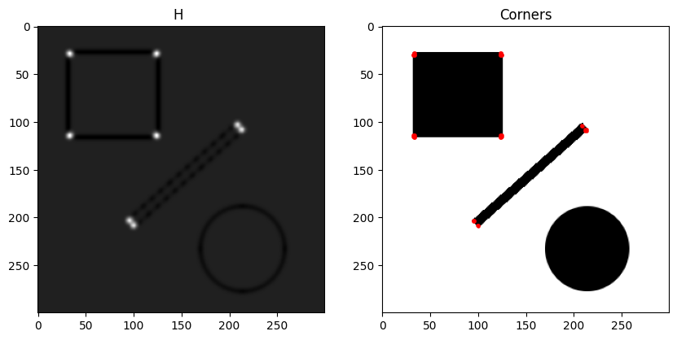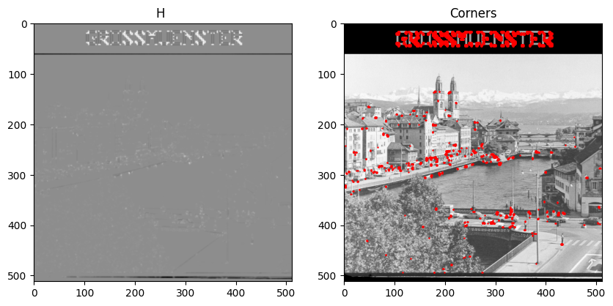the scaling
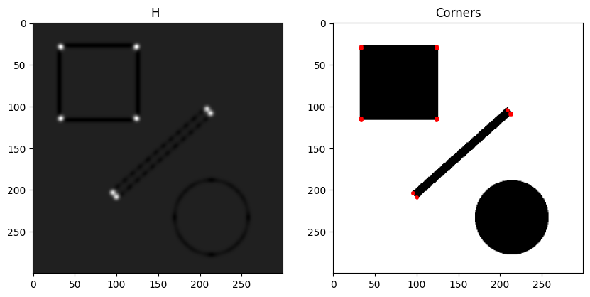
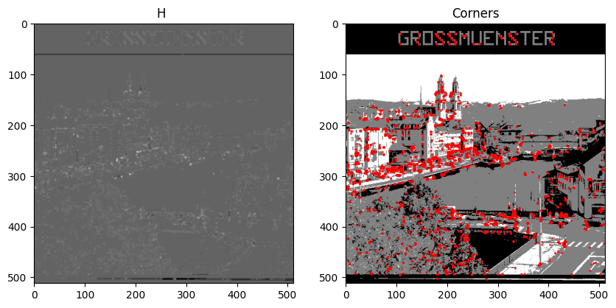
- Is the Harris corner detector robust with respect to translation ?

Yes, because the calculation of the Harris response is based on local properties of the image, such as the gradients and moments around each pixel. Gradients and moments are not affected by a simple translation.
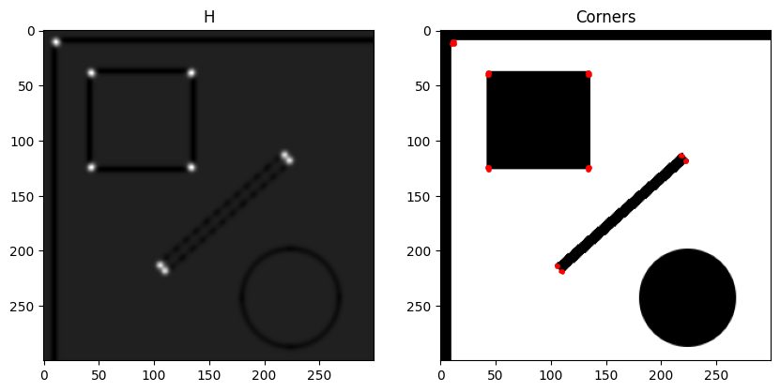Here we have difficulties due to the complexity of the image
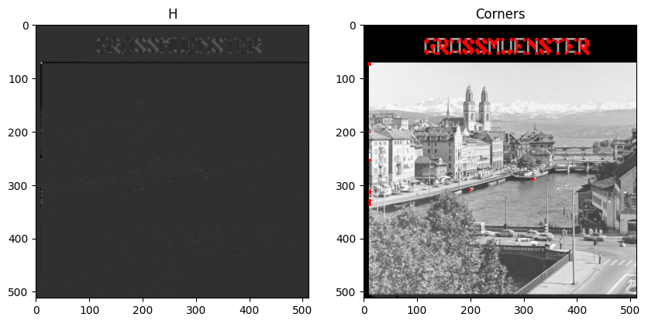But if we adapt the parameter of the treshold teta we find our basic result with no change except on the border but this is normal because new corner has appeared thanks to the black border:
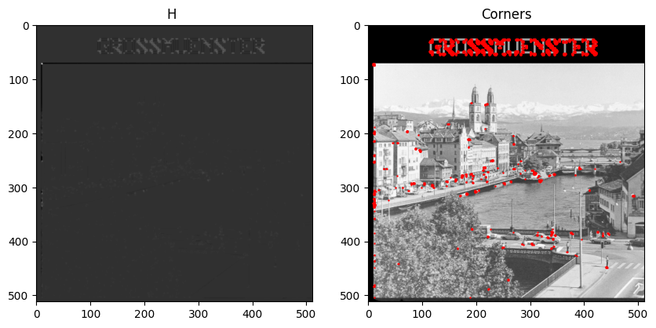
- Is the Harris corner detector robust with respect to rotation ?

Yes, because it detects corners by analysing local variations in intensity, regardless of the orientation of the image. Corners remain points of rapid intensity change in all directions, which is invariant under rotation.
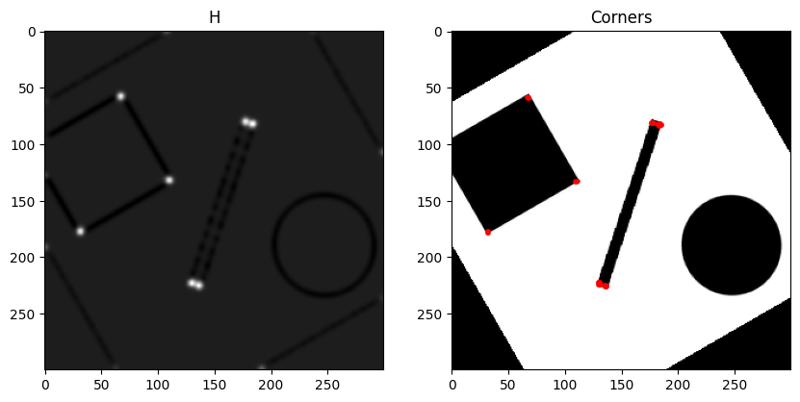
Like the translation we find our basic result with no change except on the border but this is normal because new corner has appeared thanks to the black border:
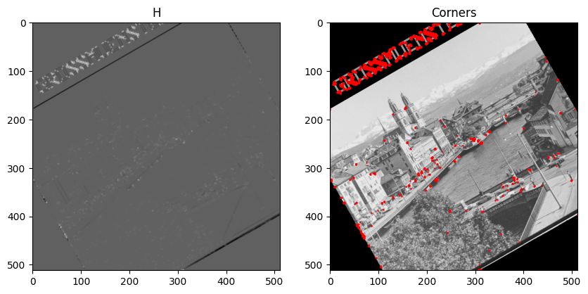
As expected, our Harris corner detector is really robust with the effects on the first image, but he is less robust compared to the effects on the second more complex image, few side effects and artefact of intensity change appears.

2 - CANNY EDGE DETECTION

Now, we will see another computer vision method: Canny Edge Detection. But this time the aim is to detect the contours of objects in an image while the goal of Harry detector was to detect corners.

STEP 1: Gaussian smoothing
This first step of Canny Edge Detection involves smoothing the image with a Gaussian filter to reduce noise. This prevents random variations in intensity from being mistaken for edges.
Below are the four images on which we're going to test our implementation of Canny Edge Detection. Before smoothing:
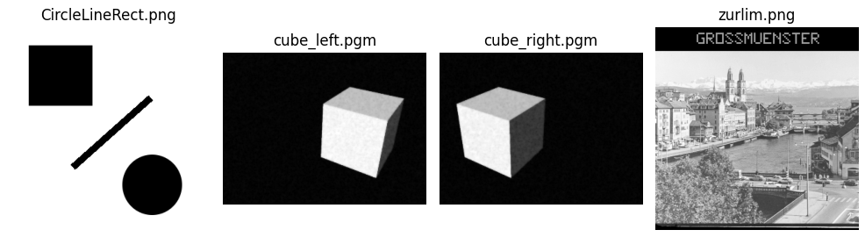
After smoothing:
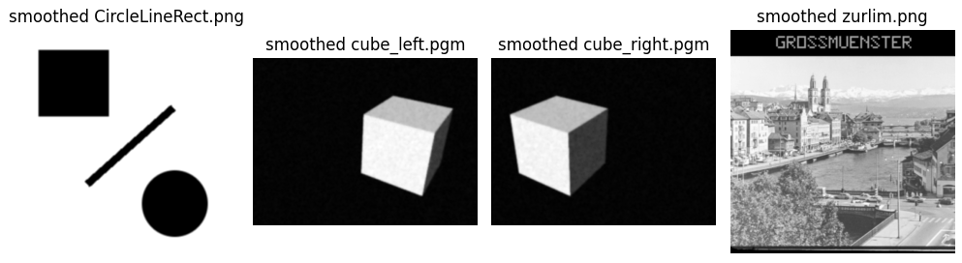

Before looking for contours, it is important to remove any noise that could be detected as a contour. Smoothing preserves the true contours while reducing the small variations caused by noise. To do this smoothing we use a Gaussian Filter.
When the Gaussian filter is applied to an image, the algorithm scans each pixel in the image. For each pixel, it considers a region around it and applies a weighted average according to the Gaussian distribution to all the pixels in this region. This region is called the window. The sigma parameter is the standard deviation of the Gaussian distribution. By varying sigma, more or less importance is given to pixels that are far from the central pixel.
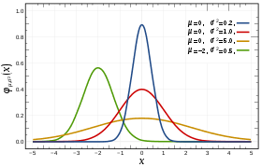
In short, the greater the sigma, the more blurred the image.

STEP 2: Gradient calculation
The second step 2 involves calculating the gradients of the image. This makes it possible to detect areas where there are sudden changes in intensity. Abrupt changes in intensity correspond to contours in an image. We calculate partial derivative Ix and Iy to approximate the image’s gradient in horizontal and vertical directions. Ix and Iy represent the variation in light intensity in the image about direction.
Ix represents intensity change from left to right and Iy represents intensity change from top to bottom. To compute the gradients, we apply a sobel filter. To do this, we use “Sobel” function from the cv2 library.

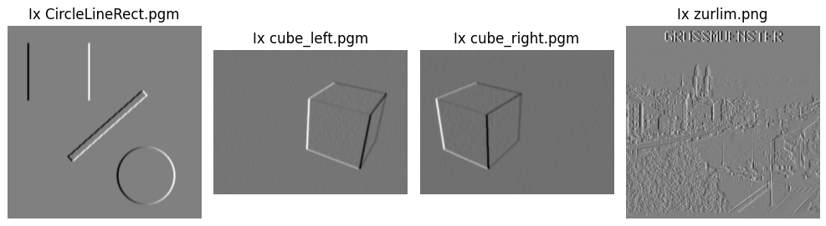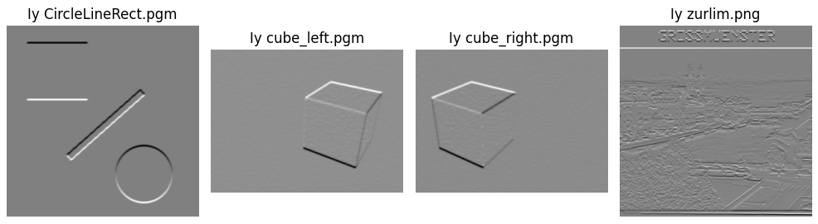

STEP 3: Direction and magnitude gradient calculation
Now, we want to compute direction and magnitude gradient. Calculating the magnitude of the gradient tells us how abruptly the light intensity changes at each point in the image. The magnitude tells us about the strength of contours. Calculating the direction tells us about the orientation of the edge i.e. if the contour is vertical, horizontal or diagonal.

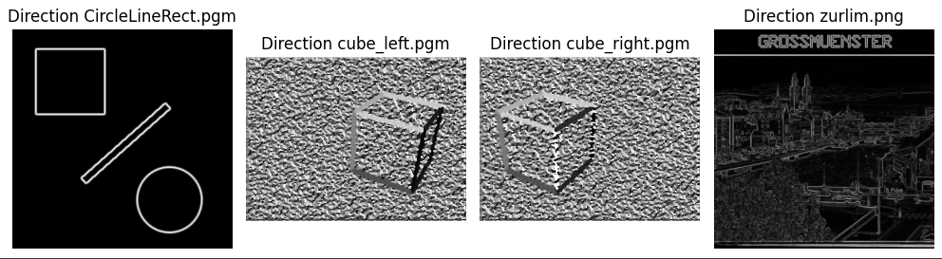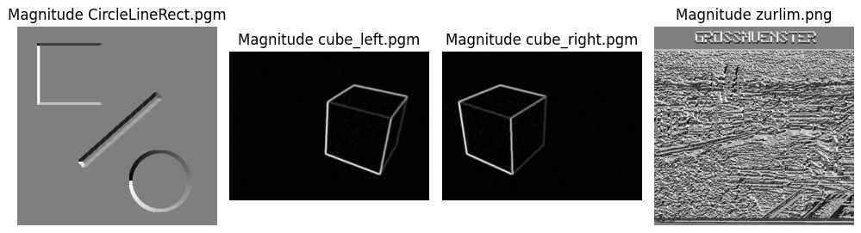

STEP 4: Non-maximum suppression for candidate edges
The contours are refined by retaining only the most significant pixels, i.e. those which are at their local maximum in the direction of the gradient. We start by converting the direction of the gradient into degrees to make it easier to classify angles between 0° and 180°. We compare each pixel with its neighbours perpendicular to the direction of the gradient. If the pixel has a magnitude greater than or equal to that of its two neighbours perpendicular to the gradient, it is retained as a contour.
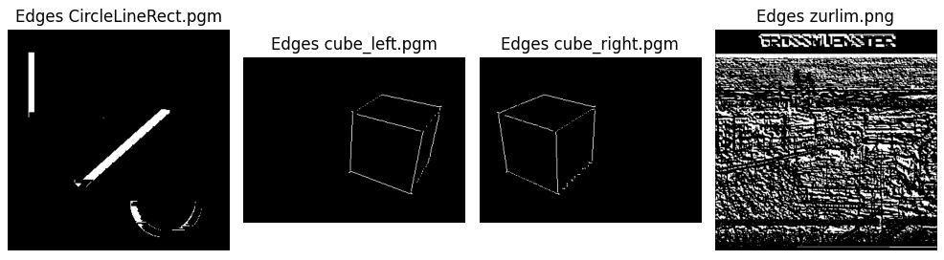
After several tests with different combinations of parameters, we noticed that the algorithm worked well for the ‘pgm’ format but not for the png format. I tested other functions from a different python library and the result works by changing the calculation functions used to calculate Ix, Iy, magnitude and direction. The new results are shown above.
Substituted functions :
- Cv.GaussianBlur --> gaussian_filter
- Cv.sobel --> gaussian_filter1d
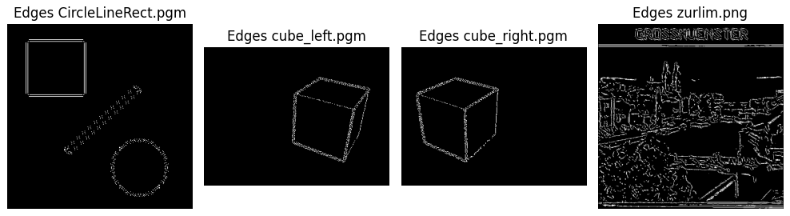
Questions :
We compute the derivative along the y-axis, which highlights the vertical edges. Similarly, if we calculate the derivative along the x-axis, the horizontal edges become visible. By combining these 2 derivatives, we can detect and outline all the edges in the image.

