Software Requirements Specification
Container Delivery Management System (CDMS)
University Metropolitan Tirana — Software Engineering Analysis & Design

Document Contents
1. Functional Requirements (FR-01 – FR-34)
2. Non-Functional Requirements (NFR-01 – NFR-20)
3. User Scenarios & BPMN Diagrams (3 scenarios)

3. User Scenarios & BPMN Diagrams
This section describes the three primary user scenarios of the CDMS. Each scenario includes a narrative description, step-by-step process, and a BPMN diagram showing the flow of activities across system roles. BPMN swim lanes represent the actors involved: Customer, Dispatcher, Driver, Yard Staff, Accountant, and System.

Scenario 1 — Job Creation & Dispatch
Primary Actor: Dispatcher (with Customer input)
A customer contacts the company requesting a container delivery. The dispatcher creates a job record, verifies resource availability, assigns a container, truck, and driver, and confirms the job. The system generates a delivery note and notifies the driver.
Process steps:
1. Customer provides pickup address, drop-off address, date, and container type.
2. Dispatcher creates a new job record in the system.
3. System validates the data and checks for scheduling conflicts.
4. Dispatcher reviews real-time container, truck, and driver availability.
5. Dispatcher assigns a container, truck, and driver to the job.
6. System warns if any conflict is detected (double-booking).
7. Dispatcher confirms the job; status changes to Confirmed then Assigned.
8. System automatically generates the delivery note and waybill.
9. System notifies the assigned driver of the new job.

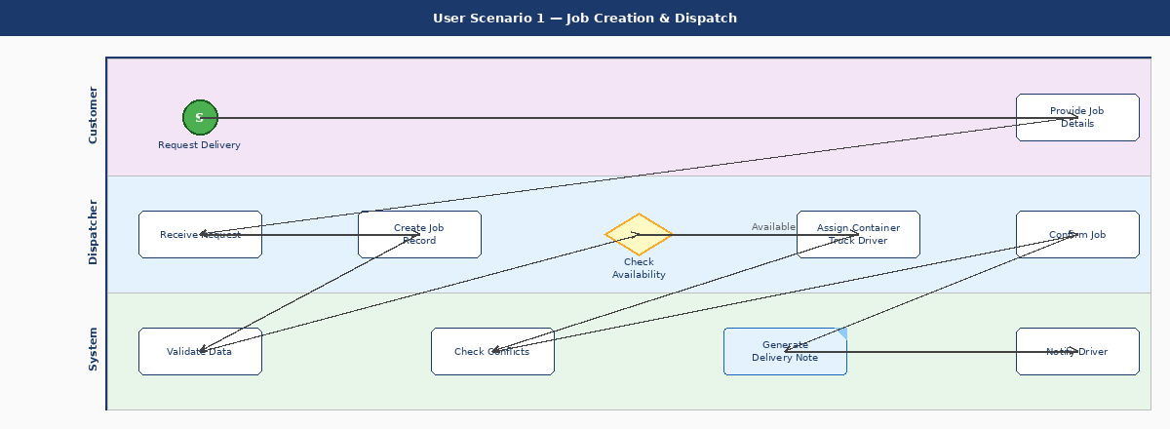
Figure 1 — BPMN: Job Creation & Dispatch

Scenario 2 — Delivery Execution
Primary Actor: Driver and Yard Staff
The driver picks up the assigned container from the yard, carries out the delivery, uploads proof of delivery, and marks the job complete. Yard staff handle the container check-out, inspect its condition, and update its location.
Process steps:
1. Driver views assigned job details on their mobile device.
2. Yard staff check out the container and inspect its condition.
3. If damage is found, yard staff log a damage report; otherwise they update container location.
4. Driver collects the container and updates job status to In Transit.
5. System records the status change with a timestamp.
6. Driver delivers the container to the customer drop-off point.
7. Driver uploads proof of delivery (photo or signed document).
8. System records the POD against the job.
9. Driver marks the job as Delivered; system updates job status accordingly.

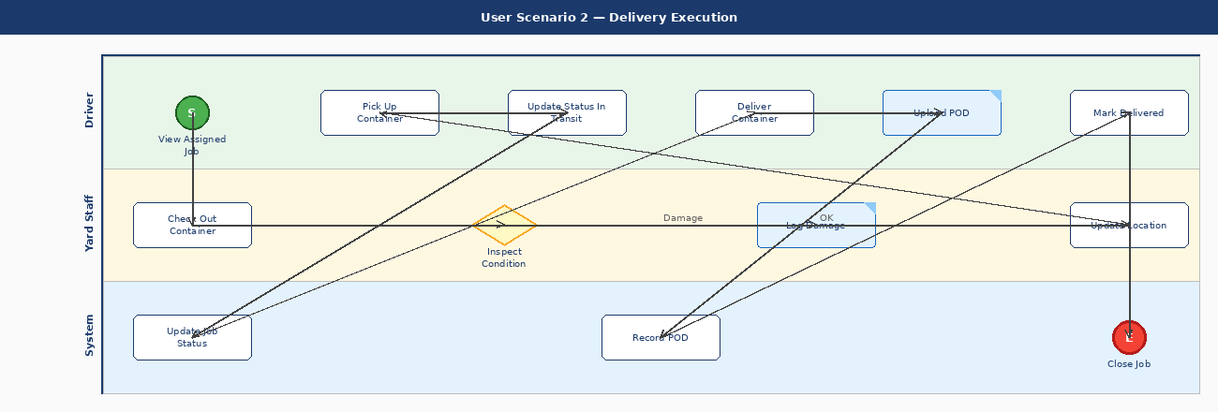
Figure 2 — BPMN: Delivery Execution

Scenario 3 — Invoice & Payment
Primary Actor: Accountant and Customer
After a job is marked Delivered, the accountant generates and sends an invoice. The customer reviews it, either pays or raises a dispute. The accountant records the payment and the system closes the financial cycle.
Process steps:
1. Accountant reviews jobs with Delivered status.
2. System can auto-generate a draft invoice for each delivered job.
3. Accountant reviews the draft, adds extra charges if needed, and finalises it.
4. System sends the invoice to the customer by email or via the portal.
5. Customer receives and reviews the invoice.
6. If the customer disputes the invoice, it is returned to the accountant for correction.
7. If the customer approves, they make payment.
8. Accountant records the payment in the system.
9. System updates invoice status to Paid and links payment to the job.

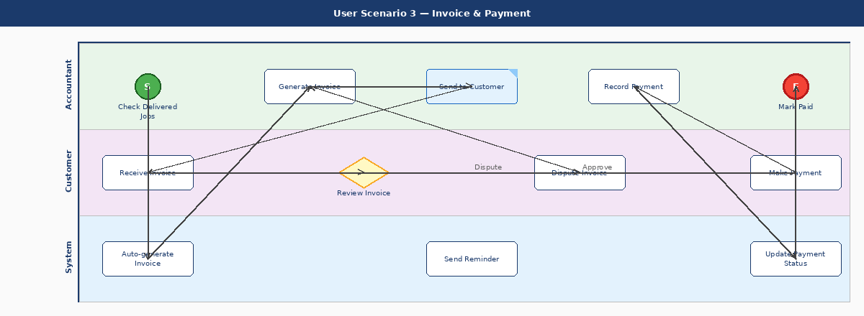
Figure 3 — BPMN: Invoice & Payment

