To configure Alma to export your invoices go to:

General Configuration -> Configuration Menu -> Under External Systems click on Integration Profiles -> Add External System for code PS_INVOICES

General Information tab:

We FTP the XML file that Alma generates to one of our servers (FTP_RAICHU).

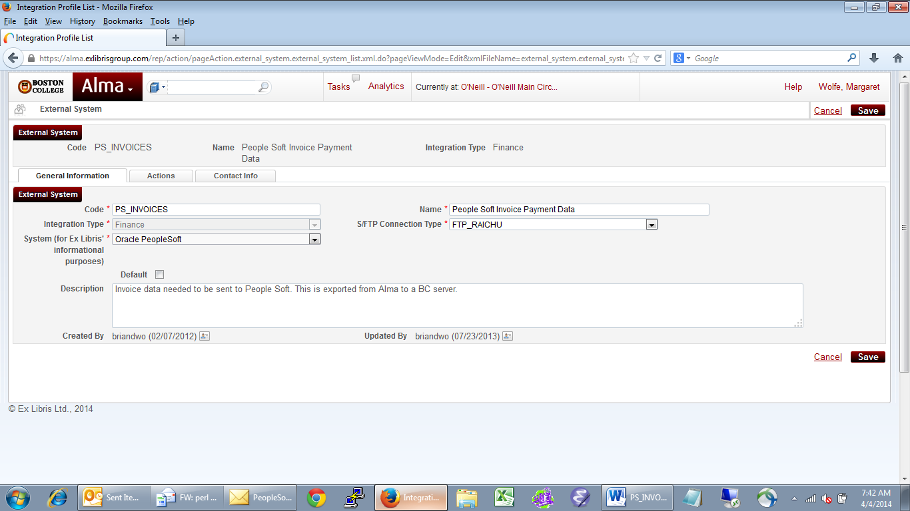

Actions tab:

