Company A 2018 Employee Report

Contents
A. Report Overview 3
Analysis of Company A Employees by Age 3
Analysis of Company A Employees by Gender 3
B. Conclusion 3

- Report Overview

This report goes over basic information on Company A to give an overview of how the report writer works.

Analysis of Company A Employees by Age

We first go over the age of employees. The following table shows the ages of the 30 employees at Company A.

Table 1: Number of Employees by Age

Age | Count
22-30 | 4
30-50 | 15
51+ | 11

Figure 1 shows the percent of employees by age.

Figure 1: Employees by Age
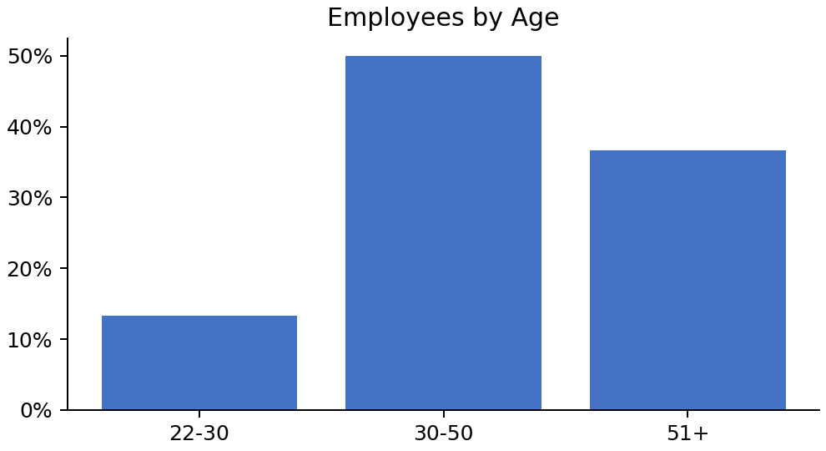

Analysis of Company A Employees by Gender

Figure 2 shows the percent of employees by gender.

Figure 2: Employees by Gender
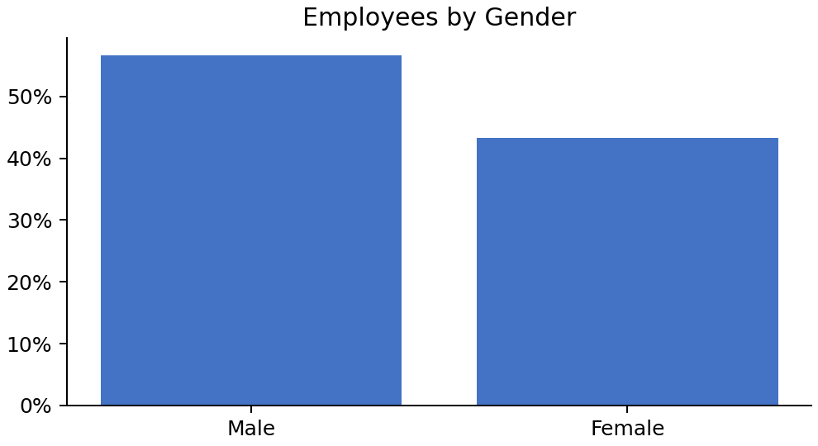

The number of employees by gender is presented below:

- There are 17 males in company A
- There are 13 females in company A

- Conclusion

This concludes our analysis of the 30 employees at Company A.

DO

