Company B 2018 Employee Report

Contents
A. Report Overview 3
Analysis of Company A Employees by Age 3
Analysis of Company A Employees by Gender 3
B. Conclusion 3

- Report Overview

This report goes over basic information on Company B to give an overview of how the report writer works.

Analysis of Company B Employees by Age

We first go over the age of employees. The following table shows the ages of the 3 employees at Company B.

Table 1: Number of Employees by Age

Age | Count
22-30 | 1
30-50 | 2
51+ | 0

Figure 1 shows the percent of employees by age.

Figure 1: Employees by Age
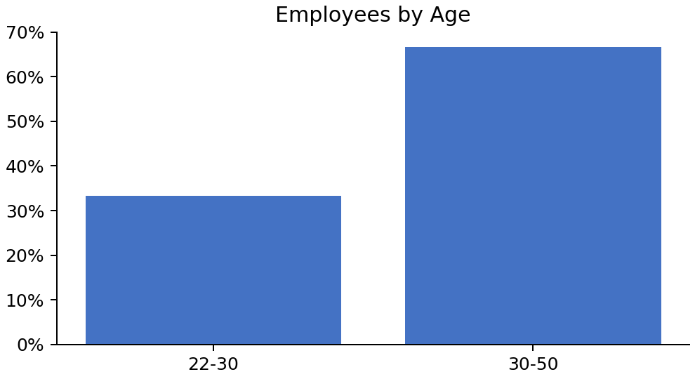

Analysis of Company B Employees by Gender

Figure 2 shows the percent of employees by gender.

Figure 2: Employees by Gender
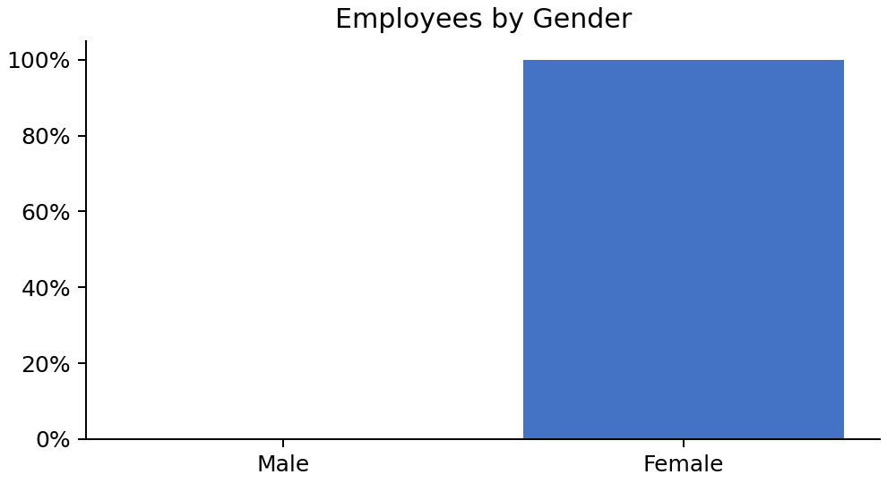

The number of employees by gender is presented below:

- There are 0 males in company B
- There are 3 females in company B

- Conclusion

This concludes our analysis of the 3 employees at Company B.

DO

