Company A 2026 Employee Report

Contents
A. Report Overview 3
Analysis of Company A Employees by Age 3
Analysis of Company A Employees by Gender 4
B. Conclusion 5

- Report Overview

This report goes over basic information on Company A to give an overview of how the report writer works.

Analysis of Company A Employees by Age

We first go over the age of employees. The following table shows the ages of the 30 employees at Company A.

Table 1: Number of Employees by Age

Age | Count
22-30 | 4
30-50 | 15
51+ | 11
Table 2: Number of Employees by Age

Age | Count
22-30 | 4
30-50 | 15
51+ | 11

Table 3: Employee counts and percentages by gender

 |  | Statistics
 |  | Count | Percent
Gender | Male | 17 | 57%
Gender | Female | 13 | 43%
Table 4: Number of Employees by Age
Age | Count
22-30 | 4
30-50 | 15
51+ | 11

Figure 1 shows the percent of employees by age.

Figure 1: Employees by Age
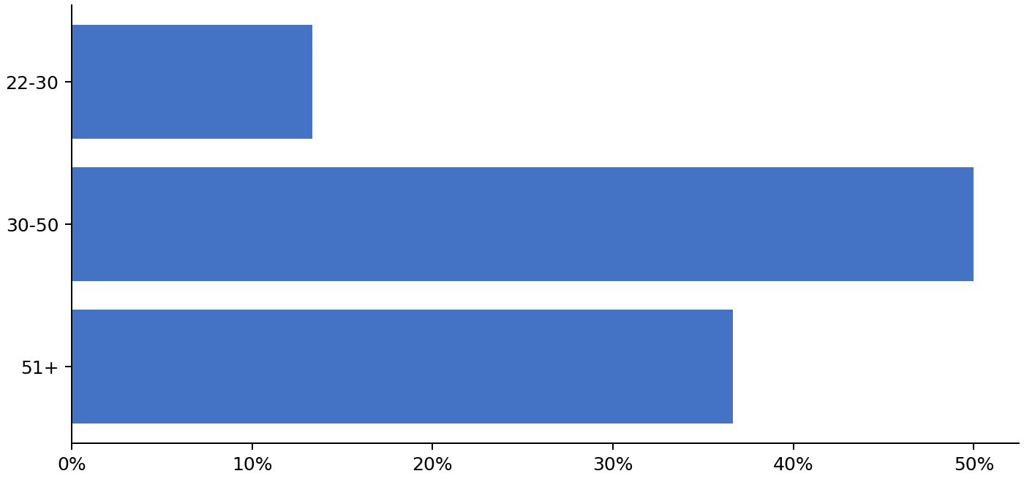

Analysis of Company A Employees by Gender

Figure 2 shows the percent of employees by gender.

Figure 2: Employees by Gender
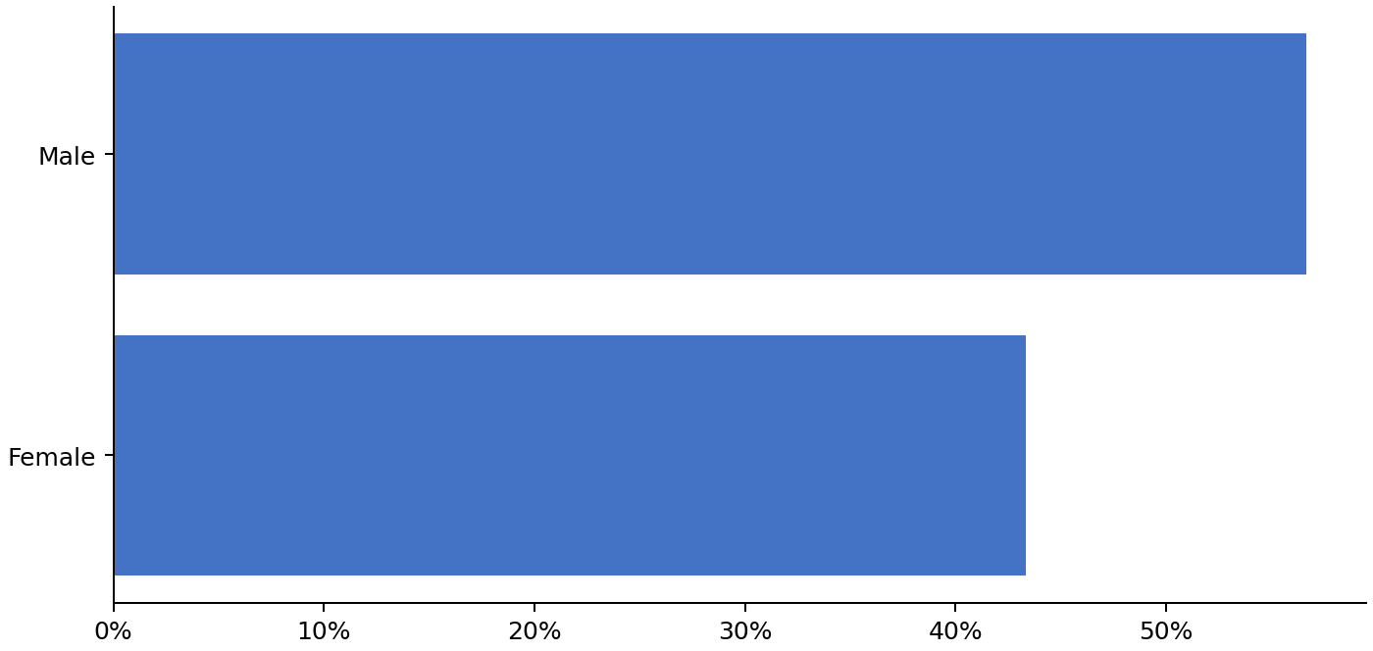

The number of employees by gender is presented below:

• | There are 17 males in company A
• | There are 13 females in company A

This is a test sentence to for the add sections functionality. Simply put your documents in to add into a specific folder, reference that folder in the “AddDocX” worksheet cell A2, then lists the document names and the subsequent tag in the template.

- Conclusion

This concludes our analysis of the 30 employees at Company A.

This is a test of global replace: N/A N/A

N/A
N/A
N/A
N/A
N/A
N/A
N/A.0
N/A
N/A
N/A
N/A
N/A

DO

