Company B 2026 Employee Report

Contents
A. Report Overview 3
Analysis of Company B Employees by Age 3
Analysis of Company B Employees by Gender 4
B. Conclusion 4

- Report Overview

This report goes over basic information on Company B to give an overview of how the report writer works.

Analysis of Company B Employees by Age

We first go over the age of employees. The following table shows the ages of the 3 employees at Company B.

Table 1: Number of Employees by Age

Age | Count
22-30 | 1
30-50 | 2
51+ | 0
Table 2: Number of Employees by Age

Age | Count
22-30 | 1
30-50 | 2
51+ | 0

Table 3: Employee counts and percentages by gender

 |  | Statistics
 |  | Count | Percent
Gender | Male | 0 | 0%
Gender | Female | 3 | 100%
Table 4: Number of Employees by Age
Age | Count
22-30 | 1
30-50 | 2
51+ | 0

Figure 1 shows the percent of employees by age.

Figure 1: Employees by Age
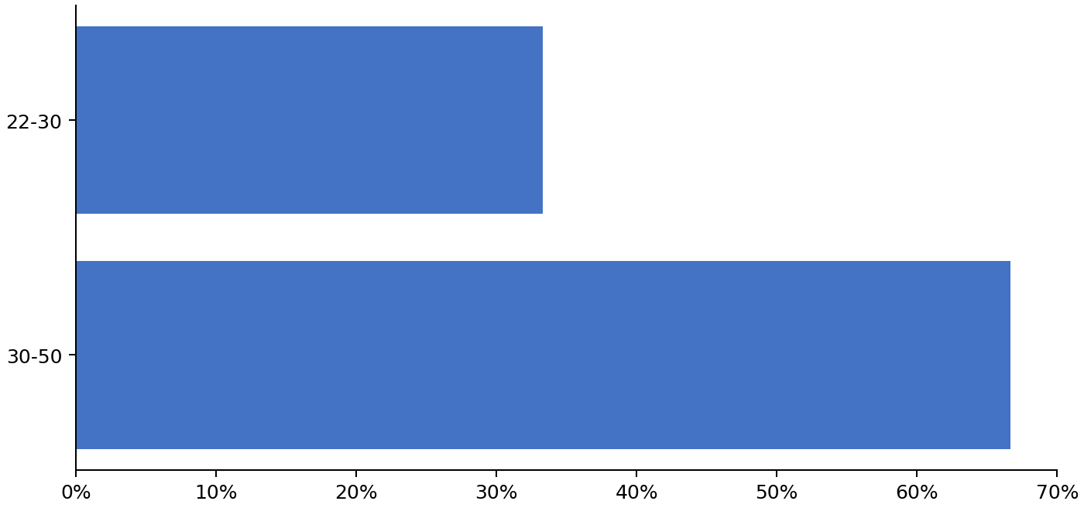

Analysis of Company B Employees by Gender
All employees at Company B are female so no analysis is provided.
- Conclusion

This concludes our analysis of the 3 employees at Company B.

This is a test of global replace: N/A N/A

N/A
N/A
N/A
N/A
N/A
N/A
N/A.0
N/A
N/A
N/A
N/A
N/A

DO

