**Portraits of the powerful**

Throughout history, the powerful have often used portraits of themselves to demonstrate their status and foster renown.

Some of the earliest examples come from Ancient Rome. In Rome portraits were often used in funerals to [honor the deceased](https://www.metmuseum.org/toah/hd/ropo/hd_ropo.htm) and their ancestors, flaunting their impressive lineage.

Figure Roman boy’s funerary altar, late 1st centiry AD, Daderot, CC0, via [Wikimedia Commons](https://commons.wikimedia.org/wiki/File:Roman_funerary_altar_for_a_boy,_end_of_1st_century_AD_-_Royal_Ontario_Museum_-_DSC09770.JPG)

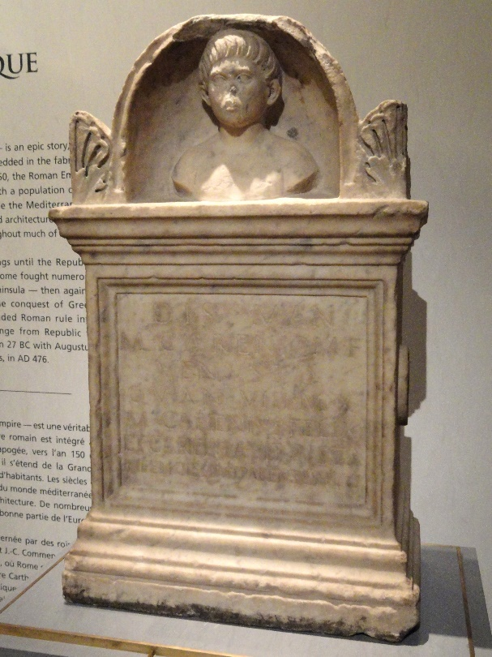

Starting in the reign of Augustus, imperial portraits were used for propaganda and power projection. The [Augustus of Primaporta](https://www.khanacademy.org/humanities/ap-art-history/ancient-mediterranean-ap/ap-ancient-rome/a/augustus-of-primaporta) is a notable example of this kind of puffery. The upraised arm suggests oratorical skill and the outfit a military one. The dolphin next to his right foot refers to the naval Battle of Actium whose victory for Augustus thrusted him to the throne. The cupid that is sitting on the dolphin is meant to connect Augustus with the gods.

Figure Augustus of Primaporta, Vatican Museums, Public domain, via [Wikimedia Commons](https://commons.wikimedia.org/wiki/File:Statue-Augustus.jpg)

Another royal example is Queen Elizabeth I’s [*Armada Portrait*](https://www.rmg.co.uk/stories/topics/symbolism-portraits-queen-elizabeth-i). It also commemorates a crucial military victory: that over the Spanish navy, which can be seen sinking in the top-right panel. The pearls adorning her outfit represent virginity, which was a reputation that was a great source of strength for her. Her right hand atop a small globe rests across the Americas, indicating her ambitions there.

Figure Elizabeth I (Armada Portrait) via [Wikimedia Commons](http://www.luminarium.org/renlit/elizarmada.jpg)

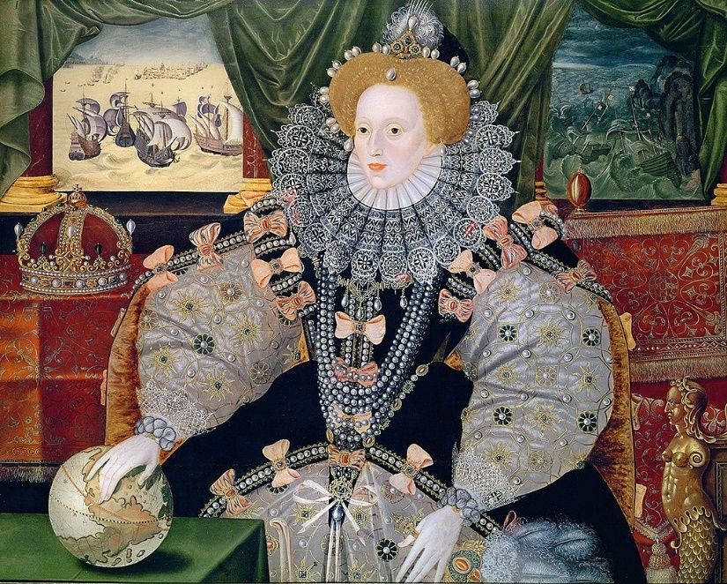

As the middle class developed in the Renaissance, its members commissioned portraits to showcase their wealth. One example is the [*Portrait of Jan Jacobsz Snoeck*](https://www.bbc.com/culture/article/20220204-why-portraits-have-fascinated-us-for-millennia) by Jan Gossart. It heavily emphasizes documentation and writing apparatuses throughout the painting because writing and bookkeeping were signs of wealth.

Figure Portrait of Jan Jacobsz Snoeck by Jan Gossaert, Public domain, via [Wikimedia Commons](https://commons.wikimedia.org/wiki/File:Jan_Gossaert_-_Portrait_of_a_Merchant_-_Google_Art_Project.jpg)

Unlike photos, portraits are more easily able to convey what their commissioners want them to convey. For the historically powerful, they can be great opportunities to trumpet their own eminence. For the modern viewer of these portraits, they can be windows into the ideal self-images of some of history’s great movers and shakers.