Quiz 3

1 – What is the difference between a confidence interval and a predictive interval?

* **The prediction interval indicates the range over which individual values might occur. The confidence interval indicates the range over which the average value might occur.**
* The confidence interval indicates the range over which individual values might occur. The prediction interval indicates the range over which the average value might occur.
* The prediction interval is based on the p-value, the confidence interval is not.
* The prediction interval is for the slope. The confidence interval is for the intercept.

2 – Identify the regression assumption that was violated in this plot:

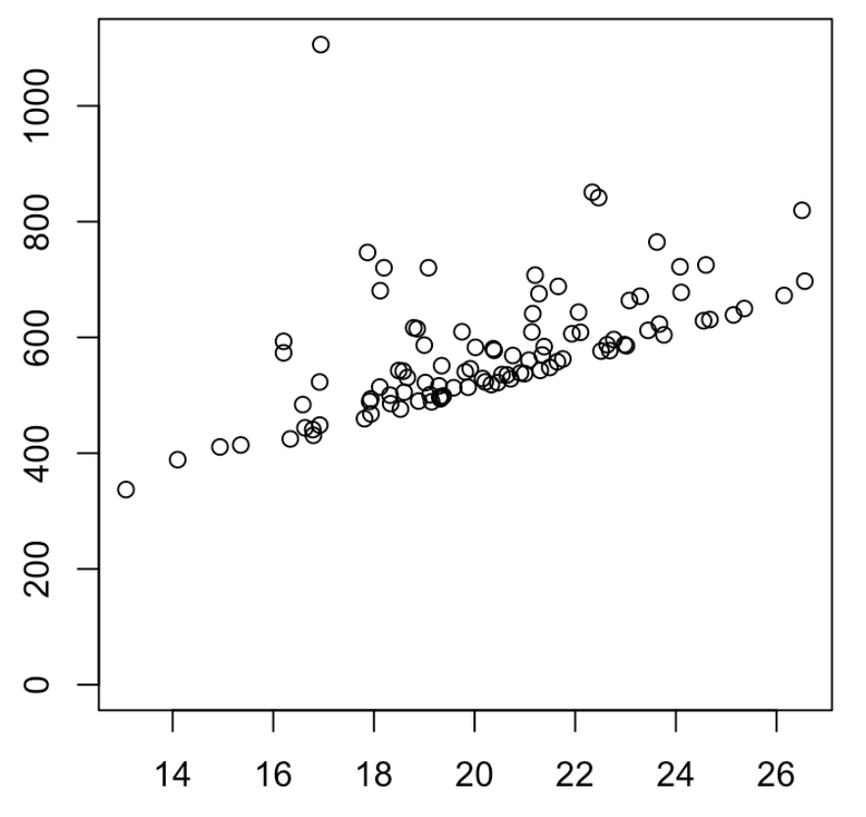

* No autocorrelation
* **Normality of residuals**
* Homoscedasticity
* Linearity

3 – Identify the regression assumption that was violated in this plot:

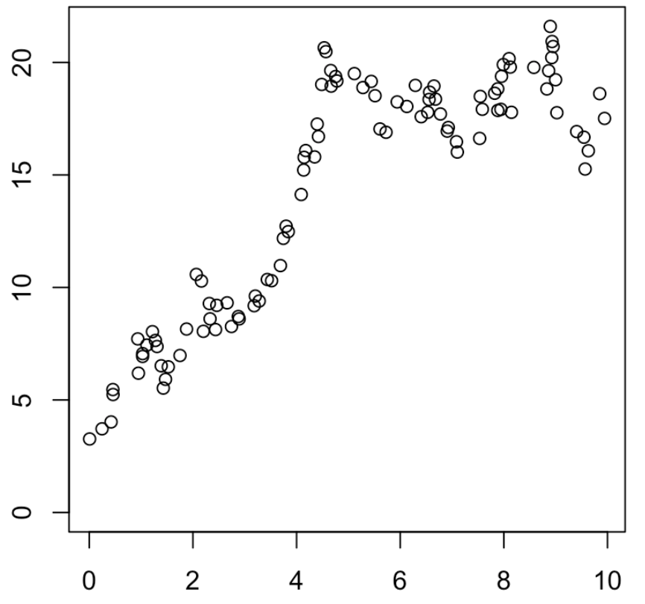

* **No autocorrelation**
* Normality of residuals
* Homoscedasticity
* Linearity

4 – Identify the regression assumption that was violated in this plot:

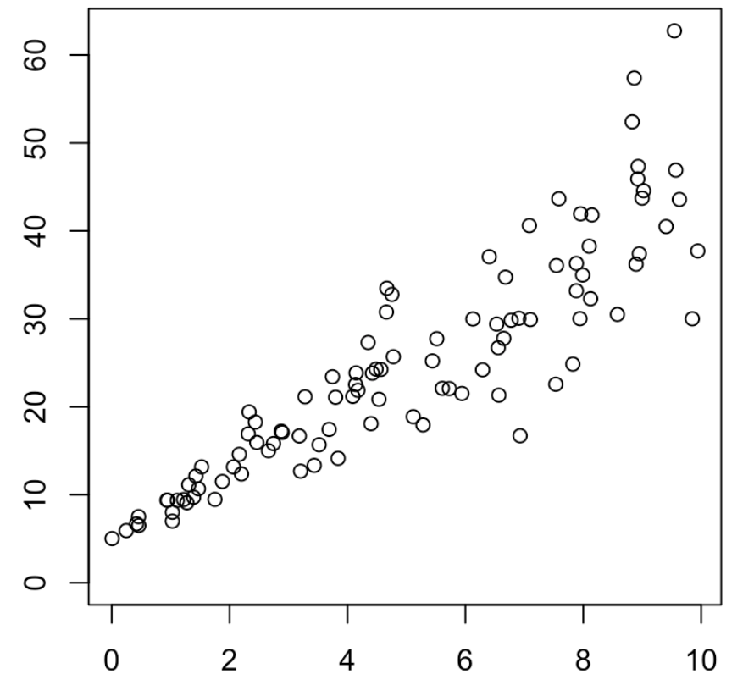

* No autocorrelation
* Normality of residuals
* **Homoscedasticity**
* Linearity

5 – Which of the following describes making predictions about a response (y) outside of the observed range of x-values used in your analysis?

* **Extrapolation**
* Extrascedastic
* Interpolation
* Interscedastic