### exercise 3 key

### dataset 1

datum <- read.csv("exercise_3_dataset1.csv")

head(datum)

str(datum)

datum$Group <- as.factor(datum$Group)

results <- lm(Density ~ Group, data=datum)

summary(results)

confint(results)

(3.166-2.104)/2

# we found that exclusion plots were 2.64 deer/ha (+/-0.53; +/-95% CI) greater in deer density than control plots (p = 2.64e-13).

### dataset 2

datum <- read.csv("exercise_3_dataset2.csv")

head(datum)

str(datum)

datum$Habitat <- as.factor(datum$Habitat)

results <- aov(QuailDensity ~ Habitat, data=datum)

summary(results)

# 1. ANOVA indicated that at least two of the habitat types were significant different from each other (p = 8.66e-12).

plot(QuailDensity ~ Habitat, data=datum, xlab= "Habitat type", ylab="Quail density (quail/ha)")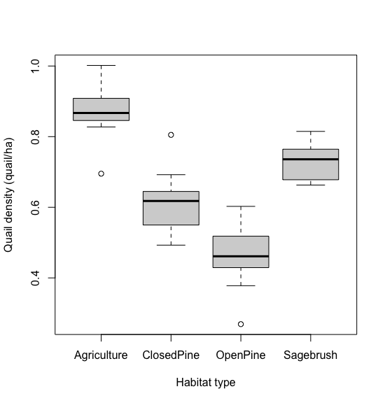

# 2. copied to Doc

TukeyHSD(results)

(-0.3624353--0.15728517)/2 # 95% CI for closed pine-ag

(-0.5110354--0.30588532)/2 # 95% CI for open pine-ag

# 3. We found that closed pine forests had 0.26 quail/ha (+/-0.10; +/-95% CI) less quail density than agricultural lands (p = 0.0000003).

# We found that open pine forests had 0.40 quail/ha (+/-0.10; +/-95% CI) less quail density than agricultural lands (p = 0.00000000).

### dataset 3

datum <- read.csv("exercise_3_dataset3.csv")

head(datum)

str(datum)

datum$Method <- as.factor(datum$Method)

results <- aov(Success ~ Method, data=datum)

summary(results)

# 1. ANOVA indicated that at least two of the hunting methods were significantly different from each other (p = <2e-16).

plot(Success ~ Method, data=datum, xlab= "Hunting method", ylab="Success rate (pronghorn harvested/hunter)")

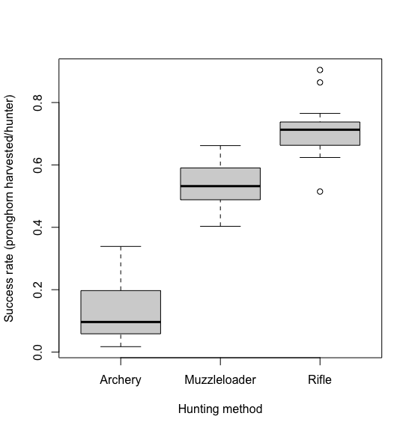

# 2. copied to Doc

TukeyHSD(results)

(0.4799878 - 0.31921488)/2 # 95% CI for muzzie vs. archery

(0.6536238 - 0.49285085)/2 # 95% CI for rifle vs. archery

(0.2540224 - 0.09324951)/2 # 95% CI for rifle vs. archery

# 3. We found that muzzleloader hunters had 0.40 pronghorn harvested/hunter (+/-0.08; +/-95% CI) greater success rate than archery hunters (p = 0.0e+00).

# We found that rifle hunters had 0.57 pronghorn harvested/hunter (+/-0.08; +/-95% CI) greater success rate than archery hunters (p = 0.0e+00).

# We found that rifle hunters had 0.17 pronghorn harvested/hunter (+/-0.08; +/-95% CI) greater success rate than muzzleloader hunters (p = 1.4e-05).

dummy <- model.matrix(~datum$Method - 1)

colnames(dummy) <- c("Archery", "Muzzleloader", "Rifle")

datum <- cbind(datum, dummy)

results2 <- lm(Success ~ Muzzleloader + Rifle, data = datum)

summary(results2)

confint(results2)

results3 <- lm(Success ~ Archery + Rifle, data = datum)

summary(results3)

confint(results3)

# The effects are the same, but the confidence intervals and p-values are smaller.

### dataset 4

datum <- read.csv("exercise_3_dataset4.csv")

head(datum)

str(datum)

datum$FertCat <- as.factor(datum$Fertilizer)

plot(Biomass ~ FertCat, data=datum)

# 0. copied to doc

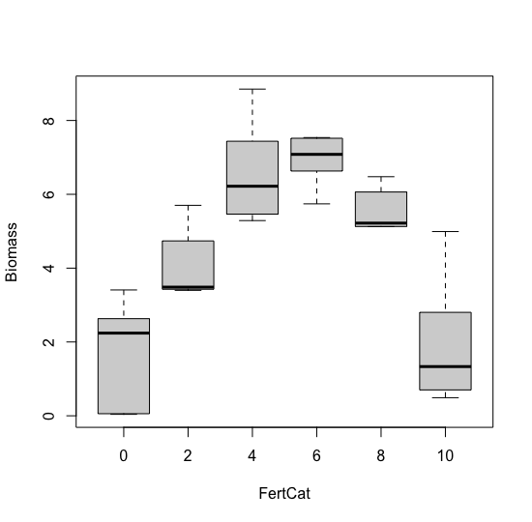

results <- lm(Biomass ~ FertCat, data=datum)

summary(results)

# 1. ANOVA indicated that at least two of the fertilizer groups were significantly different from each other (p = 9.139e-07).

# We found that fertilizer treatment with 2 grams produced 2.48 kg/ha (+/-1.64; +/-95% CI) greater biomass than unfertilized plots (p=0.00604).

results2 <- lm(Biomass ~ relevel(FertCat, ref = "2"), data=datum)

summary(results2)

# 2. We found that fertilizer treatment with 4 grams produced 2.50 kg/ha (+/-1.64; +/-95% CI) greater biomass than plots fertilized with 2 grams (p=0.00559).

results3 <- lm(Biomass ~ Fertilizer, data=datum)

summary(results3)

# 3. We found that for each 1 gram increase in fertilizer treatment, we observed

# a 0.093 kg/ha (+/-0.26; +/-95% CI) increase in biomass; however, this result was

# not statistically significant (p = 0.478).

# Use an F-drop test to compare the categorical and continuous models

anova(results, results3)

# 4. An F-drop tests found an F-statistic of 18.5 with p=4.601e-07.

# 5. This suggests that the more complex model is a significantly better fit to the data.

# 6. The relationship between fertilizer and sagebrush biomass is nonlinear.