### dataset 1

datum <- read.csv("exercise_5_dataset1.csv")

head(datum)

# y = beta0 + beta1*density + beta2*pine + beta3*density*pine + error

# x-variables: density = road density, pine = dummy-coded variable for pine (1) or aspen (0)

# beta0 = average squirrel density when road density = 0 in aspen forests

# beta1 = effect of road density on squirrels in aspen forests

# beta2 = the difference between pine and aspen forests when road density equals zero

# beta3 = the difference in the road effect between pine and aspen forests OR

# = the difference in the forest effect as road density increases

results1 <- lm(Squirrels ~ RoadDensity + ForestType + RoadDensity:ForestType, data = datum)

summary(results1)

# We ran a linear model with effects of road density, forest type, and a road

# density x forest type interaction; we observed a significant interaction between

# road density and forest type (P = 6.53x10-9).

# Therefore, we separated our data by forest type and ran two models of squirrel

# density by road density in different forest types.

results1a <- lm(Squirrels ~ RoadDensity, data = subset(datum, datum$ForestType == "Aspen"))

summary(results1a)

confint(results1a)

# We found that for each one road per sq. km increase in road density in aspen forests,

# we observed a -0.52 squirrel per ha (+/-0.12; +/-95% CI) decrease in squirrel density (p = 2.21x10-10).

results1b <- lm(Squirrels ~ RoadDensity, data = subset(datum, datum$ForestType == "Pine"))

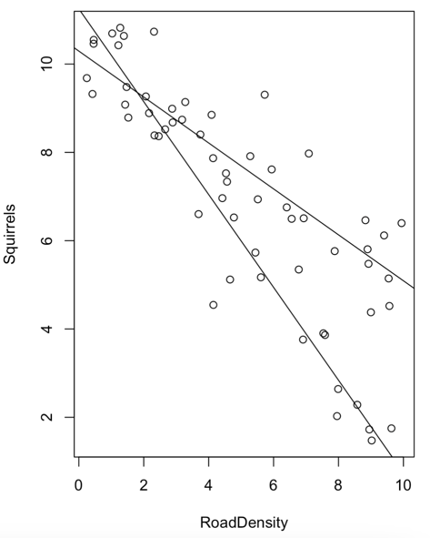summary(results1b)

confint(results1b)

# We also found that for each one road per sq. km increase in road density in pine forests,

# we observed a 1.05 squirrel per ha (+/-0.11; +/-95% CI) decrease in squirrel density (P = 2.2x10-16).

plot(Squirrels ~ RoadDensity, data = datum)

abline(results1a)

abline(results1b)

# ~2 road/km2

# save plot to exercise

# OR

# using predictions from the models

datumPredict <- data.frame(RoadDensity = 1.79)

predict(results1a, datumPredict, interval = "prediction")[1]

predict(results1b, datumPredict, interval = "prediction")[1]

### dataset 2

datum2 <- read.csv("exercise_5_dataset2.csv")

head(datum2)

# y = beta0 + beta1*male + beta2*treatment + beta3*male*treatment + error

# beta0 = average size of placebo females

# beta1 = the effect of treatment on females

# beta2 = the effect of being male for placebo treatments

# beta3 = the difference in the effect of treatment for males than females

results2 <- lm(Size ~ Male + Treated + Male:Treated, data = datum2)

summary(results2)

# We observed a significant interaction between sex and treatment (P = 6.34e-10 ***).

results2a <- lm(Size ~ Treated, data = subset(datum2, datum2$Sex == "Females"))

summary(results2a)

confint(results2a)

# We split the data by sex and estimated the effect of treatment for each sex.

# We found that treated females were 0.48 kg (+/-0.11; +/-95% CI) larger than placebo females (P = 1.97e-11).

results2b <- lm(Size ~ Treated, data = subset(datum2, datum2$Sex == "Males"))

summary(results2b)

confint(results2b)

# We found that treated males were 1.03 kg (+/-0.12; +/-95% CI) larger than placebo males (P = <2e-16 ***).

### dataset 3

datum3 <- read.csv("exercise_5_dataset3.csv")

head(datum3)

# y = beta0 + beta1*lat + beta2*elevation + beta3*lat*elevation + error

# beta0 = average size of salamanders when latitude and elevation are zero

# beta1 = the effect of latitude on size when elevation is zero

# beta2 = the effect of elevation on size when latitude is zero

# beta3 = the difference in the effect of latitude as elevation increases

results3 <- lm(Size ~ Latitude + Elevation + Latitude:Elevation, data = datum3)

summary(results3)

# We found that for each 1 degree increase in latitude at elevation of zero, we observed a 0.0017 g () decrease

# in body size (<2e-16 ***).

# We foundt hat for each 100 m increase in elevation at latitude of zero, we observed a 0.125 g () decrease

# in body size (<2e-16 ***).

# We observed a significant interaction between latitude and elevation on body size (P = <2e-16 ***),

# such that for each 1 degree increase in latitude, we observed that the slope of the elevation-body size

# relationship increased by 0.001 g/m ().