Analyze as Continuous or Categorical…?

NRES 710

Last compiled: 2024-10-07

## Review

Up to this point we have been working with the linear model and we have explored situations where the X-variable is continuous or categorical. We can analyze both of those instances using ‘lm()’, and the only difference is how we report the results.

* Continuous X: “For each one unit change in X, we observed a […] unit change in Y”
* Categorical X: “We found that group 1 was [beta] larger than group 2…”

Today we are going to talk about a special case that can be useful in statistics: when you have an X-variable that can be treated as either continuous or categorical.

## Continuous or categorical X

**X-variable – categorical *or* continuous**. Today we will discuss an example where:

* **Y-variable – biomass (continuous)**
* **X-variable – number of bison (continuous or categorical)**

This is a hypothetical example where we have a bunch of different fields where we are measuring biomass at the end of the experiment. At the start of the experiment, we put a bunch of **American Bison** (*Bison bison*) out into the field – any given field could receive between 1–5 bison. Our research question of interest is what is the effect of a large native herbivore, bison, on ecosystem productivity, which we measure with biomass?

The key thing here is that our X-variable is a **number**, so it could be treated as **continuous**. But also because we have multiple fields with that same number of bison in it, we could treat it as **categorical**.

To illustrate this, let’s consider a few examples:

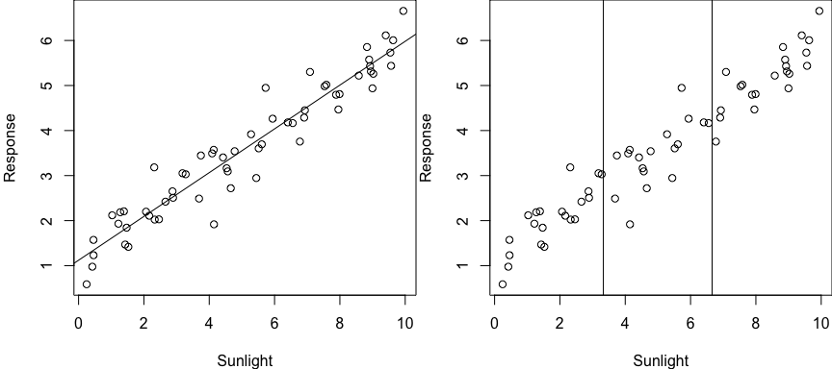

Here our X-variable is definitely continuous, and the correct and most robust approach to testing for the effect of sunlight on the response variable is using linear regression (**left panel**).

However, some people who haven’t taken this class might be more comfortable with an ANOVA-style approach to analysis, and they may be tempted to *bin* their X-data to place it into ~3 groups to facilitate ANOVA (**right panel**). Split the continuous measure into ‘low’, ‘medium’ and ‘high’ sunlight categories. This causes you to lose a lot of information! And then it creates a more complicated and less clear analysis that provides no real advantage.

In this case, you should always treat this as continuous.

Alternatively, another example is where your X-variable is a ‘text’ variable, such as where you have categorical variable with four factors: urban, forest, ag, wetland.

For this example, the variable is words that cannot be translated into a numeric scale. You have to treat this as a categorical variable.

### Replicated regression

Let’s revisit the bison example I mentioned previously. We want to know: what is the effect of bison on ecosystem productivity?



Photo: Ted Naninga (iNaturalist)

For this example, we have a bunch of different fields where we put a bunch of American Bison (*Bison bison*) out into the fields, and any individual field could receive between 1–5 bison. Our data might look something like this:

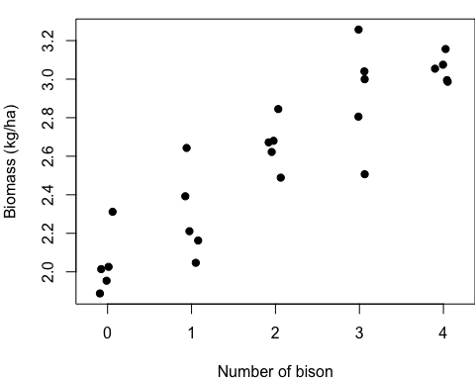

We measure the biomass in replicate areas with different numbers of bison. Some call this ‘**replicated regression**’ (e.g., Cottingham et al. 2008). We could analyze this two ways:

1. As a continuous X-variable
2. As a categorical X-variable, with five groups

Technically, this is not truly continuous, as you cannot have 1.5 bison in an area. Another X-variable, like fertilizer, could be a truly continuous variable, that we could set-up with a replicated regression experiment with 1g, 2g, 3g, etc. But if we ignore that technicality for the bison example, these data look continuous, and we could easily fit a regression line to the data.

Alternatively, we have a bunch of samples collected at each number of the X-variable. We could very easily treat this as a categorical variable – and no binning would be necessary to do so; it’s already set up this study design in such a way that it could be treated as a categorical variable. So the second way to analyze these data would be as a categorical variable.

So with these two options in mind, how should we handle this variable? Continuous or categorical? Let’s come back to that.

To figure this out, let’s consider how our linear model would look in both of these instances.

First, what would it be if we treated X as a **continuous variable**?

$$Y=β_{0}+β_{1}Bison+ϵ∼N\left(0,σ\right)$$

That’s it! Our beta is our slope; with each one bison increase, the slope tells us how much more biomass we would get.

What if we treat the X as **categorical**?

$$Y=β_{0}+β_{1}Bison1+β_{2}Bison2+β_{3}Bison3+β_{4}Bison4+ϵ∼N\left(0,σ\right)$$

In this case, our betas are the differences between groups. $β_{1}$ is the difference between 0 and 1 bison, $β_{2}$ is the difference between 0 and 2 bison, so on so forth. If we want to know the differences between other pairs, we have to change the reference.

**Q:** So let’s pose the question to you all: which of these approaches do you want to do? And why?

Truthfully, *there is no right or wrong answer*. You can do either one.

But let’s draw up a list on the board identifying *pros* and *cons* of both options – that might help us make recommendations about how to do things…

| Continuous X | Categorical X |
| --- | --- |
| **Simple model - 1 beta** | Complicated - 3 betas |
| **No worries about inflating Type I error** | Post-hoc test |
| **1 results sentence** | 10 sentences |
| **Interpolation/extrapolation** | No predictions |
| Assumption of linearity | **No assumption of linearity** |
| **More power**\* | Less power* |

One thing that we haven’t talked about yet for categorical X data is the **assumptions**! We already talked about the 5 assumptions of regression (linearity, homoscedasticity, no autocorrelation, normality of residuals, continuous Y). All of these assumptions still hold for categorical X – **except for one**.

Analysis with categorical X-data makes no assumptions of linearity or about the shape of relationships at all. Instead, all it does is make comparisons between groups. So this is something that is more flexible for categorical X data.

This last reason is the **most important reason** why you might want to use a continuous X variable. And this relates to the first bullet on our list: simple vs. complex. Since it only has 1 beta (effect), it will have **more power** than the more complicated model! More power means you are more likely to have lower P-values and thus correctly reject the null hypothesis, when appropriate.

Why is that?

Everytime you add a beta to your model, it adds another *degree of freedom* to your model. This causes the model to eat up one of your samples and thus functionally decreases your sample size. And we’ve already talked at great length about how sample size influences p-values. By decreasing our sample size, we are less likely to recover a low p-value and correctly reject the null.

So, in the bison example, if you use this more complicated model, you have reduced your sample size by three. And because of that, it has less power.

Now, there is a caveat… hence the ‘asterisk’ above.

*If, and only if, the assumption of linearity is met.

If the assumption of linearity is not met, then we might have more power with the more complicated model.

### Example

What if our data looked like this:

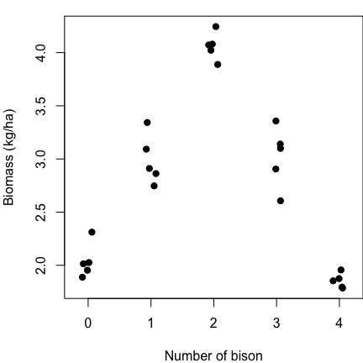

Maybe this could happen if there was some sort of *intermediate disturbance* that benefited biomass production.

**Q:** If you ran an ANOVA, would you detect a significant difference between these categorical groups? **YES**

**Q:** If you ran a regression, would you detect a significant difference between these categorical groups? **NO**

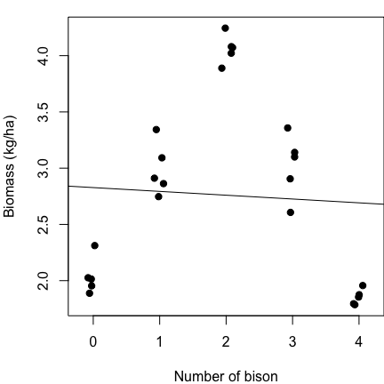

This happens because the assumption of linearity is very clearly violated. There is significant variation among these data, but we are trying to fit a linear model – a straight line – to data that do not have a linear relationship.

In this case, it would be much better to consider X as a categorical variable, which will give us more Power to detect a significant relationship.

### What does this all mean?

If we go back to our list, it’s pretty clear that treating X as a continuous variable is better in *many* ways – unless the assumption of linearity is not met. If the assumption of linearity is not met, then we:

* Should not describe it with a simple linear equation, because it’s not linear.
* We would lose power by treating it as a linear relationship.
* Making predictions with a straight line would be very incorrect; it would be better to fit a curve.

The advantages from our table fall apart if we don’t have linear data. Which leads to my **recommendation**!

**Recommendation: Always treat X-variable as continuous, unless treating as categorical ‘significantly improves the fit of the model to the data’ – which will only happen if the relationship is non-linear**

This very nicely fits in with the principle of parsimony – Occam’s razor.

**Occam’s razor – the world is simple, and it’s best to use simple explanations to describe the world unless there is significant evidence that more complexity is needed.**

* Simple ideas are best, unless you can disprove the simple model in favor of a more complicated model.

What do we mean by ‘significantly improve the fit’?

There is an idea in statistics (truism; axiom) that whenever you make a model more complex, *it will always improve the fit*. It will decrease the Sum of Squared Error, and it will increase the $R^{2}$. Why?

* With two points, adding a linear beta will connect them.
* With three points, adding a quadratic beta will connect them.
* With four points, adding a cubed-term will connect them.

So given that we can always improve a fit of a curve to points by increasing the complexity of the model, we want to demonstrate that it is a **significant improvement of fit**. We want to show that this variable isn’t just improving fit, it is improving fit more than would be expected if the variable didn’t have any explanatory value whatsoever.

### Testing model fit

A simple way that I was taught to do this is using an **‘F-drop test’**. However, there is some confusion about what this is really called and names vary widely. Some other names include:

* **Extra sum of squares F-test**
* **Type III sum of squares test** (e.g., SAS)
* **Partial likelihood ratio test**

I prefer ‘F-drop test’ because this is how I was taught and it is an easy and simple term.

No matter what you call it, you are comparing a **more complex model** to a **more simple model** to test whether the **more complex model is a significant improvement to the fit in the data**.

In other words, we are comparing our simple model:

$$Y=β_{0}+β_{1}Bison+ϵ∼N\left(0,σ\right)$$

To the complex model:

$$Y=β_{0}+β_{1}Bison1+β_{2}Bison2+β_{3}Bison3+β_{4}Bison4+ϵ∼N\left(0,σ\right)$$

And asking ourselves: do we need these extra betas?

Another way of thinking about it is… we are testing the null hypothesis that these extra betas are all equal to zero, with:

$$H_{0}:β_{2}+β_{3}+β_{4}=0$$

You might be scratching your head and thinking: the meanings of $β_{1}$ are different between the two models… That’s okay, the meanings of these two betas can be different. The question here is whether we need additional betas beyond that first one to improve the fit of the model.

**Final thought**: you will only reject the null when the more complicated model is a better fit to the data. When that happens, what does that mean about the relationship between X and Y?

Our data are significantly nonlinear! By comparing these two models, we can use this as a way to test for non-linearity.

### Summary

We are talking about a continuous X variable that could also be treated as a categorical variable – either way is appropriate. Generally, the recommendation is treat it as continuous, unless it is a significant improvement in the fit of the data to treat it as categorical. We can evaluate this using an ‘F-drop’ test.

## Comparing model fit in R

Let’s briefly examine truth. We can peak at the code I used to simulate it.

### Code for F-Drop tests  
  
# Read in the data  
datum <- read.csv("lecture_10_dataset1.csv")  
head(datum)  
  
# Plot the data  
plot(Biomass ~ Bison, data = datum)

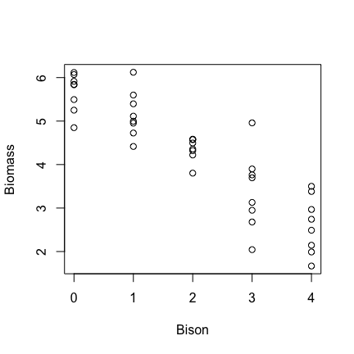

# In this case, R saws numbers in the 'Bison' column and treated the variable as continuous  
  
# Plot the data with X as a categorical variable  
plot(Biomass ~ as.factor(Bison), data = datum)

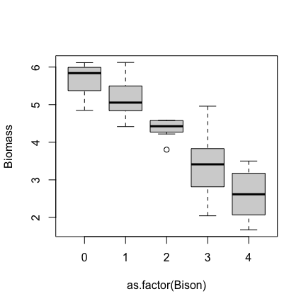

I used the as.factor function to get R to treat variable as a categorical variable. We could have manually created categorical variable or dummy-coded variables in Excel, but using as.factor is much easier. We could also also create a new variable and save it in our ‘datum’

# Run a regression, where we treat Bison as continuous  
results <- lm(Biomass ~ Bison, data = datum)  
summary(results)

##   
## Call:  
## lm(formula = Biomass ~ Bison, data = datum)  
##   
## Residuals:  
## Min 1Q Median 3Q Max   
## -1.4075 -0.3537 0.0802 0.3174 1.5081   
##   
## Coefficients:  
## Estimate Std. Error t value Pr(>|t|)   
## (Intercept) 5.8207 0.1596 36.5 < 2e-16 ***  
## Bison -0.7899 0.0652 -12.1 1.3e-14 ***  
## ---  
## Signif. codes: 0 '***' 0.001 '**' 0.01 '*' 0.05 '.' 0.1 ' ' 1  
##   
## Residual standard error: 0.583 on 38 degrees of freedom  
## Multiple R-squared: 0.795, Adjusted R-squared: 0.789   
## F-statistic: 147 on 1 and 38 DF, p-value: 1.26e-14

Bison is continuous, because R saw numbers for that variable. How do we know this? **We only got 1 beta from the analysis.**

# Run an ANOVA - treat Bison as categorical  
results2 <- lm(Biomass ~ as.factor(Bison), data = datum)  
# use the as.factor function to get R to treat 'Bison' as continuous  
summary(results2)

##   
## Call:  
## lm(formula = Biomass ~ as.factor(Bison), data = datum)  
##   
## Residuals:  
## Min 1Q Median 3Q Max   
## -1.3464 -0.4255 0.0594 0.3186 1.5692   
##   
## Coefficients:  
## Estimate Std. Error t value Pr(>|t|)   
## (Intercept) 5.672 0.211 26.94 < 2e-16 ***  
## as.factor(Bison)1 -0.507 0.298 -1.70 0.0978 .   
## as.factor(Bison)2 -1.305 0.298 -4.38 0.0001 ***  
## as.factor(Bison)3 -2.282 0.298 -7.67 5.4e-09 ***  
## as.factor(Bison)4 -3.062 0.298 -10.28 4.1e-12 ***  
## ---  
## Signif. codes: 0 '***' 0.001 '**' 0.01 '*' 0.05 '.' 0.1 ' ' 1  
##   
## Residual standard error: 0.595 on 35 degrees of freedom  
## Multiple R-squared: 0.802, Adjusted R-squared: 0.78   
## F-statistic: 35.5 on 4 and 35 DF, p-value: 7.1e-12

The ‘Bison’ variable as a whole is highly significant – this is the p-value at the bottom. All groups are all significantly different from Bison0. But other pairs of neighbor groups might not be.

But the question here is: is this more complicated model a significant improvement in the fit to the data?

Use an F-drop test!

# Conduct the F-drop test  
anova(results2, results)

## Analysis of Variance Table  
##   
## Model 1: Biomass ~ as.factor(Bison)  
## Model 2: Biomass ~ Bison  
## Res.Df RSS Df Sum of Sq F Pr(>F)  
## 1 35 12.4   
## 2 38 12.9 -3 -0.499 0.47 0.71

# The two models we have are the arguments  
# Usually, you should list the more complicated model first (the one with more betas)  
# Note: the two models can't have the same number of parameters  
# A significant p-value means the more complex model is a significant improvement in fit  
# A non-significant p-value means the simpler model is adequate  
# Note: RSS (which is the same thing as SSE) is always lower in the more complex model

The F-drop tests compares the residual sum of squares (RSS) of the two models and asks: how much does the sum of squares change when we add all those variables? Does it change a lot, such that there is a significant improvement in fit? Or did it not really decrease that much error?

In this case, it didn’t change the error that much, and the test did not recover a significant improvement in model fit by the more complex model. Therefore, the more complicated model does not significantly improve the fit to the data.

### F-drop rules:

**If P < 0.05, the complex model is a significant improvement (better) in fit.**

**If P > 0.05, the complex model is *not* a significant improvement in fit; the simpler model is adequate.**

This does not mean the simpler model is *better*; it is **adequate**. The simpler model will never be better, as the more complex model will always be better due to the extra parameters. The question is: is the complex model significantly **better**, or is the simple model **adequate**.

As always, the limitations of p-values apply here: sample sizes, effect sizes, etc.

Now, let’s consider another scenario. What if our data really looked like the second example from above?

# Read in the data  
datum <- read.csv("lecture_10_dataset2.csv")  
head(datum)  
  
# Plot the data  
plot(Biomass ~ Bison, data = datum)

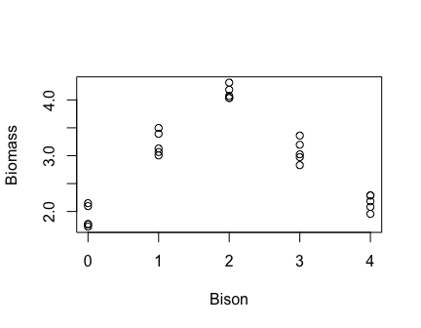

We know that fitting a line to this data is not a good fit, and we also know that a categorical approach would also fit this data pretty well.

But what about an in-between approach, where we fit one line but it is non-linear?

### Quadratics

One of the easiest ways to fit a non-linear line to your data is using a **quadratic** approach.

* *A bit of a caveat*… a quadratic may not be a good mechanistic explanation, because there are very few things in ecology that follow quadratic equations and they are hard to interpret. We will talk more about the difference between mechanistic and phenomenological explanations in data later in the semester.. But, for now, the quadratic might be good descriptions of your data.

$$Y=β_{0}+β_{1}Bison+β_{2}Bison^{2}+ϵ∼N\left(0,σ\right)$$

Notice that this curve has the advantage of **no assumption of linearity** and also doesn’t use nearly as many betas as treating X as categorical. In those ways, it is a **good compromise** between the two options we have discussed so far.

# BONUS: How to fit a quadratic curve to data when x is continuous  
  
# Fit a linear model  
results <- lm(Biomass ~ Bison, data = datum)  
  
#Fit a quadratic curve to data when x is continuous  
results3 <- lm(Biomass ~ Bison + I(Bison^2), data = datum)  
anova(results3, results)

## Analysis of Variance Table  
##   
## Model 1: Biomass ~ Bison + I(Bison^2)  
## Model 2: Biomass ~ Bison  
## Res.Df RSS Df Sum of Sq F Pr(>F)   
## 1 22 1.75   
## 2 23 16.50 -1 -14.8 186 3.3e-12 ***  
## ---  
## Signif. codes: 0 '***' 0.001 '**' 0.01 '*' 0.05 '.' 0.1 ' ' 1

The quadratic model is the more complicated model here, because it has more parameters than the linear model.

The quadratic model is a **significant improvement** in model fit compared to the simple linear model.

**Takehome points**:

1. We can use this approach to compare any two models, as long as one model is more complicated than the other. We cannot use this approach to compare models that have the same number of effects (betas).
2. When comparing two models, we need to make sure the datasets are exactly the same. If you use different datasets for two models, you can’t compare those two models using this approach and other approaches we will explore in the semester.

### Marginal p-values

So far in this class, we have always calculated p-values the same way: by comparing a model with that variable, to one without that variable. But I haven’t explained how this works yet…

When we ran the F-drop test above, we compared two models:

Simple model: $Y=β_{0}+β_{1}Bison+ϵ∼N\left(0,σ\right)$

More complex model: $Y=β_{0}+β_{1}Bison+β_{2}Bison^{2}+ϵ∼N\left(0,σ\right)$

This test evaluates the significance of the additional quadratic beta. Is this $β_{2}$ significantly different from zero? If $β_{2}$ is zero, then the models are the same, and the more simple model is adequate. If $β_{2}$ is non-zero, this will significantly improve model fit. So essentially, we are testing whether this additional parameter is **significant**.

We can also do an F-drop test comparing these two models:

Complex model: $Y=β_{0}+β_{1}Bison+ϵ∼N\left(0,σ\right)$

Simple model: $Y=β_{0}+ϵ∼N\left(0,σ\right)$

An F-drop test evaluates whether $β_{1}$ is significantly different from zero.

In truth, this is what the p-value from our simple linear regression analysis is evaluating! These ‘marginal p-values’ are the results of F-drop tests comparing whether the model with intercept and slope for bison is *significantly better* than a model without that slope.

# Read in dataset 1  
datum <- read.csv("lecture_10_dataset1.csv")  
  
# Simple linear model  
results <- lm(Biomass ~ Bison, data = datum)  
summary(results)

##   
## Call:  
## lm(formula = Biomass ~ Bison, data = datum)  
##   
## Residuals:  
## Min 1Q Median 3Q Max   
## -1.4075 -0.3537 0.0802 0.3174 1.5081   
##   
## Coefficients:  
## Estimate Std. Error t value Pr(>|t|)   
## (Intercept) 5.8207 0.1596 36.5 < 2e-16 ***  
## Bison -0.7899 0.0652 -12.1 1.3e-14 ***  
## ---  
## Signif. codes: 0 '***' 0.001 '**' 0.01 '*' 0.05 '.' 0.1 ' ' 1  
##   
## Residual standard error: 0.583 on 38 degrees of freedom  
## Multiple R-squared: 0.795, Adjusted R-squared: 0.789   
## F-statistic: 147 on 1 and 38 DF, p-value: 1.26e-14

This p-value is called a **marginal p-value** and is asking whether or how much that additional parameter marginally improves the fit to the data beyond the simpler model without that variable. (This is also called Type III Sum of Squares). It is essentially an F-drop test that is built into our linear model.

So, anytime you need a p-value, if R gives it to you, it is most likely giving you a marginal p-value that comes from an F-drop test.

Next class, we will explore more situations around this topic.

## Truth

Here is code to simulate the data we analyzed in this lecture.

###################### 'Truth' ########################   
### Lecture 10: code to simulate data for F-drop tests   
  
# Set the seed for reproducibility  
set.seed(111)  
  
## First dataset  
# X variable  
Bison <- c(rep(0, 8), rep(1, 8), rep(2, 8), rep(3, 8), rep(4, 8))  
  
# Error  
error <- rnorm(length(Bison), 0, 0.5)  
  
# Y variable  
Biomass <- 6 - 0.8*Bison + error  
  
# Create dataframe  
datum <- data.frame(Bison, Biomass)  
  
# Save the CSV file  
write.csv(datum, "lecture_10_dataset1.csv", row.names = FALSE)  
  
## Second dataset  
# X variable  
n <- 25  
x <- c(rep(0, 5), rep(1, 5), rep(2, 5), rep(3, 5), rep(4, 5))  
  
# Error  
error <- rnorm(n, 0, 0.2)  
  
# Dummy code x  
dummy <- data.frame(x = as.factor(x))  
dummy <- data.frame(model.matrix(~ dummy$x - 1, data=dummy))  
colnames(dummy) <- c("Zero", "One", "Two", "Three", "Four")  
  
# Simulate continuous y-variable data  
y <- 2 + dummy$One * 1 + dummy$Two * 2 + dummy$Three * 1 + dummy$Four * 0 + error  
  
# Create dataframe  
datum <- data.frame(Bison = x, Biomass = y)  
  
# Save the CSV file  
write.csv(datum, "lecture_10_dataset2.csv", row.names = FALSE)

[–go to next lecture–](lecture_11.html)