Module 8: Critical Thinking - Project code and GitHub link
Brian Goff – 344580
Colorado State University - Global
24WB-MIS581 - Capstone - Business Intelligence and Data Analytics
Dr. Justin Bateh
9 February 2025

GitHub Link:
https://github.com/briang7165/Retail_Analytics_Capstone

Code:
Retail and Wherehouse Sales Prep

/* Step 1: Validate the Dataset */
proc contents data=work.import;
title "Dataset Structure: Retail and Warehouse Sales";
run;

proc print data=work.import(obs=10);
title "Preview of Raw Dataset";
run;

/* Step 2: Handle Missing Values */
proc stdize data=work.import reponly missing=mean out=work.retail_cleaned;
var "Retail Sales"n "Retail Transfers"n "Warehouse Sales"n; /* Use name literals if column names contain spaces */
run;

data work.retail_cleaned;
set work.retail_cleaned;
if missing(Supplier) then Supplier = "Unknown";
run;

proc means data=work.retail_cleaned n nmiss;
var "Retail Sales"n "Retail Transfers"n "Warehouse Sales"n;
run;

proc print data=work.retail_cleaned(obs=10);
title "Preview of Cleaned Dataset";
run;

/* Step 3: Seasonal Revenue Trends */
proc sql;
create table monthly_revenue as
select MONTH,
sum("Retail Sales"n + "Retail Transfers"n + "Warehouse Sales"n) as Total_Revenue
from work.retail_cleaned
group by MONTH
order by MONTH;
quit;

proc sgplot data=monthly_revenue;
vbar MONTH / response=Total_Revenue datalabel dataskin=pressed;
xaxis label="Month";
yaxis label="Total Revenue (USD)";
title "Seasonal Revenue Trends";
run;

/* Step 4: Average Revenue by Item Type */
proc sql;
create table avg_revenue_by_item as
select "ITEM TYPE"n as Item_Type,
mean("RETAIL SALES"n + "RETAIL TRANSFERS"n + "WAREHOUSE SALES"n) as Avg_Revenue
from work.retail_cleaned
group by "ITEM TYPE"n
order by Avg_Revenue desc;
quit;

proc sgplot data=avg_revenue_by_item;
vbar Item_Type / response=Avg_Revenue datalabel dataskin=pressed;
xaxis label="Item Type";
yaxis label="Average Revenue (USD)";
title "Average Revenue by Item Type";
run;

/* Step 5: Sales Distribution by Item Type */
proc sql;
create table sales_distribution as
select "ITEM TYPE"n as Item_Type,
sum("Retail Sales"n + "Retail Transfers"n + "Warehouse Sales"n) as Total_Sales
from work.retail_cleaned
group by "ITEM TYPE"n
order by Total_Sales desc;
quit;

proc sgpie data=sales_distribution;
pie Item_Type / response=Total_Sales;
title "Sales Distribution by Item Type";
title2 "Sum of Total_Sales by ITEM TYPE";
run;

Scanner data code
/* Step 1: Inspect the Raw Dataset */
proc contents data=work.import1;
title "Dataset Structure: Scanner Data (Raw)";
run;

proc print data=work.import1(obs=10);
title "Preview of Raw Scanner Data";
run;

/* Step 2: Fix Date Format and Rename Columns */
data work.scanner_cleaned;
set work.import1;

/* Correct the Date format */
if _n_ = 1 then do;
informat Date ddmmyy10.;
format Date yymmdd10.;
end;

/* Rename columns for clarity */
retain Date Customer_ID Transaction_ID SKU_Category SKU Quantity Sales_Amount;

/* Drop unnecessary columns (e.g., VAR1) */
drop VAR1;
run;

/* Step 3: Validate the Cleaned Dataset */
proc contents data=work.scanner_cleaned;
title "Dataset Structure: Scanner Data (Cleaned)";
run;

proc print data=work.scanner_cleaned(obs=10);
title "Preview of Cleaned Scanner Data";
run;

/* Step 4: Handle Missing Values */
/* Check for missing values */
proc means data=work.scanner_cleaned n nmiss;
var Quantity Sales_Amount;
run;

/* Impute missing numeric values with the mean */
proc stdize data=work.scanner_cleaned reponly missing=mean out=work.scanner_final;
var Quantity Sales_Amount;
run;

/* Step 5: Validate the Final Dataset */
proc contents data=work.scanner_final;
title "Dataset Structure: Scanner Data (Final)";
run;

proc print data=work.scanner_final(obs=10);
title "Preview of Final Scanner Data";
run;

/* Step 6: Summary Statistics */
proc means data=work.scanner_final mean std min max n;
var Quantity Sales_Amount;
title "Summary Statistics for Scanner Data";
run;

/* Step 7: Top 10 SKU Categories by Sales */
proc sql;
create table sales_by_category as
select SKU_Category,
sum(Sales_Amount) as Total_Sales_Amount
from work.scanner_final
group by SKU_Category
order by Total_Sales_Amount desc;
quit;

data top_10_categories;
set sales_by_category;
if _N_ <= 10; /* Keep only the top 10 rows */
run;

proc sgplot data=top_10_categories;
vbar SKU_Category / response=Total_Sales_Amount datalabel dataskin=pressed;
xaxis label="SKU Category";
yaxis label="Total Sales (USD)";
title "Top 10 SKU Categories by Sales";
run;

/* Step 8: Top 10 Products by Sales */
proc sql;
create table sales_by_sku as
select SKU,
sum(Sales_Amount) as Total_Sales_Amount
from work.scanner_final
group by SKU
order by Total_Sales_Amount desc;
quit;

data top_10_skus;
set sales_by_sku;
if _N_ <= 10; /* Keep only the top 10 rows */
run;

proc sgplot data=top_10_skus;
vbar SKU / response=Total_Sales_Amount datalabel dataskin=pressed;
xaxis label="Product SKU";
yaxis label="Total Sales (USD)";
title "Top 10 Products by Sales";
run;

/* Step 9: Correlation Analysis Between Quantity and Sales */
proc corr data=work.scanner_final;
var Quantity Sales_Amount;
title "The CORR Procedure";
run;

/* Step 10: Summary Statistics for Correlation Variables */
proc means data=work.scanner_final mean std sum min max;
var Quantity Sales_Amount;
title "Summary Statistics for Quantity and Sales Amount";
run;

H1 and H2 Code:
/* Step 1: Box Plot for Sales Distribution by Product Category */
proc sgplot data=work.retail_cleaned;
vbox "Retail Sales"n / category="Item Type"n;
xaxis label="Product Category" fitpolicy=stagger; /* Staggered labels for clarity */
yaxis label="Retail Sales (USD)" min=0 max=1000; /* Adjust axis range to reduce compression */
title "Sales Distribution by Product Category (Adjusted)";
run;

/* Step 2: Perform ANOVA for Product Categories and Sales */
proc anova data=work.retail_cleaned PLOTS(MAXPOINTS=15000);
class "Item Type"n;
model "Retail Sales"n = "Item Type"n;
means "Item Type"n / tukey;
title "ANOVA for Product Category and Sales";
run;

/* Step 3: Add Season Variable */
data work.retail_seasonal;
set work.retail_cleaned;
length Season $10; /* Ensure Season variable has character length */
if MONTH in (3, 4, 5) then Season = "Spring";
else if MONTH in (6, 7, 8) then Season = "Summer";
else if MONTH in (9, 10, 11) then Season = "Fall";
else if MONTH in (12, 1, 2) then Season = "Winter";
run;

/* Step 4: Summarize Sales by Season and Product Category */
proc sql;
create table work.seasonal_sales as
select "Item Type"n as Category,
Season,
sum("Retail Sales"n) as Total_Sales,
mean("Retail Sales"n) as Avg_Sales
from work.retail_seasonal
group by "Item Type"n, Season
order by Category, Season;
quit;

/* Step 5: Perform Two-Way ANOVA */
proc anova data=work.retail_seasonal;
class Season "Item Type"n;
model "Retail Sales"n = Season | "Item Type"n;
means Season "Item Type"n / tukey;
title "Two-Way ANOVA for Seasonal Trends and Product Categories";
run;

/* Step 6: Bar Chart: Total Sales by Season and Product Category */
proc sgplot data=work.seasonal_sales;
vbar Season / response=Total_Sales group=Category groupdisplay=cluster datalabel;
xaxis label="Season";
yaxis label="Total Sales (USD)";
title "Total Sales by Season and Product Category";
run;

/* Step 7: Interaction Plot: Seasonal Trends by Product Category */
proc sgplot data=work.seasonal_sales;
series x=Season y=Avg_Sales / group=Category markers lineattrs=(pattern=solid);
xaxis label="Season";
yaxis label="Average Sales (USD)";
title "Seasonal Trends by Product Category";
run;

/* Step 10: Recode SKU and Sales_Category to Numeric */
data work.sales_categorized_numeric;
set work.import;
/* Ensure SKU is numeric */
SKU_Code = input(SKU, best12.); /* If SKU cannot be converted, assign numeric codes manually */
/* Recode Sales_Category */
if Sales_Category = "Low" then Sales_Code = 1;
else if Sales_Category = "Medium" then Sales_Code = 2;
else if Sales_Category = "High" then Sales_Code = 3;
run;

/* Step 11: Verify Recoded Dataset */
proc contents data=work.sales_categorized_numeric;
title "Verify Recoded Dataset";
run;

/* Step 13: Prepare Data for Time-Series Plot */
proc sql;
create table work.sales_trends as
select YEAR, MONTH,
sum("Retail Sales"n) as Total_Sales
from work.import
group by YEAR, MONTH
order by YEAR, MONTH;
quit;

/* Step 14: Line Chart: Monthly Sales Trends */
proc sgplot data=work.sales_trends;
series x=MONTH y=Total_Sales / markers lineattrs=(color=blue pattern=solid thickness=2);
xaxis label="Month";
yaxis label="Total Sales (USD)";
title "Monthly Retail Sales Trends";
run;
H3 code
/* Step 1: Filter Data to Match H3 Results */
proc sql;
create table filtered_sales as
select *
from work.import1
where Sales_Amount > 0 /* Remove invalid sales values */
and SKU is not missing /* Ensure SKU is present */
order by Sales_Amount desc; /* Sort by sales amount for subset selection */
quit;

/* Step 2: Assign Numeric Codes to SKU */
data work.sales_categorized_numeric;
set filtered_sales;
SKU_Code = _N_; /* Assign a unique numeric identifier */
run;

/* Step 3: Perform Regression Analysis */
proc reg data=work.sales_categorized_numeric(obs=305); /* Match H3 sample size */
model Sales_Amount = SKU_Code;
title "Regression Analysis for SKU Code and Sales Amount - Filtered Data";
run;

/* Step 4: Generate Fit Plot */
proc sgplot data=work.sales_categorized_numeric(obs=305);
reg x=SKU_Code y=Sales_Amount / clm cli;
title "Fit Plot for Sales_Amount";
run;
H4 Code:
/* Step 1: Aggregate Sales Data by Customer */
proc sql;
create table customer_data as
select Customer_ID,
sum(Sales_Amount) as Total_Sales,
count(Transaction_ID) as Number_of_Transactions
from work.IMPORT1 /* Use the correct dataset */
group by Customer_ID;
quit;

/* Step 2: Define Retention Status */
data customer_data_retention;
set customer_data;
if Number_of_Transactions > 1 then Retention_Status = "Retained";
else Retention_Status = "Non-Retained";
run;

/* Step 3: Categorize Total Sales */
data customer_data_retention;
set customer_data_retention;
if Total_Sales <= 100 then Sales_Category = "Low";
else if Total_Sales <= 1000 then Sales_Category = "Medium";
else Sales_Category = "High";
run;

/* Step 4: Chi-Square Test for Sales Volume and Retention Status */
proc freq data=customer_data_retention;
tables Sales_Category*Retention_Status / chisq;
title "Chi-Square Test for Sales Volume and Retention Status";
run;

/* Step 5: Correlation Analysis */
proc corr data=customer_data_retention;
var Total_Sales Number_of_Transactions;
title "Correlation Analysis Between Sales Volume and Customer Retention";
run;

/* Step 6: Scatter Plot of Sales Volume and Number of Transactions */
proc sgplot data=customer_data_retention;
scatter x=Number_of_Transactions y=Total_Sales / group=Retention_Status;
xaxis label="Number of Transactions";
yaxis label="Total Sales (USD)";
title "Scatter Plot of Sales Volume and Number of Transactions";
run;

Retail and Warehouse Results:
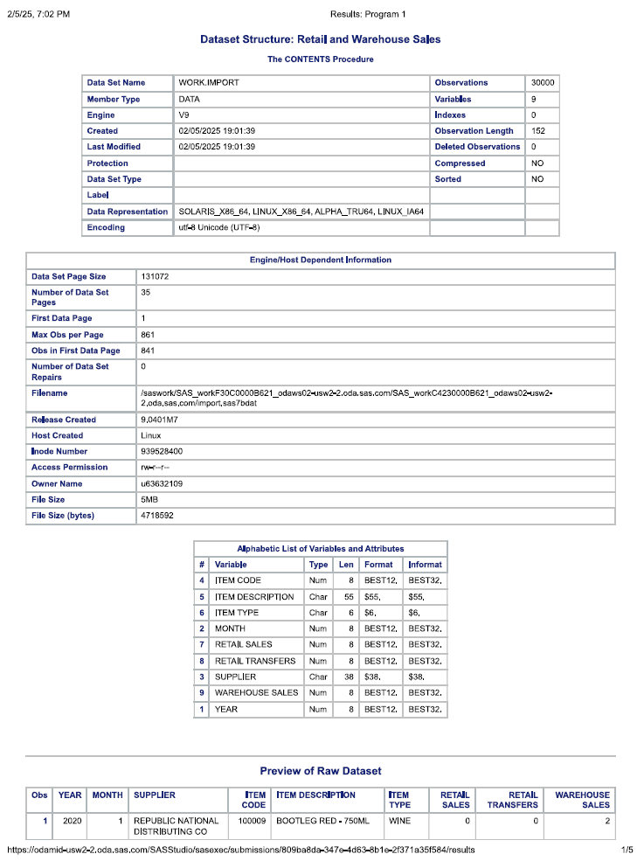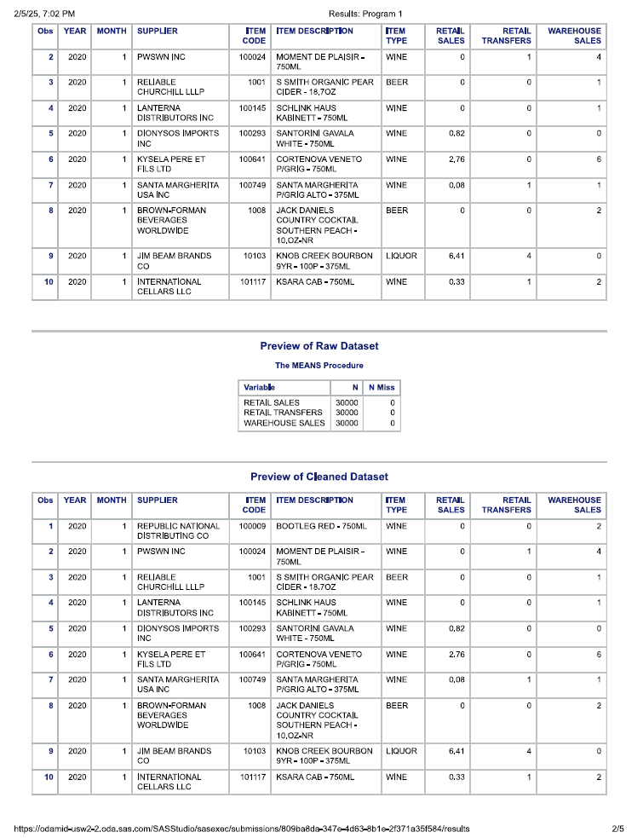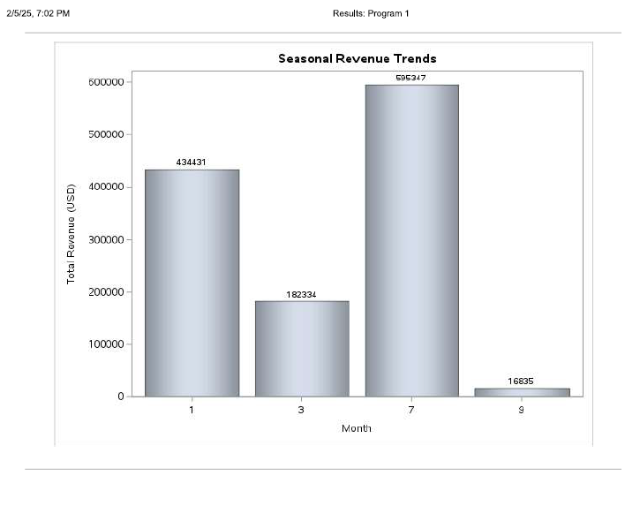

Scanner Data results:
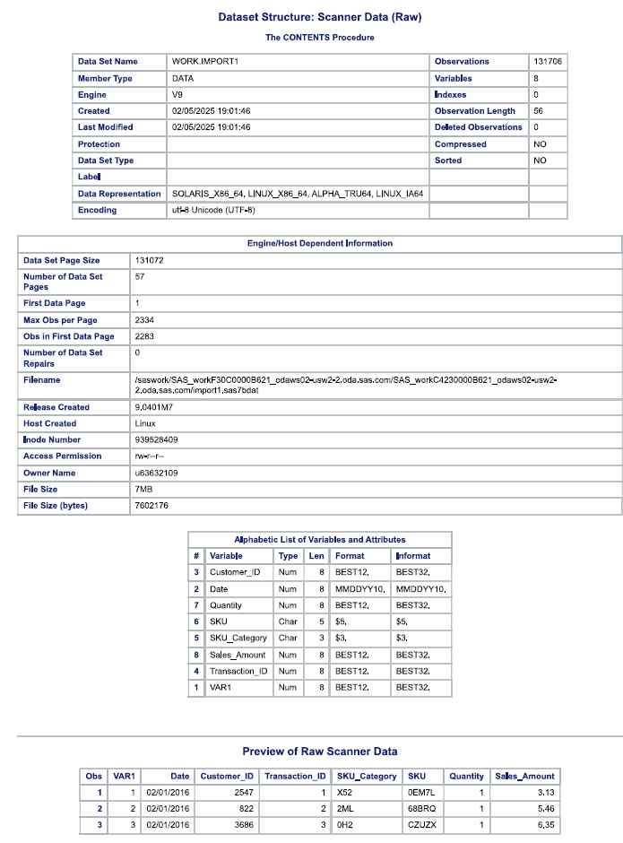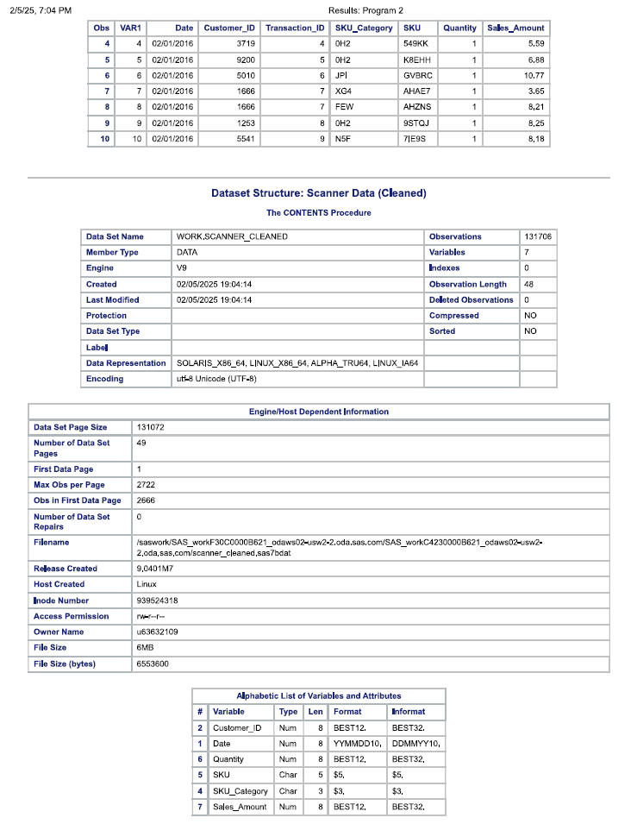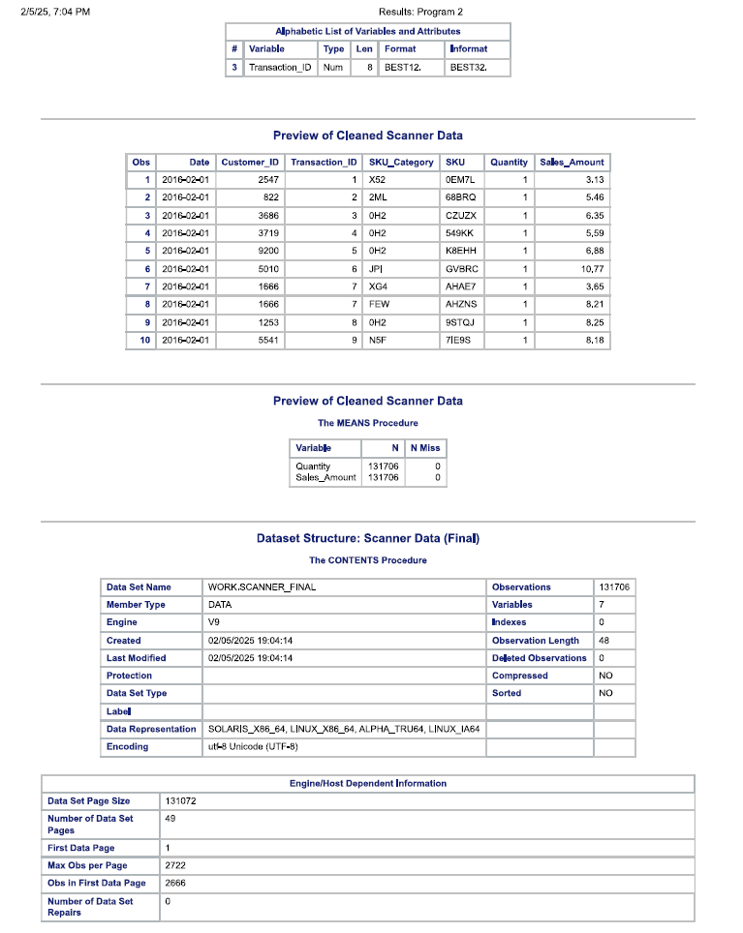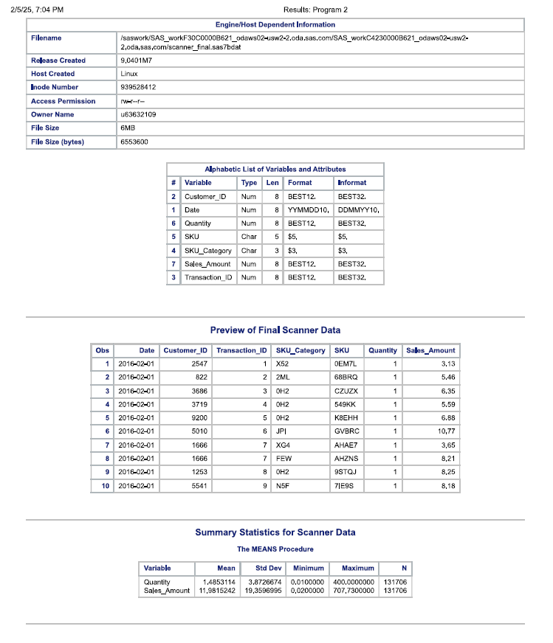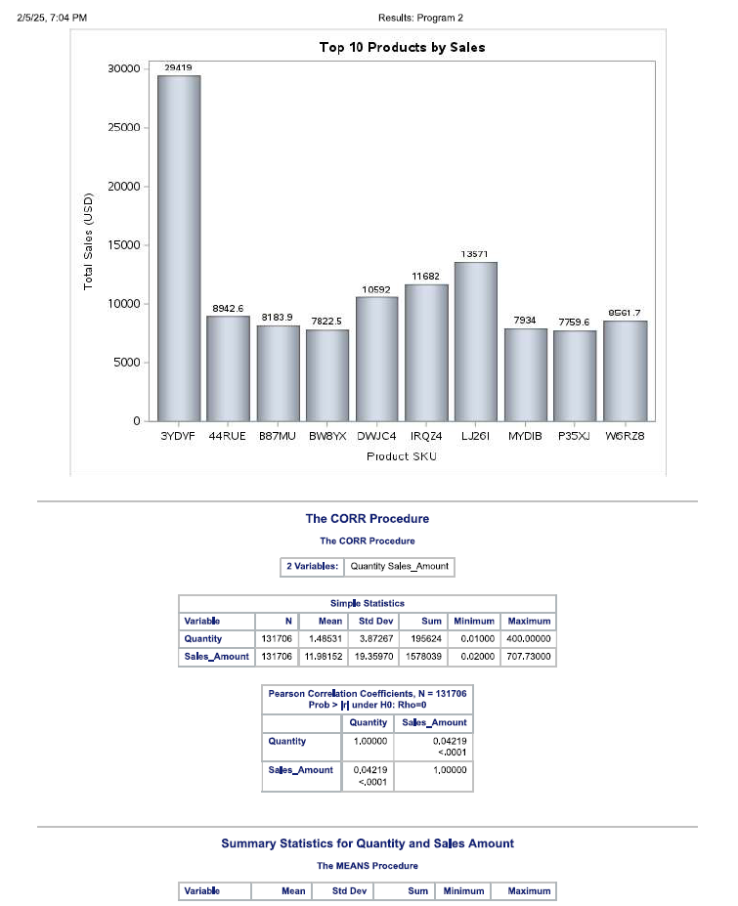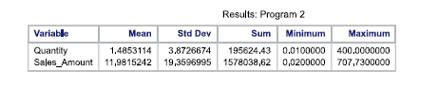
Hypothesis 1 and 2 results:
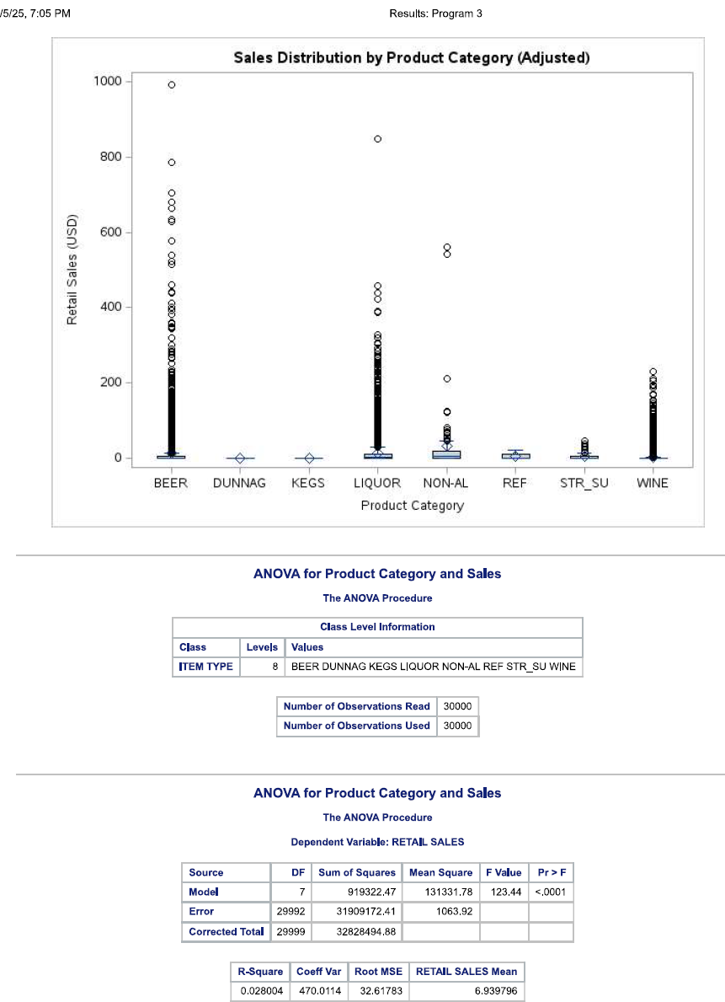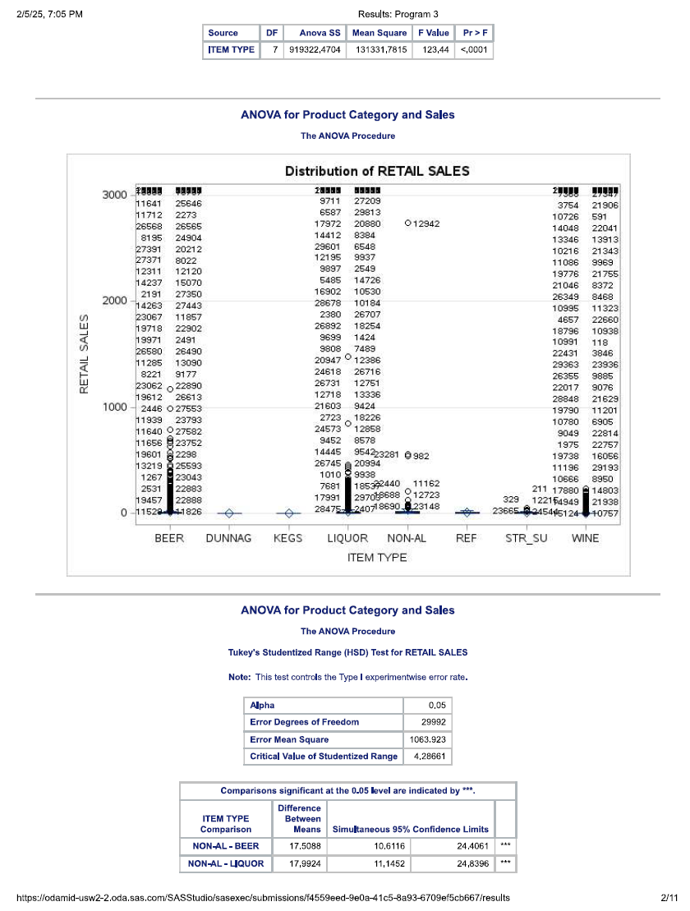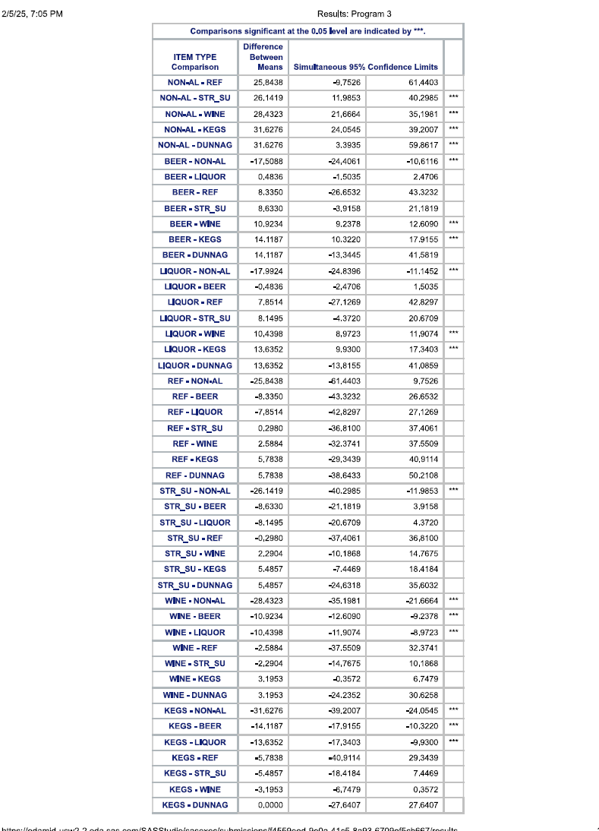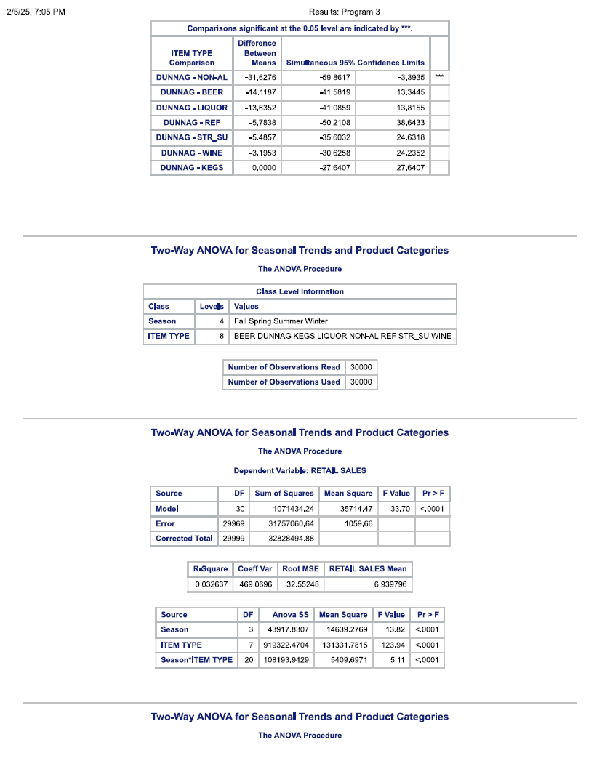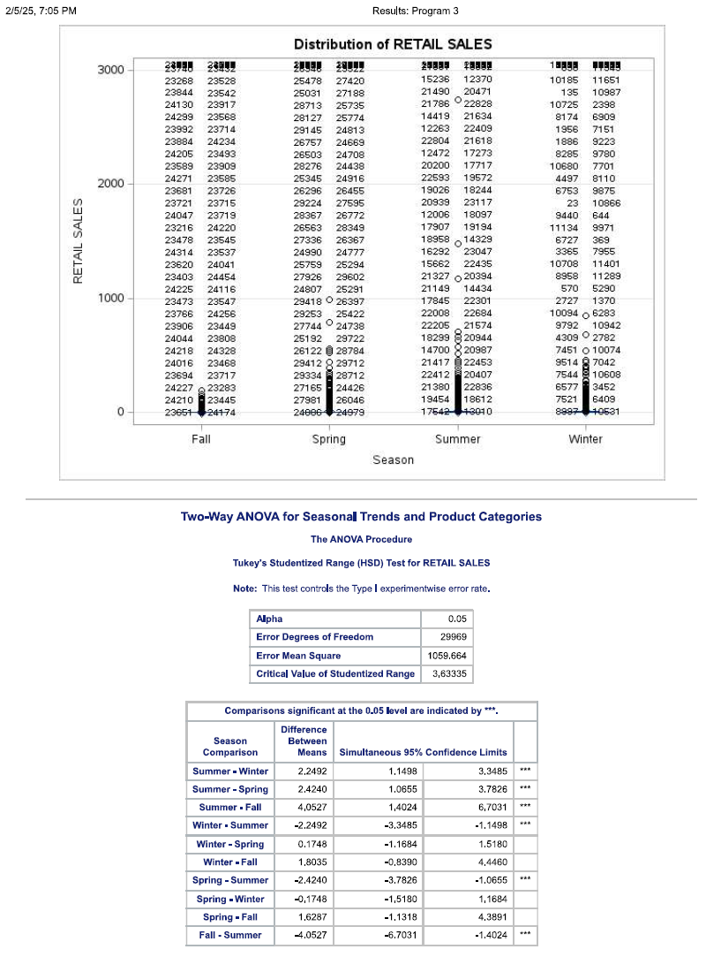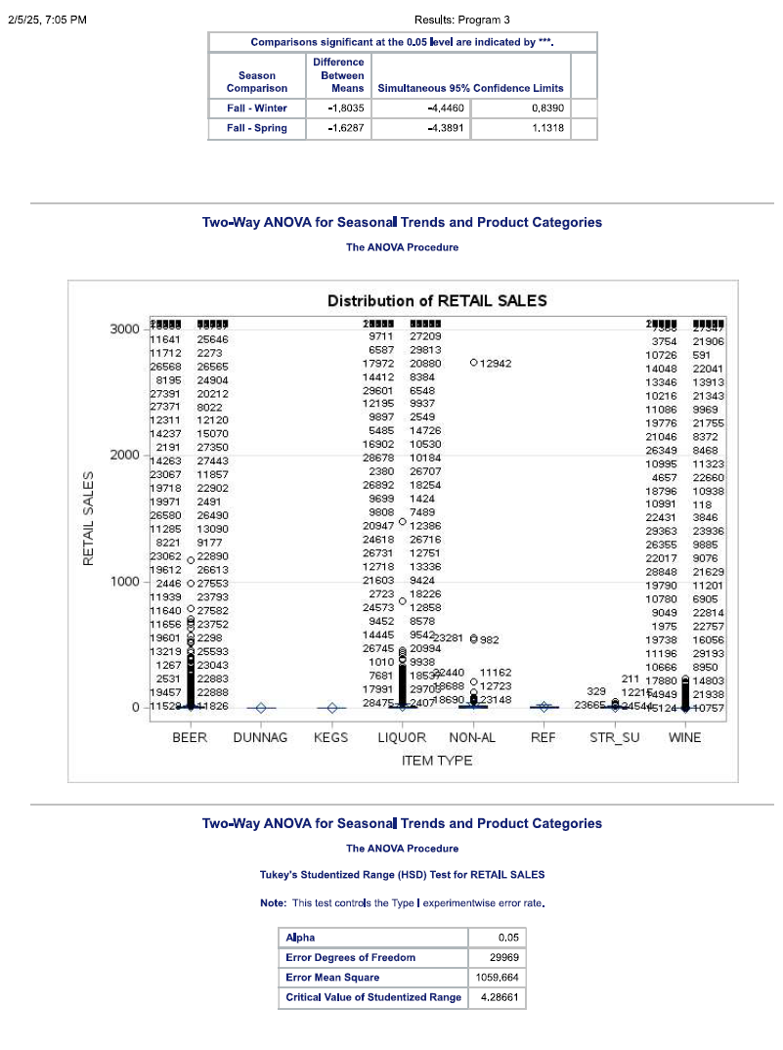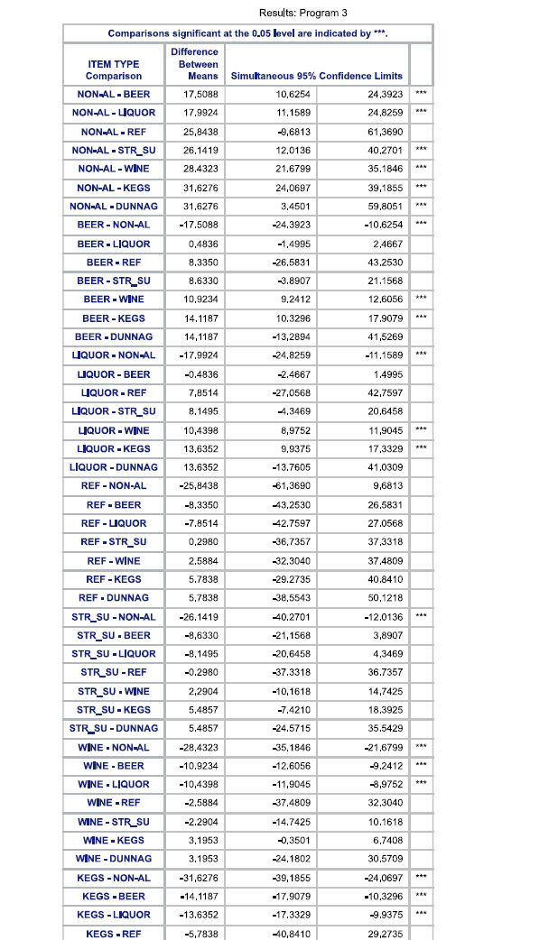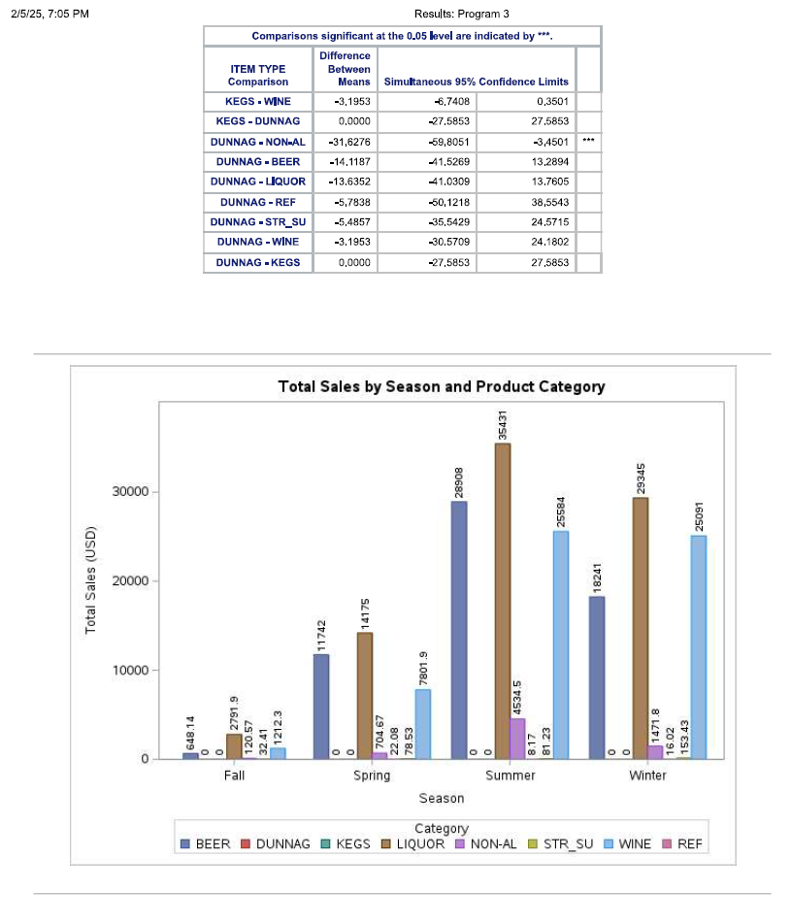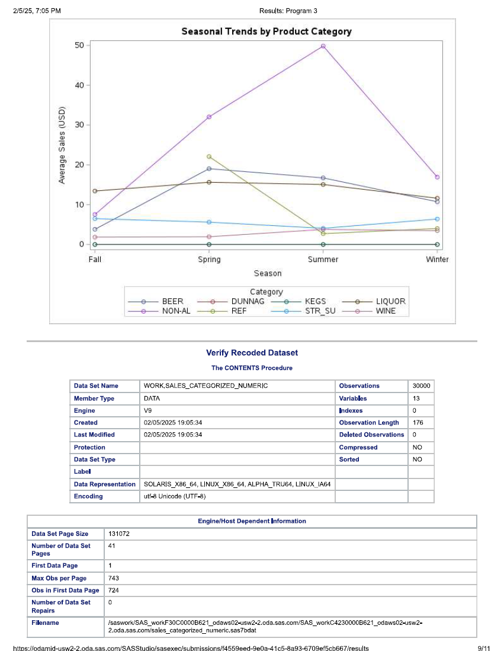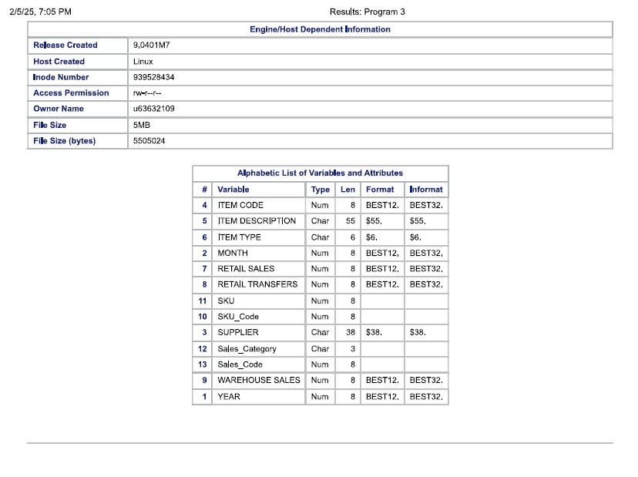

Hypothesis 3 results:
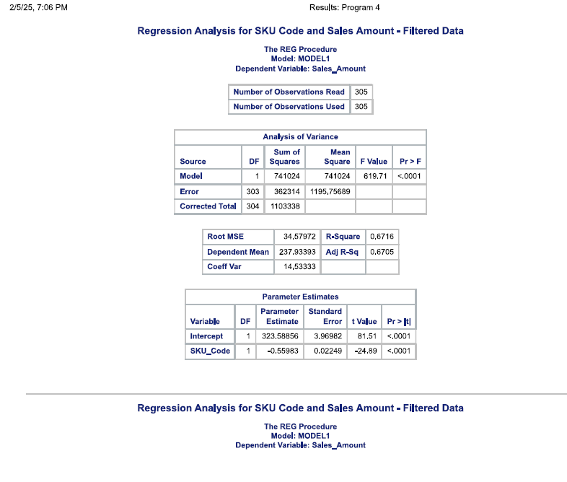

Hypothesis 4 results:
