Lab 2: Choropleth Mapping & Data Classification

Assigned: 10:00am, 01/14/2020 | **Due date:** 10:00am, 01/21/2020

### **Objectives:**

### To reinforce the basics of choropleth maps;

### To experiment with different classification methods;

### To create a new choropleth map of proportion or rate data from an existing dataset;

1. To learn the basics of labeling.

### **PART 1: Examining the Data**

### Download the “data.zip” file from Canvas, then extract the contents to **LAB2** **folder in your workspace**

1. Start ArcGIS Pro. Under *Create A New Project*, click *Blank*. And name your project “lab2”, and save it to LAB2 folder in your workspace.

### On the *Insert* tab, click *New Map* in the *Project* group. You can then find a world basemap in the *Contents*.

1. On the *Map* tab, click *Add Data*, and add the Benton2000 shapefile from your lab2 data folder. And then rename the map **Benton** (Click *Map* in *Contents*, and then click it again to make it editable). Zoom it to the layer. In the meantime, remove the world Topographic Map in the *Contents*.

### Right-click on the layer (Benton2000) in *Contents* and choose *Attribute Table* to open its attribute table.

The Benton2000 shapefile represents the block groups of census tract in Benton County that contain a variety of useful information. Notice the names of each column (field) in the attribute table. It’s impractical to show long descriptive names in the table, so code names are used. Here is some brief metadata about each field:

|  |  |
| --- | --- |
| **Field Name** | **Description** |
| P001001 | Total population: Total |
| P006002 | Total population: White alone |
| P006003 | Total population: Black or African American alone |
| P006008 | Total population: Two or more races |
| P030002 | Workers 16 years and over: Means of transportation to work; Car; truck; or van |
| P030005 | Workers 16 years and over: Means of transportation to work; Public transportation |
| P030012 | Workers 16 years and over: Means of transportation to work; Motorcycle |
| P030013 | Workers 16 years and over: Means of transportation to work; Bicycle |
| P030014 | Workers 16 years and over: Means of transportation to work; Walked |
| P030015 | Workers 16 years and over: Means of transportation to work; Other means |
| P030016 | Workers 16 years and over: Worked at home |
| P031003 | Workers 16 years and over: Did not work at home; Travel time to work; Less than 5 minutes |
| P031004 | Workers 16 years and over: Did not work at home; Travel time to work; 5 to 9 minutes |
| P031005 | Workers 16 years and over: Did not work at home; Travel time to work; 10 to 14 minutes |
| P031006 | Workers 16 years and over: Did not work at home; Travel time to work; 15 to 19 minutes |
| P031007 | Workers 16 years and over: Did not work at home; Travel time to work; 20 to 24 minutes |
| P031008 | Workers 16 years and over: Did not work at home; Travel time to work; 25 to 29 minutes |
| P031009 | Workers 16 years and over: Did not work at home; Travel time to work; 30 to 34 minutes |
| P031010 | Workers 16 years and over: Did not work at home; Travel time to work; 35 to 39 minutes |
| P031011 | Workers 16 years and over: Did not work at home; Travel time to work; 40 to 44 minutes |
| P031012 | Workers 16 years and over: Did not work at home; Travel time to work; 45 to 59 minutes |
| P031013 | Workers 16 years and over: Did not work at home; Travel time to work; 60 to 89 minutes |
| P031014 | Workers 16 years and over: Did not work at home; Travel time to work; 90 or more minutes |
| P037002 | Population 25 years and over: Male |
| P037011 | Population 25 years and over: Male; High school graduate (includes equivalency) |
| P037015 | Population 25 years and over: Male; Bachelor's degree |
| P037016 | Population 25 years and over: Male; Master's degree |
| P037018 | Population 25 years and over: Male; Doctorate degree |
| P037019 | Population 25 years and over: Female |
| P037028 | Population 25 years and over: Female; High school graduate (includes equivalency) |
| P037032 | Population 25 years and over: Female; Bachelor's degree |
| P037033 | Population 25 years and over: Female; Master's degree |
| P037035 | Population 25 years and over: Female; Doctorate degree |
| P053001 | Households: Median household income in 1999 |
| P082001 | Total population: Per capita income in 1999 |
| P087002 | Population for whom poverty status is determined: Income in 1999 below poverty level |
| P087010 | Population for whom poverty status is determined: Income in 1999 at or above poverty level |

There are a couple of fields for population counts, but all are absolute counts. From the lectures, you might remember that we should NOT make choropleth maps using absolute counts. Why is that? Let’s instead make a map of block groups population proportions.

### **PART 2: Symbolization and On-the-fly Normalization**

1. In the *Contents* pane, click the Benton2000 layer.
2. You can find *Appearance* contextual tab appears on the ribbon. Click *Appearance*. And in the *Drawing* group, click down arrow on *Symbology*. Select *Symbolize your layer by quantities* -> *Graduated Colors*.
3. Click the *Field* dropdown arrow under *Primary symbology* on Symbology Pane, and choose the field that contains the values you want to map. In this case you can start off by selecting the field that corresponds with Total population: White alone (P006002). Keep the Class breaks at 5.

Now notice that you have some values of population broken into 5 different classes. Your screen should look similar to the image below.

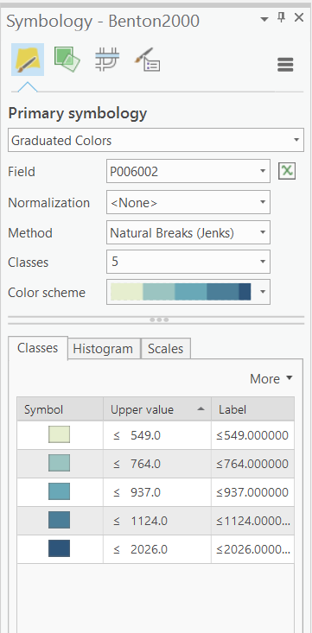

If you click *Histogram* in the lower half of the *Symbology* pane, you can find that, at Benton County, we have a minimum of 265 and a maximum of 2026 people classified as White alone in any one block group of census tract.

1. Click the dropdown for the Color Ramp and notice you have a whole host of color options to experiment with. Choose any one of them. Click Apply.

But these are still raw counts! We need to create some form of *normalization*. To allow for a comparison of the map before and after normalization, we will set up two Map Frames that allow us to display both versions in the final layout. First, we will need to create another map to show *normalization.*

1. On the *Insert* tab, click *New Map* in the *Project* group. And on the *Map* tab, click *Add Data*, and add the Benton2000 shapefile from your lab2 data folder. And then rename the map **Benton2**. Zoom it to the layer. And remove the world Topographic Map in the *Contents*.
2. Similarly, Change the Symbology of Benton2000 shapefile in this new map. For the value *Field* choose Total population: White alone and for the *Normalization* field chooses Total population: Total. (you may need to go back to the former table to see the corresponding code)

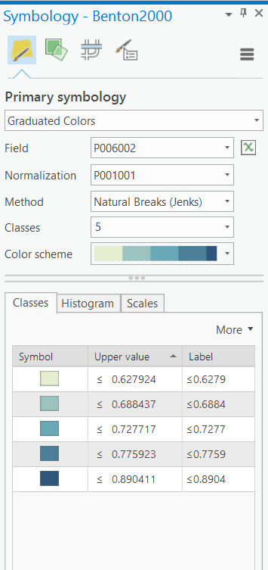

Now you have two different maps! And you can show them in one layout to compare them!

1. On the *Insert* tab, in the *Project* group, click *New Layout*. A menu appears with options for layouts based on paper sizes. And then from the *ANSI – Portrait* group, choose *Letter*.
2. We are going to use two map frames to show the maps. First insert a new data frame into the Contents: *Map Frame*🡪*Benton*🡪 *Default*. You can then find a new Map Frame in the Layout, click Map Frame, and click it again to change its name to *RawData Map Frame*.
3. Similarly, insert another map frame into the Contents, *Map Frame*🡪*Benton2*🡪 *Default* and name this new map frame as *NormData Map Frame*.

Then you need to set the position and resize the two data frames to make more rooms for other map elements.

1. Right-click *RawData Map Frame* and choose Properties. Then in the *Element* pane, under Map Frame, click the *Placement* button . Change the Size entries to the following values: Width: 6.5 in; Height:4.5 in. And then change the Position entries to the following values: X: 1 in; Y:5.5 in.
2. Similarly, change the size and position of *NormData Map Frame* using following settings: Width:6.5 in; Height:4.5 in; X: 1 in; Y:1 in.
3. Right-click on Benton2000 and choose Zoom to layer if your data is not shown properly on your layout.

Now look at the map you just made. The normalization is done ‘on-the-fly’ by displaying the ratio between white and total population on the map so that you get white population as a percent of total population.

1. Make sure to use the same color ramp to set both maps so that you can compare them.

Now add additional elements. We want to add the following to the main map: a title, a scale bar, a legend, and author information

1. Click *RawData Map Frame***.** On the *Insert* tab🡪 *Text* group, click the Text down arrow and choose *text*. Click anywhere in the layout, and double-click the default text to make it editable, type a title to explain what is being mapped. And then place the map title at the top of the layout after resizing it.

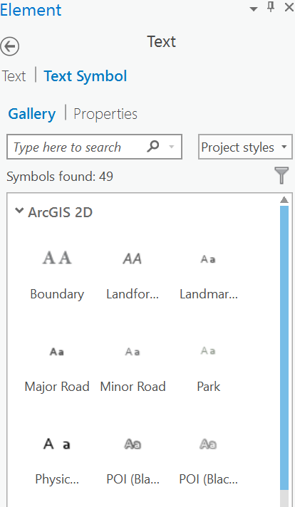

1. Similary, add author (your name), and the data you make the map. Place it on proper place(for example, on the bottom of the map.
2. In the Map Surrounds group, click Legend. Draw a box in proper empty place beside the map. And if you want, resize the legend. Similary, add a North Arrow, and Scale bar.
3. Add map elements on *NormData Map Frame*.
4. Export your map. On the *Share* tab, in the *Export* group, click *Layout*. Browse to LAB2 in your workspace, and export this map.

|  |
| --- |
| **Deliverable 1:** Thinking about the process you just completed above, you are now asked to do a very similar task to map something a little more interesting: the population under the poverty level in Benton County. Read the following requirements carefully:  .Set the top one to the field that corresponds to **Population for whom poverty status is determined: Income in 1999 below poverty level**. This will be the aggregate count of the population below the poverty level. Set the layer in the bottom data frame to show a proportion of the total population that is below poverty level.  You can continue using 5 classes with the Natural Breaks(Jenks) method. Remember to have both maps use the same color ramp, so that they are easier to compare.  For the proportional map, reduce the number of decimal places shown by clicking on the Label heading in the Symbology tab, then Format Labels. Set it to 2 decimal places, or a percentage with 0 decimal places. **Do this in the rest of the deliverables, too.**    Include a **title** for **each map frame** to explain what is being mapped. Include an **explanatory text** box on your map that explains this comparison and that highlights some key differences in the two maps. Also include all other necessary **map elements** placed in some intellectual and visual hierarchy (**see Design Guidelines, last page**). Your final map should have both map frames in the same layout view at the same scale and size to fit onto on 8.5 by 11 inch page. You can use the Rulers and Align to make the layout process (select the map frames and right click to align) (10 points)  Tip: you will need to start with new maps. Instead of inserting new maps, you can use the old map as the base. In the Catalog 🡪 Maps, copy the old maps, and then paste it here. Open the Symbology of the map to change which fields they are visualizing. This will save you time, but make sure to change the name of the map so you know what contents you are mapping. |

### **PART 3: Changing Map Appearance**

Typically you need to adjust the number of classes and the type of classification scheme for your map to make it better. Color choice is also an important part of map design. In this part of the exercise, you will be experimenting with both.

### **Change the number of classes:**

1. We will start from the map about poverty rates normalized by total population you just made. In the *Catalog* 🡪 *Maps*, copy this map, and paste it here. Rename it to poverty_class3. Double click to open it.
2. In the *Contents*, click on Benton2000 shape file. Open the *Symbology*. In the *Classes* box you can select different numbers of classes. Select 3 as class numbers and see how the classes change.
3. Similarly, make another three maps with 5, 7, 9 as class numbers.

|  |
| --- |
| **Deliverable 2:** Plot four different maps of the four classifications that you just tested, together on 1 page. This means you need four separate map frames in ArcGIS pro. Tip: How you get two map frames in Deliverable 1?  The map frames should be the same size and have the same scale. Make sure to include all of the same map elements as in the last deliverable, and label each map according to its classification. Note: you only need one scale bar and north arrow, since all four maps have the same extent and scale.  Also, insert a text box with an explanation of which one you think is the best and why (based on the textbook and your notes). (10 points) |

**Change the color scheme:**

1. Back on the symbology tab of the layer properties window, click the ‘Color scheme” button to see a selection of different color schemes for your map.
2. Experiment for a while with different schemes to find one that you feel gives your map a good appearance and readability. If you'd like some help choosing choropleth color schemes, check out <http://colorbrewer2.org/>

Change the type of classification method:

1. Click the *Histogram* to see the distribution of the data and the current class breaks.
2. Based on the best class number (from deliverable 2) you found previously, try different classification methods: equal interval, natural breaks, quantile, and standard deviation (i.e. If you found the 3 class map to be the best in requirement 2, you would plot the 4 different classification methods above using 3 classes for each) (Tips: click drop down on Method to find different classification methods).

|  |
| --- |
| **Deliverable 3:** Plot the four resultant maps TOGETHER on 1 page. Make sure to include legends and titles for each map and the necessary map elements.  Include an explanatory text on the map giving a brief definition in your own words of what the purpose of each classification method is (your textbook, ArcMap Help and class notes will help here).  Make sure that you use an appropriate color scheme for your map (See Colorbrewer and class notes). Standard deviation maps work best with divergent color schemes (15 points) |
|  |

**Lab Report**

The lab report will consist of the three maps completed following all the requirements outlined above. Attention to detail and good map design will be emphasized in the grading, so be sure to follow the design guidelines listed below. To make sure that your maps are readable in the Word document, change the picture size and word wrapping settings so that each map fills the page.

**Design Guidelines**

These design guidelines apply to this and all following exercise assignments. Following these guidelines should create more professional-looking products.

**Map Elements**

When the instructions ask you to include “the usual map elements,” this means a title, author, legend, north arrow, and scale bar.

**Scale Bar**

Use a simple-looking scale bar with nice round numbers for intervals. You can change the length of the scale bar by grabbing its handles on the left or right side and dragging it, and you can change the number of intervals by right-clicking the scale bar and opening its properties (see the “Scale and Units” tab and the “Numbers and Marks” tab).

Check the lengths of A) the whole scale bar, B) the major divisions, and C) the subdivisions. In most situations, all three should have whole number values.

Check to see how the divisions are labeled. If the subdivision lengths are obvious, there is no need to label them or the first midpoint, which is the default for many scale bars.

Never use decimal degrees or degrees/minutes/seconds in a scale bar. Use meaningful lengths like miles, meters.

**Layout**

Make sure all map elements and data frames are spaced far enough away from each other to be distinct. If there are multiple data frames in the map, you will probably want to make sure that they are precisely aligned to each other. You can align elements and data frames by selecting them in layout view and right-clicking them and choosing “align.” You can also right-click a selected group and choose “distribute” to make them the same size, if that fits with your design.

**Legend**

Remove the “Legend” title – we know what it is, there's no need to have it labeled.

By default, quantitative data may be shown with many decimal places. Reduce the decimal places being displayed to a sensible amount. If your class breaks are spread out by hundreds, you probably don't need decimal places at all.

Turn off headings for legend items where the layer names provide enough explanation.

**Text**

You can insert text boxes by using the button on the Insert tab. The text tool that looks like the character **A** does not automatically word-wrap, but the tool that looks like an **A** with a rectangle behind it does.

Make sure to check for spelling errors.

**Inserting your map into Word**

Make sure that your exported map doesn't look distorted or has been resized to the point the text is unclear in Word.

If your map is the standard 8.5x11” size, then right-click the image in Word and make sure it's size is 100%, and change the text wrapping mode to “Square.” It should then fill up the whole page in Word.

If the map instructions do not specify a page size to use, you can make a smaller map that will fit within the default margins of a Word document. You can change the page size under File->Page and Print Setup in ArcMap.

**Consistency**

If you have multiple map frames on the page, use consistent design between them. If you are showing the same area in multiple data frames, make each data frame the same size and set each to the same map scale. Each data frame should have the same border style (usually, it's easiest to turn off the borders).

If the data frames are showing different areas or otherwise have different scales, then each data frame will need its own scale bar. Make sure each scale bar uses the same style. If each data frame is at the same scale, then you only need to have one scale bar for the layout.