FL WINS UAT Test Report
June 17, 2025, 09:54 AM EST
Area Path: FL WINS\Testing Team | Iteration Path: FL WINS\Milestone 2\UAT
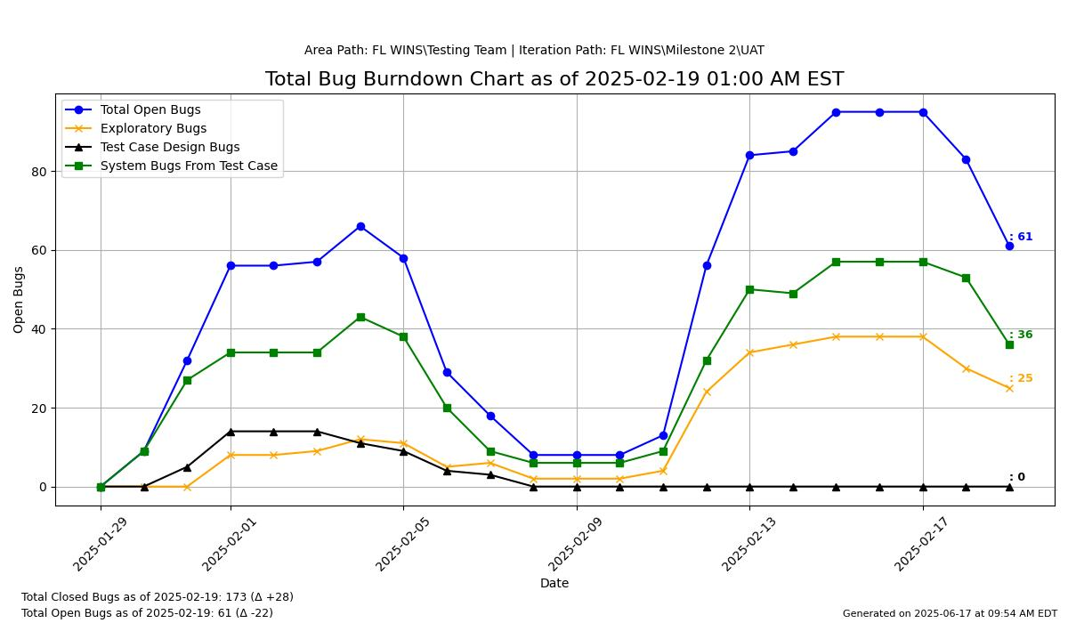
FOR ILLUSTRATION ONLY
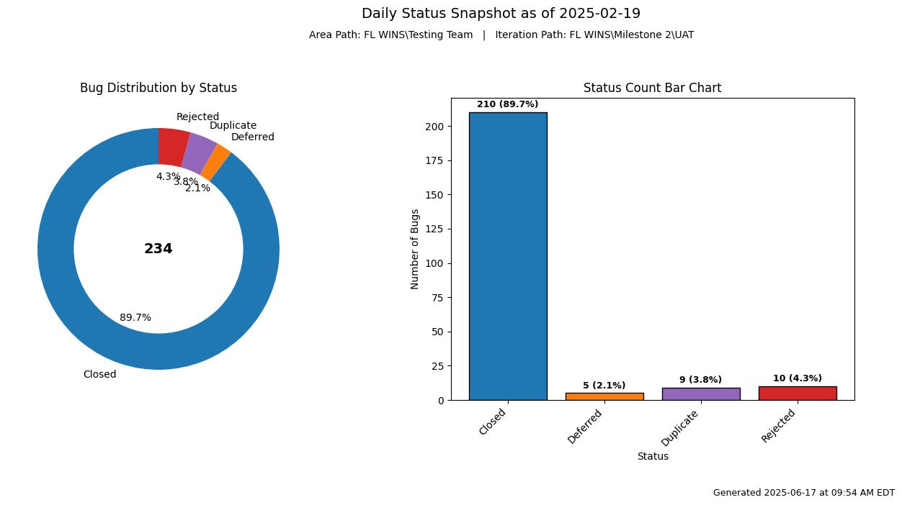
FOR ILLUSTRATION ONLY
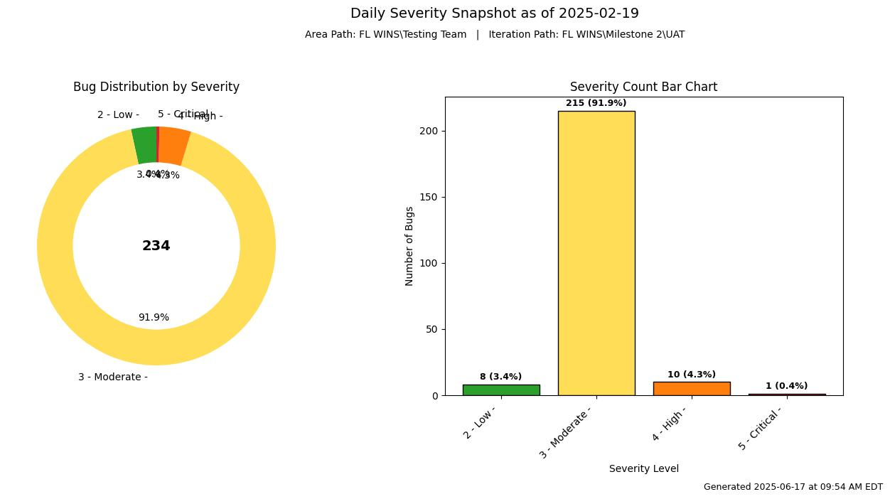
FOR ILLUSTRATION ONLY
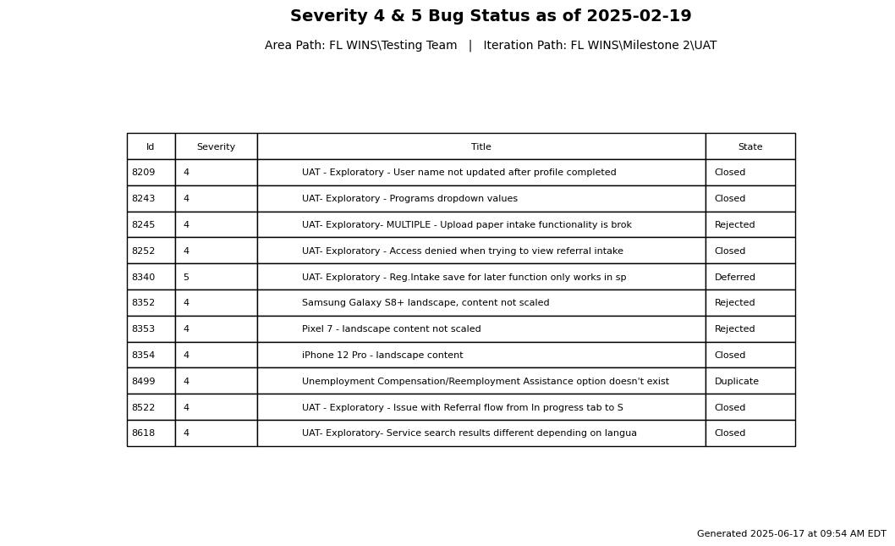
FOR ILLUSTRATION ONLY
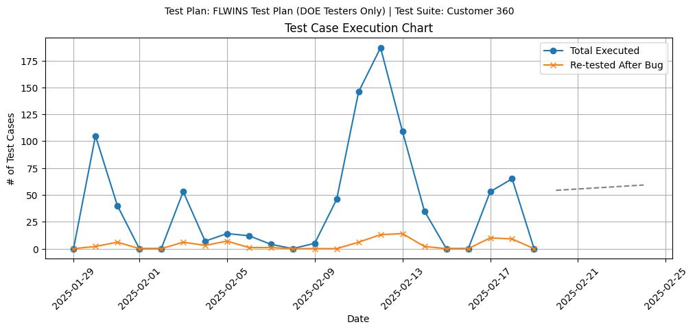
--- Planned
FOR ILLUSTRATION ONLY
NOTE: There will be a Test Case Execution Chart for every active test suite.
- The dotted lines at the end represent the trend for total test cases executed. It is projecting the total test cases executed 5 days into the future.
- In future versions, the chart will be scaled to fit the “Planned” execution over time.

ACTION ITEMS:
1.
2.
Etc.….

SMOKE TEST:
AS of xx/xx/xx, XX: XX AM ET, UAT Environment is ready for test.

