FL WINS UAT Test Report
August 12, 2025, 03:15 PM EST
Area Path: FL WINS\Testing Team | Iteration Path: FL WINS\Milestone 3\UAT
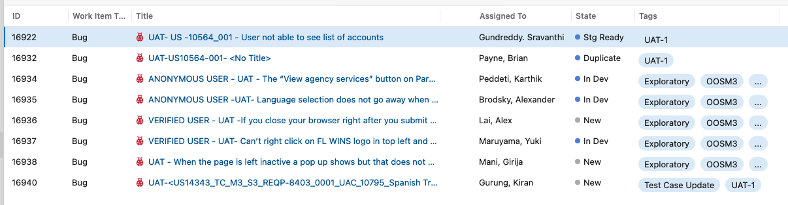
Priority - Portal
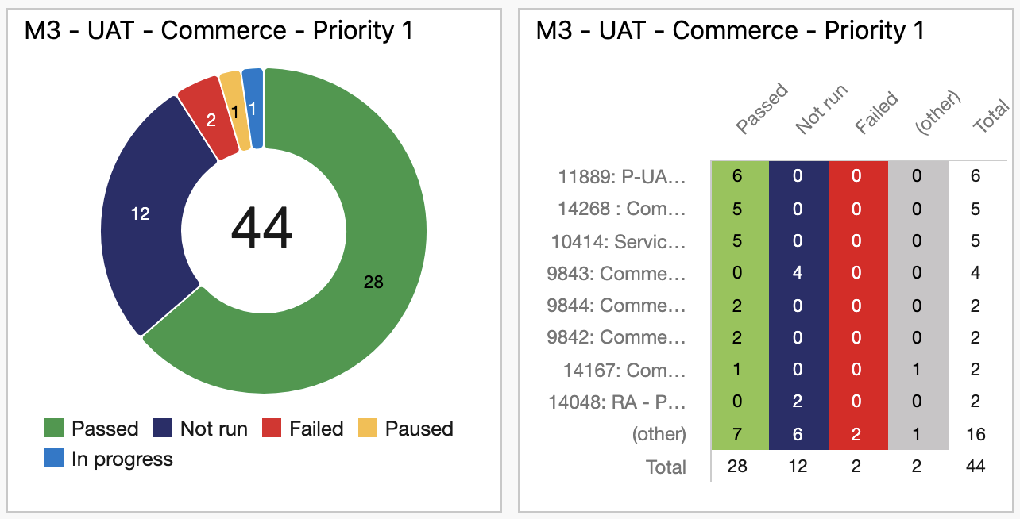

Priority 2 – E2E - PEGA
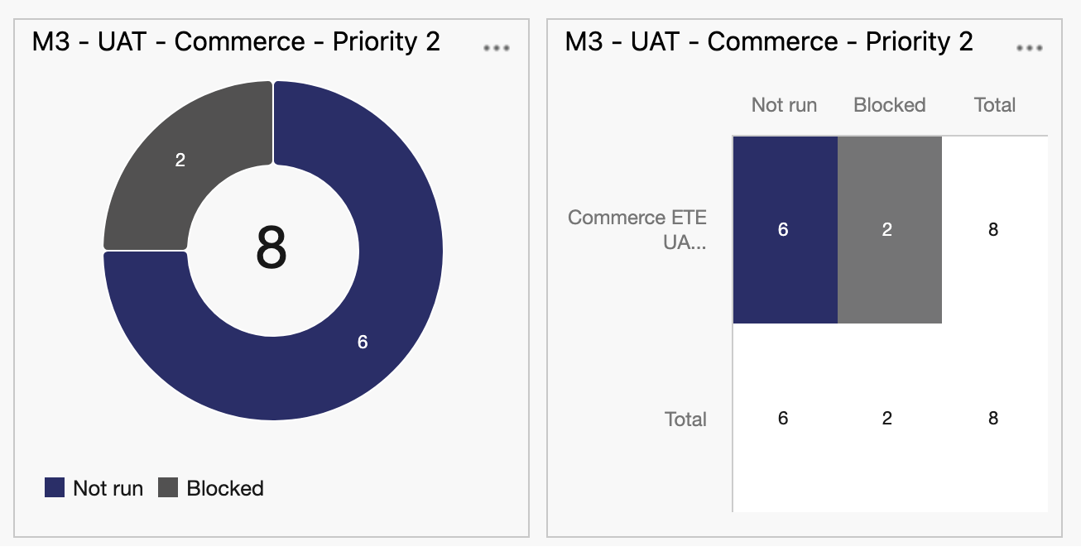
Priority 3 – C360
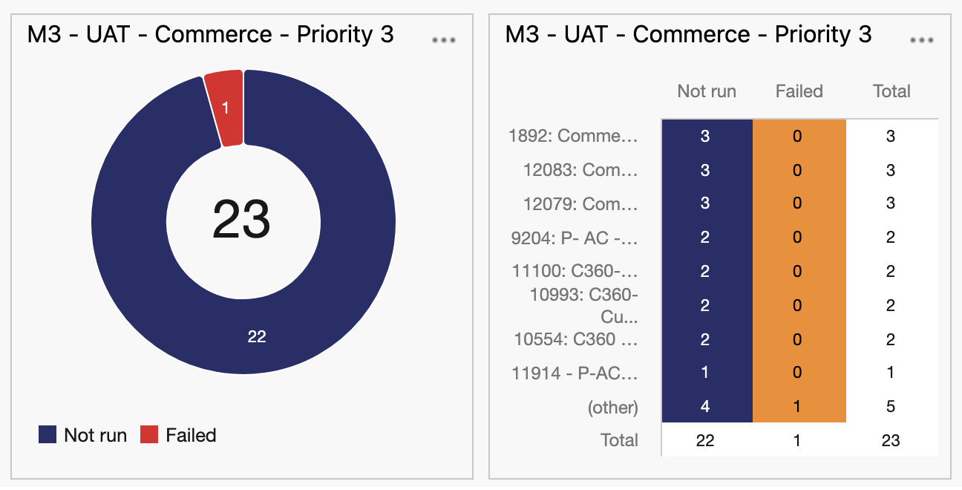

Priority 4 - Translations
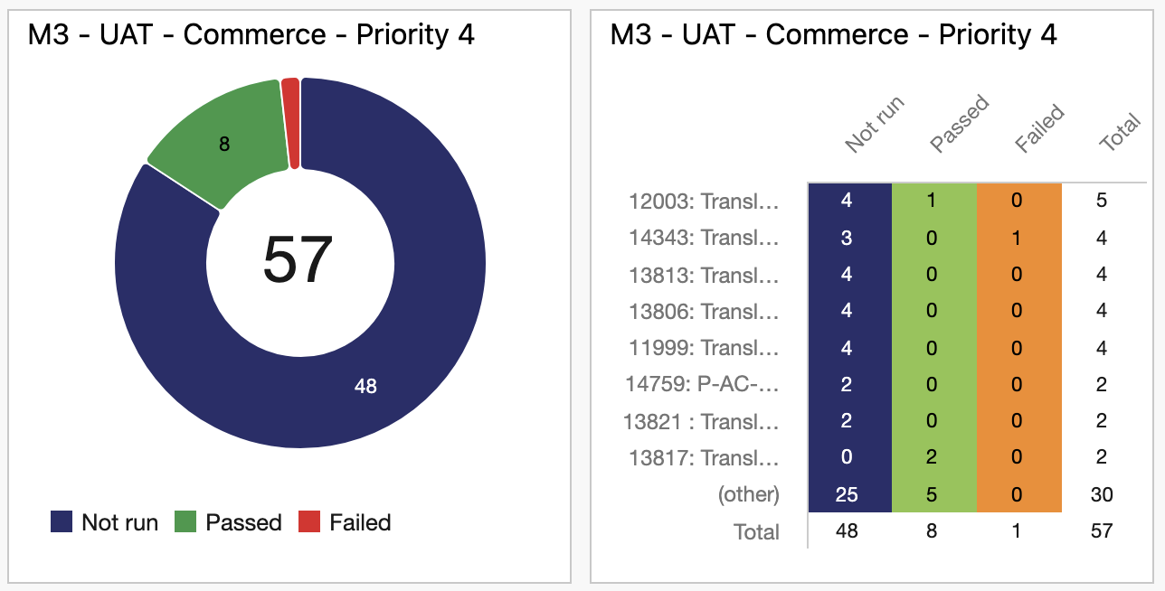
DOE – Priority 1 - Portal
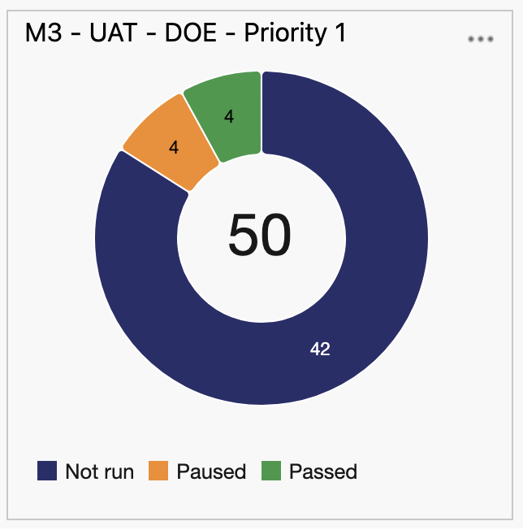

DOE – Priority 2- C360
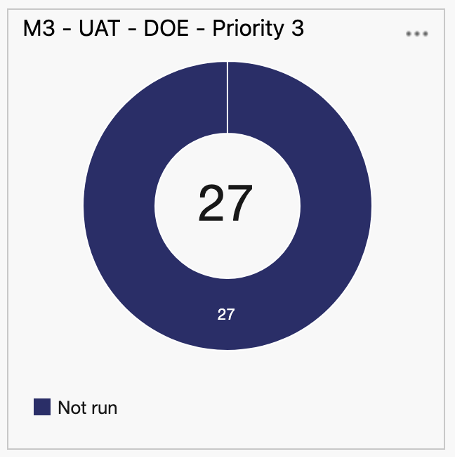
DOE – Priority 3 – Translation and Accessibility
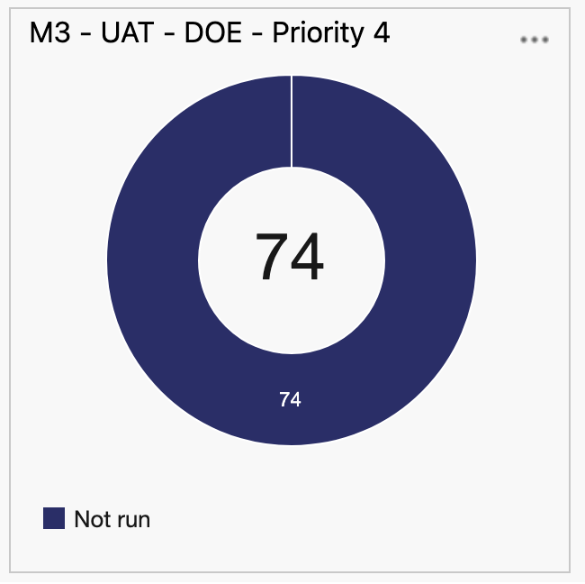
ACTION ITEMS:
- Brian - As more test execution data is collected, Test Reporting scripts to be integrated.

SMOKE TEST:
AS of 08/12/2025, 9:45 AM ET, UAT Environment is ready for test.

