FL WINS UAT Test Report
August 13, 2025, 04:30 PM EST
Area Path: FL WINS\Testing Team | Iteration Path: FL WINS\Milestone 3\UAT
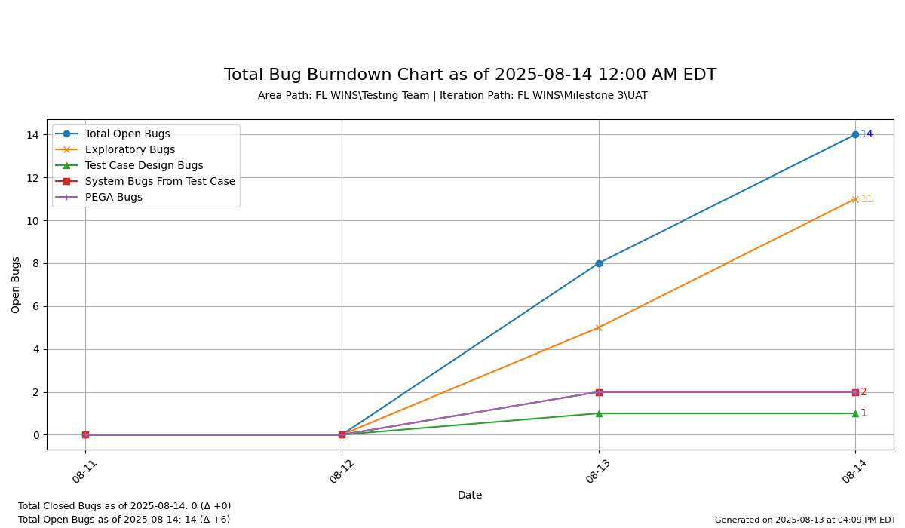

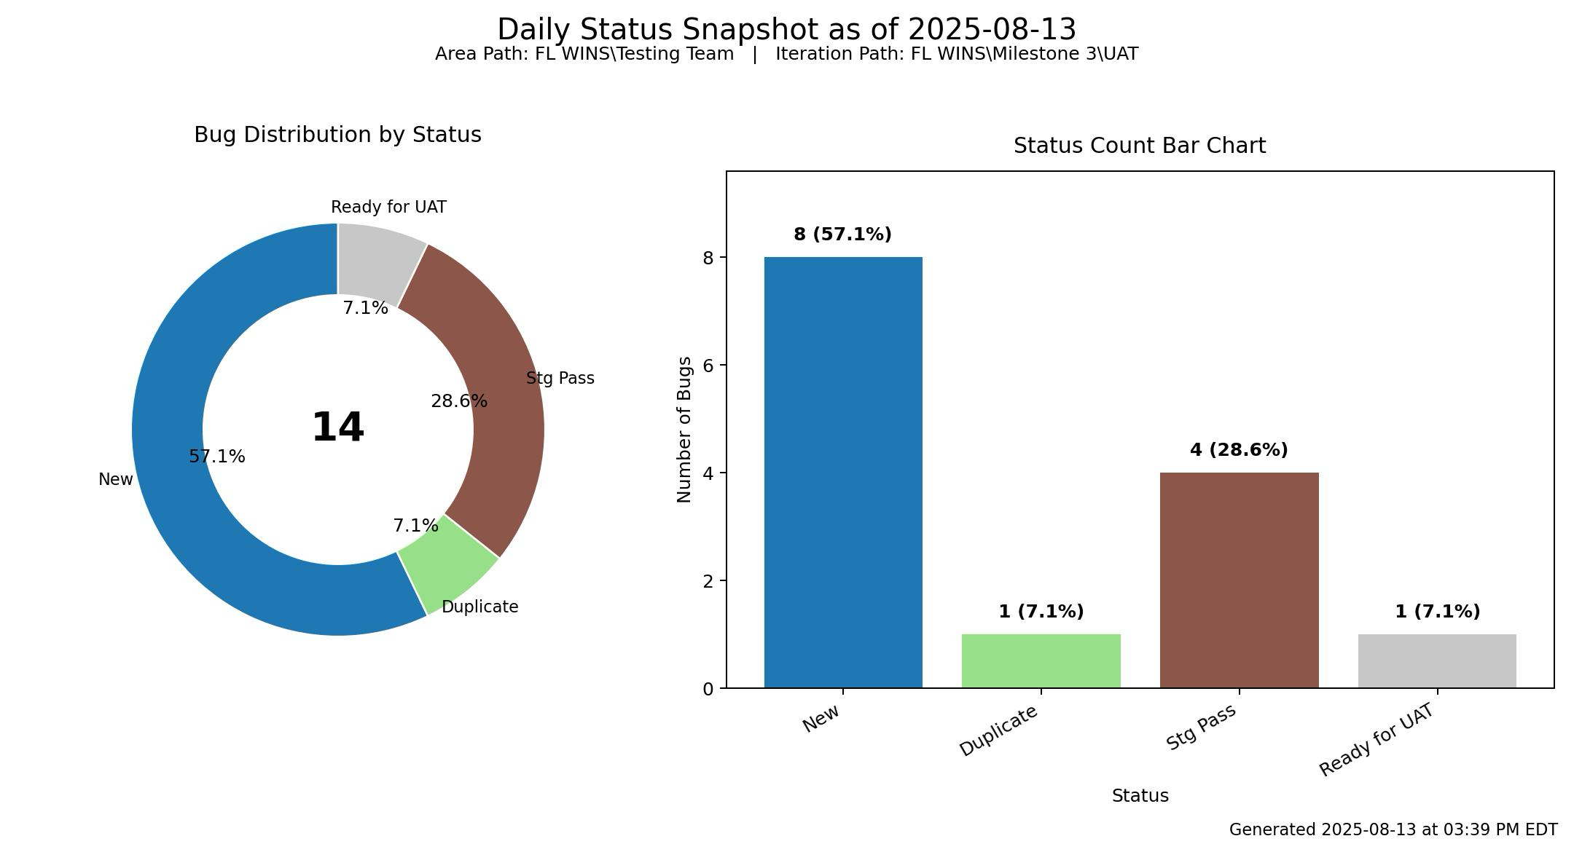

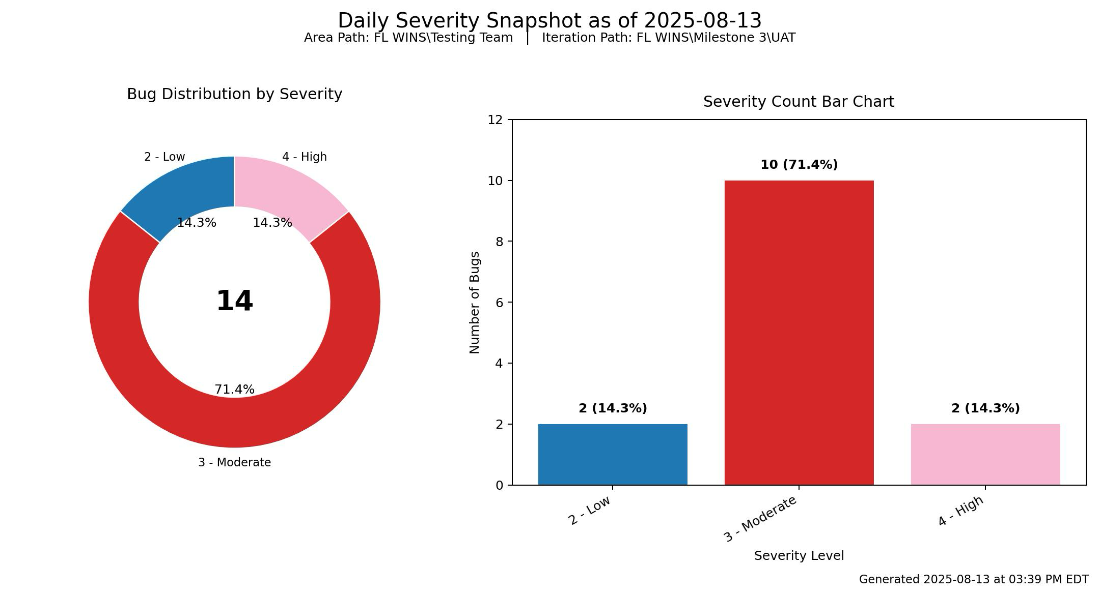
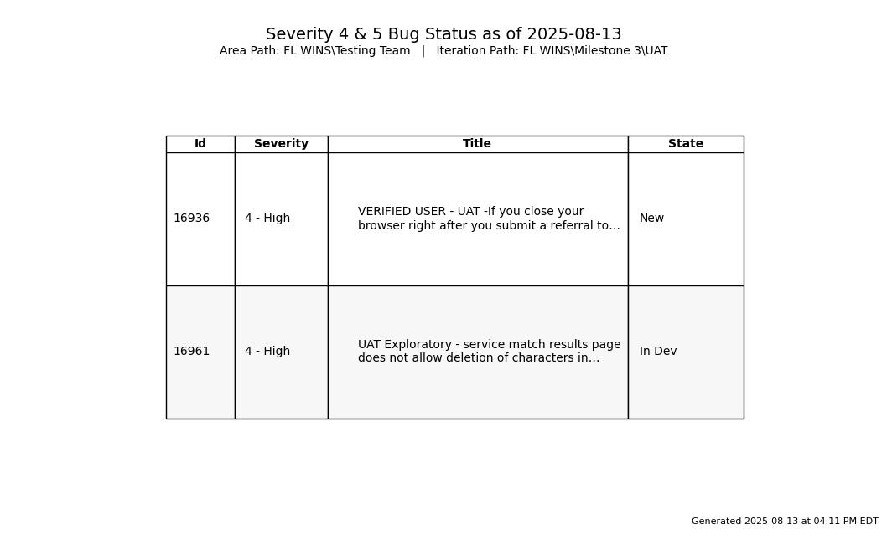

Priority – Portal
30 Passed (+2)
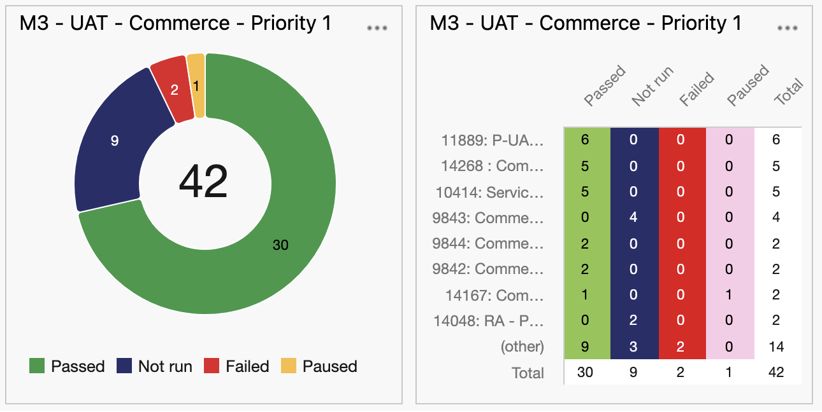
Priority 2 – E2E – PEGA
(delta 0)
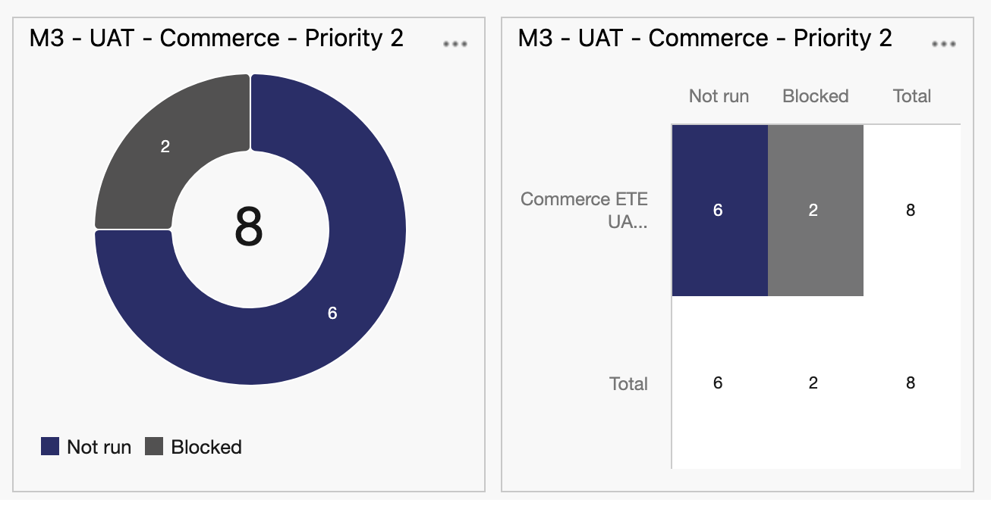

Priority 3 – C360
6 Passed (+6)
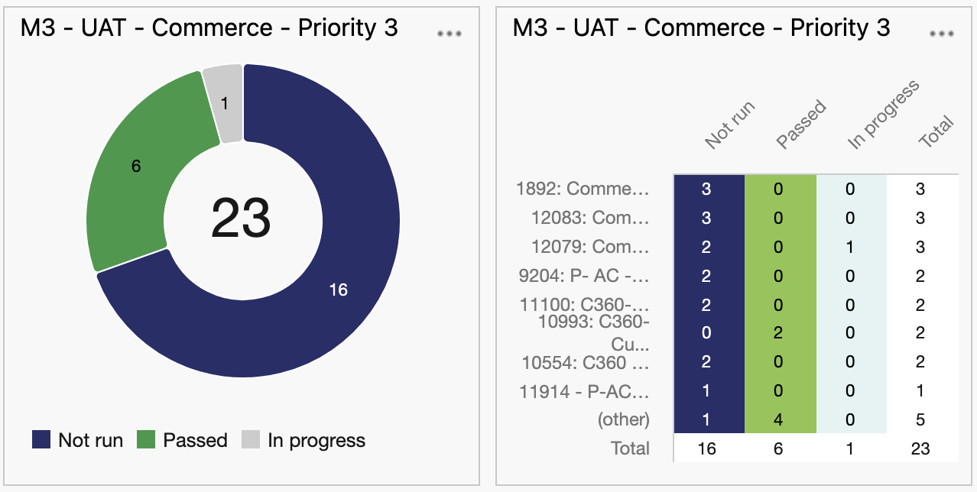

Priority 4 – Translations
12 Passed (+4)
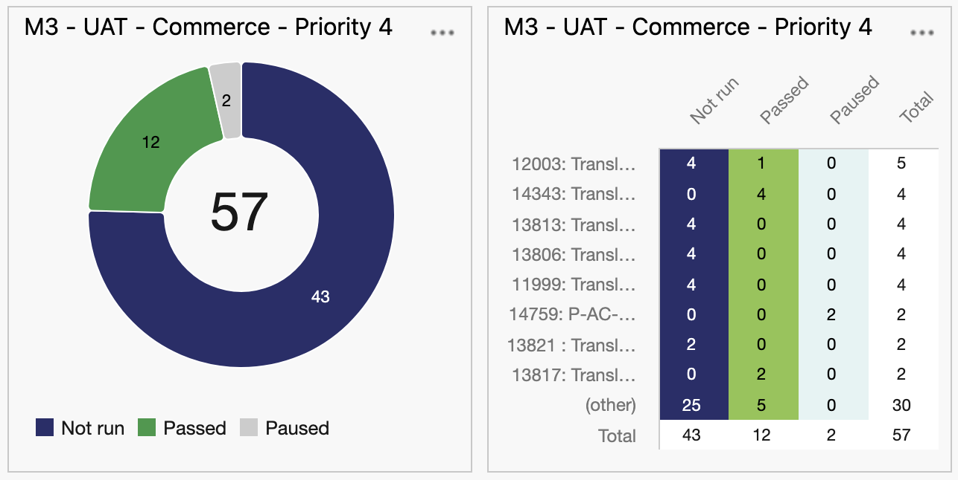

DOE – Priority 1 – Portal
11 Passed (+7)
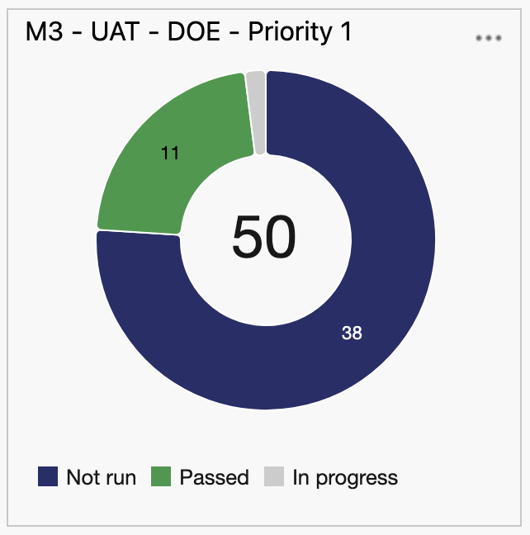
DOE – Priority 2- C360
2 Passed (+2)
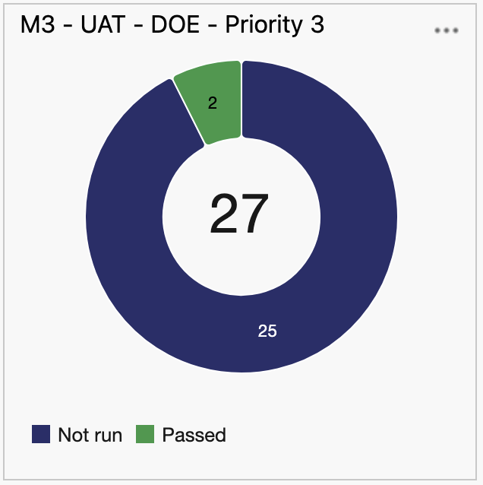

ACTION ITEMS:
- Brian – Gather feedback with FL WINS on test execution planning burndown.
SMOKE TEST:
AS of 08/13/2025, 9:45 AM ET, UAT Environment is ready for test.

Additional Charts per Internal Feedback:

Total M3 UAT- Commerce
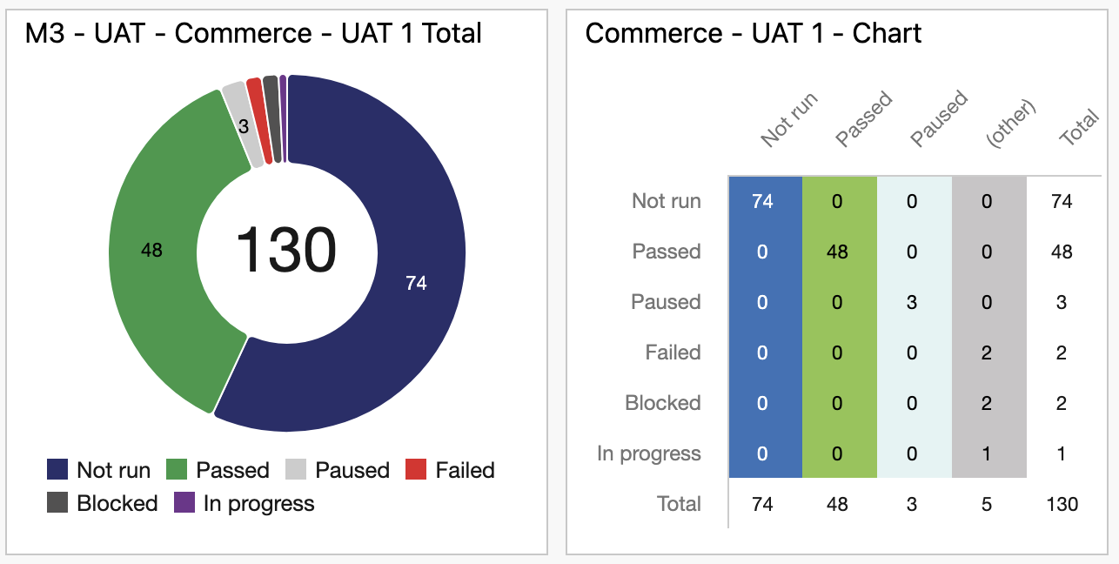
Total M3 UAT – DOE
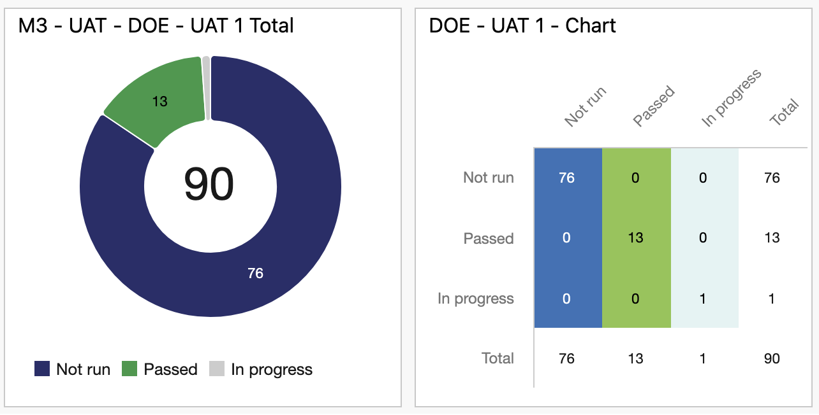

Commerce Test Cases Passed Burndown
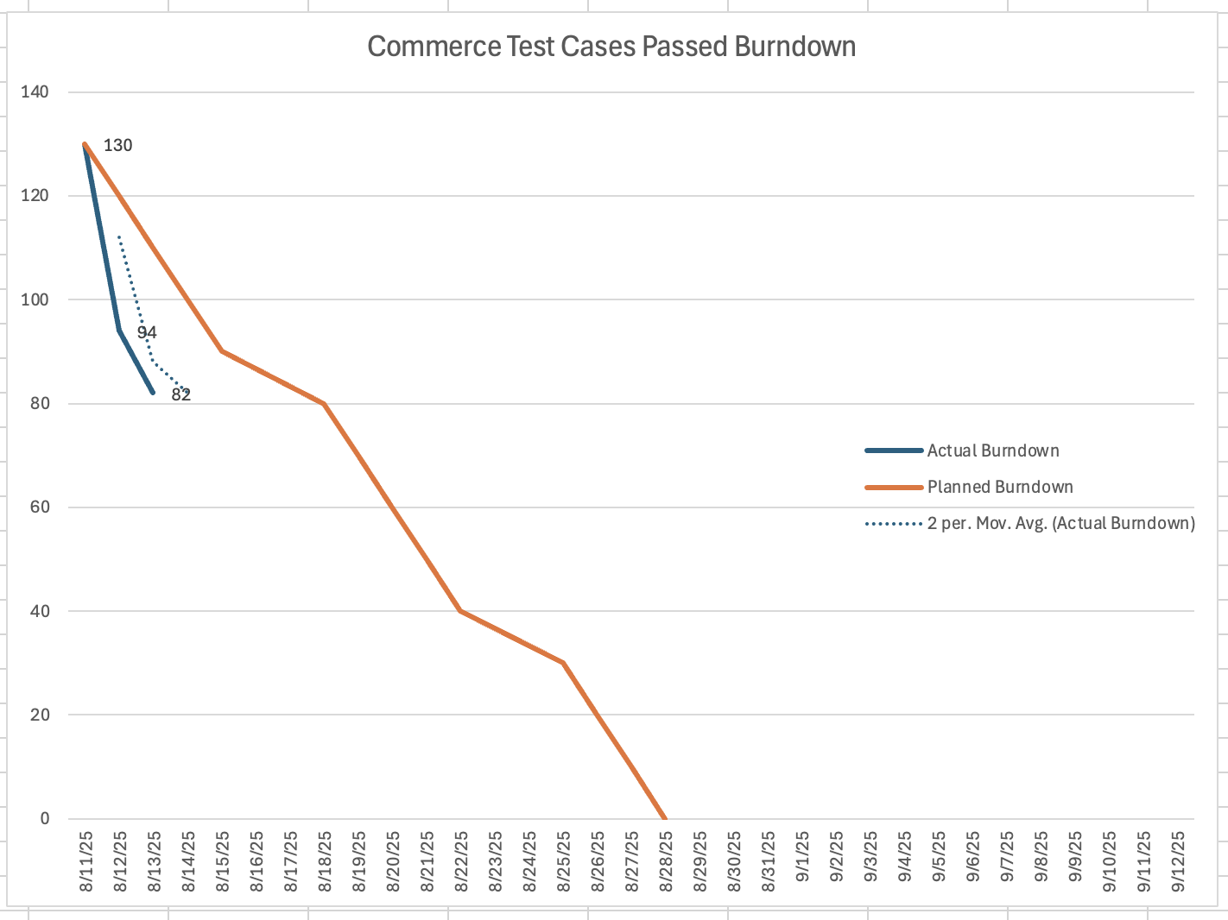
Commerce Test Cases Executed Burndown
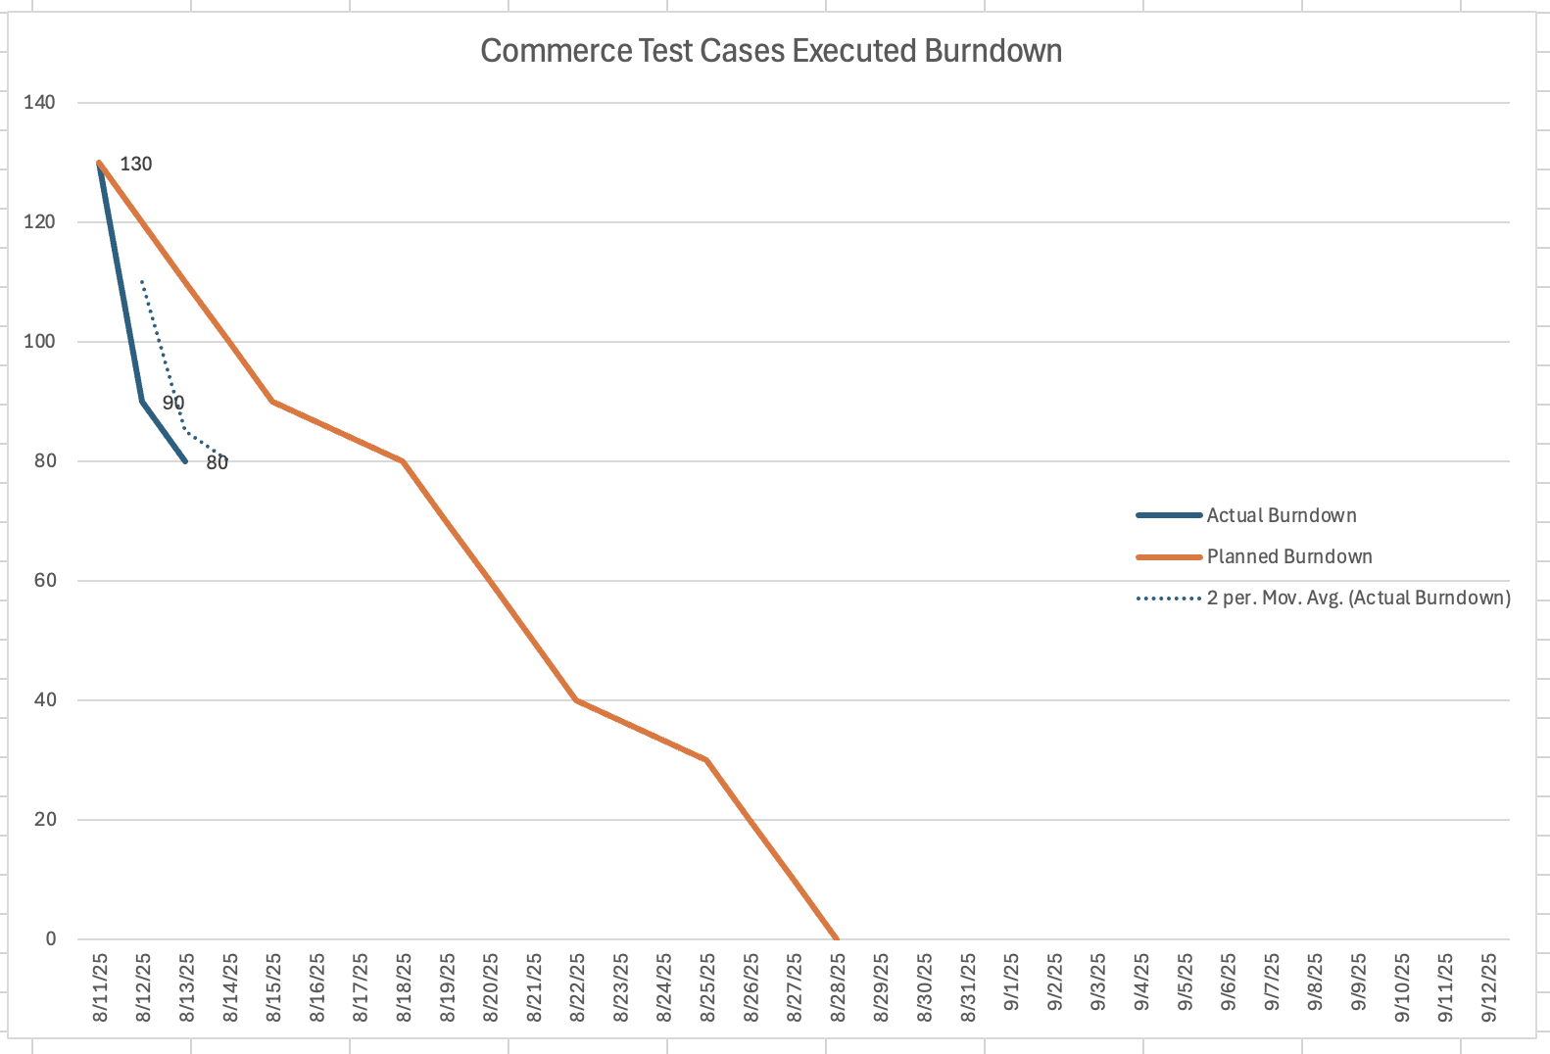

DOE Test Cases Passed Burndown
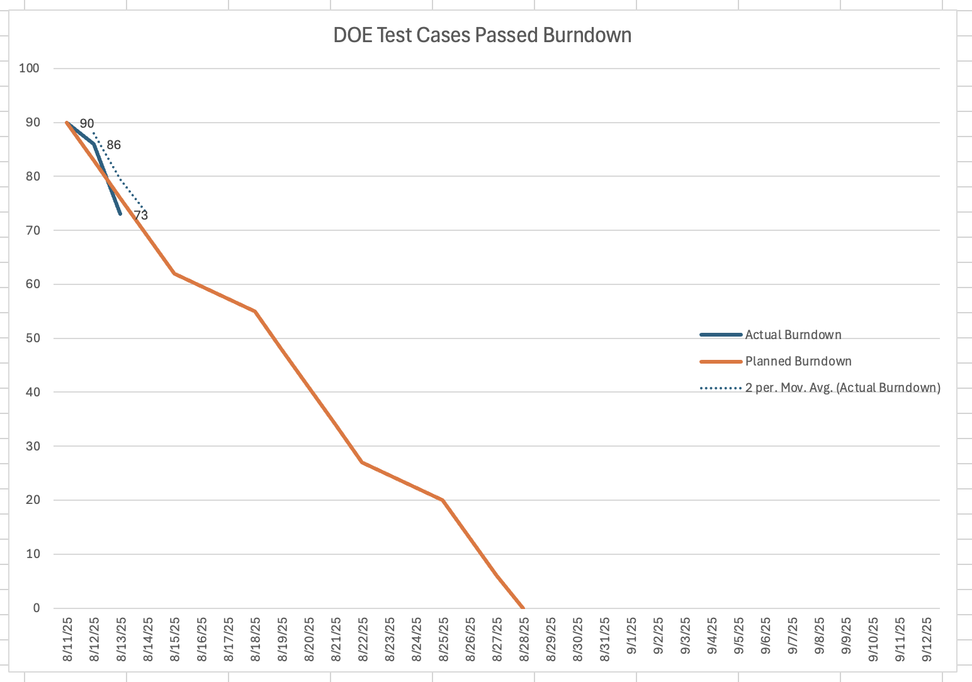
DOE Test Cases Executed Burndown
