FL WINS UAT Test Report
August 14, 2025, 03:00 PM EST
Area Path: FL WINS\Testing Team | Iteration Path: FL WINS\Milestone 3\UAT
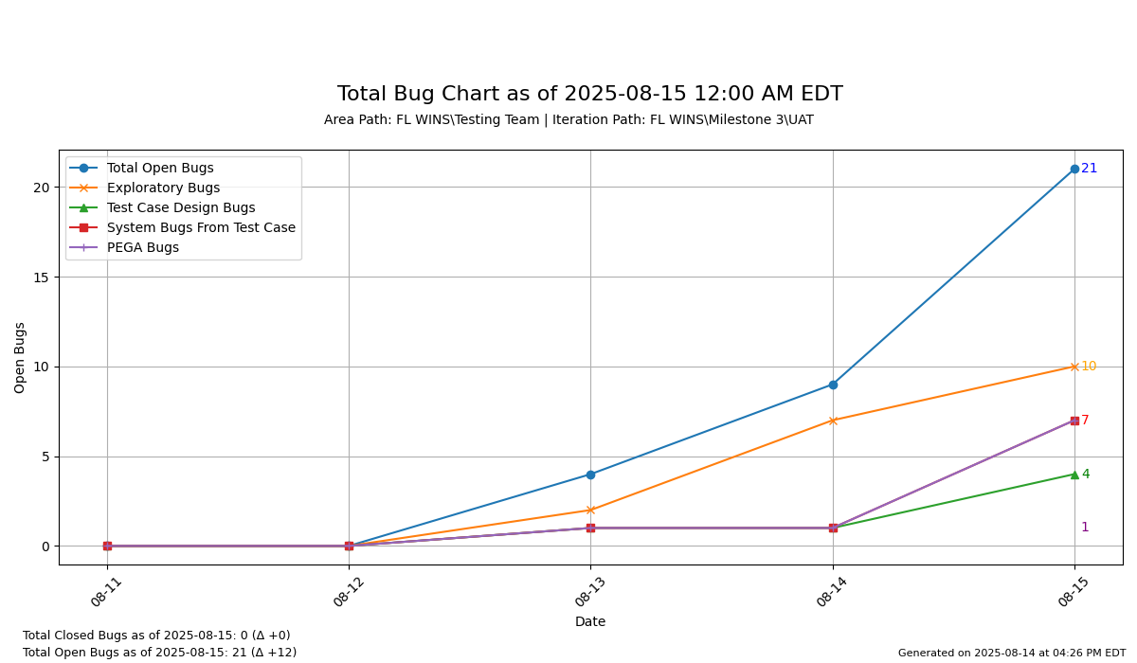

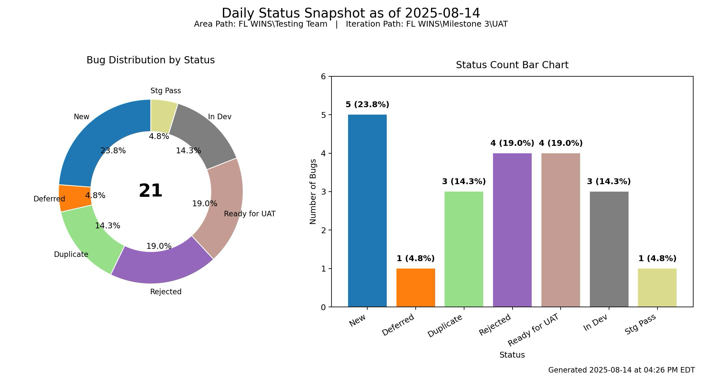

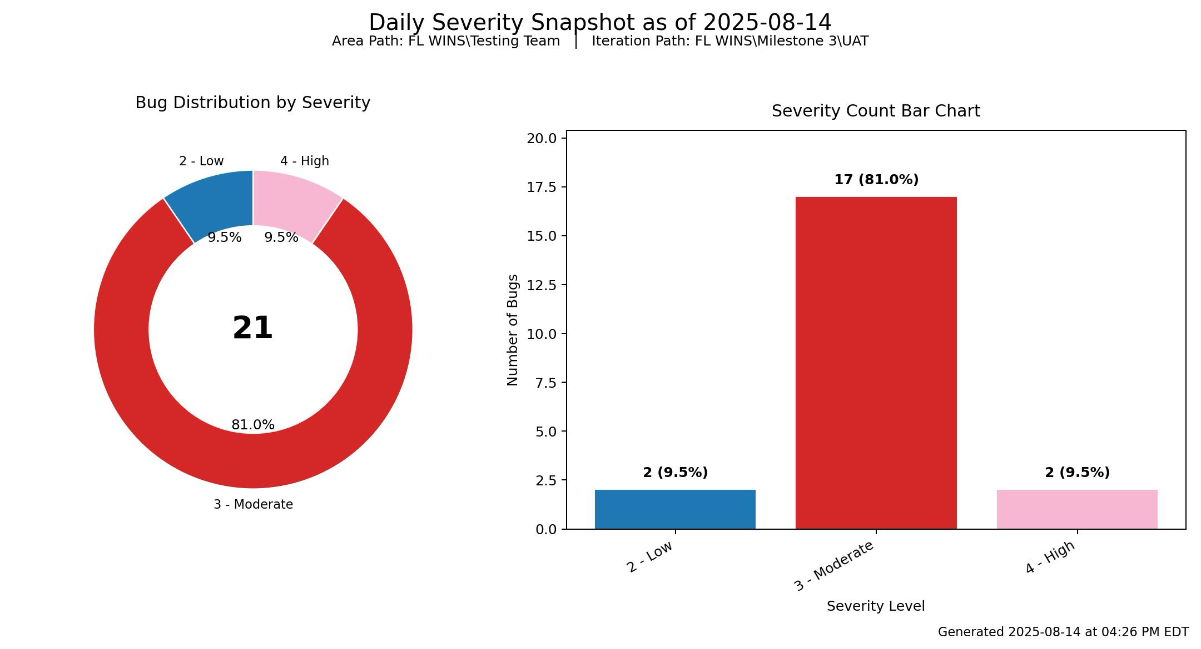

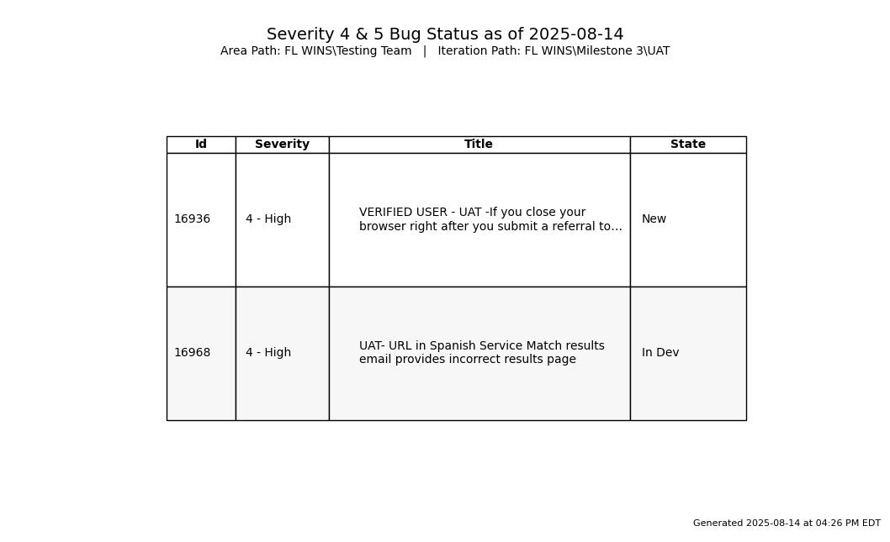

Commerce – UAT 1 Total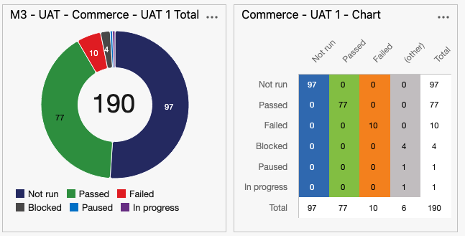
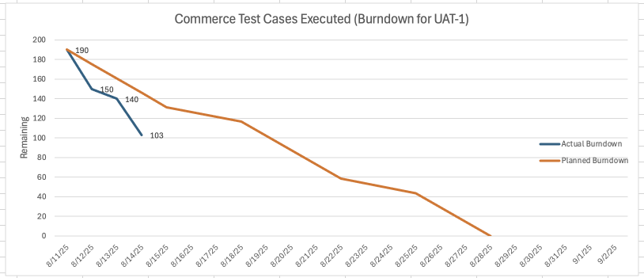
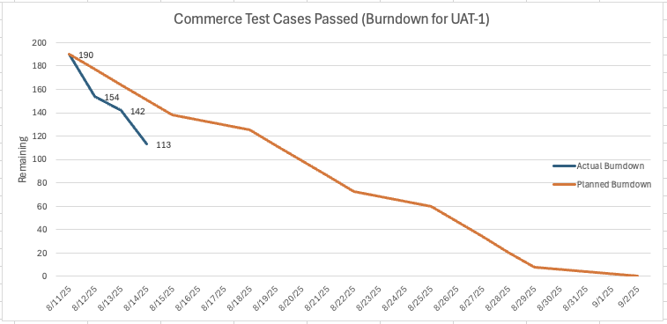

DOE – UAT 1 Total
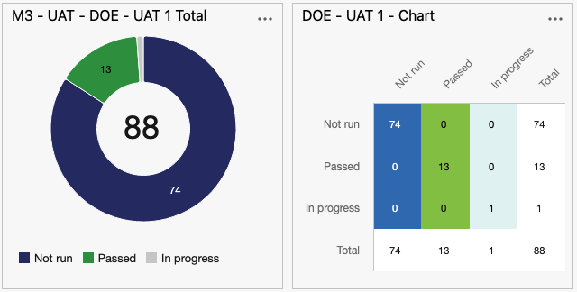
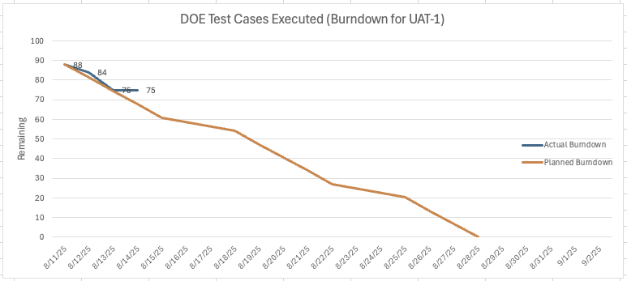
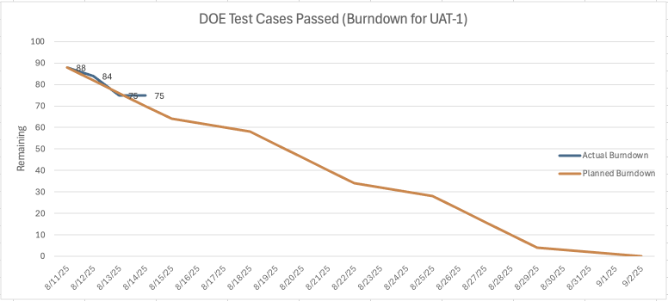
ACTION ITEMS:
SMOKE TEST:
AS of 08/14/2025, 9:45 AM ET, UAT Environment is ready for test.

