# Bilag ? – Billeddokumentation fra Inspiration Card Workshop

10. April 2008, deltagere: Brian Hauge Hansen, Mads Stenhøj, Jakob Andersen samt Niels Larsen og Anne Henriksen.

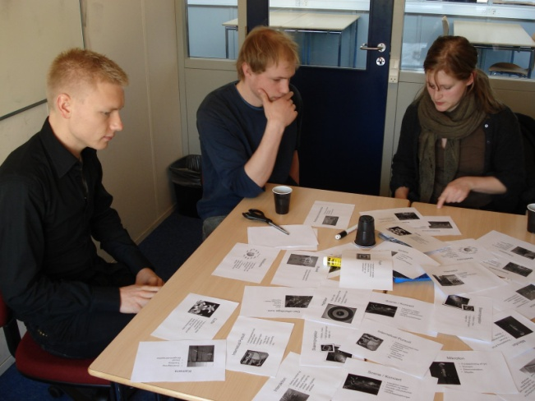 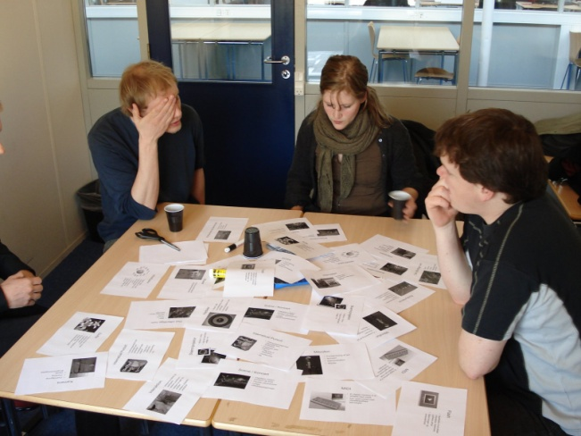

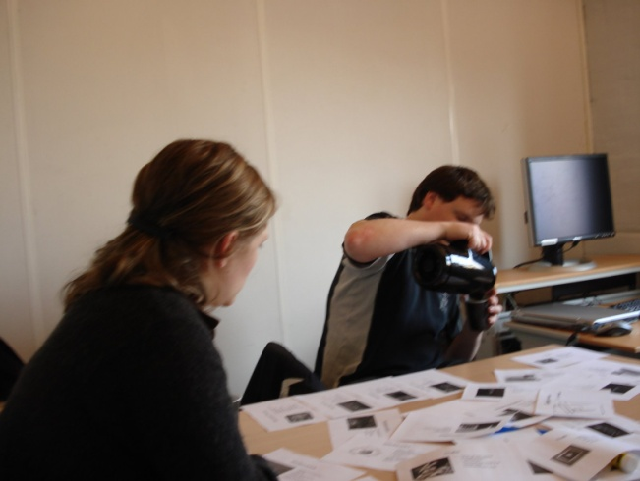 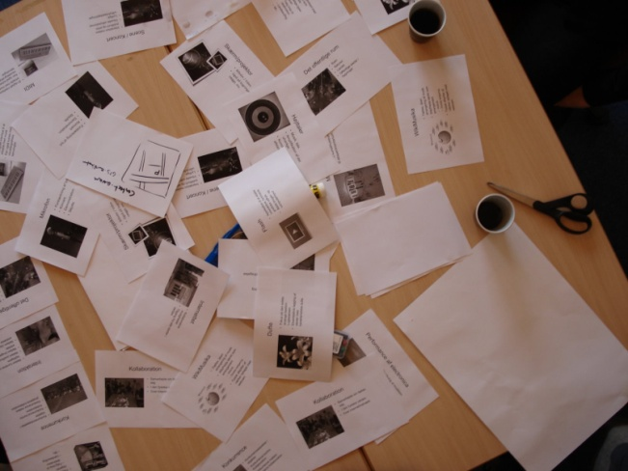

# DSC02084 DSC02085Bilag ? – Uddrag af inspirationskort

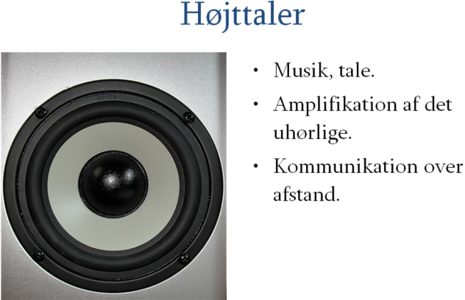 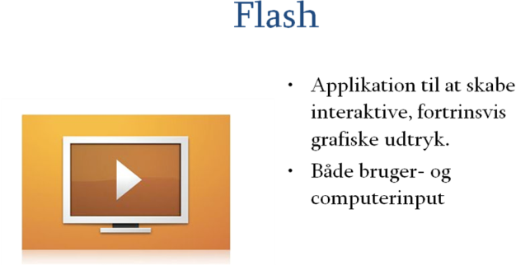 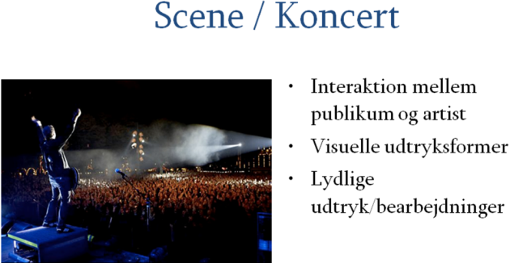 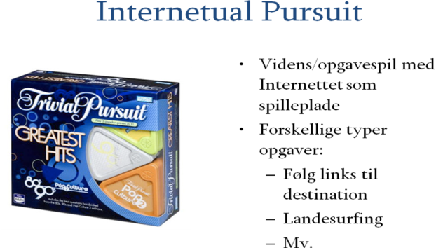 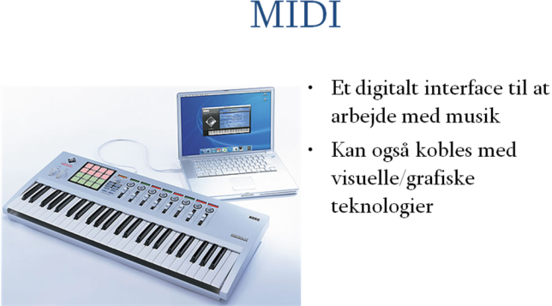 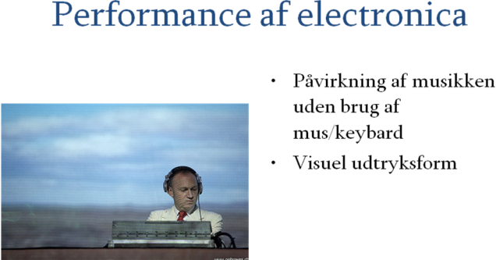 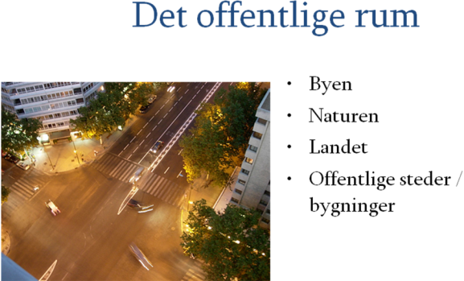 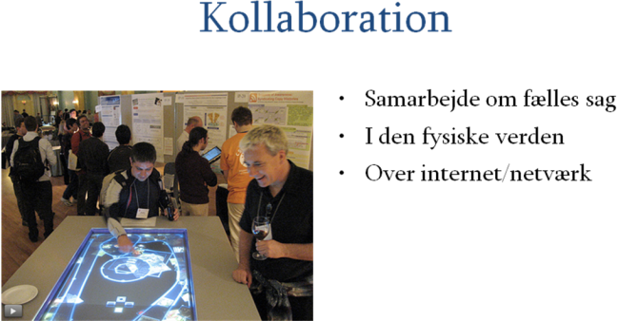

**Referencer:**

Kurose, James F et al. ”Computer Networking – A top-down approach featuring the internet” (*forlag og udgivelseår)*

Zimmermann, Hubert - *"OS1 Reference Model-The IS0 Model of Architecture for Open Systems Interconnection"* (IEEE TRANSACTIONS ON COMMUNICATIONS, vol. com-28, no. 4, april 1980)

**Bindslev**, Jesper og Jon Froda - Web 2.0 = PR 2.0? Kommunikationsforum - 15. februar 2006

(http://www.kommunikationsforum.dk/default.asp?articleid=12269)

**Referencer:**

Emmerson, Simon: *Living Electronic Music* (Ashgate Publishing Limited, 2007)

Frith, Simon: *Performing Rites – On the value of Popular Music* (Harvard University Press, 1996)

Lockspeiser, David: *Debussy, His life and mind* (Volume II: 1902-1918, Cambridge University Press, 1978)

Toynbee, Jason: *Making Popular Music: Musicians, Creativity and Institutions* (Arnold Publishers, 2000)

**Referencer:**

Bertelsen, Olav W.; Breinbjerg, Morten; Pold, Søren: *Instrumentness for creativity mediation, materiality & metonymy* (Creativity and Cognition, Proceedings of the 6th ACM SIGCHI conference on Creativity & cognition,Washington, DC, USA, s. 233-242, 2007)

**Referencer:**

Andersen, Christian U.: *Mellem illusion og virkelighed* (Spillets Verden, 1.udg., 1. oplag, Danmarks Pædagogiske Universitet, 2005, s.11-28)

Dalsgård, Peter; Koefoed Hansen, Lone - *Performing perception – staging aesthetics of*

*interaction* (University of Aarhus, 2007)

Reeves, Stuart; et al: *Designing the Spectator Experience*

(CHI 2005, April 2–7, 2005, Portland, Oregon, USA)