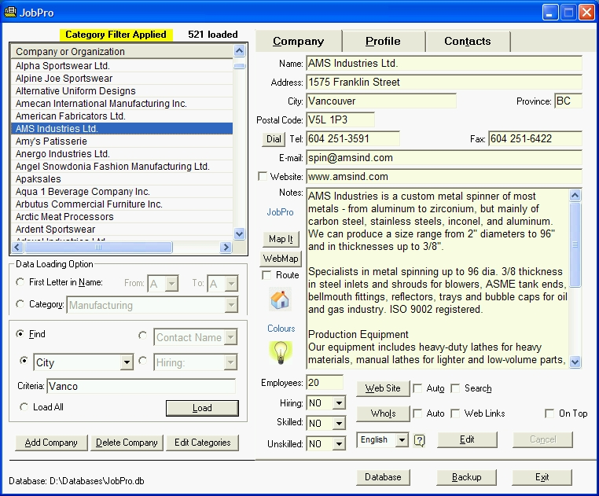
Finding Better Employment Faster
I invite you to discover two new career development resources in British Columbia which together can help you find better employment faster. They are:
1) JobPro™ Employer Contact Software & BC Employers Directory
● Enables you to easily find company and contact information for over 7,900 BC employers, and is a powerful tool for researching companies and contacts as part of your proactive job search campaign targeting employers and jobs within the “Hidden Job Market.”
● Makes it easier for you to find and target employers pre-disposed to hiring you by providing you with the information and the tools you need to do important and otherwise time-consuming, error-prone job search tasks quickly and easily.
● Instantly creates personalized, template-based cover letters and sends them together with your résumé using built-in registered e-mail or opens them in Microsoft Word with a single mouse click.
● Launches one-click Google searches to find additional Company and Contact information and to confirm existing contacts. ● Maps single and multiple Employer Locations based on Street Address, Postal Code/partial Postal Code, City, Employer Category, and many other criteria. ● Opens employer web sites in your native language to enable you to research employers faster.
Simply put, an investment in JobPro more than pays for itself by allowing you to find better employment faster.
Call the number below to try JobPro for free and without obligation, or to arrange a JobPro demonstration.
2) Targeting Employers as Part of a Proactive, Effective Job Search Campaign
This unique and free guide for job seekers targeting employers provides proven techniques for finding work and advancing your career. Sections include Tapping the "Hidden Job Market", Building a Network of Contacts, Cold Calling: What It Is and Why You Need to Cold Call Employers, Creating Quality Résumés and Cover Letters, and much more. See www.datacentrik.com/jobsearch.
Brian Hauk, DataCentrik Solutions
Tel. 604 688-4451
brian@datacentrik.com
www.datacentrik.com/jobpro
Helping BC Job Seekers Find Better Employment Faster
Effective Job Search Campaigns:
What it Takes to Wage a Successful Job Search Campaign and Tap the "Hidden Job Market"
from www.datacentrik.com/jobsearch.html - Why Invest in JobPro Employer Contact Software?
• Tapping the "Hidden Job Market" and Building a Network of Contacts
• Cold Calling: What It Is and Why You Need to Cold Call Employers
• Applying for Work in Person
• Understanding the Job Search Challenge and the Importance of Generating Leads
• Information Interview / Job Interview Preparation
Don't Wait for Employers to Post Jobs or Find Your Résumé!
Instead find them! Targeting Employers to Put You in Control of Your job Search
Finding jobs in today's competitive job market is challenging. Job seekers as a result must effectively use proven job search methods to find better employment and minimize time spent "between jobs." Not surprisingly, if you act on the knowledge of what it takes to lead a successful job search campaign, you can find better jobs faster. The following job search tips are designed to be accurate and sufficiently complete to help you find better work soon.

Job search results prove that workers who draw on the lessons of other successful job seekers experience a heightened ability to efficiently find better employment in less time than would be required using conventional job search ideologies and methods.

Because of increased competition for jobs in today's job market, job seekers able to stand head and shoulders above the competition by applying effective job search strategies that are relatively unknown to the majority of job hunters will benefit to the tune of thousands of additional dollars in their bank accounts as they find work faster while avoiding possible loss of self-esteem and unemployment-related depression and anxiety.
That said, it may sometimes be overly optimistic to believe that you can beat the competition through hard work and clever tactics. In some cases, it may be necessary to change objectives to find work and recognize that your job finding problems are rooted in a tough job market to avoid feeling that you must be doing something wrong when employers are not calling you for interviews.
Understanding What Works and What Does Not

The collective experience of job seekers proves that posting your résumé at hundreds of job sites or "blasting" it to hundreds of recruiters and employers is a self-defeating strategy. This approach won't let you customize it for a specific employer or job opportunity, and so you likely will not be called. You also won't be able to follow up by calling or e-mailing the large number of employers who receive your résumé and will miss opportunities to establish contact and move your application forward in the hiring process.
In fact, sending a résumé in response to an ad is one of the least effective methods of finding a job, according to J. Michael Farr, author of "Getting the Job You Really Want" (JIST Works Inc., 2002). This is because hundreds of other candidates are responding to ads, causing a deluge of résumés in human resource departments.

As part of your proactive job search campaign, you will find it more effective to (when possible) send résumés only to named individuals having the power to hire you. Try to avoid office managers, the Human Resources department where it exists, and other "gatekeepers" whose duty is to keep you from communicating with people having the authority to hire you.
As an alternative to mass mailing form letters, you can take important steps toward meeting employer contacts by sending individual, targeted messages to these named individuals as part of building your network.
The key word here is 'contacts,' because, as part of implementing the proactive job search campaign targeting employers advocated in this paper, you will be creating a network of employer contacts who know you as someone intelligent, trustworthy, interesting and easy to work with, in addition to being skilled and experienced [if you are]. Once you're clear on the steps taken by employers to recruit new hires [explained later], the value of being in this position will become even more evident.

To develop and strengthen your network of contacts, you will need to research employers to learn about their needs and also to find the names and contact information for people working for them who have the power to hire you. These are the people you need to include in your network, and to meet, so that they can get to know you.

The feedback you receive while researching and getting to know employers and employer contacts can provide you with the motivation you need to take action to advance your job search. Having quick access to company and contact information as you go about this task will enable you to maintain your job search momentum and avoid getting bogged down in the time-consuming task of manually searching for the information you need to effectively target employers.

Your employer research will help you identify employer needs, and your main challenge knowing those needs will be to find a way to communicate your ability to meet those needs using your cover letter and résumé, and by talking to them on the phone and in person. Contacting employers and making your talents known to them is easier than you think, especially when you use the following proven job search ideas and methods.

These job search ideas and methods are on topics ranging from What Networking Is to Tapping the Hidden Job Market, to Effective Résumés and Cover Letters, and are here to assist you in making an informed choice on how to most effectively find your next job, future jobs, and continue building your career.
(continued at www.datacentrik.com/jobsearch.html)
JobPro Employer Contact Software for Vancouver and Area Job Seekers

JobPro Employer Contact software with its BC Employers Directory offers Vancouver and area job seekers the Company and Contact information you need to find, research and target local employers as part of your proactive job search campaign.

