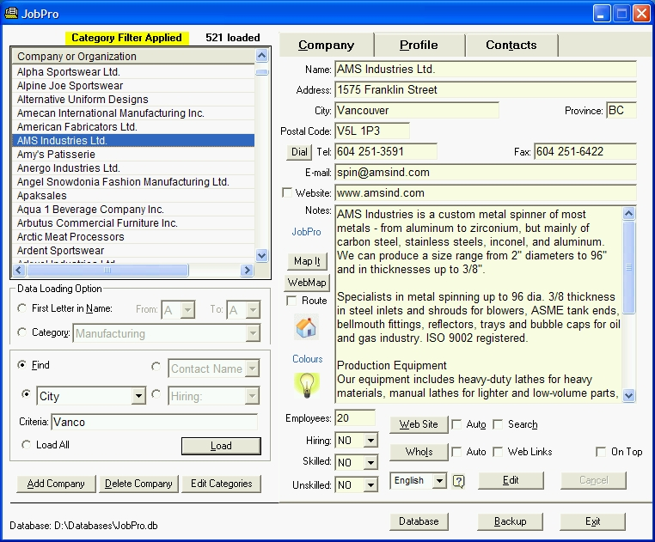
Making Your School More Attractive
In the Eyes of Prospective Students
I invite you to discover a new career development resource for schools working to differentiate themselves from other institutions. Named JobPro Employer Contacts, this software and BC Employers Directory package enables your school to more easily demonstrate to prospective students that it best meets their current and future career development needs.
JobPro™ Employer Contact Software and BC Employers Directory
● Enables staff and students to save time building better student-employer matches by providing you with access to up-to-date company and contact information for over 7,900 British Columbia employers.
● Makes it easier for you to find and target employers pre-disposed to hiring students by providing you with the tools to do important and otherwise time-consuming, error-prone tasks quickly and easily.
● Instantly creates personalized, template-based cover letters and sends them together with students’ résumés using built-in registered e-mail or opens them in Microsoft Word with a single mouse click.
● Launches one-click Google searches to find additional Company and Contact information and to confirm existing contacts. ● Maps single and multiple Employer Locations based on Street Address, Postal Code/partial Postal Code, City, Employer Category, and many other criteria.
● Opens employer web sites in your native language to enable you to research employers faster.
Simply put, an investment in JobPro more than pays for itself by enabling you to effectively assist significantly more students with the same number of staff.
Call the number below to try JobPro for free and without obligation in your office for one month, or to arrange a JobPro demonstration.

Brian Hauk, DataCentrik Solutions
Tel. 604 688-4451
brian@datacentrik.com
www.datacentrik.com/jobpro
Helping BC Schools Exceed Students’ Expectations
P.S. To help break down barriers to using this leading-edge job search resource, JobPro ‘early adopters' will have the opportunity to evaluate JobPro without cost or obligation for a period of one month to prove beyond doubt that an investment in JobPro makes sense for you. I invite you to call me to learn more, and to arrange a short demonstration at your convenience.

