Brian Horlick-Cruz

Lab 2

GEOG 662, Fall 2020

**Part I:**

For this analysis, I began by creating an excel document of the required variables by selecting them from the various 2010 census Excel documents and copying them into a new document. I kept them associated with their ct2010 ID’s, which I then used to join the new dataset to the attribute table of the 2010 census tract shapefile. Thereafter, working in Arcmap, I created new fields in the 2010 census tract attribute table to create indices for each of these factors (e.g. rent_occ_ind, hh_7_ind, etc.). I then calculated proportions based on the Wu 2002 et al. method for each index using the field calculator. I would use the statistics option for each field to find the maximum value, then use that in the equation (e.g. rent_occ_ind = rent_occ/rent_occ max value). I then created a final field for the social vulnerability (SVI) scores, in which I calculated the sum of each of the index scores per census tract. Afterwards, I symbolized the SVI scores on the map, categorizing census tracts according to standard deviations above and below the mean score. During my observations, I created an additional field in the dataset’s attribute table to calculate population density per census tract, which allowed me to compare the population densities of high-SVI-scoring tracts and the state overall.

Afterwards, I opened the 2- and 5-foot sea level rise (SLR) datasets in Arcmap and used the union function to create two larger shapefiles showing the overall SLR for each scenario across the state’s entire coastal area. I then used the tabulate intersection function to calculate the percentage of the area of each census tract that overlaps with the SLR, setting the census tracts as the zones and SLR datasets as the classes. This then produced new datasets which included the census tract, SVI, SLR, and percentages of intersected area data which I then symbolized by the latter variable. This allowed me to spend some time comparing the SVI scores to the areas of greatest vulnerability to SLR-driven area loss.

To finish, I returned to the original census tract/SVI map and displayed and examined the data from each individual index to see how each one compared with the overall SVI scores.

See Appendix A for graphical representation of workflow.

**Part II:**

1. The highest social vulnerability index scores (1.3+) are mostly clustered around and between the Baltimore and Washington, D.C. metro areas, roughly outlining the I-95 corridor through the state. There are additional high-vulnerability regions in certain areas surrounding Salisbury, Hagerstown, Waldorf, and Lexington Park, MD. The regions with the highest vulnerability scores have an average population of 5,964.80 and population density of 7,892.90 which are significantly higher than the statewide averages of 4,141.72 and 4,864.62/square mile respectively. See Appendix B for SVI map of the state of Maryland.
2. If any, it appears as though there may be a negative correlation between high social vulnerability as defined by the index and exposure to projected SLR. From a total of 291 census tracks that have some degree of projected risk of exposure to SLR, there are only 11 high-SVI census tracts in the 2-foot rise scenario and 12 high-SVI census tracts in the 5-foot scenario. In the more severe 5-foot SLR scenario, the mean area of land loss among these high-SVI census tracts is 3%, with the highest one being 11%. These are all well below the projected percentages of land loss for the most severely affected census tracts (over 30% land-loss).

Looking beyond the highest-scored SVI census tracts, the average SVI of any given census tract with exposure to SLR land losses is 0.56 in the 2-foot scenario and 0.57 in the 5-foot scenario. These are both below the mean SVI for the entire state (0.70). Moreover, the mean SVI’s for the census tracts with the highest exposure to SLR-driven land losses are 0.37 in the 2-foot scenario and 0.39 in the 5-foot scenario—even lower than the mean SVI for both the general area of exposure and the entire state. Based on this information, I would be inclined to say that there is potentially a negative relationship between high SVI and high risk of exposure to SLR in the state of Maryland and as defined by the criteria in this SVI.

See appendices C – D for maps of risk of exposure to SLR for 2- and 5-foot SLR scenarios.

1. The distributions of most of the individual SVI indices aligned closely with those of the higher-scoring SVI census tracts. High concentrations of renter-occupied homes and single-female households with children under 18 generally fall between the urban areas and along the I-95 corridor along with concentrations of non-white populations, which are especially heavily concentrated in the areas immediately outside of Washington, D.C. and Baltimore.Households of 7 or more are distributed very similarly to the areas with high indices for non-white populations, with a large concentration outside of Washington, D.C., and near Lexington Park. The index for homes with people aged 75 or more seems to be the most diffuse, with higher concentrations in the rural areas of the northern, western, and eastern parts of the state. Overall, the urban sprawl between Washington, D.C. and Baltimore saw high scores for most indices which reflects the overlapping concentration of high-scoring SVI census tracts in the SVI map. See appendices E – I for maps of individual variable proportions.
2. I think that the analysis can be improved by adding household income and real-estate value as variables for both the SVI and risk of exposure to SLR. In many places, coastal properties can be very expensive or exclusive and attract wealthy residents, therefore it may yield insights as to whether there is a relationship between wealth and exposure to SLR in Maryland. This question can then be approached by simply adding income and home-value data to the existing tables for the SLR maps and examining the values for the most exposed census tracts. Moreover, the data can be used to form two new indices—low income households and low-value homes—which can be factored into a revised SVI and which may change the results of the analysis.

**\*Please score the following re: your experience with this lab exercise:**

1.(a) techniques: 3  
(b) overall concepts:3

2. On a scale of 1 🡪   
 (a) # hours to complete assignment: 13-14  
 (b) rating on scale of 1🡪5: 4

Appendix

Appendix A - Workflow for Lab 2

Appendix B - Map of MD SVI Scores based on the 2010 U.S. Census

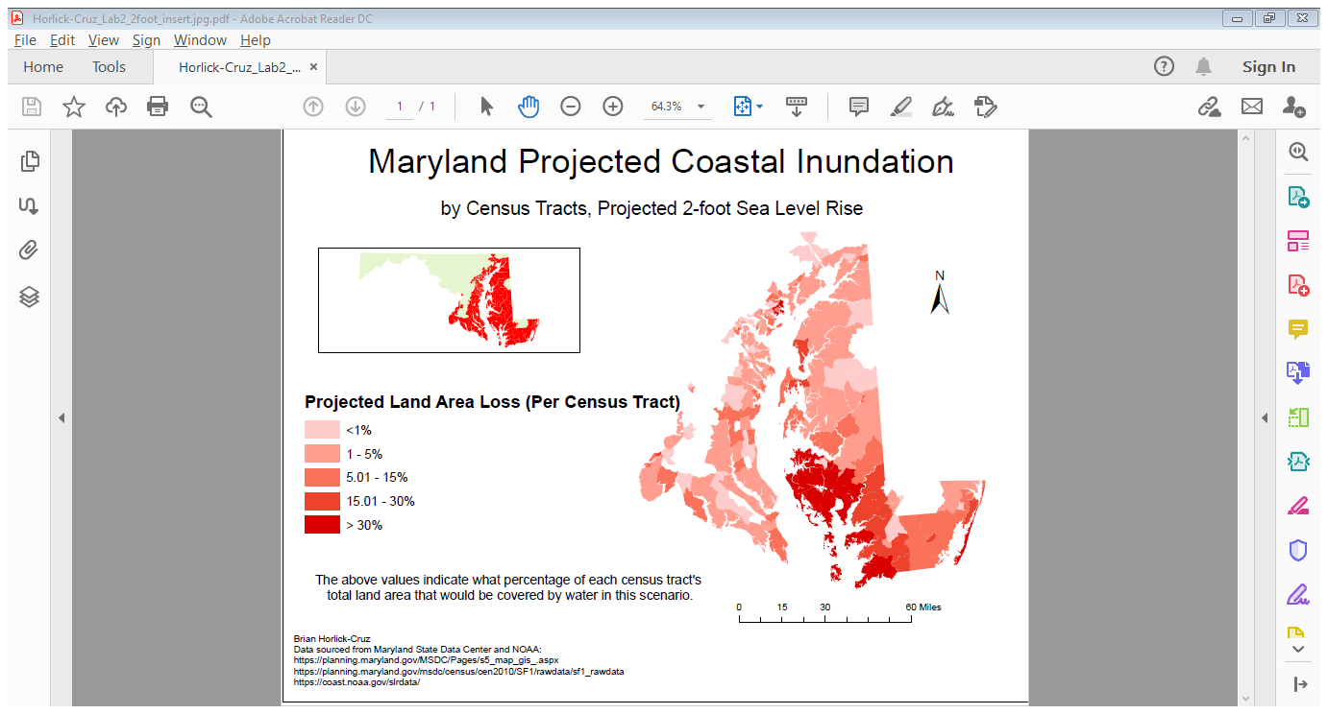

Appendix C - Projected 2-foot Seal Level Rise of Coastal Maryland. These sea levels roughly align with the NOAA’s “high” projections beginning around the year 2040.

Appendix D - Projected 5-foot Sea Rise Level for Maryland. These sea levels roughly align with the NOAA’s “high” projections beginning around the year 2070.

Appendix E - Proportions of Households with Members Aged 75+

Appendix F - Proportions of Non-White Populations

Appendix G - Proportions of Renter-Occupied Homes

Appendix H - Proportions of Single-Female Households with Children Under 18

Appendix I - Proportions of Households of 7 or More