I had some extra time today, so I did the same PCA genre mapping described in my previous post on another group of texts: the books of the *King James Bible*. Once again, this method performed remarkably well on clustering the books of the *KJB* according to genre.

Here is the genre map:

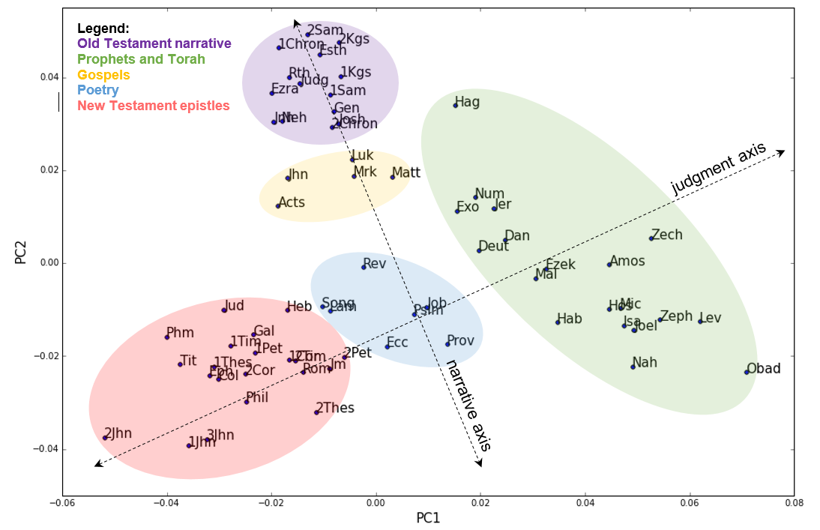

The words most strongly associated with the first principle component (PC1) were “shall” and “cut.” A brief inspection of the uses of “shall” and “cut” reveal that these words are often used when God is pronouncing judgment through the Old Testament prophets, e.g., “And it shall come to pass in that day, saith the Lord of hosts, that I will cut off the names of the idols out of the land, and they shall no more be remembered” (Jeremiah 13:2).

The second principle component (PC2) is most strongly associated with the active verbs “go” and “say” (it’s worth mentioning that some lemmatization was done on the original data, so words like “going” and “went” would map onto “go”). These words had higher frequencies in narrative books.

There are a few interesting results worth mentioning, but not as much as in the Shakespeare map. The book of Revelation is nearer to books of poetry like the Song of Solomon or the Psalms, rather than the judgment literature. Genesis is firmly placed within Old Testament narrative, although some have classified parts of it as closer to books of poetry. The books of the law (Exodus through Deuteronomy) are grouped together with books of prophecy, probably because of high frequencies of words like “shall.”

Still, the ability for PCA on word frequencies to identify generic structure is clearly demonstrated on a second data set. And therefore the same questions about genre may apply to the Bible as well. How useful is it to think of a book of the Bible, like the Psalms or 1 Corinthians, beyond their traditional genres?